GSE33000:
In the browser, open the URL: https://www.ncbi.nlm.nih.gov/geo/query/acc.cgi?acc=GSE33000
The interface appears as follows:
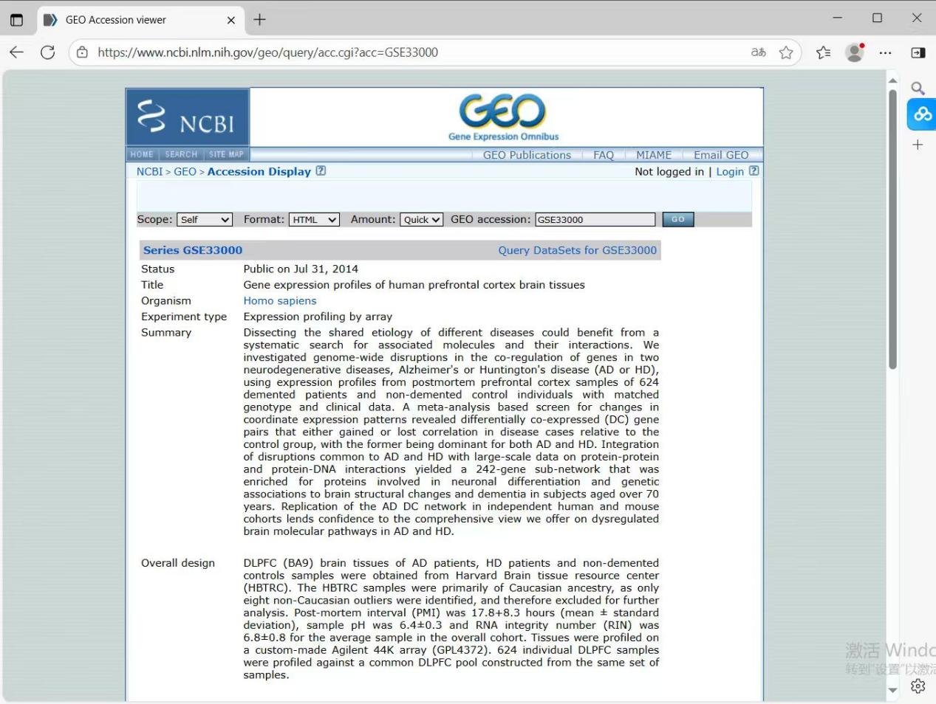
Scroll to the very bottom of the page
The interface appears as follows:
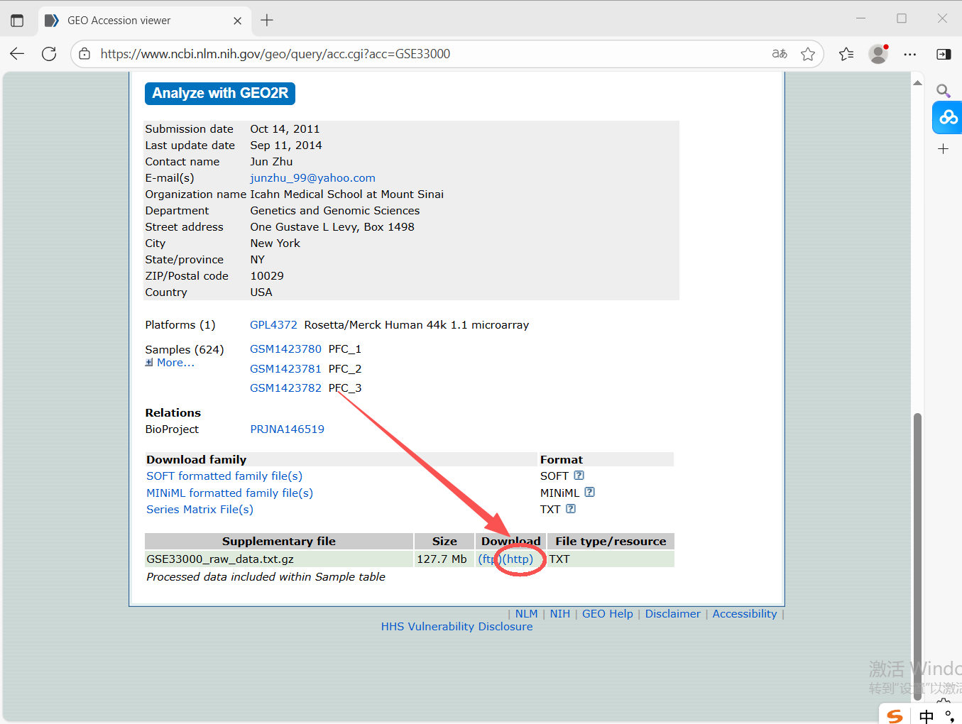
Click the blue text (http) marked in red to download the file. After extraction, it will be ready for use.

GSE44770:
In the browser, open the URL: https://www.ncbi.nlm.nih.gov/geo/query/acc.cgi?acc=GSE44770
The interface appears as follows:
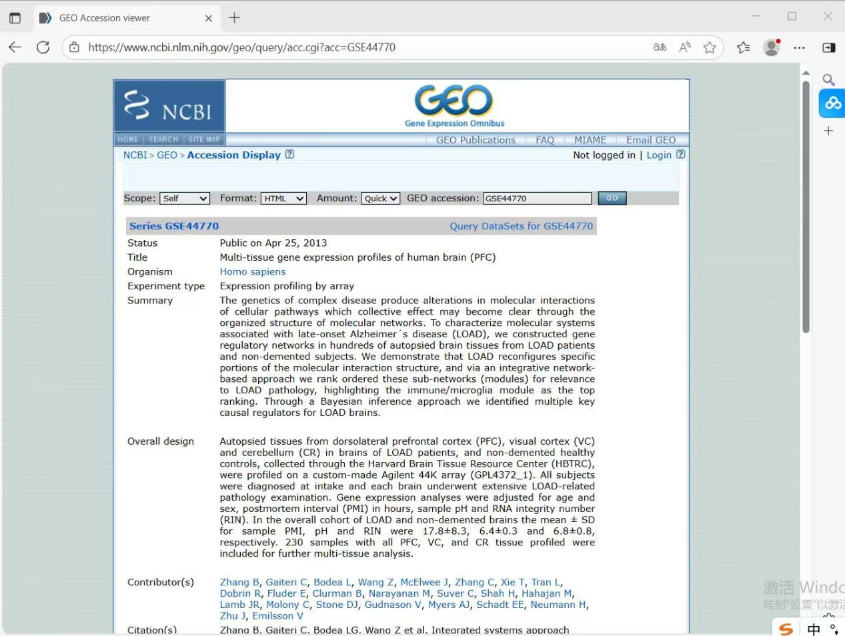
Scroll to the very bottom of the page
The interface appears as follows:
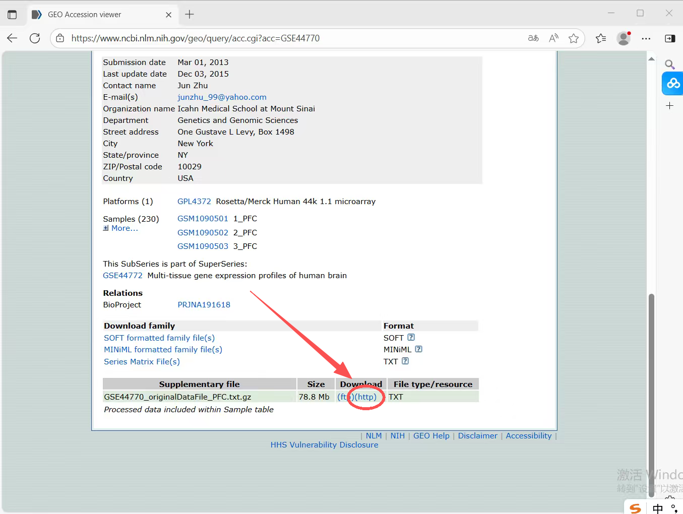
Click the blue text (http) marked in red to download the file. After extraction, it will be ready for use.
Load the two downloaded database files mentioned above before the code for "AD - Chapter 3 - PJ Hypothesis Validation".
Then run the code "AD - Chapter 3 - PJ Hypothesis Validation".

