**SIR SYED C@SE INSTITUTE OF TECHNOLOGY ISLAMABAD**



**PROJECT NAME**

**YUM YUM CAMPUS BITES FOOD APPLICATION**

**(LOGIN FORM)**

**CODE:**

package FOOD_PANDA_APP;  
  
import javax.swing.*;  
import java.awt.*;  
import java.io.BufferedReader;  
import java.io.FileReader;  
import java.io.IOException;  
public class SignIn2  
{  
 private static final String *FILE_PATH* = "user_records.txt"; // Declare the FILE_PATH constant  
 void SignIn2()  
 {  
 /*final String FILE_PATH = "user_records.txt";*/  
 JFrame frame=new JFrame("LOGIN");  
 frame.getContentPane().setBackground(Color.*black*);  
  
 JLabel label4 = new JLabel("SIGN-IN");  
 label4.setForeground(Color.*white*);  
 label4.setBounds(250, 90, 300, 30);  
 frame.add(label4);  
  
 JPanel panel = new JPanel();  
 JTextField textField = new JTextField("USER NAME");  
 textField.setForeground(Color.*white*); // it will color the text in text field;  
 textField.setBounds(70, 70, 200, 150);  
 textField.setBackground(Color.*black*);  
 panel.add(textField);  
 frame.add(panel);  
  
 panel.setBounds(150, 100, 200, 50);  
  
 JPanel panel1 = new JPanel();  
 JPasswordField passwordField = new JPasswordField();  
 passwordField.setEchoChar('*'); // Display asterisks for password input  
 passwordField.setBounds(70, 70, 400, 200);  
 passwordField.setBackground(Color.*black*);  
 passwordField.setForeground(Color.*white*);  
 panel.add(passwordField);  
 frame.add(panel1);  
 panel.setLayout(new GridLayout(4, 4));  
 /*  
 * row1 = username  
 * row2 = password  
 * row3 = signin  
 * row4 = signup  
 */  
 panel.setBounds(120, 130, 300, 200);  
 frame.add(panel, BorderLayout.*CENTER*);  
  
 JButton button = new JButton("LOGIN");  
 Color Color3 = new Color(229, 156, 23); // RGB values for b  
 button.setBackground(Color3);  
 button.setForeground(Color.*black*);  
 button.setSize(50,60);  
 panel.add(button);  
  
 JButton button1 = new JButton("SIGN-UP");  
 Color Color4 = new Color(229, 156, 23); // RGB values for b  
 button1.setBackground(Color4);  
 button1.setForeground(Color.*black*);  
 panel.add(button1);  
  
 JMenuBar JMenuBar=new JMenuBar();  
 JMenu SignUp = new JMenu("<-- SignUp");  
 SignUp.setForeground(Color.*black*);  
 Color Color2 = new Color(229, 156, 23); // RGB values for b  
 SignUp.setBackground(Color2);  
 SignUp.setBorder(BorderFactory.*createLineBorder*(Color.*darkGray*));  
 JMenuItem SignUp1,Home1;  
  
 SignUp1=new JMenuItem("<-- SignUp");  
 SignUp.add(SignUp1);  
 SignUp1.setForeground(Color.*black*);  
 Color Color1 = new Color(229, 156, 23); // RGB values for b  
 SignUp1.setBackground(Color1);  
 SignUp1.addActionListener(e -> {  
 SignUp2 s2=new SignUp2();  
 frame.dispose();  
 s2.SignUp2();  
 });  
 Home1=new JMenuItem("<-- HOME");  
 SignUp.add(Home1);  
 Home1.setBorder(BorderFactory.*createLineBorder* (Color.*darkGray*));  
 Home1.setForeground(Color.*black*);  
 Color Color11 = new Color(229, 156, 23); // RGB values for b // rgb stands for red green blue  
 Home1.setBackground(Color11);  
 Home1.addActionListener(e -> {  
 Home h=new Home();  
 frame.dispose();  
 h.Home1();  
 });  
 JMenuBar.add(SignUp);  
 frame.setJMenuBar(JMenuBar);  
 Color Color0 = new Color(229, 156, 23); // RGB values for b  
 JMenuBar.setBackground(Color0);  
  
 button.addActionListener(e -> {  
 String enteredUsername = textField.getText();  
 String enteredPassword = new String(passwordField.getPassword());  
  
 if (*authenticateUser*(enteredUsername, enteredPassword)) {  
 JOptionPane.*showMessageDialog*(frame, "Login Successful!");  
 Home h=new Home();  
 frame.dispose();  
 h.Home1();  
 } else {  
 JOptionPane.*showMessageDialog*(frame, "Invalid username or password.");  
 }  
 });  
  
 button1.addActionListener(e -> {  
 SignUp2 s2=new SignUp2();  
 frame.dispose();  
 s2.SignUp2();  
 });  
  
 frame.setLayout(null);  
 frame.setVisible(true);  
 frame.setResizable(false);  
  
 frame.setBounds(0,0,550,500);  
 frame.setDefaultCloseOperation(JFrame.*DISPOSE_ON_CLOSE*);  
 }  
  
 public static boolean authenticateUser(String username, String password) {  
 try (BufferedReader br = new BufferedReader(new FileReader(*FILE_PATH*))) {  
 String line;  
 while ((line = br.readLine()) != null) {  
 String[] parts = line.split(",");  
 if (parts.length >= 2 && parts[0].equals(username) && parts[1].equals(password)) {  
 return true;  
 }  
 }  
 } catch (IOException e) {  
 e.printStackTrace();  
 }  
 return false;  
 }  
  
}

**OUTPUT:**

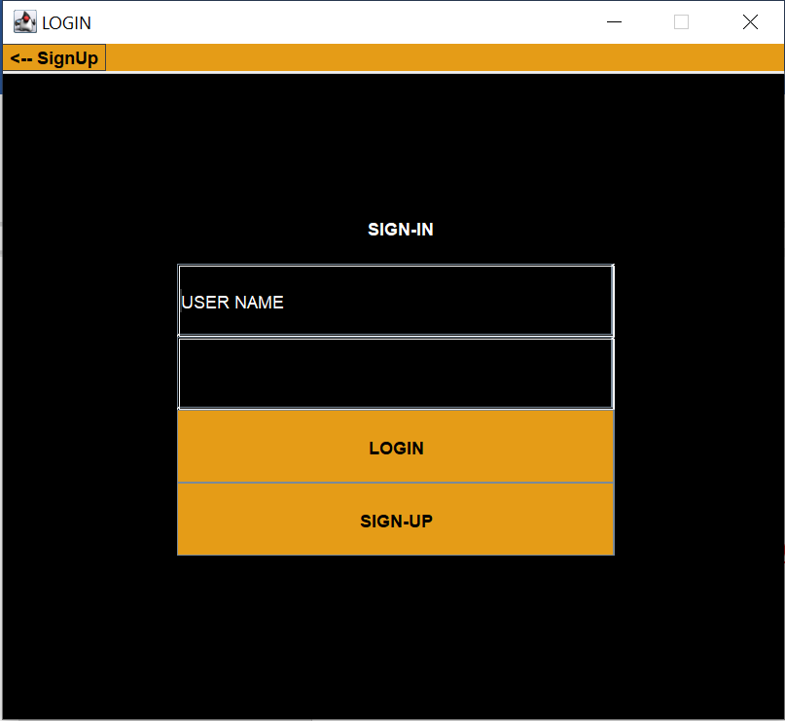

**After filling following panels we get**

