MICLAT, CHADLE REI M.

WD-201

**Step 1:** Install the following extensions on VSCode.

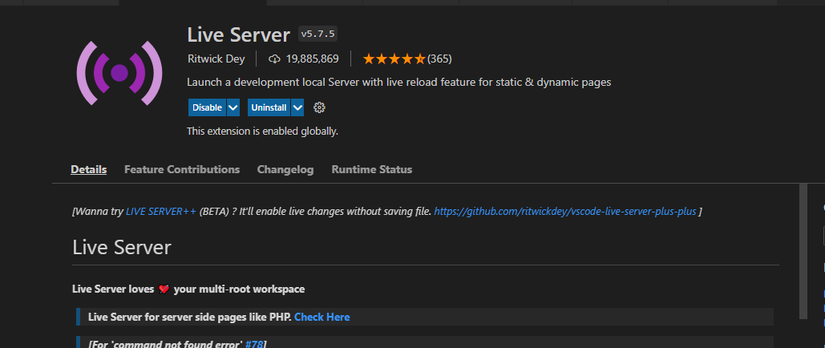

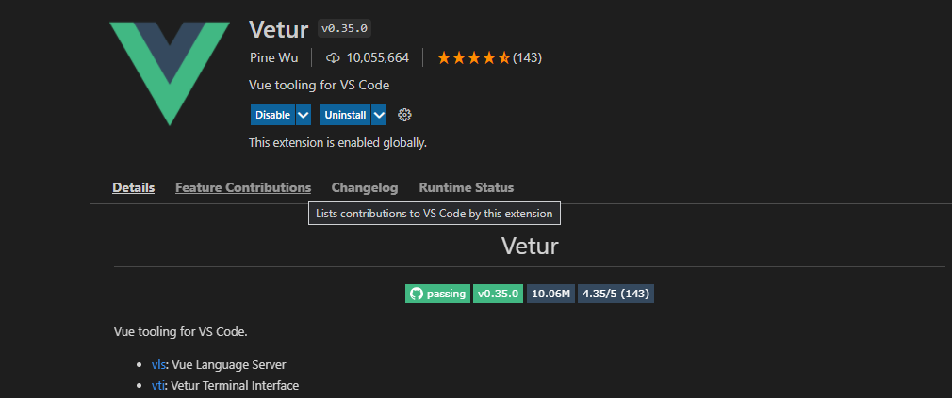

**Step 3:** Create the necessary files and folders

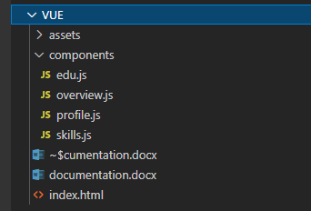

**Step 4:** Inside the header tag, link the script of vue v3.



**Step 5:** Write the HTML code with directives. Here, the Overview part is an example. Give the div an ID.

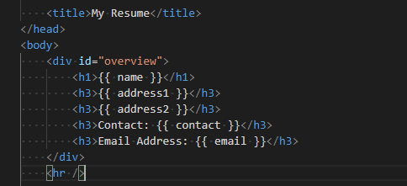

**Step 6:** Write the js code. Be sure the mount matches the div ID from the HTML code.

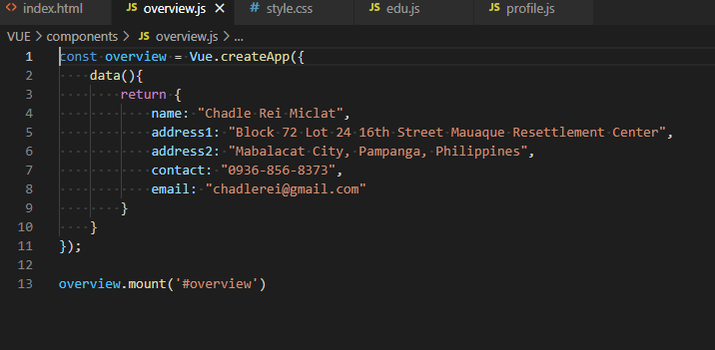

**Step 7:** In the HTML code, link the scripts to the appropriate js files.

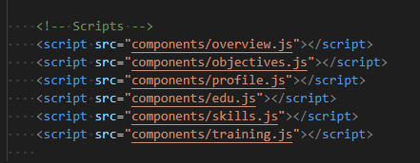

To add a list, write the following code:

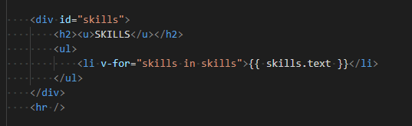

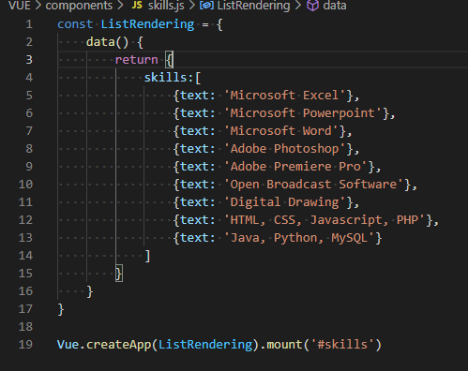

**Step 8:** Add a CSS Style

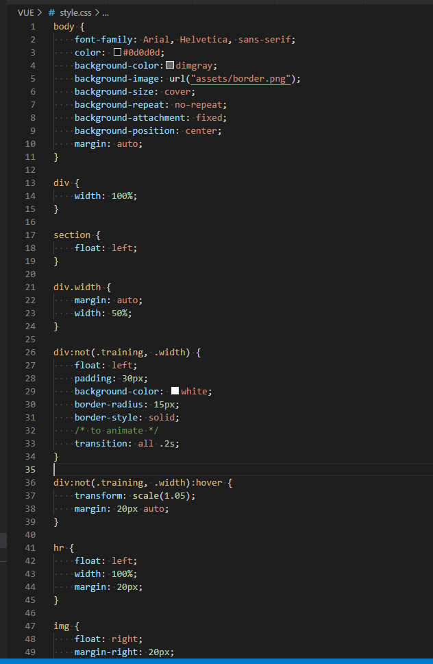

**Step 9:** At the bottom right of VSCode, click the Go Live button to run the web application on your browser.

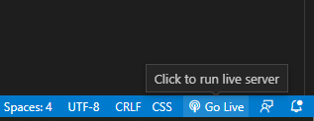

**Step 10:** The web application is done!

