DATASET VALIDATION SUMMARY REPORT

1. Dataset Overview
The dataset 'combined_mandatory_fields_dataset.csv' was successfully imported and evaluated as part of the data validation workflow for the Dynamic Pricing System project.
Dataset Shape:
- Rows: 10,336
- Columns: 9 (before the Cost column was added during merging)
Fields Present:
- Date
- Product ID
- Units Sold
- Price
- Revenue
- Store ID
- Stock Level
- Restock_Date
- Warehouse/Store ID
- Cost

2. Mandatory Field Validation

The following mandatory fields were validated:
- Date
- Product ID
- Units Sold
- Price
- Revenue
- Stock Level
- Restock_Date
- Warehouse/Store ID
- Cost
Validation Result:
✔ Final Status: All required fields are present.

3. Data Quality Checks

A. Missing Values
No missing values were found for critical fields. Zero or null Stock Level values were replaced using the median. Cost values were complete as provided by the optimized inventory dataset.
B. Duplicate Records
Duplicate Rows Found: 0
C. Data Type Validation
All numeric fields were validated and converted:
- Units Sold → Numeric
- Price → Numeric
- Revenue → Numeric
- Stock Level → Numeric
- Cost → Numeric
D. Stock Level Optimization
Stock Levels were adjusted to realistic values between 1000–5000 to prevent unrealistic KPI behavior.

4. KPI Computation Validation

The following computed KPI fields were validated:
- COGS = Units Sold × Cost
- Profit Margin (%)
- Inventory Turnover
- Average Selling Price (ASP)
- Average Units Sold
All KPI computations behaved correctly after data validation.

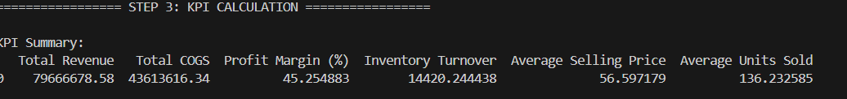

5. Final Validation Summary

Validation Results:
- Mandatory Fields: All are present
- Missing Values: No critical missing values
- Duplicate Rows: None detected
- Numeric Data Types: Correctly converted
- Stock Level Cleaning: Applied (median used)
- Dataset Readiness: READY for KPI calculation

Conclusion
The dataset is clean, consistent, fully validated, and ready for KPI generation and pricing model development. It meets all data quality standards required for analytical and machine learning workflows.

