A GRAPHICAL REPRESENTATION USING A HISTOGRAM TO SHOW THE HOUSE PRICE OF UNIT AREA IN A REALESTATE DATA.

**HISTOGRAM OF A POPULATION OF 414 SAMPLES**

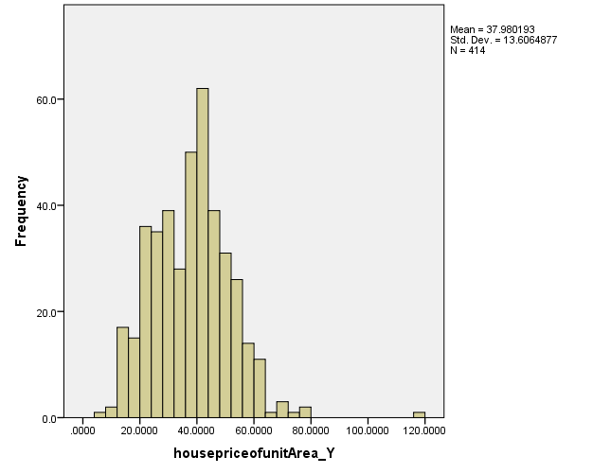

From the data we can conclude that the standard house price is 37.90. This suggests that most house prices are averagely above the 37.98. The minimum house price of the unit area is 7.6 while the maximum house price per unit area is 117.5. Due to the atypical small value, the histogram is slightly skewed to the left side, or negatively skewed. Therefore, without this value the graph would be symmetric

GRAPHICAL REPRESENTATION USING A BOXPLOT TO SHOW THE HOUSE PRICE OF UNIT AREA IN AREAL REALSTATE DATA.

**BOXPLOT OF A POPULATION OF 414 SAMPLES**

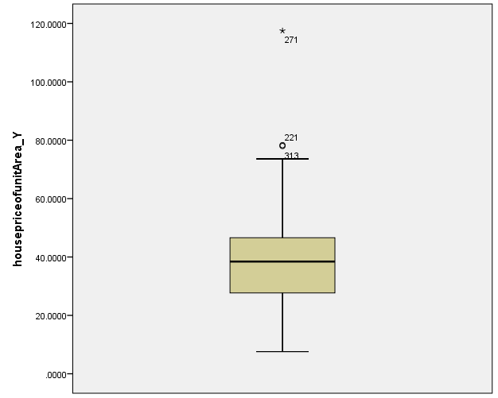

We can see from the above data that the minimum value is 7.6 per unit and the maximum value is 117.5 per unit. The median value is 38.45, and it is asymmetrical, indicating that the bulk of the values are clustered on the right. The skewness is 0.6, suggesting that our data is left or negatively biased, implying that the majority of people have a score of less than 38.45. The outlier value is 271; this means that there were 271 people present during the study.

A HISTOGRAM MADE WITH REAL ESTATE DATA FROM A POPULATION OF 414 HOUSEHOLDS. THE AGE OF EVERY PERSON IN EVERY HOUSEHOLD IS CONTAINED IN THIS INFORMATION.

**HISTOGRAM OF A POPULATION OF 414 SAMPLES**

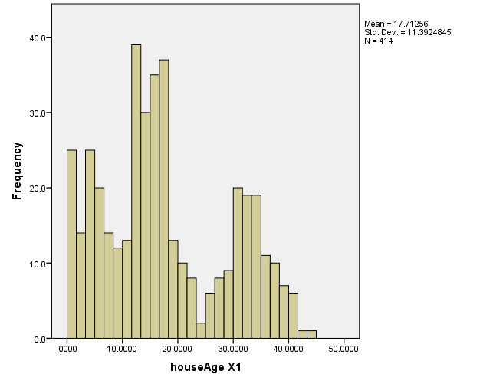

From the data above, not symmetric. Thus, the age was varying from one house to another hence it being asymmetrical. From this data we saw that the youngest element had 0 years while the oldest had 43.8 years while the middle age of all elements was 16.1. Finally, due to the large value or extreme value of ages of the respondents the histogram is slightly skewed to the right or it’s positively skewed.

A GRAPHICAL PRESENTATION OF HOUSE AGE DATA.

**BOXPLOT OF A POPULATION OF 414 SAMPLES**

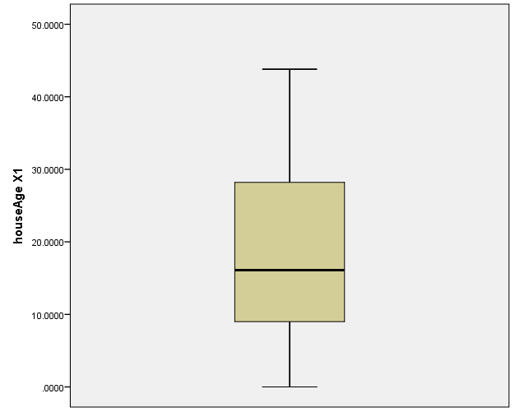

The data above indicates that the age was not symmetrical. As a result, the age of each house varied is asymmetrical. We can see from this data that the youngest individual has 0 years, the oldest individual has 43.8 years, and the median age of all elements is 16.1. Finally, due to the large or outlandish value of the respondents' ages, the histogram is slightly skewed to the right or it’s positively skewed

A GRAPHICAL REPRESENTATION USING A HISTOGRAM TO SHOW THE NUMBER OF THE CONVINIENCES STORES IN AREAL REALSTATE DATA

**BOXPLOT OF A POPULATION OF 414 SAMPLES**

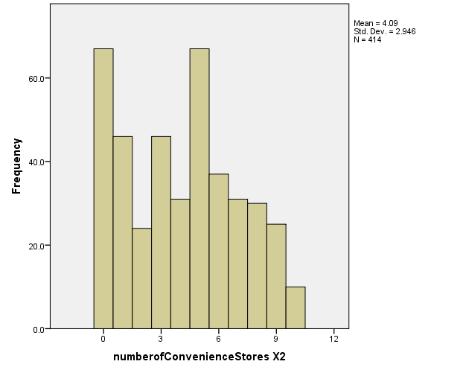From the above data the number of convenience stores is slightly above average. The minimum number of conveniences in this population is 0 and the maximum number of conveniences is 10. Finally, the histogram is slightly skewed to the left, or negatively skewed, due to the atypically small value. Therefore, without this value the graph would be reasonably symmetric

A GRAPHICAL REPRESENTATION TO SHOW THE NUMBER OF THE CONVINIENCES STORES IN AREAL REALSTATE DATA.

**BOXPLOT OF A POPULATION OF 414 SAMPLES**

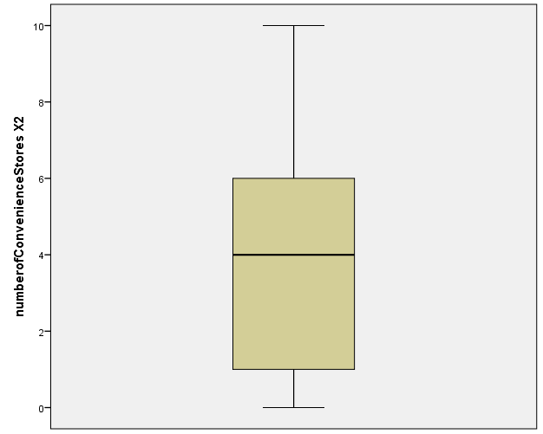

We can see from the above data that the minimum value per component is 0 and the maximum value is 10. The average value is 4.09, which is asymmetrical, indicating that the bulk of the values are clustered to the right. The skewness is 0.155, showing that the data is left or negatively biased, suggesting that the majority of people have a score of less than 4.09.

.

A GRAPHICAL REPRESENTATION USING A HISTOGREAM TO SHOW THE DISTANCE TO THE NEAREST TRANSIT STATION IN AREAL REALSTATE DATA.

**BOXPLOT OF A POPULATION OF 414 SAMPLES** 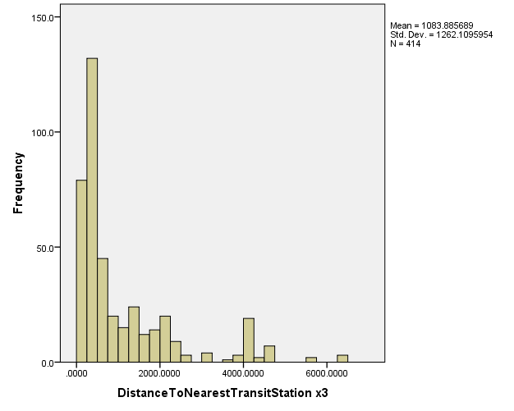

Based on the above histogram, the age was not symmetrical. As a result, the distance to the nearest transit station ranged from one house to the next, rendering it asymmetrical. We can see from this data that the shortest distance to the transit station is 23.38, the longest distance is 6488.021, and the middle distance is 492.231. At last, the histogram is marginally skewed to the right or positively skewed due to the respondents' large or extreme distances to the transit station.

A GRAPHICAL REPRESENTATION USING A BOXPLOT TO SHOW THE HOUSE PRICE OF UNIT AREA IN AREA REALSTATE DATA.

**BOXPLOT OF A POPULATION OF 414 SAMPLES**

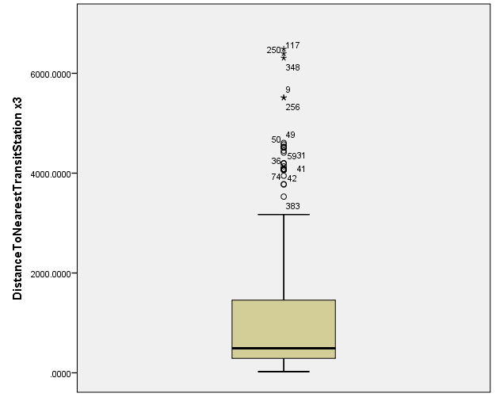

From the boxplot above the minimum value is 23.3828 while the maximum value is 6488.0210. The skewness is 1.889 hence the data is positively skewed. The median is 559.80