**Database Visualiser – Initial Impressions 24 July 2018**

**General comments**

Can we add a Victoria logo to the header? (This can replace the home icon, which I don’t think is necessary – everyone nowadays knows to click the main header to go home.)

Can we call it “HTS Wire **Critical Current** Database” in the header? Similarly, can the title of the webpage (window title) be “RRI HTS Wire Critical Current Database” instead of “Visualizer”?

**Dataset selection page**

Can we offer the option to sort the two columns, Datasets alphabetically ascending/descending, Published Date new to old/old to new? Ideally by just clicking the header text, not by the addition of any further UI elements. If we can’t do this, can we at least order them new to old? At present, I cannot distinguish any order to them.

Can we relegate the incompatible datasets to the bottom of the list or to a separate list? Can we have a text that appears when we hover over the exclamation mark icon explaining what it means? Can these items be greyed out or offer some other visual indication that they can’t be selected? If they are clicked, can we report to the user why nothing happens? Can we provide a means to link through to these incompatible datasets on Figshare?

From a technical point of view, I would be interested to understand why some of the datasets are failing the compatibility check, for example the SuperOx and the Shanghai Creative. I would like to investigate this in further detail with you.

How does this page handle many datasets? If I had 100, would they all appear in one long list, or would they be broken up into pages?

**About page**

Can I provide some final text later for this page?

**Graphical display page**

I like the circle while loading, however it appears too low, it seems to me (below the bottom of the finished page). I think it would be nice to superimpose some text saying “Loading” on the image, but maybe you disagree with that (too old-fashioned).

The heading, e.g. “Critical current characterisation of Shanghai Superconductor 2G HTS superconducting wire”: I’m not sure how this is constructed, but if possible I would prefer the omission of the word superconducting. This is the S in HTS anyway. I’m half thinking it would be best just to keep the name of the dataset as displayed on the selection list since this header gets quite long. Also, if it splits over two lines, it splits in the middle of words – that’s not ideal.

We should set a minimum width of the window. It does not work well if the window gets too narrow. Also I notice that the height of the graph is fixed, only the width varies.

I think we agreed it would be best to display a dataset (any dataset) upon loading, rather than presenting the user with a blank graph that leaves them wondering what to do next. Even I was stuck. The graph appears showing Ic/w versus Temperature, but no data is shown. I could not figure out how to get this data to appear.

I don’t see the need for the headings “Y-axis” and “X-axis” on the dropdown selection boxes. If the Y-axis label is going to be horizontal (which is fine) and at the top of the axis (which is fine), I would like to see the X-axis label at the far right of the x-axis.

**It is essential that units be displayed on the axes. This is as simple as renaming Ic to Ic (A), Ic/w to Ic/w (A/cm), Temperature to Temperature (K), Field to Field (T), and Angle to Angle (°).** n-value has no units, but might be better displayed as n-value instead of just n. For an added challenge, you can attempt to subscript the c and italicise the I, w and n. Alternatively, you can get the axis label to display vertically and write out “Critical current”.

**At present, there remains no way to display multiple curves on the graph. This should be your top priority in terms of functionality.**

The data selection is clunky. This may be due to thinking forward to future functionality, but at the moment, if I want to look through the data, I have to “clear” the current selection (which, confusingly, doesn’t clear the graph) and then I have to select the new parameter. Why do I have all these extra steps? Why can’t I simply select the new data I want to see?

At the moment, there is no data export functionality. At a bare minimum, we need a link through to the Figshare page of the relevant dataset. Ideally you would allow the export of the data from the graph, in both textual and graphical forms.

**I was easily able to get the software into a state where the selections I made had no effect on the graphical display and it was not clear why. This is unacceptable. What is shown must always be accurate. At the moment, it is not (see example below).**

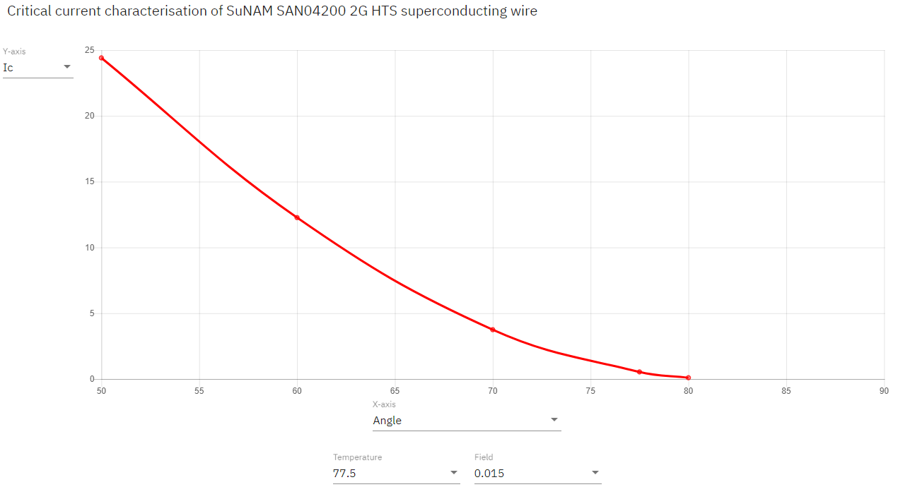

I hesitate to suggest this, because it is easy to go too far in the opposite direction, but the graph seems a little faint, as evident from the screenshot above. Is it possible at least to make the numbers a little larger, similar to the dropdowns, and the main x and y axes a bit stronger?

No logarithmic axis functionality.

I had to leave off at this point. The application ceased to respond. I don’t know why.

**Attribution**

Have you considered putting a footer across all pages? This should credit yourselves with the work, while copyrighting it to us, and perhaps contain other information about the licensing of the datasets. If we had a placeholder here, I could come up with some content. Have you considered how you would like to be credited in such a way that benefits your future career, i.e. a link or some contact details, or at least a statement of your names so that when you point future employers to this as an example of your work, they can verify that you were involved?

**Mobile compatibility**

I worked through it on desktop this time (although occasionally resizing my window). I’ll try it out on mobile at a future iteration.

**Queries / Discussion points**

Is the style of the website contained in a simple stylesheet or other easily editable form? For example, if I wanted to change the green colour of the header bar, how easy would that be to do?