**Database Visualiser – Iteration 3 Comments 24 August 2018**

**General comments**

Font of “Robinson Research Institute” in footer: Georgia. You could try the green stripe as RGB 0 71 47. Heading (“High temperature superconducting wire critical current database”) should be the same size (and font?) as Robinson Research Institute in the footer.

Window title: improved, but don’t use DB, instead “Database”. I’m happy to keep all our superconductor jargon in there, but I don’t want any computer science jargon. ;-)

Filter is good. Only works on dataset name. Could be good to work on date also, e.g. if I enter “2016”. UI needs a bit of thought. For example, could you include the entry field beside the “Datasets” header of the table? Even in the smallest window size, there is space for it there.

How about framing the app (middle bit) in a page of regular HTML that I could edit? (This is the thinking point I made in the meeting, and it’s repeated again below.)

A final tweak at the end of the project would be to ensure the data selection page and the graph page remain the same size. In other words, the header and footer would never move, however you click around. Implementation of this would require a bit of thought. It comes down to sizing things (the dataset list on the selection page and the graph on the display page) to the window height, but more basically just keeping both of these two main pages the same vertical height. At the moment the two are independent heights. Fixing them to be equal would increase the cohesiveness of the app as a whole.

Some new things: The Victoria logo in the footer should be a link to <https://www.victoria.ac.nz> (the one in the header should remain a link back to the database homepage), the Robinson Research Institute text should be a link to <https://www.victoria.ac.nz/robinson> (without underline or any other visual indication of the link). Based on our discussion today, I notice that the Victoria logo links to htsdb.ecs.vuw.ac.nz. Will this update automatically if we change the domain name or is this hardcoded into the app and therefore not able to be altered?

**Dataset selection page**

Column widths and resizing are good. Figshare icon is nice, but seems to go to the web app dataset before forwarding to figshare. The back button then takes us back to the graphical display page, not the dataset selection page. Can we eliminate this slow redirect and unexpected behaviour?

**BUG:** Steps to reproduce. 1. Open htsdb.ecs.vuw.ac.nz in Chrome. 2. Click the figshare link to the first (AMSC) dataset. We first load the dataset then quickly redirect to figshare. This is the issue highlighted above, but not the bug. 3. Click the back button. We go back to the graph page instead of the dataset selection page, but this is still not the bug. 4. Click the back button again. We go back to the dataset selection page, but it is the old one (figshare icon on the left), not the current one.

Can we eliminate the “Figshare Link” column header? It’s just words getting in the way of what we want to do. If a user doesn’t know what the icon does, it doesn’t matter. They can click it to find out. Nothing bad will happen. We don’t need to force them to read an instruction manual on every page, every time they look at it. Without the text, the column could be about half the width, saving space. It would then also be nice if “Publication Date” (instead of “Published Date”) used that spare space (spanned both columns) to avoid splitting onto two lines, which would be more elegant.

Can we change the text of the tooltip on the Figshare icon to “View this dataset on figshare.” (With fullstop, like the one on the exclamation mark.)

The hover over the exclamation mark is good functionality. Could we change the text from “Dataset not supported by system.” to “Incompatible data file format.” or just “Dataset not supported.” or something that doesn’t include “system”? Also, I think it would look cleaner if those exclamation marks all appeared at the beginning of the name instead of the end. Then they would all be aligned, and would indent the incompatible dataset names, further distinguishing them from the others.

Still to consider: How does this page handle many datasets? If I had 100, would they all appear in one long list, or would they be broken up into pages? (I know you’ve answered this; just leaving it here for reference.)

**About page**

Link is back as a placeholder in the footer, good. Let’s think about how to tidy it up a bit. Basing our ideas on the legalmaori website you pointed me to, we could add a subtle line of text at the bottom right, below the logo, saying “Website design © <current year> Victoria University of Wellington, New Zealand | About”. I’m not sure right now, but let’s play with some ideas to improve this.

Still to address: Can I provide some final text later for this page? (See end of document.)

Links should be more prominent on this page (different colour text). This is essentially a normal webpage, and I expect to see what’s a link and what’s not.

**Graphical display page**

If you adjust the figshare tooltip text on the selection page, adjust it here to match. I think the figshare icon would be best on the left, just because that means it always appears in the same place, rather than jumping around the page. On either side, an additional space between it and the title would be good.

Still to address: I like the circle while loading, however it appears too low, it seems to me (below the bottom of the finished page). I think it would be nice to superimpose some text saying “Loading dataset” on the image, but maybe you disagree with that (too old-fashioned). This now looks good (to me). But the old one (too low, no text) is still present if I click the back button to go back to the selection page.

Window width adjustment works great now, and I like the way it adjusts to maintain the prominence of the graph. A very tiny subtle point, but there is a position where the margin on the left side of the options pane changes width. It would be better if this didn’t happen. It looks unintentional because you don’t gain enough width (only a few pixels) to make it worthwhile. I suggest you don’t use it, and just rely on the repositioning of the options below the graph to gain width when needed.

A later task will be to work on the height adjustment now, and make it as good. Again I would set a minimum vertical height for the graph, making use of the scrollbar if necessary. At the moment it is possible to make it too small to be usable (and in fact I can shrink the window to zero height – can you limit this the same way you have limited the width?).

Another point I was trying to make previously is that the window size “catches up” with the graph. The graph doesn’t get smaller at the same rate as the window, so I start below it and gradually cover up more and more. I would make it so it stays the same distance above the bottom of the window, down to some minimum window height.

Question to consider: are graph images exported as they appear or in some standard size…?

Still to address: I don’t like the excess text: “Y Axis Options” and “X Variable Options”. This is just clutter; it doesn’t need to be there, it doesn’t tell the user anything useful. Likewise, we simply don’t need headings on the boxes to “Choose the Y axis” and to “Change the scale”. The user can just try it and see. It’s not dangerous, they don’t need to be carefully guided through it. Let’s just have the options.

Selectable legend is great, just want the “select all” and “select none” (not “deselect all”, in fact just “all” and “none” will suffice) displayed at the top of the legend. (As discussed today, I appreciate this may be difficult. If it can’t be done, so be it, but keep it in mind in case you have a bright idea. If you eliminated the title of the graph, perhaps it would be possible to position them well. I’m not sure if the title is needed, and if it is, it could just be written in text, outside of the graphing environment.)

What would I like to see in the point label box? Three independent parameters on the top line, e.g. 90 K, 0.3 T, 125°, and graph value (Ic, Ic/w or n as appropriate) on the bottom line, with unit, ideally expressed as, for example “*I*c = 500.5 A”. Do you have this much control? If not, can you just show the value, with unit? If not, perhaps we should consider disabling this functionality completely (which would be a shame).

I can see the gridlines now, it’s good. However, the one at the very top of the graph appears to be missing. We show the label (e.g. 1,000), but we don’t have the line, and it makes the graph look incomplete. Ideally we would use the ever-so-slightly heavier lines we have on the left and bottom of the graph also to frame it on the top and right, but it’s okay if not. Next, is it easy to put a very little space between the labels and the tick marks that extend outside of the graph. At the moment they are exactly touching (y-axis, where the digit is zero) and this makes it look messy. X-axis is better, due to a shorter tick mark being used, but could also benefit from fractionally more space.

The axis labels are a touch small. Can they be made the same size as the numbers? Normally they would be slightly larger than the numbers, but let’s try at equal size first. The title (if we retain it) should be at least as big as the axis labels.

The watermark is a great feature, however I see it being difficult. At the moment its positioning is not quite right (extending outside the pane of the graph on the left), and I see it jumping around from time to time, which I think is a result of the automatic resizing. I would prefer this to be graphical, but I’m not sure how (if) it’s going to work. I’ll provide a graphic, but if this can’t be done, we may just turn it off. Also, consider positioning it top right to be out of the way on most curves.

Still to address: In general your approach of showing all curves is correct, and exactly what I want to see. However, there is one exception. It’s very hard to get to the temperature dependence at zero field, and actually I think it doesn’t exist, which means your parsing of the data has missed one (call it an edge case, maybe) because this is present in the data. For this reason, it would be best if this were the graph that were shown by default on first accessing the page.

For an added challenge, you can attempt to subscript the c in *I*c.

Data selection is much improved.

Data export is good. We’re considering the nature of the csv export. We’re hopefully going to replace these text buttons with icons. It’s helpful to have both save PNG and copy PNG to clipboard (which works via right-click). It would be nice if the print graph was implemented via the browser print function rather than (cleverly, I admit) via a separate page. I think there’s a way with style sheets to specify what gets printed, but maybe this is too much work. Don’t worry too much; the existing functionality is good.

Still to address:As an added extra, can you make the increment of the angle scale a multiple of 30?

We have some colour options for the graph now. It’s a good example, perhaps I can provide an additional palette. Again, would be nice to have buttons for these simple options.

We got rid of the borders around the graph, but there’s still one around the options. Can it go too?

**Mobile compatibility**

I worked through it on desktop this time (although occasionally resizing my window). I’ll try it out on mobile at a future iteration. It looks like it’s getting to the point where it should work well.

**Queries / Discussion points**

Is the style of the website contained in a simple stylesheet or other easily editable form? For example, if I wanted to change the green colour of the header bar, how easy would that be to do? See above idea, also discussed in the meeting: How about framing the app (middle bit) in a page of regular HTML that I could edit? Then I can even embed the app on other webpages to increase its exposure. I’m thinking of something like a frame, that could be put anywhere. Like Youtube videos can be put on any webpage, for example. That’s the same thing: the webpage server doesn’t run Youtube, that runs on it’s own server (AWS in your case). But the host webpage can be arbitrarily simple.

**Additional features (just a list so we don’t forget something)**

I want the graph to look good when printed out.

Data export features – copy graph to word document, access *actual* data files.

Metrics.

Admin options: flag to hide incompatible datasets, way to edit stylesheet?

Fit curves instead of point joining (I expect this to be deferred to a future project).

Display DOI and CC BY 4.0 icon?

How to support VUW rebranding…

**About page text**

**The Robinson Research Institute high-temperature superconducting wire critical current database**

This database comprises high temperature superconducting (HTS) wire performance data measured at the Robinson Research Institute of Victoria University of Wellington. Its principal focus is on commercially available materials, and it aims to provide the most comprehensive performance data available, enabling informed materials selection and the efficient modelling, design and construction of high temperature superconducting machines and devices.

The database will continue to be expanded over time, and submissions of additional (commercially-available) materials for measurement and potential inclusion in the database are welcomed.

**About the Institute**

The multidisciplinary Robinson Research Institute melds innovative engineering and applied physics to build advanced technologies for businesses worldwide. We are a world-leading team of scientists and engineers who create and commercialise applications of high temperature superconductors and other technologies together with our industry partners. Want to find out more about us? Visit our <main website>link to <https://www.victoria.ac.nz/robinson>.

**About the measurements**

Superconductor characterisation data is acquired on our in-house SuperCurrent *I*c measurement system. This system facilitates measurements of critical currents up to 1000 A at temperatures down to 15 K and in magnetic fields up to 8 T. A description of the system can be found in <N. M. Strickland, C. Hoffmann, and S. C. Wimbush, A 1 kA-class cryogen-free critical current characterization system for superconducting coated conductors, Rev. Sci. Instrum. 85 (2014) 113907>link to <https://dx.doi.org/10.1063/1.4902139>. Purchasing enquiries can be directed to <HTS-110 Limited>link to https://www.hts-110.com.

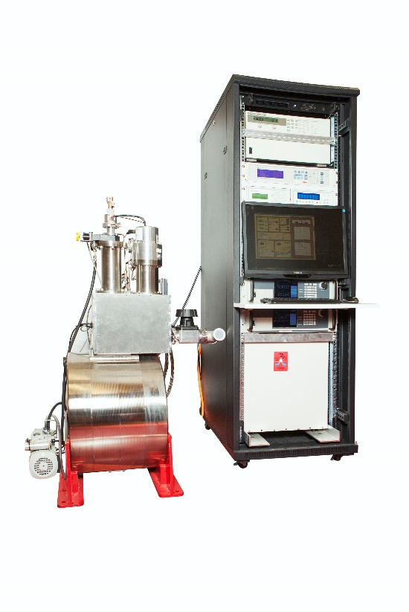

**About the data**

Complete datasets are stored on <figshare>link to <https://figshare.com/collections/A_high_temperature_superconducting_HTS_wire_critical_current_database/2861821>, where they are publically accessible in their entirety. Each dataset is a comprehensive characterisation of the performance of a particular sample wire over a wide range of potential operating conditions of temperature, magnetic field, and field angle. Data can be viewed in terms of the absolute critical current of the wire, or normalised to its width. *n*-value data is also available. The database is described in <S. C. Wimbush and N. M. Strickland, A public database of high-temperature superconductor critical current data, IEEE Trans. Appl. Supercond. 27 (2017) 8000105>link to <https://dx.doi.org/10.1109/TASC.2016.2628700>.

**About the data visualiser**

This data visualiser provides a means of direct graphical access to the wire performance datasets. Desired performance curves can be accessed and exported for further use. The latest datasets are automatically sourced from the underlying figshare database.

The data visualiser web application was developed by: <list of your names, as at present>

**Copyright**

The design of these webpages and the data visualiser web application are copyright © <current year> Victoria University of Wellington. The individual datasets presented are licensed under a Creative Commons Attribution 4.0 International (CC BY 4.0) licence. You must give appropriate attribution for any reuse of the data provided here. Permission is granted for republication of graphical images exported from this web application under the same terms.