Actual issue: offset

Method1: offset channel by 1.5 V

Method 2: use a pot between VCC- (pin4) and v- of the power supply, and adjust it until its in the middle

Different problem

It doesn’t work cause cutoff frequency is too low.

To make it work, either reduce capacitor/resistor or both

Or reduce the frequency of the input signal to significantly lower number

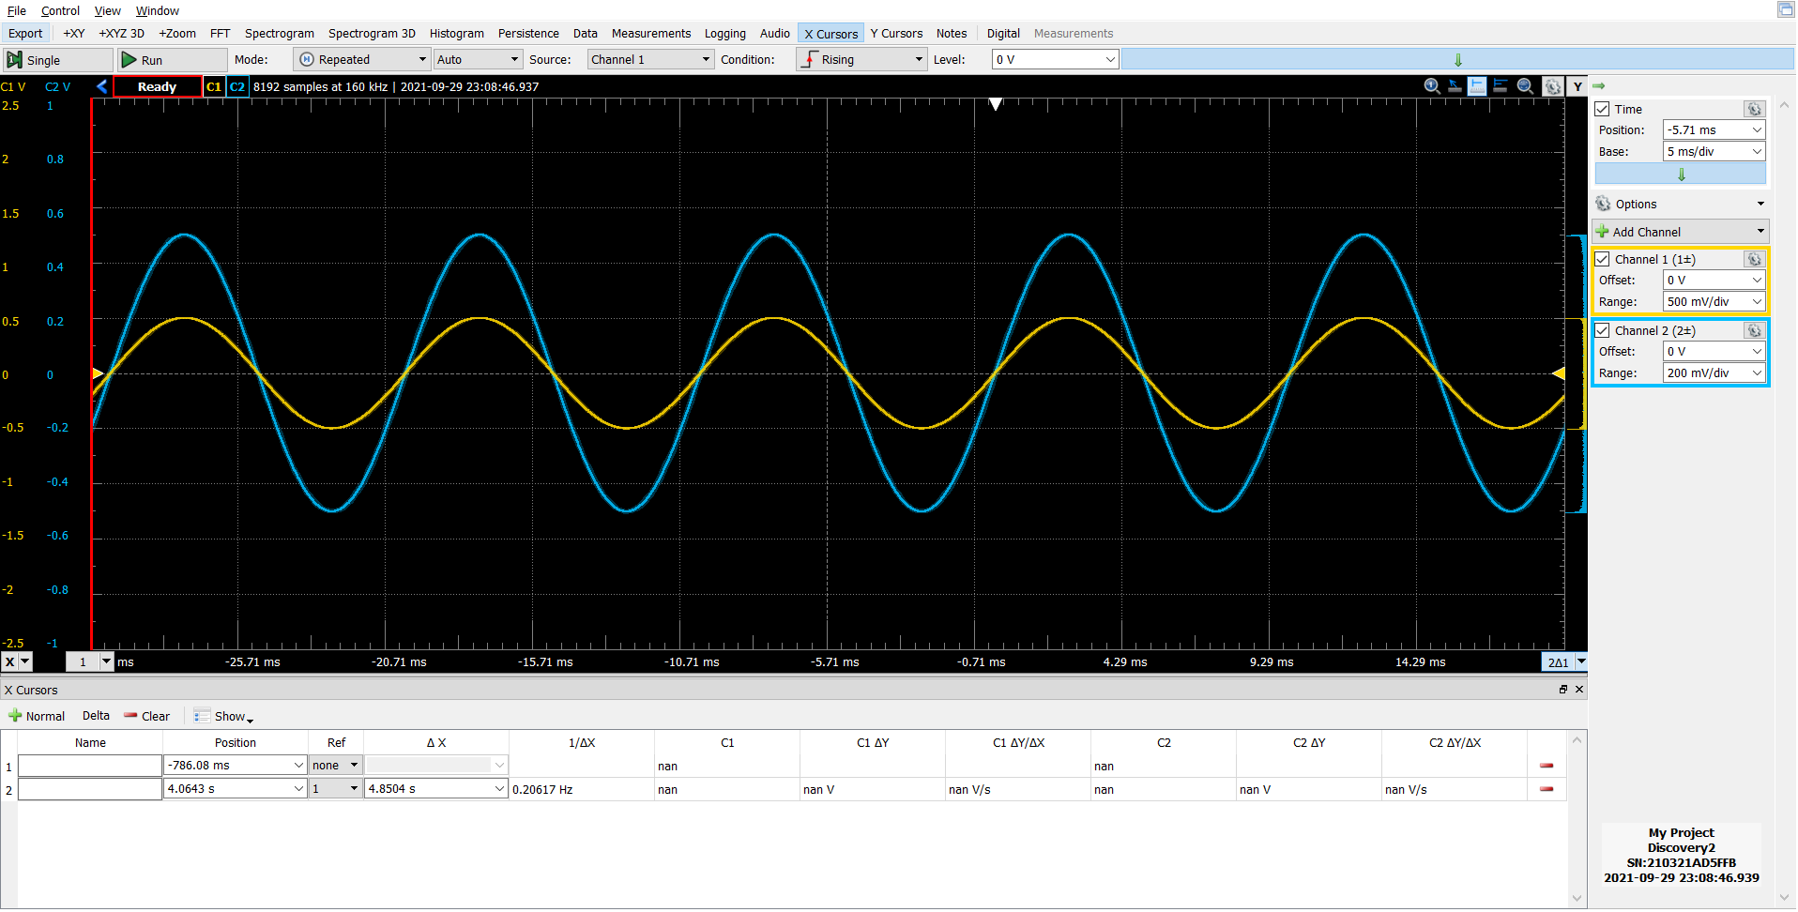

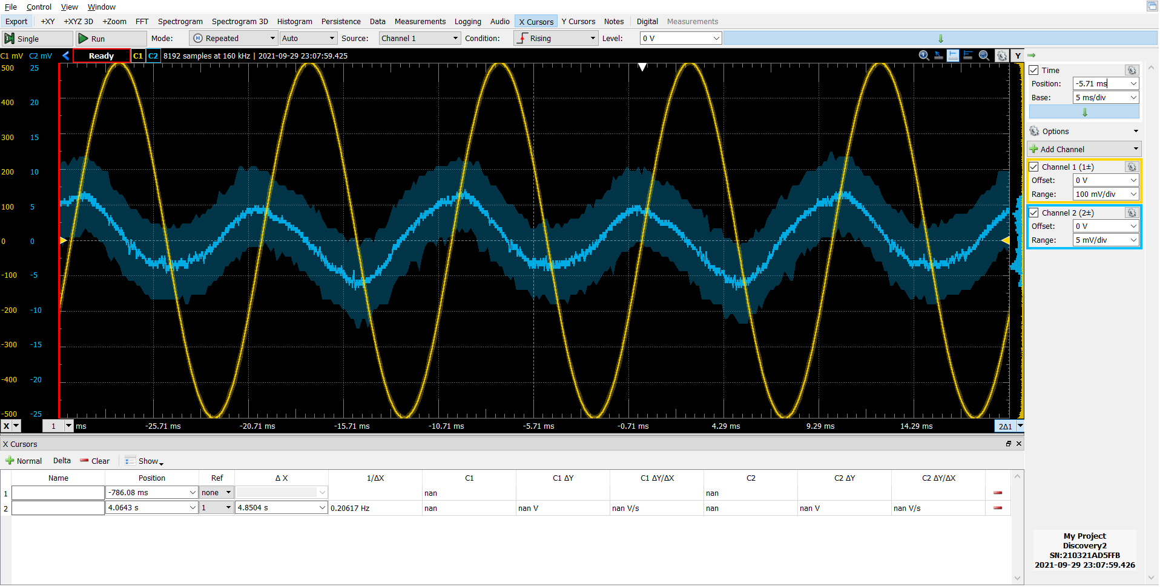choosing a 10pico farad capacitor and 1 ohm resistor seems to work. The output signal does need to be amplified though.

Second method:

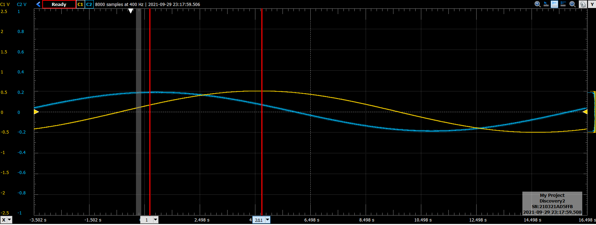

Task 9

Vout is a bit scaled as expected due to scaling factors and factor which arises due to differentiation

Task 10

10,20,40 Hz, amplitude of 1V

Non-inverting

**NEED TO DO ARDUINO PART**

Task 11

1. passes when signal is negative and makes it +veChart, line chart

   Description automatically generated
2. Full wave rectifier, but output is -|input| and second part also provides some gain

