|  |  |  |  |  |
| --- | --- | --- | --- | --- |
| VCE,V1 | Ib | Ic | Vbe | **beta** |
| 5,1 | 2.61mA | 292.95mA | 943.09mV | 112.24 |
| 5,2 | 24.61mA | 1.06A | 1.46V | 43.07 |
| 5,2.5 | 37.34mA | 1.32A | 1.68V | 35.35 |
| 5,3 | 50.5mA | 1.54A | 1.89V | 30.495 |
| 5,5 | 105.4mA | 2.24A | 2.68V | 21.25 |

Question 2.1 Please identify which region is the transistor working at when the LED (Light Emitting Diode) is on? And off? (5 points) 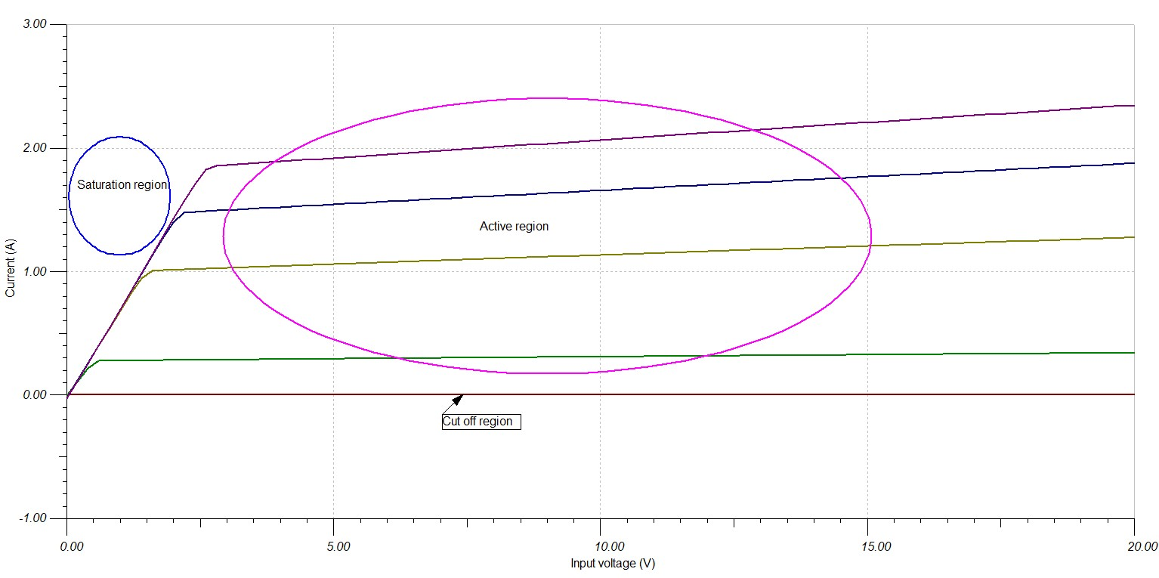 Active region, IC>0

Question 2.2: Calculate the blinking frequency. (5 points) 0.5Hz, 1 half cycle of square wave every second.

Question 2.3: Modify the code, change the blinking frequency to 50 Hz. Include and submit your Arduino code. (5 points)

50Hz ->20ms so half cycle is 10ms

Question 3.1: Identify the BJT operation region under this bias point based on your simulation. (5 point).

V_{b} = V_R1[2,0] = 840.16 mV

V_{e} = V_R3[3,0] = 206.17 mV

V_{c} = V_R2[4,7] = 2.05 V

Cut-off region : Vb<Ve => V_{ib} < V_{R3} => V_{R1}<V_{R3} .

Active region: Ve<Vb<Vc

Saturated region: Vb>Vc

So active region

Question 3.2: Calculate the AC gain based on your simulation. (5 points)

AC gain = V_load/V_in = 597.95/100 = 5.98 (V/V)

Question 3.3: Explain why we need the capacitor C1 and C2? (Hint. Compare the differences between simulation and breadboard). (5 points)

We need the capacitor to smooth/filter out dc noise . a capacitor blocks dc, this allows us to ignore any dc bias and only amplify the AC portion of the signal.

Question 3.4: Calculate the breadboard circuit AC gain and compare it with the simulation result. Give some comments. (5 points)

