**Production 2017 - Art Bible**

**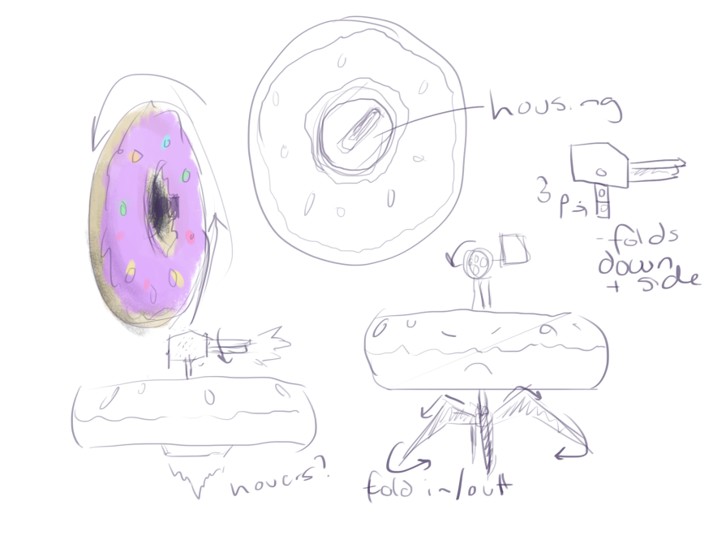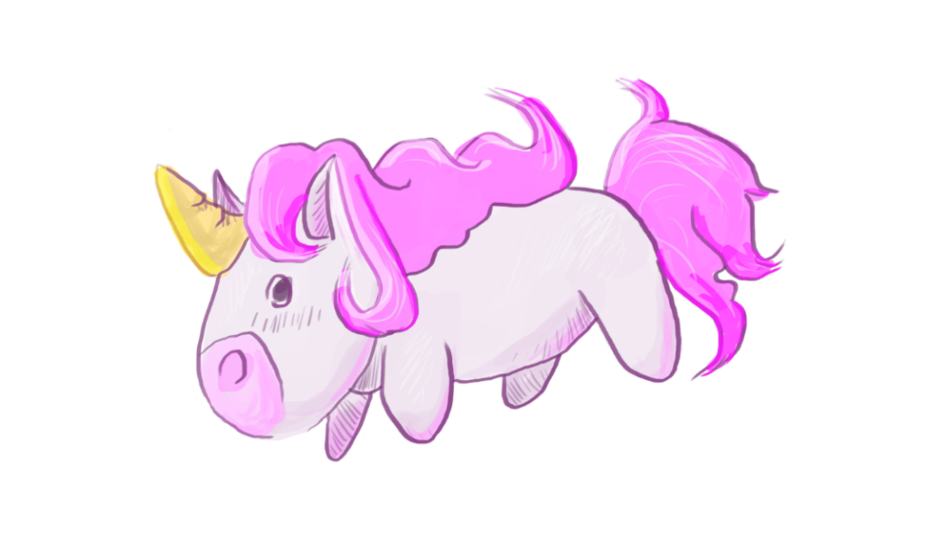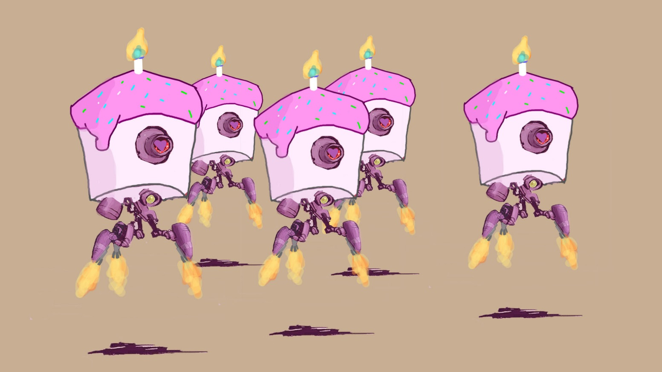***Humorous Overkill*

**Table of Contents**

# Team Art Style Overview Colour Palette Atmosphere Camera Character Art Environment Art UI Technical Specifications Reference Art

**List your individual team member’s names:**

Rohan Harvey  
Daniel Jones  
Kathryn Rynne  
Jardene Mackay  
Ian Dela-Cruz

**Art Style Overview**

The style of our project is focused heavily on an 8-year-old girls dream game. Initial loading screen is going to be as if a military style game, such as Call of Duty, however will be altered upon initial load. Shader style is going to be cell shaded, with AO to assist with the lighting information from the models. Colours will be brighter tones to suit the dynamic of an 8-yo girls’ preferences.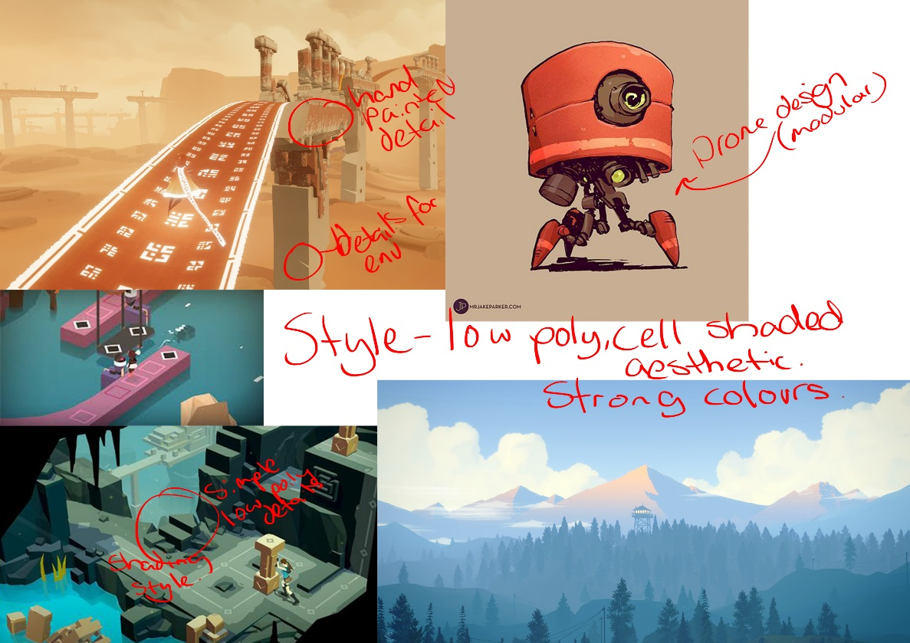

**Colour Palette**

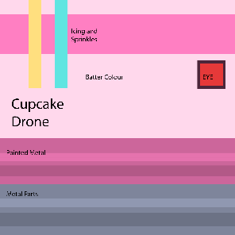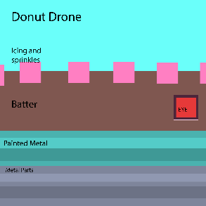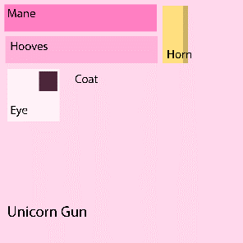The colour palette for the level will be bright, pastel colours that suit the mindset of an 8-year-old girls favourite tones.

**Atmosphere**

The level atmosphere is set to be bright and colourful, but at the same time, claustrophobic and chaotic as the player progresses.

**Camera**

The camera is set up as first person, similar to most shooter games such as the Halo series and the Call of Duty series.

**Character Art**

The characters to be modelled are:

* Donut drones: Circular rolling donuts with mechanical workings to deploy a gun once stationary and rolled on its side. Animations (rolling, gun unfolding, legs/thruster lifting body, flipping over and turning), rigging.
* Cupcake Drones: Updated model of the normal drones, with a cupcake formed around the body. Colour palette similar to the hacked half of the room, no rig required (dependent on build) but animation the same as the last model. Built the same as last drone model.
* Character: hands. Design is set to be low poly. Hands need to be rigged. Movement in hands animated for reload and firing mechanics.
* Unicorn: Modelled, textured following theme of the hacked room, and rigged simply to animate the breathing/firing mechanic.

**Environment Art**

Environment aspects to be modelled:

* Walls: Concrete walls with simple details such as carved cracks and fractures, including 3 variants to be reused.
* Pillars: Concrete pillars made with stacked blocks, allowing for several different versions with cracks and fractures.
* Floor: Concrete blocks similar to the walls, darker tones of grey and brown to show constant use. Stickers and decals of arrows to point a path for the player.
* Ceiling: Solid concrete blocks, reuse of the floor blocks with different textures. Cleaner, less grungy.
* Party poppers: small pickups with floating loop. Small and colourful.
* Ice Cream containers: ammo refill for unicorn beam. Small tubs with simple colours and still animation.
* Decals: Different images of cupcakes, rainbows and fluffy animals etc lining the walls and pillars of the second phase to lighten the military aspect of the room.
* Crates: fills empty spaces to make the room look used.
* Health packs: box of cookies. Simple box.
* Space fillers: different types of crates, boxes, concrete blocks, etc. to fill the space, make it look used
* Guns: FUBAR models to be scattered through the rooms
* Catwalk: Railings and heightened walkways to give extra dimension to the environments
* Doors: to close behind the player as they enter a new room.
* Sandbags: cover for player.
* Spotlights: guides player through the rooms, lights walls along hallways and set to make effective use of the celshader.
* Shipping container: for player to jump up to different levels of the room.
* Extra assets: teddy bears, tables, stools, decorations to further populate room

**User Interface**

UI elements include health, ammo, and recharge bars for the player and their weapons. Set up to resemble an 8-year-old’s scribbles, and animated when necessary.

**Technical Specifications**

File types:

* Models: FBX   
  *Modelname_AssetType_VersionNumber*(e.g. CharacterHands_Mesh_V1.fbx)
* Textures: PNG   
  *ModelName_TextureType_VersionNumber*(e.g. CharacterGun_Emissive_v1.png)

Workflow: initial mockup sketch -> detailed concept -> block-out -> full model -> texturing -> rigging (if required) -> animation

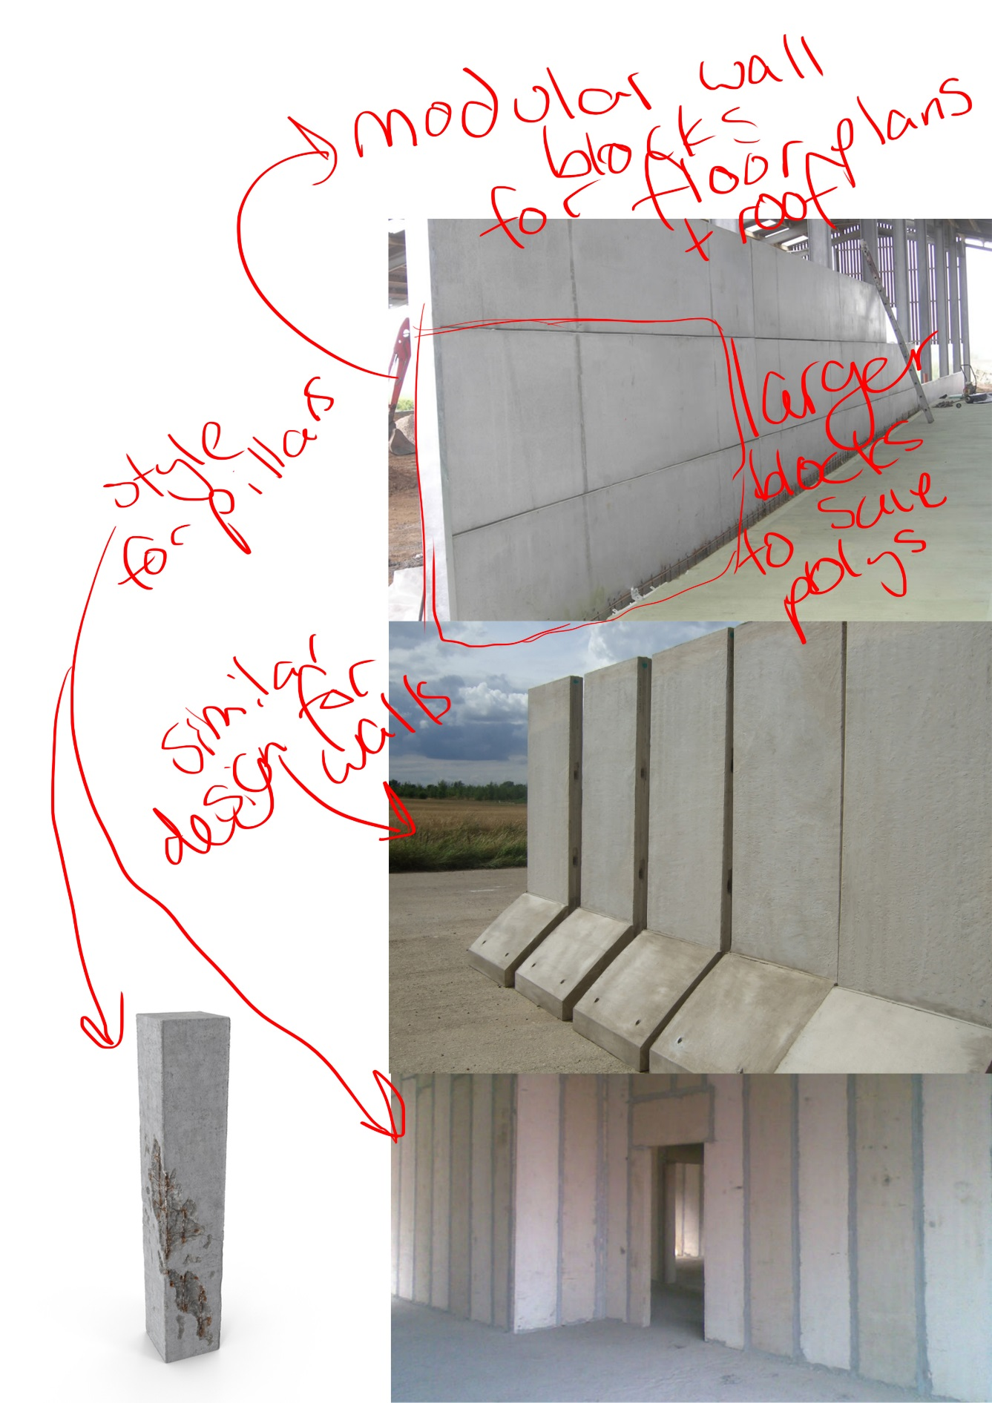Vert count: 2,500 vert limit per higher poly model, 12,000 total.  
Texture sizes: 1024x1024pix. MAX  
Restraints: 60fps definite.

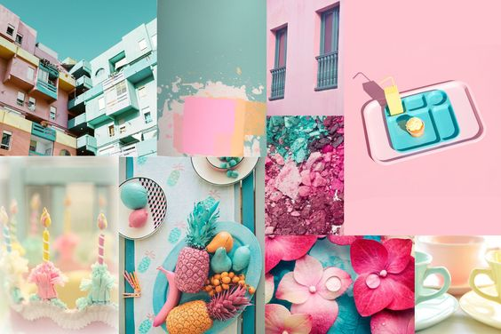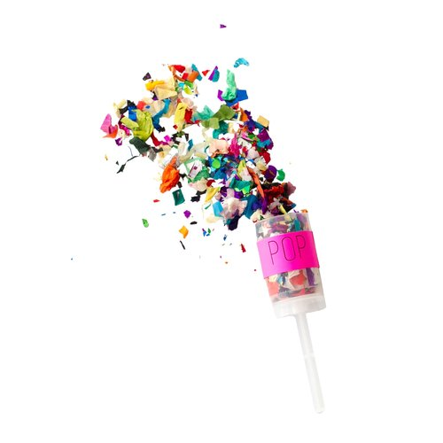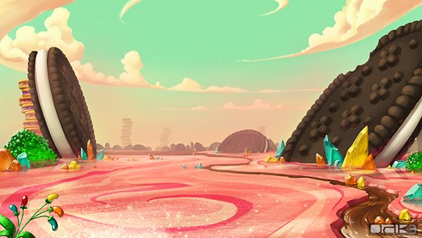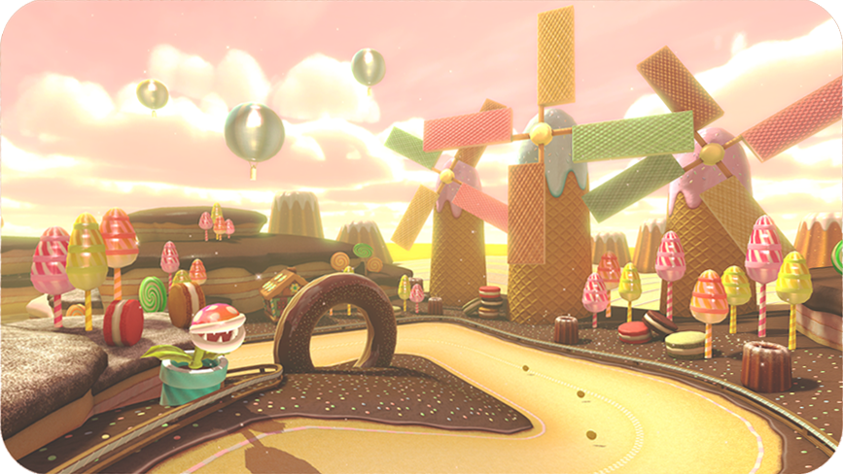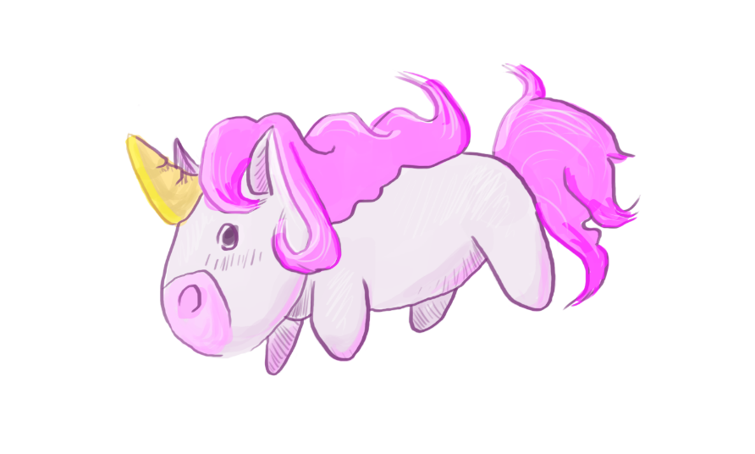**Reference Art**

