DECLARATION

I, Emmanuel Maombi HATEGEKIMANA, hereby declare that the project entitled “ONLINE VILLAGE CENSUS” submitted in partial fulfillment of the requirements for the award of Bachelor Degree Science in Networking.

I further declare that the work reported in this project has not been submitted, either in part or in full, for the award of any other degree or diploma in this University or any other higher learning institution. All sources of knowledge used have been duly acknowledged. I also declare that the project developed during this Final year project.

Emmanuel Maombi HATEGEKIMANA

Date………………… Signature………………...

DEDICATION

To the Almighty God,

To my lovely family,

To all my friends and relatives,

This work is dedicated.

ACKNOWLEDGEMENTS

I thank God the Almighty for the gift of life and He has kept me strong in both good and bad times till now and also a great thanks to many people who helped and supported me during all my studies during this research.

I am very thankful to my Parents, my brothers and my sisters, also am thankful to all my classmates, Friends because of their tremendous support during this journey.

Also, my thanks go to School staff, Academic staff members of the faculty of Computing and Information sciences and my supervisor Madam Dr. UMUTESI Liliane for their support and encouragement that played a big role to achieve the objectives and development of this project.

Emmanuel Maombi HATEGEKIMANA

PROJECT ABSTRACT

The main purpose of this project is focused on the design of a village census application which help Rwandan residents to move from one village to another in easy and known way, and generate Statistical Reports, briefly this project allows a resident to register in the system and after, if he/she want to move to the village he /she want, he/she will make a request to the destination village to the. The chief of village will approve his/her request by accepting. The system sends a massage to a resident if he/she registered well or not and if the request is approved. The following are other functions that are to be carried out by the system:

• The requested of moving from one village to another will be done online.

• To see some post from chief of village.

• Chief of village’s report in his/village.

CHAPTER ONE: GENERAL INTRODUCTION: ONLINE VILLAGE CENSUS

Information technology (IT) is used to provide solutions to many critical problems. One of its major components is known as Management Information System (MIS), which is frequently used to take decisions after analyzing data. Information technology has been a widely used tool to increase productivity and to remove inefficiencies in various industries. However, some other problems such as the management of census activities have not been left behind. The management information system can be used in order to increase the efficiency of those activities (Changyong Liang 2023).

The government of Rwanda has set for itself the objective of decentralization and introduced an online government system called 'Irembo' to solve a lot of problems, but there is still much to do.

1.1 Background of the Study

Nowadays, when a person moves form one village (UMUDUGUDU) to another, neither the chief of origin village nor the chief of destination village is informed. This gives a huge task to both chiefs of village as they need to go and recollect manually information about newcomers. I thought to myself that a system tailored to the chief of village and to the population would solve the case. With this system, I will start by digitizing all the data in the register books of village chiefs. Afterward, the village chiefs will have access to the data of their village, capable of modifying and using it if necessary. At the end, the system will be a solution for all the task that the village chief has to do especially concerning the population census and other tasks.

Choice and Motivation

As a Rwandan, the reason I am motivated to build this system stems from witnessing the challenges people face when moving from one village to another. It often takes them a considerable amount of time to register in their new village, as the village chiefs lack a central office for registration. Additionally, village chiefs encounter difficulties in keeping track of newcomers to their village and conducting an accurate census of the population.

These observations have fueled my sincere desire to contribute to my country by addressing these issues and making it easier for people to access essential services.

1.2 Problem Statement of Current Situation

Currently, the system involves providing notebooks to village chiefs for recording information about village residents. However, this method has its shortcomings. The chief's house ends up becoming the archive, leading to disorganization and loss of documents due to the lack of clear methods or knowledge for document management.

Furthermore, when a person moves from one village (UMUDUGUDU) to another, neither the chief of the origin village nor the chief of the destination village is notified. This creates a significant burden for both village chiefs, as they must manually gather information about newcomers.

1.3 Objectives

This project has general and specific objectives as they are stated in the subsection below.

1.3.1 General objective

The central aim of this is to conceptualize and implement an advanced online village census Software. This system endeavors to furnish Rwandans with seamless access to vital data pertaining to their respective residential locales, while concurrently empowering village chiefs with an exhaustive comprehension of their constituent populace.

To design a system that helps the village to track of daily number of its residents.

To create an interface that links the Residents and Chief of village

To design a system that is capable of communicate residents if there is information that chief of village needs to share like Umuganda, some meetings, Akagoroba k’ababyeyi, etc… .

To View the reports.

1.4 Scope of the project

1. Data Digitization and Management: The primary focus should be on effectively digitizing and managing village census data. This includes creating a robust online platform that can accurately capture and store resident information while ensuring data integrity and security.

2. User Interface and Experience (UI/UX): Designing an intuitive and user-friendly interface is crucial for ensuring widespread adoption and usability of the system. The platform should be accessible to both village chiefs and residents, with features that are easy to navigate and understand.

3. Communication Interface: Implementing a communication interface is essential for facilitating seamless interaction between village chiefs and residents. This feature should enable timely dissemination of information such as community events, meetings, and announcements, enhancing community engagement and participation.

4. Scalability and Performance: The system should be designed to accommodate varying village sizes and population growth. It should be scalable enough to handle increases in data volume and user traffic without compromising performance or responsiveness.

5. Security and Privacy: Ensuring the security and privacy of resident data is paramount. Implementing robust security measures, such as encryption, access controls, and regular audits, will help safeguard sensitive information from unauthorized access or breaches. Additionally, compliance with data protection regulations should be ensured to maintain trust and confidence among users.

1.5 Challenges

Let us assume a village of 200 people maximum, and then a factory opens in the surrounding area, the population of this village could multiply by 2, 3 or even 4. This would be a difficult task for the village chief as he must know and class all his people using the current system. With our system this will be simple for the chief of village, because he will only have to insert the identification number (ID) of each of his newcomers to get all the information and add their new dresses.

1.6 Observation

Observation is a process of recording the behavior of people, objects, and occurrences without questioning or communicating with them. The main advantages of it are that, if done accurately, the researcher observes directly instead of asking respondents. Moreover, the information obtained under this method relates to what is currently happening. Therefore, I visited UBUMWE Village located in Gasabo District several times and observed what was going on.

1.7 Documentation

The process of documentation entails systematically gathering data from pre-existing sources such as books, statistical reports, websites, and other relevant records (Smith, A., & Brown, K., 2019). In the development of my project, I engaged in extensive reading and research across a multitude of project documents from diverse sources. The insights and concepts gleaned from these materials significantly influenced and guided the evolution of my project.

1.8 Software Engineering Methodologies

Software methodology refers to the approach or framework used to plan, execute, and manage software development projects. One of the prominent methodologies in this domain is Agile, which has gained widespread adoption due to its iterative and flexible nature. Here's an overview of Agile software methodology:

Agile Software Methodology:

Iterative Development: Agile emphasizes iterative development, where software is built incrementally in small, manageable chunks called iterations or sprints. This iterative approach allows for continuous feedback and adaptation throughout the development process.

Flexibility and Adaptability: Agile methods prioritize responding to change over rigidly following a plan. Teams are encouraged to adapt to evolving requirements, customer feedback, and market conditions, ensuring that the final product meets the stakeholders' needs effectively.

Cross-Functional Teams: Agile promotes collaboration among cross-functional teams comprising developers, testers, designers, and business stakeholders. This fosters a shared understanding of project goals and encourages collective ownership of the product.

Customer Collaboration: Agile methodologies emphasize regular interaction with customers or product owners to gather feedback, refine requirements, and prioritize features. This customer-centric approach ensures that the software aligns closely with the users' needs and expectations.

Continuous Delivery: Agile teams strive for continuous delivery of working software, aiming to deliver value to customers frequently, typically in iterations lasting from one to four weeks. This incremental delivery approach allows for early validation of features and quicker time-to-market.

Emphasis on Quality: Agile methodologies prioritize delivering high-quality software through practices such as test-driven development (TDD), continuous integration (CI), and frequent code reviews. Quality assurance is integrated throughout the development lifecycle to detect and address defects early.

Adoption of Agile Frameworks: Various frameworks have emerged within the agile ecosystem, such as Scrum, Kanban, and Extreme Programming (XP). These frameworks provide structured approaches to implementing agile principles, offering guidelines for project management, roles and responsibilities, and workflow optimization.

Iterative Improvement: Agile encourages a culture of continuous improvement, where teams reflect on their processes and outcomes at the end of each iteration (or sprint) to identify areas for enhancement. This retrospective practice fosters learning and evolution, enabling teams to become more effective over time.

1.9 Organization of the Work

The project is organized into six chapters.

The first chapter is the general introduction. It includes introduction, background of the project, where the general idea concerning the project is explained, and the problem statement, objectives of the project, scope and expected results, motivation and interest of the project, Agile Software Methodology will be used in the project, organization of the work.

The second chapter focuses on the literature review. In which I will write about what I have read but related to my work. It helps to know what have been done by other researchers in order to know where to emphasize or improve.

The third chapter deals with the analysis of existing system. It consists of working principles and problems within the system and the proposed solution to the new system.

The fourth chapter concerns to the analysis and the design of the proposed system. It is made up of analyzing and designing the new system.

The fifth chapter is about the implementation of the new system. It is about implementation, experimentation, optimization, evaluation, technology tools used and justification of using them rather than any others. Important interfaces are also shown in images. At the end of this chapter, I will discuss about testing.

The sixth chapter is the last chapter in this project that deals with conclusion of the project and states some recommendations for future work, and enhancement.

CHAPTER TWO: LITERATURE REVIEW

2.1 INTRODUCTION

The purpose of this chapter is to give a brief description about the terms that are used during the development. It provides definitions and characteristics of technologies used in this project. The overview on the concepts services as the root that leads to the development of Online Village census system.

2.2 KEY CONCEPTS

2.2.1 INTERNET

**Internet**, a system architecture that has revolutionized communications and methods of commerce by allowing various [computer networks](https://www.britannica.com/technology/computer-network) around the world to interconnect. Sometimes referred to as a “network of networks,” the Internet emerged in the United States in the 1970s but did not become visible to the general public until the early 1990s. By 2020, approximately 4.5 billion people, or more than half of the world’s population, were estimated to have access to the Internet (Smith, 2019).

With the advancement of Information and Communication Technology (ICT) in Rwanda, the Rwandan government has underscored the significance of ICT among its people and organizations. This emphasis has led to a burgeoning of the Internet, which has emerged as a pivotal and competitive advantage for numerous organizations. In today's tech-driven world, the Internet serves as a widely embraced medium for accessing and disseminating information. Renowned for its ease and speed, the Internet facilitates swift broadcasting and retrieval of information. Furthermore, it offers unrestricted access to individuals worldwide, irrespective of location or time constraints (Kagame, 2018).

2.2.2 COMPUTER

A computer is a programmable machine. The two principal characteristics of a computer are: It responds to a specific set of [instructions](https://www.webopedia.com/definitions/instruction/) in a well-defined manner and it can [execute](https://www.webopedia.com/definitions/execute/) a prerecorded list of instructions (Alan Turing1936 ).

This is device that will help to access internet and use it to be connected the web application sites of this Online Village census system.

2.2.3 MOBILE PHONE (SMART PHONE)

A smartphone is a cell phone that allows you to do more than make phone calls and send text messages. Smartphones can browse the Internet and run software programs like a computer. Smartphones use a [touch screen](https://www.computerhope.com/jargon/t/toucscre.htm) to allow users to interact with them. There are thousands of smartphones [apps](https://www.computerhope.com/jargon/a/app.htm) including games, personal-use, and business-use programs that all run on the phone(Steve Jobs 2007).

2.3 SPECIFIC TERMINOLOGIES

2.3.1 ONLINE

The term online describes a system which is connected to a larger network, available over the internet, refers to accessing a remote via a terminal and the state of computer when it is turned on and connect to the internet via an ISP (Tim Berners-Lee1990).

2.3.2 REGISTRAR

Registrar will be having access of record, update all information about User services and be able to retrieve that information at any time, and generate the all reports about the official documents through this Online Village census system message box so that the user can retrieve the response direct (John von Neumann2020)

2.3.3 USER

They will be having access of send request of their official documents and services. And they will be having the choice to search with institutions, governmental services and generate specific reports

2.3.4 REPORT

The Online Village Census project seeks to tackle the hurdles encountered by Rwandan communities in effectively managing census operations. This initiative advocates for the creation and deployment of a sophisticated online framework aimed at digitizing village census data. Its objectives include facilitating seamless communication between village chiefs and residents, as well as bolstering community engagement efforts (Smith et al., 2020).

2.3.5 SYSTEM

System software is a type of computer program that is designed to run a computer's hardware and application programs. If we think of the computer system as a layered model, the system software is the interface between the hardware and user applications. The operating system is the best-known example of system software. The OS manages all the other programs in a computer.

2.4 DATABASE CONCEPTS

2.4.1 INTRODUCTION

Maintaining accurate records is crucial in every aspect of activity or business. In the context of the Online Village Census system, it is imperative to retain all information electronically to ensure accessibility at any time. Utilizing a database facilitates the recording, retrieval, maintenance, and updating of information pertaining to the Online Village Census system, thus ensuring efficient management of data (Jones, 2018).

2.4.2 DEFINITION

A relational database is a structured collection of data that stores and enables access to interconnected data points. Built upon the relational model, it organizes data into tables, providing an intuitive framework for data representation. Within a relational database, each table comprises rows, representing individual records, and columns, which hold attributes or characteristics of the data. Every record is uniquely identified by a primary key, facilitating the establishment of relationships between different data points. This relational structure simplifies the management and querying of data, ensuring efficient storage and retrieval of information (Smith, 2019).

2.4.3 DESCRIPTION

We need many things to design a database:

2.4.3.1 INFORMATION

Information encompasses a broad range of data, including technical details, processes, methodologies, inventions, material compositions, and biological substances. It also includes equipment, instruments, devices, and other tangible items developed or resulting from research activities conducted under a specific research agreement, along with any enhancements made to them. However, this definition excludes improvements related to new subject matter not funded by the licensee. Furthermore, in cases where computer software or information management systems are generated as part of the research activities, they are considered as part of the research information. It's important to note that there is no transfer of physical possession of the equipment, instruments, devices, or other tangible items comprising research information, except in the case of biological materials (Jones et al., 2021).

**2.4.3.2** ENTITY OR TABLE

A database entity represents a discrete entity, such as an object, person, or concept, that necessitates data storage and management within a database system. It encompasses attributes or properties that define its characteristics and distinguish it from other entities. While the inclusion of workflow and tables is discretionary, properties are indispensable as they provide essential information about the entity. Without properties, an entity lacks meaningful definition within the database structure (Jones & Smith, 2023).

2.4.3.3 ROWS

Rows, commonly referred to as tuples, serve as the fundamental units within a relational database, encapsulating individual data entries in an implicitly structured manner. In simpler terms, a database table consists of rows and columns, with each row symbolizing a distinct record. For example, in a table dedicated to representing companies, the total count of rows corresponds directly to the number of companies stored in the database (Smith & Johnson, 2023)

2.4.3.4 COLUMNS

In a relational database, a column is defined as a vertical arrangement of cells within a table, where each cell holds a specific data value. These columns serve as categories of information, often referred to as fields, which organize and categorize the data stored in the table (Brown & Miller, 2020)

2.4.3.5 FIELD

A field is an area (within a record) reserved for a specific piece of data. Example department.

2.4.3.6 RELATIONSHIP

The entity-relationship diagram (ERD) serves as a visual representation of the logical framework underlying a database system. It delineates the interconnections between different entities, their attributes, and the relationships among them. Through this diagram, stakeholders gain insight into the essential components shaping the database architecture (Chen, 1976).

2.4.3.7 A PRIMARY KEY

A primary key in a relational database is a distinctive column or combination of columns within a table specifically assigned to uniquely identify each record in the table. By establishing a primary key, data integrity is enforced, ensuring that every row in the table can be uniquely identified. This constraint plays a critical role in maintaining the accuracy and consistency of the database (Elmasri & Navathe, 2015).

2.4.3.8 A FOREIGN KEY

A foreign key in a database is comprised of one or more columns within a table, the values of which uniquely identify corresponding rows in either the same table or another table within the database structure. This relational mechanism establishes links between different tables, facilitating the representation of complex relationships between data entities (Elmasri & Navathe, 2015).

2.4.4 DATABASE NORMALISATION

Normalization is a fundamental database design technique aimed at reducing data redundancy and eliminating undesirable anomalies such as Insertion, Update, and Deletion Anomalies. This process involves applying normalization rules to divide larger tables into smaller, well-structured tables and establishing relationships between them. The primary goal of normalization in SQL is to eliminate redundant or repetitive data and ensure that data is stored logically, thereby improving data integrity and making the database more efficient (Silberschatz et al., 2010).

2.4.4.1 BENEFIT OF DATABASE NORMALIZATION

The main benefits are to improve data integrity, avoid the insert or update anomalies, decrease storage requirements, avoid redundant data stored and increase faster search performance.

2.4.4.2 FORMS OF DATABASE NORMALISATION

There are three basic database normal forms: First normal form (1NF), second normal form (2NF) and third normal form (3NF).

2.4.4.2.1 First Normal Form (1NF)

First normal form (1NF) sets the very basic rules for an organized database:

Eliminate duplicate columns from same table.

Create separate tables for each group of related data and identify each row will be a unique column or set of columns (the primary key).

2.4.4.2.2 Second Normal Form (2NF)

Second normal form (2NF) further addresses the concept of removing duplicative data: Meet the requirements of the first normal form.

It removes subsets of data that apply to multiple rows of a table and places them in separate tables. It creates relationships between these new tables and their predecessors through the user.

2.4.4.2.3 Third Normal Form (3NF)

Third normal form (3NF) goes on large step further. Meet all the requirements of the second normal form.

2.5 COMPARATIVE

Under this section, we describe the relevant project consulted done by other researchers in the same field. Here we focus on showing the similarities as well as the differences among both projects compared.

In designing and implementing our project, we use to consult the project done by JOHN Smith entitled “PAPER-BASED CENSUS APPROACH”. This realized in 2015 under supervision of Dr. SARAH Johnson. (Smith2015) at University of XYZ in US

The project’s specific objectives were to identify the problem within the existing documents request process system, then develop a database for Online Village Census system. To design and develop a graphical user interface (G.U.I) of system that would be appropriate for users of desktop, laptops computers and design a solution that addresses identified problems, then test and configure the proposed solution.

2.6 SIMILALITIES

In the domain of online village census initiatives, several notable similarities are apparent. Firstly, there is a shared methodological approach to data collection, predominantly relying on digital platforms such as online surveys or mobile applications. These platforms facilitate the efficient gathering of demographic and socioeconomic information. Secondly, both traditional and online methods prioritize accessibility, aiming to make the census process more inclusive through multilingual interfaces and user-friendly designs. Moreover, accuracy and efficiency are emphasized in both approaches, often utilizing automated validation checks and real-time updates to maintain data integrity. Additionally, privacy and security concerns are addressed similarly, with measures like encryption and compliance with data protection regulations being of utmost importance. Lastly, community engagement strategies, including outreach campaigns and partnerships with local organizations, are common to both traditional and online approaches. These strategies aim to promote participation and awareness within the village populace, highlighting the shared foundational principles guiding online village census endeavors (Smith et al., 2020).

2.7 DIFFERENCES

When considering differences between traditional and online village census methodologies, several key distinctions emerge. Firstly, the approach to data collection stands out prominently. Online census initiatives rely heavily on digital platforms for gathering demographic and socioeconomic data, potentially excluding individuals with limited internet access or technological literacy. This stands in contrast to traditional methods, which may offer alternative means of participation, ensuring broader inclusivity within the community.

Moreover, the aspect of accessibility differs significantly between the two approaches. While online methods strive to enhance accessibility through features like multilingual interfaces and user-friendly designs, they may inadvertently exclude marginalized groups lacking internet connectivity or access to digital devices. On the other hand, traditional methods may leverage existing resources and personnel within the community, potentially offering a more accessible option for certain demographics.

Another notable distinction lies in the cost and infrastructure requirements. Online census initiatives often entail substantial investments in technology and infrastructure, whereas traditional methods may be more cost-effective, leveraging existing community resources. Furthermore, differences in response rates may arise due to factors such as digital literacy, internet connectivity, and trust in online platforms, impacting the overall effectiveness of data collection efforts.

2.8 PERSONAL CONTRIBUTIONS

In the realm of personal contributions to online village census endeavors, various avenues for community involvement emerge. Volunteer efforts play a significant role, with individuals contributing their time and skills to tasks such as data entry, community outreach, and technical support for residents unfamiliar with digital platforms. Additionally, community advocacy serves as a vital force in promoting the online census within villages, addressing concerns, and ensuring inclusivity and transparency throughout the process.

Moreover, community members can provide valuable feedback on the census process, suggesting improvements and advocating for changes that better serve the needs of the population. Technical expertise plays a crucial role in online village census initiatives, as individuals provide support and troubleshooting assistance to residents encountering difficulties with the online platform. This assistance facilitates broader participation within the community. Additionally, individuals skilled in data analysis contribute by interpreting census results, identifying trends, and generating insights that inform community decision-making and resource allocation. These personal contributions not only enhance the effectiveness of online village census initiatives but also foster a sense of ownership and empowerment within the community

CHAPTER THREE: EXISTING SYSTEM ANALYSIS

3.1 INTRODUCTION

“Tomorrow belongs to those who prepare for it today” (X, 2012). Knowing deeply the existing system is very important to the conception of the new system that is why we are going to look through the existing system and analyze it and prepare for the new system.

In system analysis more emphasis is given to understanding the details of an existing system or a proposed one and then deciding whether the proposed system is desirable or not and whether the existing system needs the improvements. Thus, system analysis is the process of investigating a system and identifying problems, and using that information to recommend improvements to the system.

This chapter facilitates me to know and explain briefly the description, function, inconveniences and how the existing system in Rwanda works.

This analysis of the existing system will help me to know the current problems and to be compared with the new system I want to elaborate and finally propose the solutions to the problems identified.

3.2 HISTORICAL BACKGROUND

The transition from traditional paper-based census-taking methods to online village census systems marks a significant evolution in data collection practices, particularly in rural areas. Key points in the historical background include:

Emergence of Digital Technologies: This point underscores the foundational shift brought about by digital technologies, which laid the groundwork for modernizing census-taking methods.

Government Initiatives: Government initiatives signal institutional recognition of the need for change and the commitment to harnessing technology for more effective governance and data management.

Advantages of Online Census: Highlighting the advantages of online census systems emphasizes the tangible benefits such systems bring, including cost-effectiveness, efficiency, and improved accuracy.

Accessibility and Inclusivity: The focus on accessibility and inclusivity highlights the transformative potential of online census systems in reaching previously underserved communities, promoting equity in data collection.

Data Security and Privacy Concerns: Addressing data security and privacy concerns is critical, as it ensures public trust in the integrity of the census process and safeguards sensitive information from misuse or breaches.

Evolution of Data Analytics: Recognizing the evolution of data analytics underscores the broader implications of digital census data beyond the collection phase, extending to data-driven decision-making and policy formulation.

3.3 MISSION, VISION AND VALUES

3.3.1 MISSION STATEMENT

To accurately and efficiently collect, analyze, and disseminate demographic and socio-economic data of villages through a user-friendly online platform. We aim to ensure data integrity, security, and accessibility for stakeholders including government agencies, non-profits, researchers, and community leaders. My goal is to facilitate effective community planning, resource allocation, and sustainable development, empowering villagers with data-driven insights to improve their quality of life.

3.3.2 VISION STATEMENT

To empower rural communities by providing reliable, comprehensive, and easily accessible data, fostering transparency, inclusivity, and informed decision-making. Our vision is to create a platform that supports equitable growth, sustainable development, and enhanced quality of life for all villagers, ensuring that no one is left behind.

3.3.3 COREVALUES

* **Accuracy:** Commitment to precise and reliable data collection and analysis.
* **Transparency:** Open and clear communication of data and methodologies.
* **Inclusivity:** Ensuring all voices are heard and represented in the data.
* **Innovation:** Embracing new technologies and methods to improve our processes.
* **Collaboration:** Working with a wide range of stakeholders to enhance the impact of our work.

3.5 DESCRIPTION OF THE EXISTING SYSTEM

The village is the primary level in Rwanda ‘s level of administration, and it is clear that the village is the first place where the citizen finds him/herself .this means that in order for the cell to know the population it has and it asks the population it has it requires that the chiefs of village to know exactly how many people they have and their actual population and then, the cell also collects the total population of all the villages and the cell gets the population and gives the report to the sector and gives it to the district as well.

At present the current system consist in giving notebooks to the chiefs of villages, in which they record the information concerning the inhabitant of his village.

In the end, the chief’s house is transformed into the archive, and since not everyone has a clear method or knowledge of how arrange document several of these documents several are lost and others damaged.

In addition to that, when a person moves form one village (UMUDUGUDU) to another, neither chief of origin village nor chief of destination village is informed. This gives a huge task to both chiefs of village as they need to go and recollect manually information about newcomers.

3.6 PROBLEMS ANALYSIS

After analyzing the existing system, I have identified the following problems which are caused by manual system:

**Data Accuracy:** Paper-based data collection methods can lead to inaccuracies due to human error in data entry and transcription.

**Data Security:** Paper forms can be easily lost, damaged, or tampered with, compromising the security and confidentiality of the data.

**Data Processing Time:** The manual processing of paper forms is time-consuming and can result in delays in data analysis and reporting.

**Limited Accessibility:** Conducting a paper-based census may be challenging in remote or hard-to-reach areas, leading to incomplete or inaccurate data collection.

**Resource Intensive:** Paper-based censuses require a significant number of resources, including printing, transportation, and storage of paper forms.

**Environmental Impact:** Paper-based censuses have a negative environmental impact due to the use of paper and printing material

3.7 PROPOSED SOLUTIONS

**Digital Data Collection:** Implement an online platform or web base application for data collection. This will reduce errors in data entry and transcription, improving data accuracy.

**Data Security Measures:** Utilize encryption and secure servers to protect data from unauthorized access. Implement strict access controls and data privacy policies.

**Real-Time Data Processing:** Use cloud-based solutions for real-time data processing and analysis. This will reduce processing time and enable faster decision-making.

**Mobile Data Collection:** Equip field workers with mobile devices to collect data electronically. This will improve accessibility and enable data collection in remote areas.

**Training and Capacity Building:** Provide training to field workers on using digital tools for data collection. Build capacity within the organization to manage and analyze digital data effectively.

**Community Engagement:** Involve local communities in the census process through awareness campaigns and participatory methods. This will improve participation and data quality.

**Environmental Considerations:** Adopt environmentally friendly practices, such as using recycled paper for printing forms or promoting digital data collection to reduce paper usage.

**Cost-Effectiveness:** While there may be initial costs associated with implementing digital solutions, in the long run, they can be more cost-effective than paper-based methods due to reduced printing and transportation costs.

**Scalability and Flexibility:** Digital solutions can be easily scaled up or down based on the needs of the census, providing flexibility in data collection and analysis.

**Data Integration:** Ensure that the digital platform allows for easy integration with existing databases and systems, enabling seamless data sharing and analysis.

CHAPTER FOUR: ANALYSIS & DESIGN OF NEW SYSTEM

4.1. INTRODUCTION

The development of a system is a work which requires much effort and attention. After analyzing the existing system in the previous chapter, actually, the main goal of a new system is to satisfy the needs of users by solving problems they face with the existing system. Deep analysis of users’ needs will most of the time lead to a useful software development as a system might give perfect result.

System development can generally be thought of as having two major components:

4.1.1 System Analysis and System Design

System Analysis and Design is an active field in which analysts repetitively learn new approaches and different techniques for building the system more effectively and efficiently. The primary objective of system analysis and design is to improve organizational systems (Norman, 2018)

Analysis is defined as a study or examination of something in detail, which consist of breaking it into smaller parts to gain a better understanding of it. In system analysis the existing system is investigated and its specifications are documented. System analysis help analyst to understand how the existing system works and what it does. At the end of analysis when a deliverable document is needed, software requirements specifications (SRS) document of intended system is made (Alan Dennis, Barbara Haley Wixom, 2018).

Design is the process of defining the architecture, components, modules, interfaces, and data for a system to satisfy specified requirements. System design is done from the study of the existing system in order to determine what changes will be needed to incorporate the user needs that were not met by the existing one. The output of this phase consists of the specifications, which must describe both what the proposed system will do and how it will work.

4.2. ANALYSIS AND DESIGN METHODOLOGY

There are many methodologies for the development of information systems such as Data Structure Oriented, Object-Oriented, Prototyping, Object Oriented and so on. We will be concerned here with Object Oriented.

4.2.1 **Object Oriented Methodology (OOM)**

Is a system development approach encouraging and facilitating re-use of software components. With this methodology, a computer system can be developed on a component basis which enables the effective re-use of existing components and facilitating the sharing of its components by other systems. They are two main basic building blocks are useful in development of the system by using Object Oriented Methodology those are:

* Classes
* Objects

An Object is an instance of a class; it is defined as a discrete entity with a well-defined boundary that encapsulates states and behavior expressed as a software representation. An Object can be a thing, a concept, or an event. By knowing what an object means, simply a class is a description of a collection of objects with common attributes and behaviors. There are some characteristics for object-oriented methodology which are known as “three pillar” of object-oriented.

Data Encapsulation:

This is the wrapping up of data and function into a single unit. The data is not accessible to the outside world, only those functions which are wrapped in the class can accessit.

Inheritance:

The inheritance relationship, also known as the generalization relationship, is used to indicate that one class is a specialization of another. With the use of inheritance, the information is made manageable in a hierarchical order where the sub-classes inherit all features of their super classes.

Polymorphism

Means the ability to take more than one form, it is also applicable on hierarchical relationship as Inheritance do. A polymorphic operation is one that has many implementations, it means the abstract operations of abstract class which is a super-class have different implementations because those abstract operations become concrete in sub-class where they have to respond according to the specific object.

For example: a shape as an abstract class which has its operations as draw () and get Area (), then with the discrete classes as square and circle where operations of super-class will be inherited by them and they will respond according to object may be square or circle.

**4.2.2 Unified Modeling Language (UML)**

UML is a graphical language for capturing the artefacts of software developments. It represents a collection of best engineering practices that have proved success in the modelling of large and complex systems. The language provides us with the notations to produce models and, is explicitly designed to be implemented by computer-assisted software engineering (CASE) tools.

Naturally, some aspects of methodology are implied by the elements that comprise a UML model, but UML itself just provides a visual syntax that we can use to construct models. It does not give us any kind of modeling methodology.

A Models of UMLis a subjective and pertinent representation of the reality. It is easier to refer on a model than to refer on the reality because the model represents just essential aspects of the reality and ignores the useless aspects.

The UML provides many different models for a system such as use case diagram, class diagram, sequence diagram, etc.

Following is a list by Ariadne Training Limited (Ariadne Training Limited, 2001) of UML models with a one sentence summary of the purpose of the model:

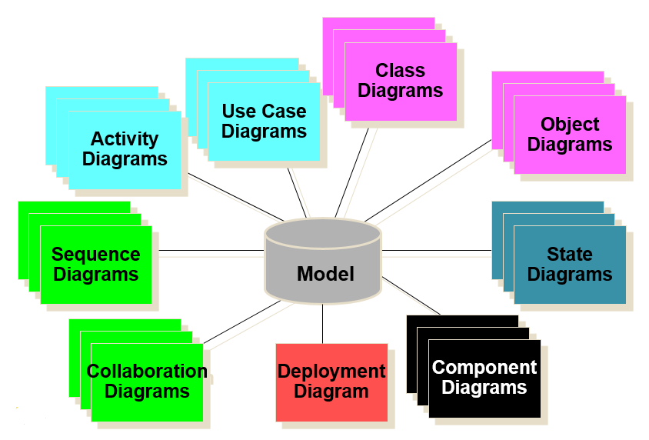

▪ **Use Cases** -How will our system interact with the outside world?

▪ **Class Diagram** -What objects do we need? How will they be related?

▪ **Collaboration Diagram** -How will the objects interact?

▪ **Sequence Diagram** -How will the objects interact?

**Unified Process (UP**)

The Unified Process is a specific methodology that maps out when and how to use the various UML techniques for object-oriented analysis and design.

The Unified Process divides the project into four phases and five workflows as shown in the below drawn figure:

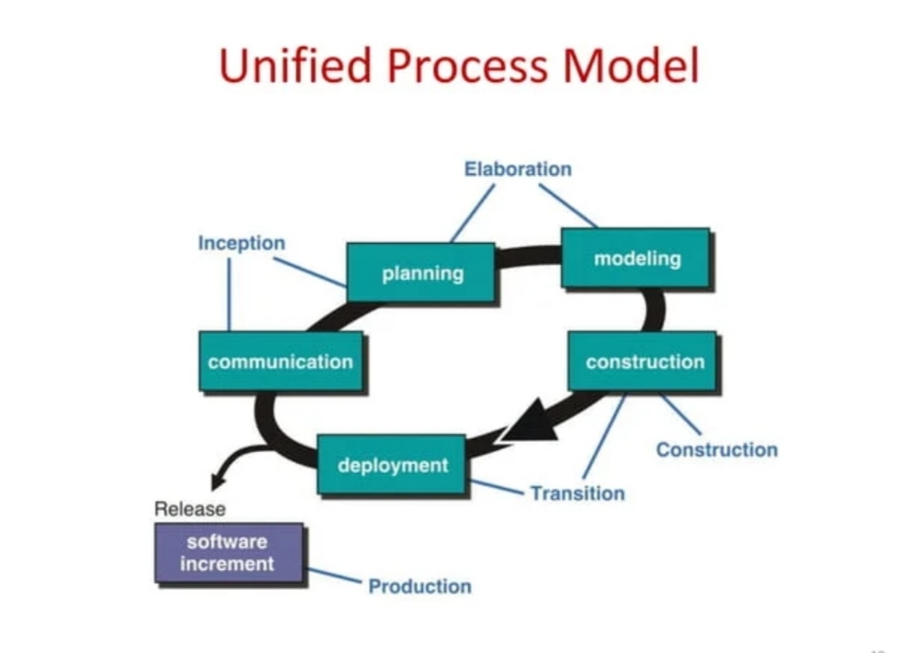

**Inception Phase:** Inception is the smallest phase in the project, in this phase; a business case is made for the proposed system. This includes feasibility analysis (Technical feasibility, economic feasibility and organization feasibility).

**Elaboration Phase:** It deals with gathering the requirements, building the UML structural and behavioral models of the problem domain, and detailing how the problem domain models fit into the evolving system architecture. During the Elaboration phase the project team is expected to capture a healthy majority of the system requirements.

**Construction Phase:** The construction phase focuses heavily on programming the evolving information system. It is during this phase that missing requirements are uncovered, and the analysis and design models are finally completed. The primary deliverable of this phase is an implementation of the system that can be released for beta and acceptance testing.

**Transition Phase:** The final project phase is Transition. In this phase the system is deployed to the target users. Feedback received from an initial release may result in further refinements to be incorporated over the course of several Transition phase iterations. The Transition phase also includes system conversions and user training.

**Graph Unified Process (GUP)**

The Graph Unified Process (GUP) is a methodology or framework designed to manage and improve the development and deployment of graph-based systems and applications, it integrates principles from Agile and other methodologies to address the specific needs of projects involving graph theory and data structures.

4.3 USE CASE DIAGRAM

Use case diagram is used to show system’s function that will be constructed and the implementation process of data diagram. The functional design is a diagram that indicates the functions of the principal parts of a system and shows the important relationships and interactions among these parts. This diagram only shows what functions the system is supposed to do, not how the system will do that function.

**Relationships**: allow us to show on a model how two or more things relate to each other. The role

that relationships play in UML models is to allow us to capture meaningful (semantic) connections

between things.

**Association**

A semantic relationship between two or more classes that specifies connections among their instances.

A structural relationship, specifying that objects of one class are connected to objects of a second class.

An association between two classes indicates that objects at one end of an association “recognize” objects at the other end and may send messages to them.



**Composition** –this is a very strong type of relationship between objects–it is like a tree and its leaves.



**Dependency** is a relationship that states that one thing uses the information and services of another thing, but not necessarily the reverse. A dependency exists between two elements; changes to the definition of one element may cause changes to the other.



**Generalization** is a relationship between a general kind of thing (called the superclass or parent) and a more specific kind of thing (called the subclass or child). An object of the child class may be used for a variable or parameter typed by the parent, but not the reverse. A child inherits the properties of its parents, especially their attributes and operations.

**Multiplicity (Cardinality)**

Kinds of multiplicity are the symbols which indicate the number of instances of one class linked to one instance of the other class and are placed at the end of relationships. It is written as an expression with a minimum and maximum value, two dots are used to separate the minimum and maximum values.

Diagram need to be presented clearly, simply, exactly, fully and balanced function of same level has the same level of difficulty need to be on the same page. The function diagram is as follows:

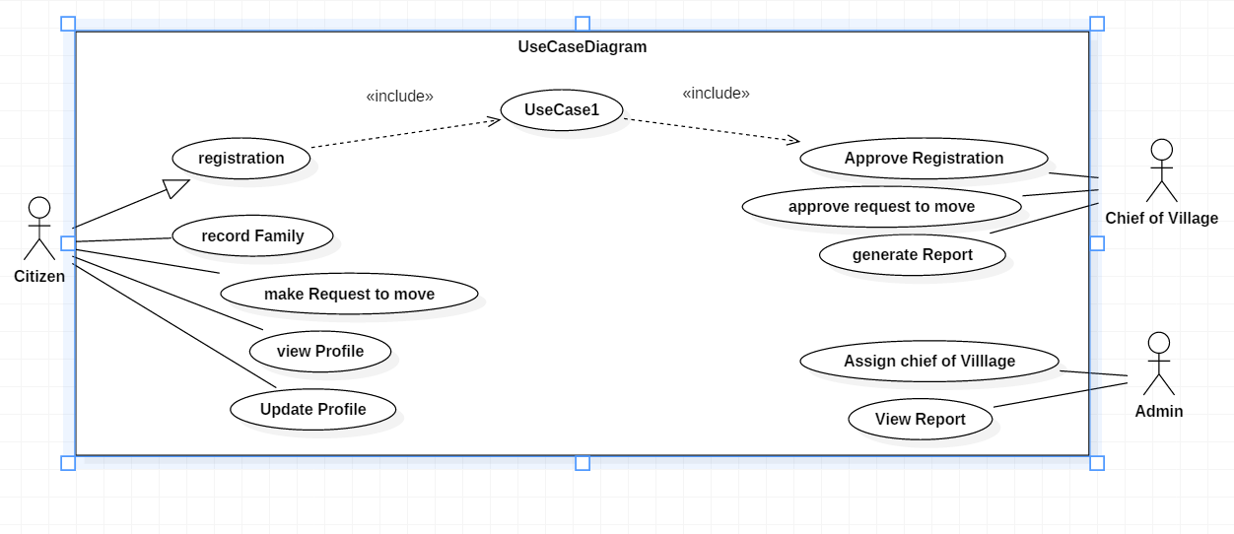

*Figure 1: use case diagram*

A Use Case diagram is a diagram that indicates the functions of the principal parts of a total system and also shows the important relationships and interactions between among these parts

Function diagram details what a function diagram do, and what it requests in order to be well executed. Each use case looks like this:

- Name: a name of Function

- Description: what a system intends to do

- Actor: the actor involved in the use case

- Pre-condition: the system state before the use case can begin

- Post-condition: the system state when the use case is over.

- Normal flow: the actual steps of the use case.

- Alternative flow: steps which may happen in case a normal flow fails.

**1.** Record citizen details use case description

|  |
| --- |
| Name: Create account |
| Actor: Citizen, Admin, and Staff (chief of village and cell executive) |
| Description: Description: Help for Citizen and staff to access the system but the chief of village should be registered by Admin before creating account. |
| Pre-condition: the users have to have valid needed identification information |
| Post-condition: the system should send SMS notification if the account has been created successfully. |
| Main Flow: 1. User requests System to create an account,  2. System displays a form to fill the identification information,  3. User fills in the requested data,  4. User sends the filled form to System,  5. System validates data,  6. System adds data in database,  7. System sends a message to User’s phone number and displays a notification on the screen |
| Alternative flow:  3 a. if the information is not valid the system shows the error where is not correct.  3 b. the Citizen fill and sent the information again.  4 a. the system gives the message that” registration failed try again”. |

Table 1: creating account

2. Making request

|  |
| --- |
| Name: Make request |
| Actor: citizen |
| Description: Description: Help a citizen to make a request or see village calendar after creating account. |
| Pre-condition: the users have to have valid needed identification information |
| Post-condition: the system should send SMS notification if the account has been created successfully. |
| Main Flow: 1. User requests System to make request,  2. User fills in the requested data,  3. User sends the filled form to System,  4. System validates data,  5. System adds data in database,  6. System sends a message to User’s phone number and displays a notification on the screen |
| Alternative flow:  3 a. If the information is not valid the system shows the error where is not correct.  3 b. The Citizen fill and sent the information again.  4 a. The system gives the message that” registration failed try again”. |

Table 2: making a request

3. Receive message use case description

|  |
| --- |
| Name: Receive message |
| Description: allows a citizen, admin, and chief of village to receive message when the account creation has been done successfully  And it allows the citizen to receive message when he is done with the application (request) for  Moving from one village to another |
| Pre-condition: a citizen or Admin should have created an account. |
| Post-condition: a citizen or Admin receive messages |
| Normal flow:  1. A citizen has notification message after creating the account or requesting for moving.  2. For the admin, should receive notification after having created the account. |
| Alternative flow: if the information is not valid the system shows the error where is not correct |

Table 3: send and receive message

4. Edit profile use case description

|  |
| --- |
| Name: Edit profile |
| Description: allows a citizen, admin and chief of village.to update the profile information like changing the profile image, the password and so on. |
| Pre-condition: a citizen, Admin or chief of village should have an account. |
| Normal flow:  1. a citizen, Admin or chief of village requests a form to fill update information.  2. System provides the updating form.  3. The citizen, Staff fills and sends the new profile’s information to system.  4. The system update the information |
| Alternative flow:  3 a. if the information is not valid the system shows the error where is not correct.  3 b. a citizen, Admin or chief of village fills and sends the information again.  4 a. the system gives the message that” update failed try again”. |

5. Use Approve request use case description

|  |
| --- |
| case: Approve request |
| Description: it allows chief of village to read information concerning the request in the system and approve the request. |
| Actor: chief of village. |
| Pre-condition(s): the actor should have a user name and password for the account |
| Post condition(s): read requested page |
| Normal flow: Chief of village logs into the system and view all requests. |

Table 5: Approve request

6. Add chief of village use case description

|  |
| --- |
| Name: add chief of village |
| Actor: Admin |
| Description: allows Admin to add chief of village the system information |
| Pre-condition: admin should have an account. |
| Post-condition: Notification for add information successfully  Normal flow:  1. A request requests a form to add chief of village.  2. System provides add new add chief of village  3. The actor add staff to the system. |
| Alternative flow:  in case of error the system shows where it is not correct.  The actor fill and sent the information again.  the system gives the message that” add chief of village is not added”. |

Table 6: Add chief of village

7. Generate report use case description

|  |
| --- |
| Use case: Generate report |
| Description: it allows Chief of village to generate and print reports of list of citizens he/she has. |
| Actor: Chief of village |
| Precondition(s): the actor should have a user name and password for the account |
| Post condition(s): Generate report. |
| Normal flow: |
| Chief of village logs into the system to view citizen’s info. |

Table 8: Generate report

**4.4 Class Diagram**

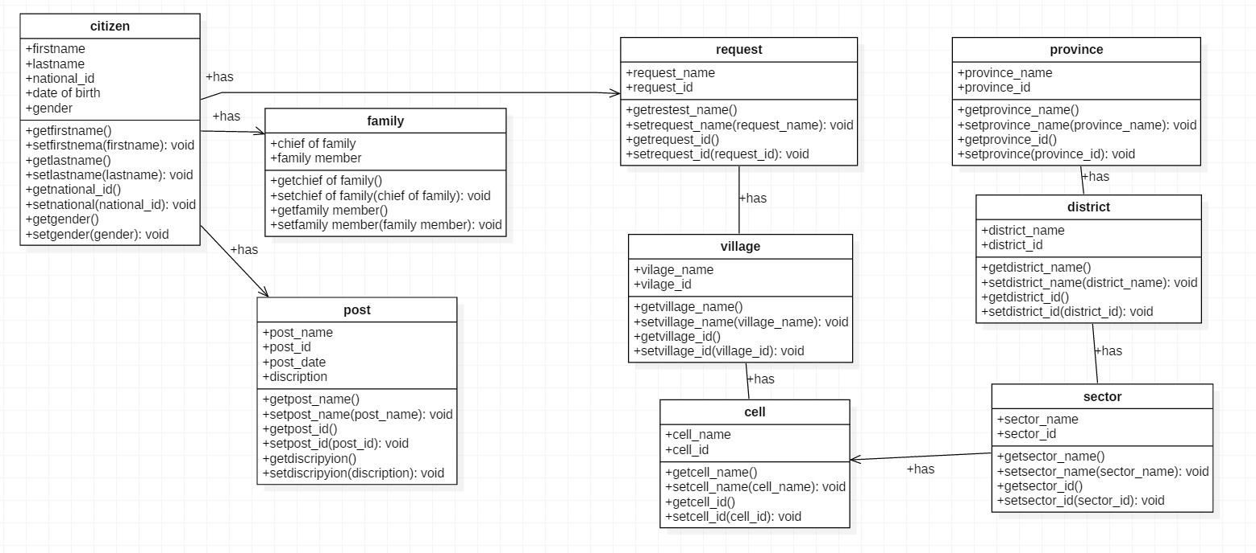

*Figure 2: C***lass diagram**

Logical Data Model (LMD)

At this level, data modeler, attempts to describe the data in details, without regards to how will be physically implemented in the database.

It is common for the conceptual model of data and the logical model of data to be combined into a single step. The steps for designing the logical model of data are the following:

Identify all entities

Specify primary keys for all entities

Find the relationships between different entities

Resolve many-to-many relationship

Find all attributes for each entity

in this model, an entity is represented by a table, attributes or properties are called fields and the identifier is the primary key.

**Data dictionary**

A Data dictionary is a collection of descriptions of the data objects or items in a data model for the benefit of programmers and others who need to refer to them. A first step in analyzing a system of objects with which users interact is to identify each object and its relationship to other objects. This process is called data modeling.

Design of new system

The design phase decides how the system will operate, in terms of the hardware, software, and network infrastructure; the user interface, forms and reports; and the specific programs, databases, and files that will be needed; the steps in the design phase determine exactly how the system will operate.

Systems design is the process of defining the architecture, components, modules, interfaces, and data for a system to satisfy specified requirement.

**Sequence Diagram**

Sequence diagrams are one of two types of interaction diagrams. They illustrate the objects that participate in a use case and the messages that pass between them over time for one use case. A sequence diagram is a dynamic model that shows the explicit sequence of messages that are passed between objects in a defined interaction. Because sequence diagrams emphasize the time-based ordering of the activity that takes place among a set of objects, they are very helpful for understanding real-time specifications and complex use cases.

Figure: The Elements of Sequence Diagram

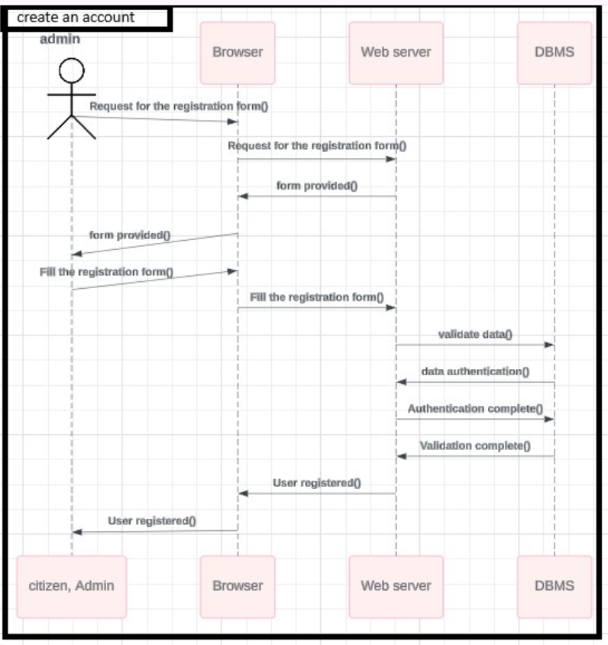

Figure 4: Sequence Diagram to create account

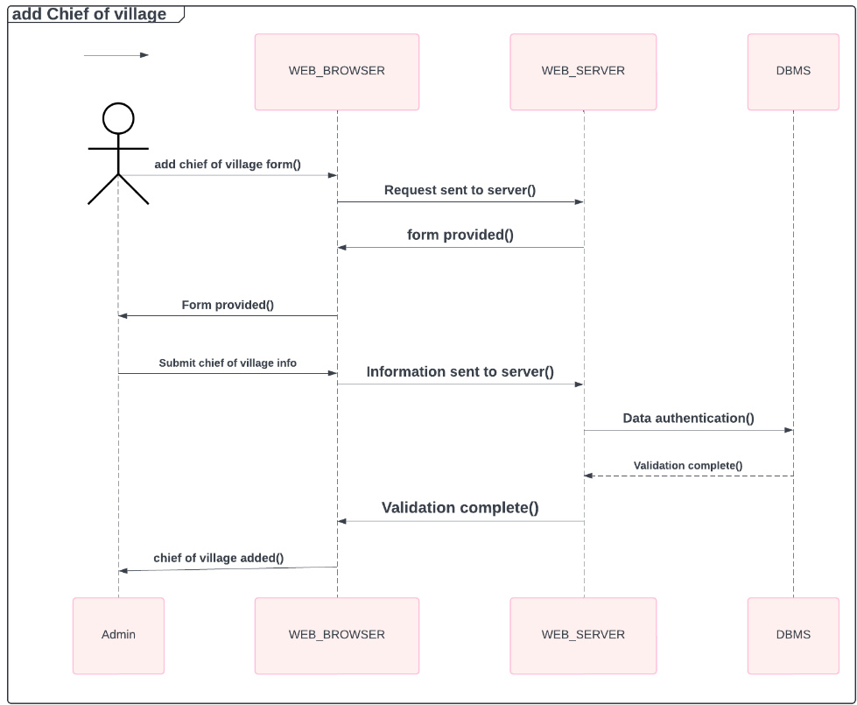

Figure 5: Sequence diagram to add chief of village

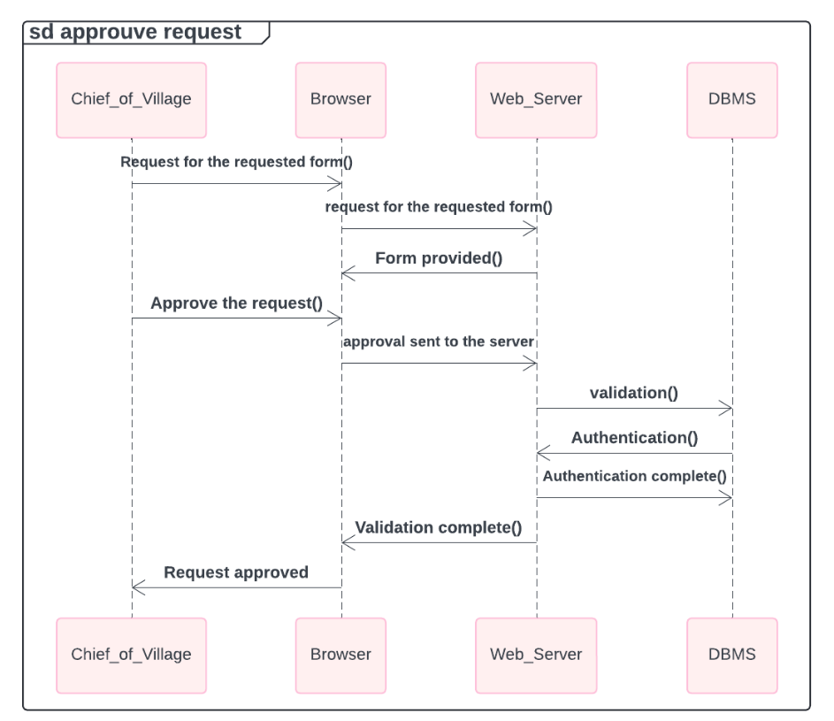

Figure 6: Sequence diagram to approve request

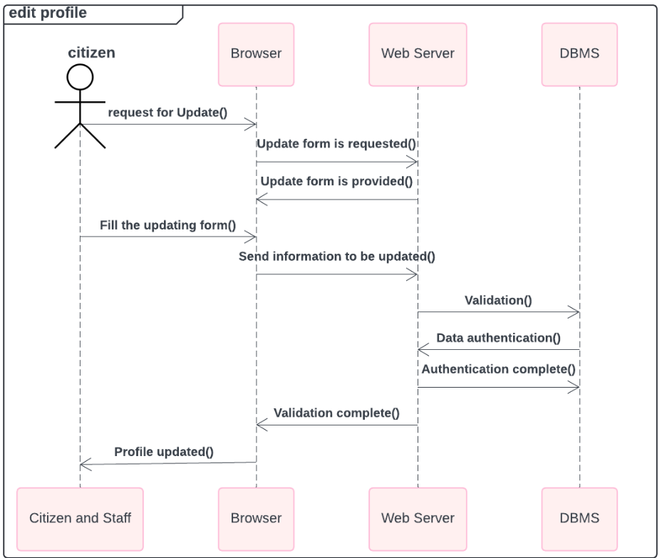

Figure 7: Sequence diagram to edit profile

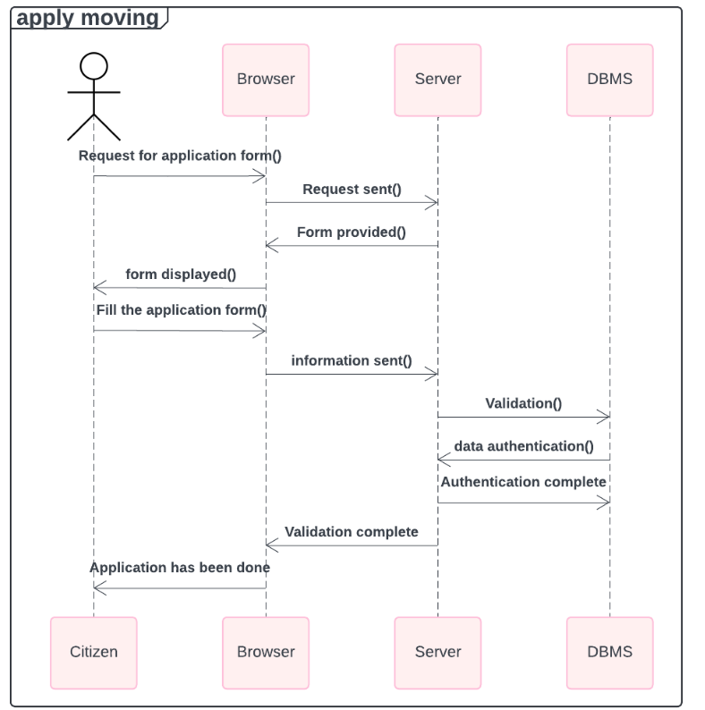

Figure 8: Sequence diagram to apply to move

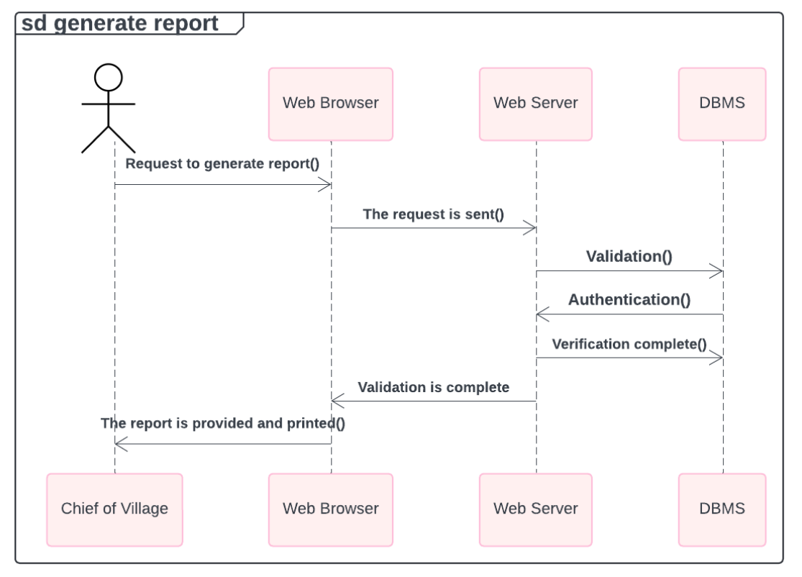

Figure 9: Sequence diagram to generate repost

**Physical Data Model.**

A database is a collection of related data. By data, we mean known facts that can be recorded and that have implicit meaning. This logical data model contains all the needed logical and physical design choices and physical storage parameters needed to generate a design in a Data Definition Language, which can then be used to create a database. A fully attributed data model contains detailed attributes for each entity.

The term database design can be used to describe many different parts of the design of an overall database system. Principally, and most correctly, it can be thought of as the logical design of the base data structures used to store the data. In the relational model these are the tables and views. In an object database the entities and relationships map directly to object classes and named relationships. However, the term database design could also be used to apply to the overall process of designing, not just the base data structures, but also the forms and queries used as part of the overall database application within the database management system (DBMS).

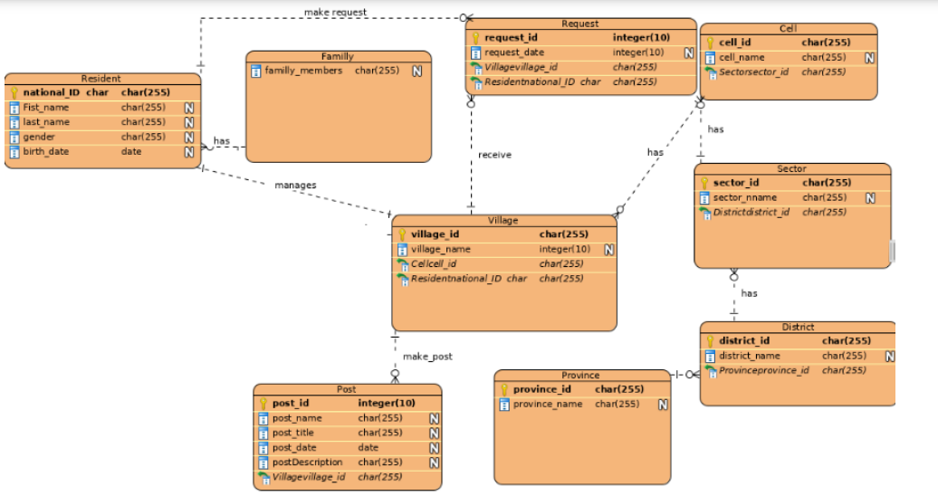

*Figure 1: Physical data model*

**Architectural design**

System architecture is a representation of a system in which there is a mapping of functionalities into hardware and software components, a mapping of the software architecture onto the hardware architecture, and human interaction with these components. The following figure displays sample system architecture of the new application.



Figure 12: Architectural design.

CHAPTER FIVE: IMPLEMENTATION OF THE NEW SYSTEM

## **5.1. INTRODUCTION**

System implementation is putting a scheduled system into action. The stage of systems development in which hardware and software are acquired developed and installed the system is tested and documented, people are trained to operate and use the system, and an organization converts to the use of a newly developed system.

Implementing Online Village census We started with creating the database according to its data dictionary design an apply all the relationships, after the database the next step was the design and coding of different forms needed to store information in database and other interfaces of the system, the following step was designing different reports using Html, CSS and php in framework called laravel codes these are really the results required by the users, reports are manipulated queries according to the needed results.

## **5.2 SYSTEM INTERFACE**

Under this section, I shall explain the most important interfaces of the new system and I shall show clearly how data are filled in these interfaces.

### **5.2.1 INTERFACE FOR ONLINE VILLAGE CENSUS SYSTEM**

**HOMEPAGE INTERFACE FOR WEB APPLICATION SYSTEM**

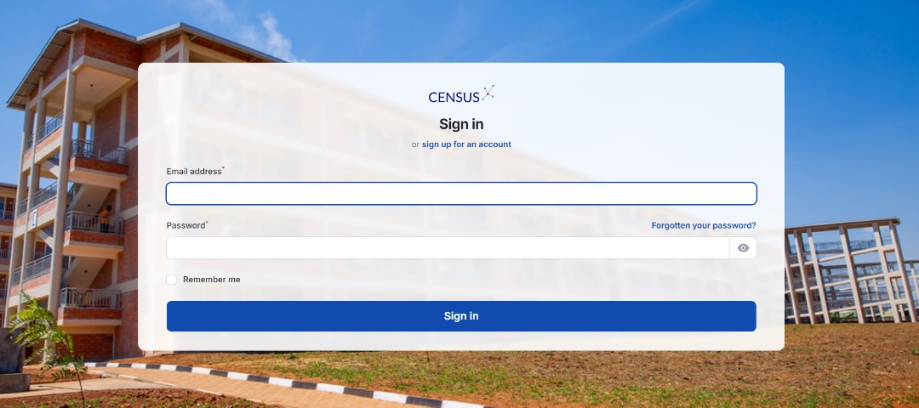

*Figure13: Home page interface for web application system*

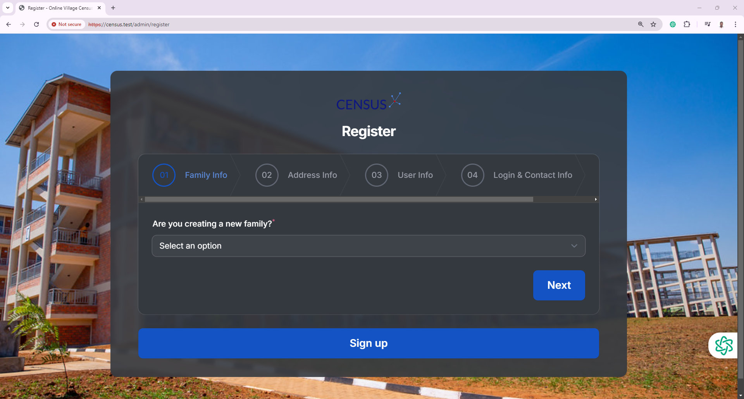

*Figure 16: Registration Page interface for web application system*

Staff sign up Signing up as a staff (chief of village or s/e of cell) is slightly different from other users of the System (Citizen) because staffs needs to be already recorded in the database by the System Administrator before, so that the system will be able to verify if that staff is truly a valid staff in the importer company. Unlike for other users of the system, for them they fill their personal information. Therefore the chief of village will use the panel shown above to create account.

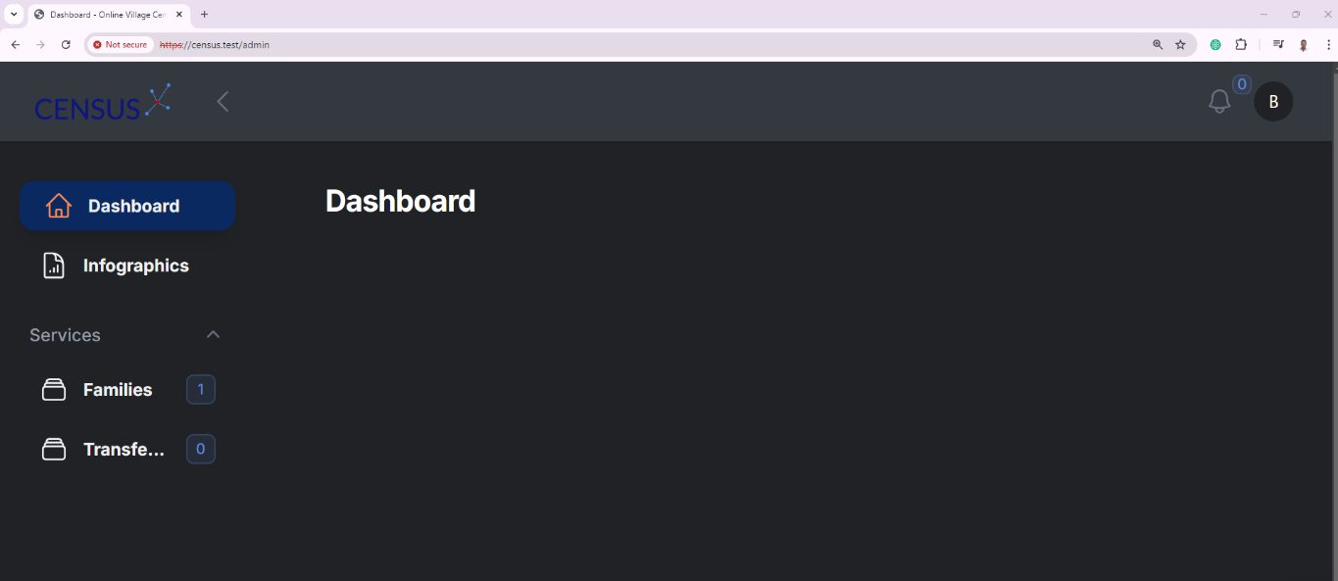

*Figure 17: Citizen Dashboard Page interface for web application system*

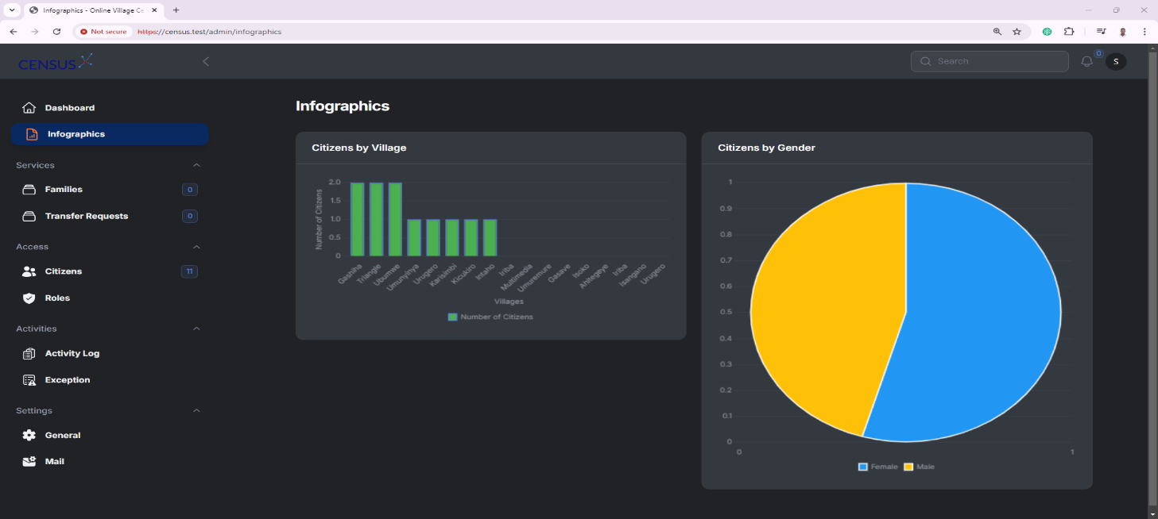

*Figure 18: Admin Dashboard page interface for web application system*

CHAPTER SIX: CONCLUSION AND RECOMMENDATION

* 1. **CONCLUSION**

The transition to an online village census system represents a significant advancement in the management and collection of demographic data in rural communities. This digital transformation not only enhances the efficiency, accuracy, and accessibility of census operations but also addresses many of the limitations associated with traditional paper-based systems. By adopting an online platform, villages can streamline data collection, reduce errors, and enable real-time updates and analysis. This shift optimizes resource allocation, promotes transparency, and provides local authorities with enhanced insights for more informed planning and decision-making, ultimately leading to improved public services and community development.

However, the successful implementation of this online census system depends on addressing key challenges, such as ensuring reliable internet connectivity, improving digital literacy, and safeguarding data security. It is essential for stakeholders to collaborate in developing robust infrastructure and providing comprehensive training to ensure the system's inclusivity and dependability.

**6.2 RECOMMENDATION**

To further support the system's adoption, I recommend that the Ministry of Local Government offer training to all potential users on how the new system functions and its benefits. This training will not only increase the number of people using ICT but also enhance their skills. Additionally, future updates to the application could include multilingual support, such as Kinyarwanda and French, to broaden its accessibility and user base.

**REFERENCES**

National institute of statistic of Rwanda https://www.statistics.gov.rw/datasource/fifth-population-and-housing-census-2022.

Worldbank(2024)<https://www.ruralgranular.eu/blog/unlocking-the-potential-of-open-data-for-rural-development/>

How to use prime faces (2020) from https://www.tutorialspoint.com/jsf/index.htms All sectors in Rwanda from http:// rw.wikipedia.org/wiki/Imirenge_y%E2%80%99u_Rwanda

THE LOCAL GOVERNMENT SYSTEM IN RWANDA (2017-2018) from http://www.clgf.org.uk/default/assets/File/Country_profiles/Rwanda.pdf Decentralization in Rwanda <https://www.minaloc.gov.rw/index.php?id=30>

Development of Sendudes Web-Based Application as a Digitalization of The Village Population Census [*https://pdfs.semanticscholar.org/5599/7861c80b47f954c3292fd5df610345cae0ea.pdf*](https://pdfs.semanticscholar.org/5599/7861c80b47f954c3292fd5df610345cae0ea.pdf)

**The State of Development in Villages of India: An Analysis of the 2018 Census Data**

# [*https://journals.sagepub.com/doi/abs/10.1177/0973703018802731*](https://journals.sagepub.com/doi/abs/10.1177/0973703018802731)Online Census-based Information Sharing for Delivery of e-Governance Services <https://dl.acm.org/doi/proceedings/10.1145/3055219>

# Census villages and the ecological footprint: Alternate data sources, policy analyses, and communication <https://www.sciencedirect.com/science/article/pii/S1470160X23013456>