The Biomedical Signal Project Three

Wavelet Transform（1）

Zhang Bing 171848

**Purpose：**

1. Study ‘wavelet transform’ concept and methods

2. Explore the Wavelet Toolbox in Matlab

3. Download a set of ECG data (5 pulse cycles) from the MIT-BIH database and plot the data curve

4. Select three mother wavelets and perform wavelet transform with the wavelet toolbox on the ECG data

5. Screen copy the GUI and demonstrate and scalograms for each wavelet transform (three GUIs)

**Materials and methods：**

**Datasets**

The datasets were retrieved from MIT-BIH, and all were prepared using this command (rdsamp -r mitdb/100 -H -f 0 -t 10 -v -pS >samples.txt). The format of the datesets as figue1.

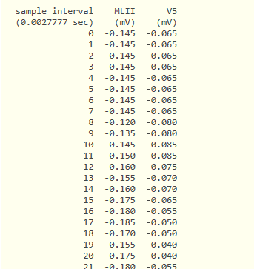

**Figure.1** The format of ECG data we download.

In order to read the data convenient, we deleted the first two lines of non-numeric data.

**Processing and visualization of signal data**

In order to get five pulse cycles of data, we use the function *findspeaks()*, and set the second parameter as ‘minpeakheight’ and the third parameter as 0.5. Then, we can get positions of all maximum point that the value greater than 0.5. These positions were used to count five pulse cycles.

We use the function *plot* to visualization the signal data. Figue2 display the curve of the signal data covered five pulse cycles, the red one represents the MLII, the blue one represents the V5.

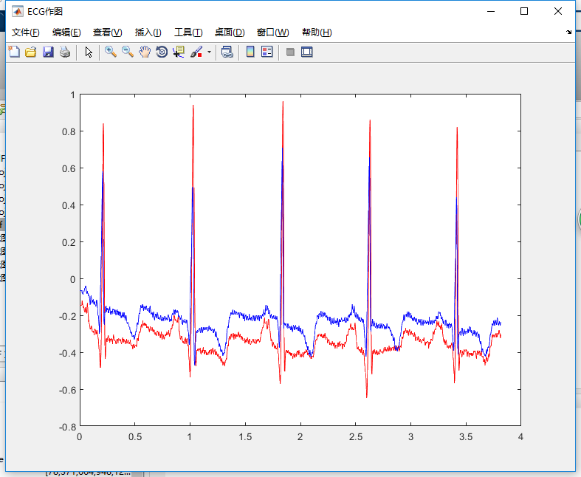After the script compiled, the data saved as *BS_Project3matlab.mat*.The mat file will be used as signal file in wavelet analysis.

**Figure.2** ECG data curve of five pulse cycles.

**Signal analysis using WAVEMENU**

We choose the function *Wavelet 1-D* in WAVEMENU. The file *BS_Project3matlab.mat* wasloaded as signal file. We can use the dataset of MLII to analysis. We use the mother wavelets *haar, db, sym* separately, the level all set as 5.The results were shown in figure3-6.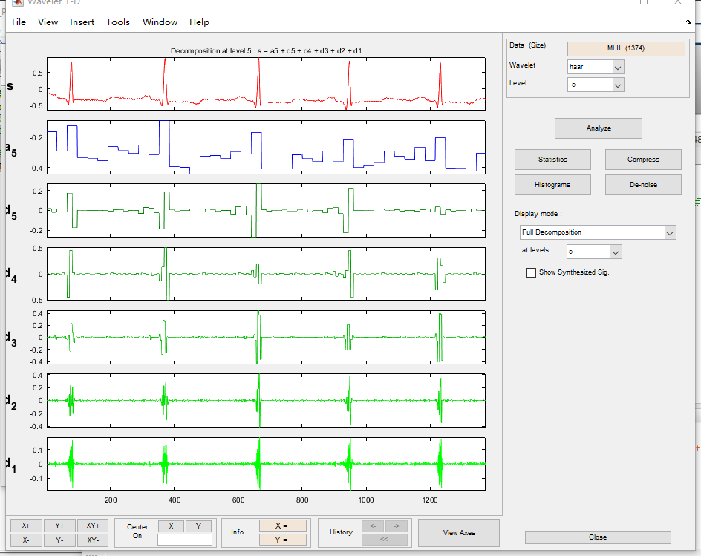

**Figure.3** MLII data analysis using haar wavelet. (Full Decomposition)

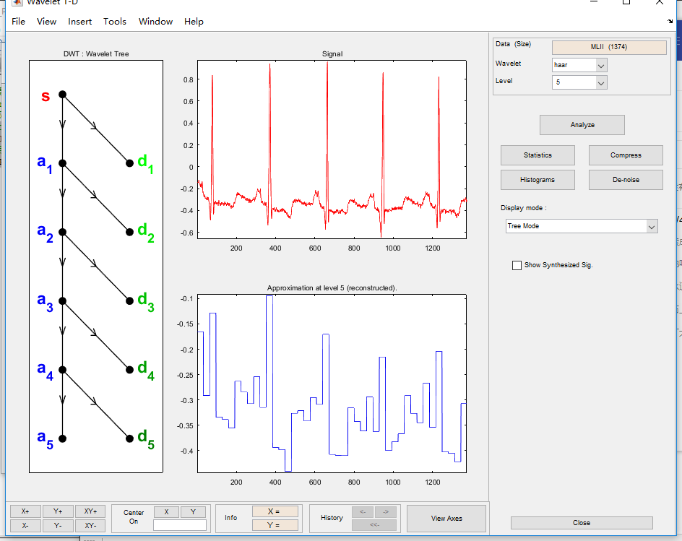

**Figure.4** MLII data analysis using haar wavelet. (Tree Mode)

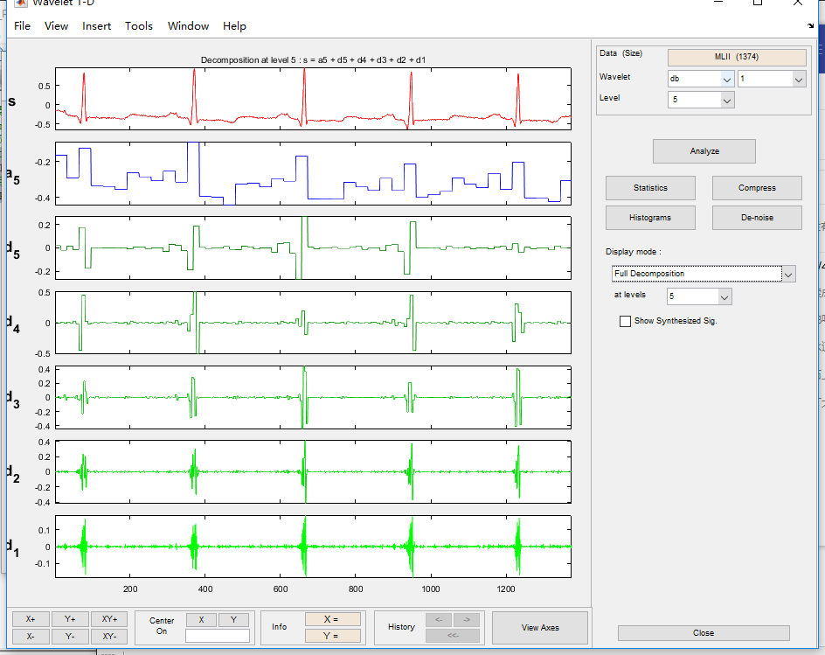

**Figure.5** MLII data analysis using db wavelet. (Full Decomposition)

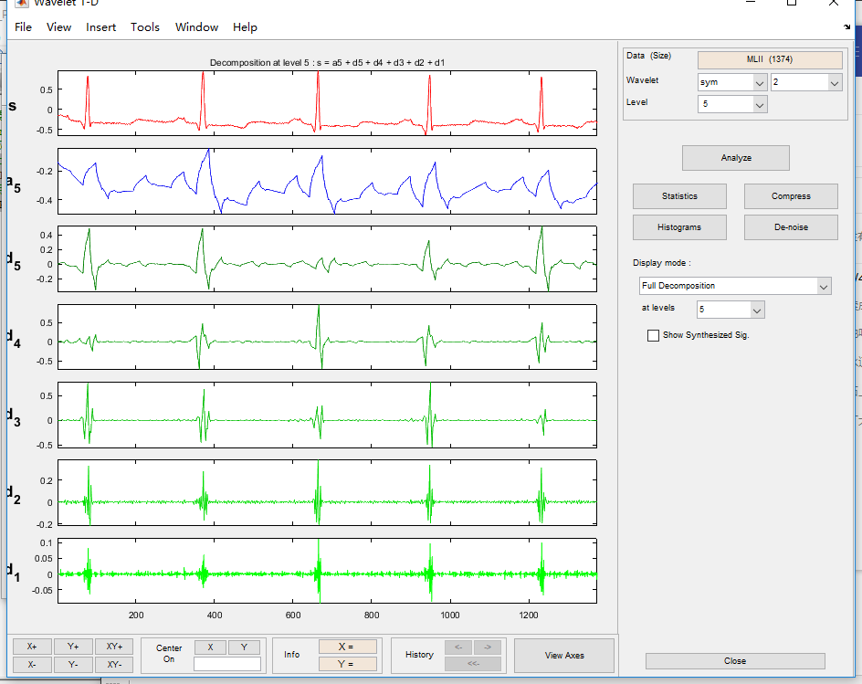

**Figure.6** MLII data analysis using sym wavelet. (Full Decomposition)

**Results and Conclusion：**

After the transform, the signal s was broken into a5, d5, d4, d3, d2, d1. The relationship of them is s = a5+d5+d4+d3+d2+d1, as the tree mode shown. The wavelet transform has the characteristics of "zoom". Wavelet decomposition can cover the entire frequency domain.

**Attach code：**

%文件名称 : BS_Project3_zhangbing_171848

%实现功能 : 读取MIT-BIH-DB文件，读取信号，画图，

% 使用wavelet toolbox，选择三个小波变换母函数进行信号转换，

% 将转换后信号画图。

%参考资料 :

%作者信息 : 171848-张冰

% 537405288@qq.com

% 18795969032

%修订时间 : 2018年4月25日19点46分

%调用格式 : 无

%参数释义 : 无

%项目路径

addpath(genpath(pwd));

clc;clear all;

%设置要读的data-set 路径

PATH = 'SignalFile';

SAMPLE = 'samples.txt';

PulseTime = 5;

%==========读取信号信息

%这里为了读取数据方便，做了数据预处理，把txt文件里的前两行非数值数据删除了

%这次没有使用原始数据信号，直接用数据库在线转换后的数据，省去了信号翻译的过程

samples = fullfile(PATH,SAMPLE);

fid = fopen(samples,'r');

z = textscan(fid,'%f %f %f');

fclose(fid);

%==========选取5个pulse数据

% 观察R值在0.5以上，并且在R值前后函数单调，所以在0.5范围以上寻找极值确定R点位置

[R_V,R_L]=findpeaks(z{2},'minpeakheight',0.5);

%信号截至选第10R点位置与第11R点位置的均值位置

signStop = mean([R_L(PulseTime) R_L(PulseTime+1)]);

Time = z{1}(1:signStop)/360;

MLII = z{2}(1:signStop);

V5 = z{3}(1:signStop);

%==========画图

figure('NumberTitle', 'off', 'Name', 'ECG作图');

clf, box on, hold on;

plot(Time,MLII,'r');

plot(Time,V5,'b');