Name: M Mudasir Chandio
Roll No. 459946
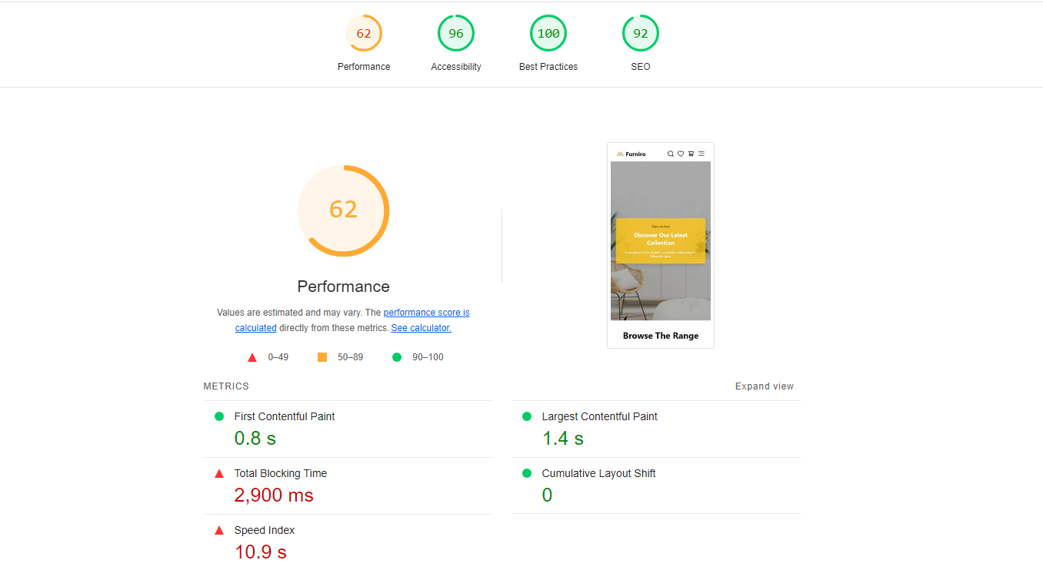

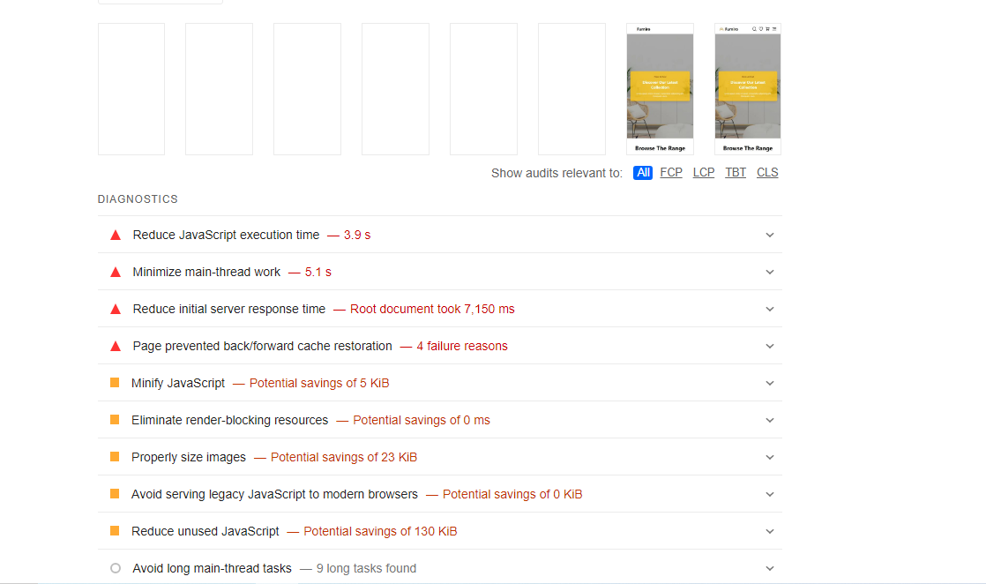
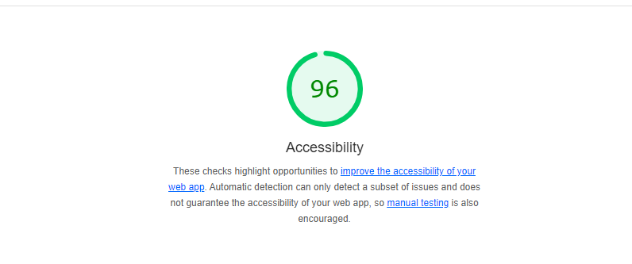

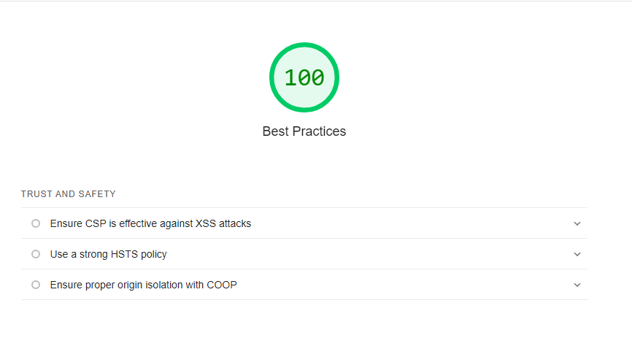

Trust and Safety
Ensure CSP is effective against XSS attacks
Use a strong HSTS policy
Ensure proper origin isolation with COOP
General
Missing source maps for large first-party JavaScript
Passed audits (14)
Show
Not applicable (2)
Show
92
SEO
These checks ensure that your page is following basic search engine optimization advice. There are many additional factors Lighthouse does not score here that may affect your search ranking, including performance on

Crawling and Indexing
robots.txt is not valid
Lighthouse was unable to download a robots.txt file
To appear in search results, crawlers need access to your app.
Additional items to manually check (1)
Show
Run these additional validators on your site to check additional SEO best practices.
Passed audits (8)
Show
Not applicable (1)
Show
- Captured at Jan 21, 2025, 12:35 AM GMT+5
- Emulated Moto G Power with Lighthouse 12.3.0
- Single page session
- Initial page load
- Slow 4G throttling
- Using Chromium 131.0.0.0 with cli

Developer Resources:
