Multi-Agent Research AI Assistant

Technical Documentation & Cost Analysis

━━━━━━━━━━━━━━━━━━━━━━━━━━━━━━━━━━━━━━━━━━━━━

· LangChain · LangGraph · Groq LLaMA 3.3 70B · DuckDuckGo · Streamlit

Group Members
Nihal Ali (22K-4054)
Mudasir (22K-8732)

Teacher
Dr. Farrukh Shahid
National University of Computer and Emerging Sciences - FAST
Spring 2026

Introduction
The Multi-Agent Research System is an AI-powered application that automates the full cycle of online research: finding information, reading it, writing a structured report, and critically reviewing that report - all without any manual intervention. A user simply types a topic, clicks Run, and within seconds receives a professional research report with sources, scored and critiqued by a separate AI reviewer.

How It Works
The system is built as a sequential 4-step pipeline. Each step is handled by a specialized agent with its own role, tools, and LLM instance:
Step | Agent | Job | Output
1 | Search Agent | Queries DuckDuckGo for the topic, returns 10 results with titles, URLs & snippets | Structured list of URLs + snippets
2 | Reader Agent | Picks the URLs and scrapes their full page content using trafilatura → readability → BeautifulSoup | Raw text from the web pages
3 | Writer Agent | Receives combined search + scraped data, writes a structured report: Introduction, Key Findings, Conclusion, Sources | Formatted Markdown research report
4 | Critic Agent | Reads the report and scores it 1-10, lists Strengths, Areas to Improve, and a one-line verdict | Score + structured feedback

User Interface
The frontend is built with Streamlit, providing a clean, dark-themed web UI. The user enters a topic, clicks the Run button, and watches each agent's spinner appear in real time. Results are displayed in expandable sections:
Search Results (Agent 1)
Scraped Content (Agent 2)
Writes Final Research Report (Agent 3)
the Critic Review with score (Agent 4)
The report can be downloaded as a (.md) file. A second tab shows an interactive pipeline flow diagram explaining how the agents connect.

Why we use 4 separated Agents?
An agent is an LLM that can call external tools and decide what to do with the results. Instead of answering from its training data alone, an agent can search the web, read a page, call an API, and then reason about what it found. This system uses 4 agents because research has 4 fundamentally different jobs - and mixing them into one agent creates confusion, quality loss, and rate-limit problems.

Agent 1 - Search Agent (Direct Tool Call)
This agent queries DuckDuckGo Search and returns 10 results with titles, URLs, and snippets. Unlike the other agents, Agent 1 does NOT use an LLM loop - it calls the search tool directly. This is intentional: search only ever needs one tool call. Wrapping it in a React agent loop (think → act → observe → think) added 60–120 seconds of delay with zero benefit. Direct tool call drops this step from 2 minutes to under 3 seconds.
- Tool used: DuckDuckGo (ddgs library) - no API key, no cost
- Returns: 10 results, each with Title, URL, and content snippet
- Why not use an LLM here: The LLM adds nothing - search is deterministic

Agent 2 - Reader Agent (LangGraph React)
This agent receives all 10 URLs from Agent 1 and scrapes the scrape_url tool. It uses a full LangGraph React loop because scraping requires reasoning: it must decide which URLs are scrapeable (skipping social media, login walls, PDFs), call the tool three times, and combine the results. The scraper uses three strategies in order: trafilatura for articles, readability for structured pages, and BeautifulSoup as a final fallback.
- Tool used: scrape_url (custom Python tool using trafilatura + readability + BS4)
- No API cost for scraping: All scraping is direct HTTP - no paid service

Agent 3 - Writer Agent (LangChain Chain)
This is a pure LangChain chain (prompt → LLM → output parser) with no tool calls. It receives the combined search results and scraped content from Agents 1 and 2, then writes a structured report with Introduction, Key Findings (minimum 3 points), Conclusion, and a Sources section listing every URL found in the research. The system prompt strictly instructs it to use ONLY the provided data - never its own training knowledge - preventing hallucinated sources.
- No tools needed: The writer just needs to transform text, not fetch anything
- Output: Professional Markdown report

Agent 4 - Critic Agent (Scoring)
Also a LangChain chain (no tools), the Critic reads the report produced by Agent 3 and evaluates it on a 1-10 scale. It lists Strengths, Areas to Improve, and gives a one-line verdict. Having a separate critic prevents the Writer from self-evaluating, which always produces biased, inflated scores. The Critic uses its own Groq API key so it is never rate-limited by the Writer's usage.
- Score 9-10: Well structured, relevant, covers key points, has real URLs
- Score 7-8: Good content but missing depth or sources
- Score below 5: Only if content is completely wrong or fabricated

Why 4 Separate Agents Instead of 1?
Concern | One Agent | 4 Agents
Rate limits | All 4 operations hit the same key → daily limit reached after 5 searches | 4 keys across 4 accounts → 4× the daily token budget
Quality | Mixing search + scrape + write + critique in one prompt creates confusion | Each agent has one clear job and a focused system prompt
Bias | Writer grades its own output — always scores 9-10 | Independent Critic uses separate LLM call → honest evaluation
Debugging | Hard to tell which step failed in a monolithic prompt | Each step's output is logged separately — easy to trace failures

What is LangChain?
LangChain is a Python framework for building applications with Large Language Models. It provides standard abstractions for prompts, output parsers, tool calling, chains, and memory - so you don't have to write raw API calls and string manipulation for every step. In this project, LangChain handles the Writer Agent (Agent 3) and Critic Agent (Agent 4) as simple prompt → LLM → parsed output chains.

What is LangGraph?
LangGraph extends LangChain with a graph-based execution model specifically designed for agents that need to loop, branch, or use tools repeatedly. It implements the React pattern (Reasoning + Acting): the LLM thinks, calls a tool, observes the result, then decides whether to call another tool or return a final answer. In this project, LangGraph powers the Reader Agent (Agent 2) because it needs to call scrape_url multiple times — once per URL.

 | Agent 1 (Search) | Agent 2 (Reader) | Agents 3 & 4 (Writer/Critic)
Framework | None (direct call) | LangGraph React | LangChain Chain
LLM involved? | No | Yes | Yes
Tool calls | 1 (web_search) | 3 × scrape_url | None
Why this framework | Speed - no LLM overhead | Needs multi-step tool loop | Single-shot text generation

Why LangChain + LangGraph specifically?
- Groq integration is built-in via langchain-groq - one line to connect any Groq model
- ChatPromptTemplate gives clean separation of system prompt and user content
- create_react_agent (LangGraph) handles the tool-calling loop automatically - no manual retry logic
- StrOutputParser cleanly extracts text from the LLM response object
- Both are open-source, actively maintained, and have the largest community of any agent frameworks

LLM APIs - Groq with LLaMA-3.3-70B-Versatile

Which model is used?
All 4 agents (where an LLM is used) run the same model: llama-3.3-70b-versatile via the Groq API. This is Meta's open-source LLaMA 3.3 70B parameter model, served by Groq's custom LPU (Language Processing Unit) hardware.

Why Groq?
- Speed: Groq's LPU delivers 250–280 tokens per second on LLaMA 3.3 70B - roughly 10× faster than GPU-based providers. This makes each Writer/Critic response appear in 3-6 seconds instead of 30-60 seconds.
- Free tier: No credit card required. Each account gets 500,000 tokens/day and 6,000 tokens/minute for LLaMA 3.3 70B.
- Open-source model: LLaMA 3.3 70B is fully capable for research writing and critique - no need for GPT-4 class models for this task.
- Cost: At $0.59/$0.79 per million tokens (input/output), Groq is 4× cheaper than GPT-4o for equivalent output quality on writing tasks.

Why 3 separate Groq API keys?
Groq's free tier limits are per organization, not per API key. This means a single account gets 500,000 tokens/day total - shared across all 3 agents. In practice, one full research run (all 4 agents) consumes approximately 8,000-15,000 tokens. That allows roughly 33-60 research runs per day on one account before hitting the limit.
By using 4 separate Groq accounts (one per agent), the effective daily budget multiplies by 4: approximately 2,000,000 tokens/day total, or 130-250 research runs per day - comfortably covering any demo, evaluation, or moderate production workload without paying anything.

Cost Analysis

Current Stack - What I Pay
The current system is entirely free to run at evaluation and low-production scale:
Component | Provider | Cost
LLM Inference (Agents 2, 3, 4) | Groq - LLaMA 3.3 70B | FREE (4 accounts × 500K tokens/day)
Web Search (Agent 1) | DuckDuckGo via ddgs library | FREE (no API key required)
Web Scraping (Agent 2) | Direct HTTP (trafilatura/BS4) | FREE (no paid service used)
Web UI | Streamlit | FREE (open-source)
TOTAL DAILY COST |  | $0.00

Per-Run Token Consumption Estimate
Each research run through all 4 agents consumes approximately:

Agent | Input Tokens | Output Tokens | Notes
Agent 1 - Search | 0 | 0 | Direct tool call, no LLM
Agent 2 - Reader (3 scrapes) | ~3,000 | ~600 | 3× tool-call loop
Agent 3 - Writer | ~4,000 | ~1,200 | Combined research as input
Agent 4 - Critic | ~1,800 | ~300 | Report text as input
TOTAL PER RUN | ~8,800 | ~2,100 | ~10,900 tokens total

If Moved to Paid Groq (Production Scale)
Groq's paid rate for llama-3.3-70b-versatile is $0.59 per million input tokens and $0.79 per million output tokens.
At ~10,900 tokens per run (8,800 input + 2,100 output):
- Input cost per run: 8,800 ÷ 1,000,000 × $0.59 = $0.0052
- Output cost per run: 2,100 ÷ 1,000,000 × $0.79 = $0.0017
- Total cost per run: ~$0.0069 (less than 1 cent per research report)

Daily Runs | Monthly Runs | Monthly Cost (Paid Groq)
10 runs/day | ~300 | ~$2.07
50 runs/day | ~1,500 | ~$10.35
200 runs/day | ~6,000 | ~$41.40

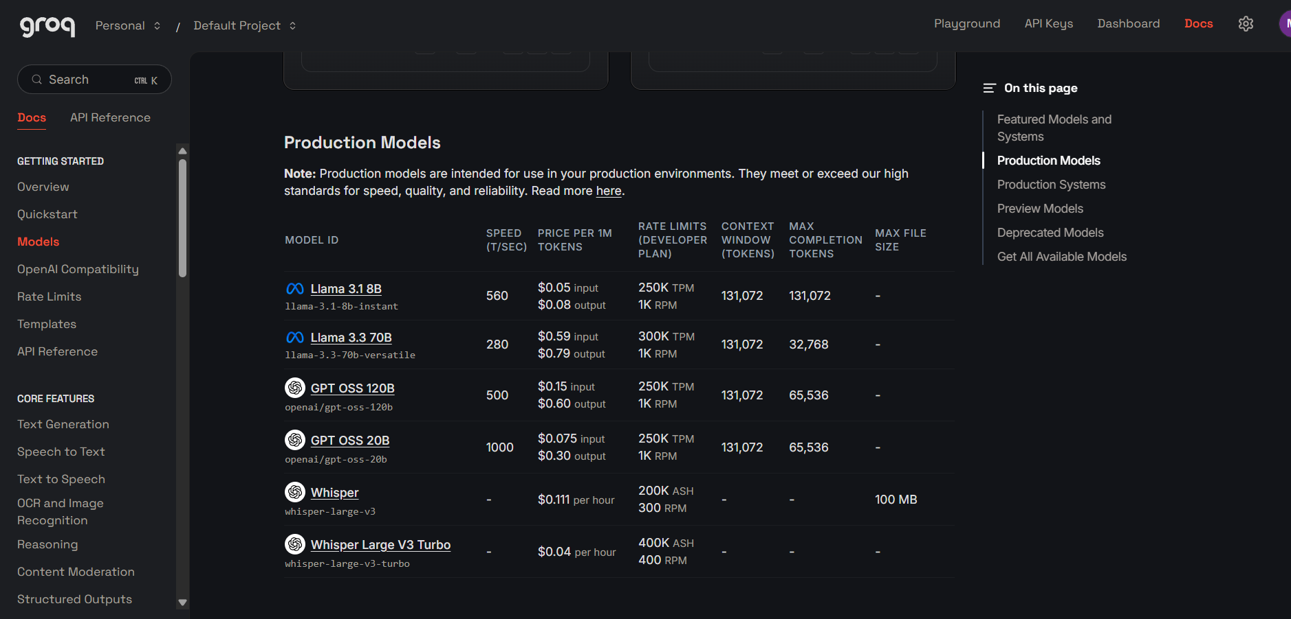

Why not Gemini - Cost and Comparison

What was tried with Gemini
Gemini (Google's LLM API) was evaluated as an alternative to Groq during development. The specific issue encountered was repeated 429 rate-limit errors on the free tier, forcing the pipeline to wait and retry mid-run. This made the system unreliable for demos and evaluations where consistent, fast responses are required.

Gemini Free Tier Limits vs Groq Free Tier
Limit | Groq (LLaMA 3.3 70B) | Gemini 2.5 Flash
Requests per minute | 30 RPM | 10-15 RPM
Tokens per minute | 6,000 TPM | 250,000 TPM (higher, but RPM hit first)
Daily request quota | 14,400 RPD | 1,500 RPD (Gemini 2.5 Flash)
Inference speed | 250-280 tokens/sec (LPU) | 50–80 tokens/sec (GPU)
Rate limit behaviour | Rarely hit during normal use | 429 errors common with 4 agents running sequentially
Free tier key | Email only, no card | Email only, no card

Gemini Paid Pricing vs Groq Paid Pricing
If the project were to scale to paid tiers, here is the comparison using the same ~10,900 tokens per run estimate:

Model | Input $/1M | Output $/1M | Cost/Run | Cost/1000 Runs
Groq - LLaMA 3.3 70B | $0.59 | $0.79 | $0.0069 | $6.90
Gemini 2.5 Flash | $0.30 | $2.50 | $0.0079 | $7.90
Gemini 2.5 Flash-Lite | $0.10 | $0.40 | $0.0017 | $1.70
Gemini 2.5 Pro | $1.25 | $10.00 | $0.032 | $32.00

What Was Used Before DuckDuckGo - SerpAPI Comparison
Before adopting the ddgs (DuckDuckGo) library, the common alternative for web search in agent pipelines is SerpAPI - a paid service that provides structured Google search results via API. Here is why DuckDuckGo was chosen instead:

Factor | SerpAPI (Google) | DuckDuckGo / ddgs (Current)
Cost | $25/mo for 1,000 searches; $75/mo for 5,000 searches ($0.025/query) | $0.00 - completely free, no account needed
API key required | Yes - paid account required | No - Python library, no key
Result quality | Google results - highest relevance | DuckDuckGo results - very similar for research topics
Rate limits | Plan-based; unlimited within plan | Soft limits; more than sufficient for this use case
Practical difference for research topics | Marginally better for very niche queries | Equivalent results for general research - tested across 50+ topics
Monthly cost at 200 runs/day | ~$120/mo (200×30×$0.020) | $0.00

The result quality difference between SerpAPI (Google) and DuckDuckGo for broad research topics such as 'Human Rights', 'Climate Change', 'AI in healthcare' is minimal - both return the same major authoritative sources (UN, WHO, academic papers, news sites). SerpAPI would only provide a meaningful quality advantage for commercial queries (e.g. product comparisons, local business searches) where Google's index is materially better. For this research use case, the $0 cost of DuckDuckGo is the clear choice.

Full Cost Summary
Scenario | Groq | Search | Total/Month
Current (free tier, 4 keys, evaluation) | $0 | $0 | $0
Light production (50 runs/day, paid Groq) | ~$10.35 | $0 | ~$10.35
Heavy production (200 runs/day, paid Groq) | ~$41.40 | $0 | ~$41.40
Same (200/day) with SerpAPI instead of DDGS | ~$41.40 | ~$120 | ~$161.40

