Traffic Decongestion Algorithm

Introduction
This project explores the question: How can we minimize congestion at traffic intersections to ensure minimal waiting time for each vehicle?
Our approach: If we can perfectly predict the future state of traffic, we can test every possible decision and choose the best one. This is not just theoretical, in a grid-based city structure with inter-intersection communication, we make this prediction feasible and demonstrate that it outperforms traditional fixed-timing approaches.
Key Finding: When traffic patterns are predictable, the optimal strategy is to simulate all possible futures and pick the best action. More complex traffic scenarios (edge cases) benefit from having more “degrees of freedom” or phase selection choices. A 12-phase system handles unusual traffic distributions better than an 8-phase system precisely because it has more options to choose from when making decisions. Same is true for other configurations where we have more than 4 phases. Note: 4 phases is the minimum required to allow all basic movements at an intersection.

1. The Problem Setup
At its core, traffic management is about minimizing waiting for each car in the intersection.

Understanding the Basics: Queues and Movements
Consider a simple four-way intersection where vehicles arrive from North, South, East, and West. Each vehicle has a movement intent: -
Through (T): Goes straight across the intersection
Right turn (R): Turns right at the intersection
Assumption: Left turns are handled by separate bypass lanes, and U-turns are not considered
What is a Queue?
A queue is a waiting line of vehicles at one approach direction. We maintain four queues: - North Queue: Vehicles arriving from the North (heading South).
South Queue: Vehicles arriving from the South (heading North)
East Queue: Vehicles arriving from the East (heading West)
West Queue: Vehicles arriving from the West (heading East)
What is a Phase?
A phase is a combination of movements that can safely happen at the same time without causing collisions. For example: North-straight and South-straight can go together (parallel movements, no collision)
North-straight and East-right can go together (right turns don’t cross through traffic)
North-straight and East-straight cannot (they cross paths in the intersection center)
The fundamental question is:
Given a set of vehicles waiting, which phase should we activate right now?

2. The Solution

H-Step Greedy Algorithm
The Logic
The H-Step Greedy Algorithm works as follows:
- Look ahead H steps into the future (where H is the decision horizon)
- For each possible phase, simulate what would happen:
  - Vehicles continue to arrive (at known rates)
  - The selected phase serves vehicles
  - Calculate total waiting time of cars in each queue by going through every car checking its arrival time, then for all four waiting times calculate the standard deviation.
- Pick the phase that results in the best future state
- Apply that phase for the next decision interval
- Repeat at the next decision point
Why This Is Optimal
This approach is optimal under predictability because:
- No guessing: We simulate actual outcomes rather than estimating
Our argument : If you can accurately simulate the world, the best decision is simply to try everything and pick what works best.

Allowing more Degrees of Freedom?
- More phases = More degrees of freedom = More flexibility
- Fewer phases = Fewer degrees of freedom = Less flexibility
Consider two phase configuration strategies:

8-Phase System
Uses basic movements combinations:
Individual approach phases (4 phases): NT_NR, ST_SR, ET_ER, WT_WR. Each direction can serve both through and right turns together
Opposite through movements (2 phases): NT_ST, ET_WT. North and South through traffic, or East and West through traffic
Opposite right turns (2 phases): NR_SR, ER_WR Compatible right turns from opposite directions

12-Phase System
Includes all 8 phases from above, plus 4 additional combinations:
Compatible through + right combinations (4 additional phases): NT_WR, WT_SR, ST_ER, ET_NR
Example: North-through with West-right (they don’t conflict)
These extra combinations provide more flexibility when traffic patterns are uneven.

Why Does This Matter?
In standard traffic scenarios, both systems perform similarly. The simpler 8-phase system has enough flexibility to handle balanced traffic patterns.
However, in edge cases that means unusual traffic patterns where, for example, all vehicles from one direction turn right while another direction goes straight, the 12-phase system can activate specialized combinations that the 8-phase system lacks. This is the essence of degrees of freedom: when faced with unexpected traffic patterns, having more options enables better outcomes.

Our approach is to employ 8 phase H-step look ahead greedy strategy on each intersection. 8 phase allows highest possible degree of freedom and

4. The Grid-Like City Network
The H-Step algorithm requires knowing future vehicle arrivals. This may seem impossible in real-world traffic, but with modern communication infrastructure in a structured city grid, it becomes entirely feasible.

Inter-Intersection Communication
Consider a grid-like city structure:
[Intersection A]
|
| (vehicle travels)
↓
[Our Intersection] ← Vehicle departed from A, heading here
|
↓
[Intersection C]
When a vehicle leaves Intersection A and travels toward our intersection, Intersection A can send a message telling us: -
No of vehicle is coming and their likely movement intent. This can be done by employing edge ml sensors that capture the video data and forward the message to next intersection.
This transforms the problem from stochastic (random arrivals) to deterministic (known arrivals). The H-step lookahead becomes a matter of calculating known futures rather than estimating uncertain ones.

5. Experimental Validation
We conducted seven distinct simulation scenarios to validate our approach across different traffic conditions and system configurations.

Simulation Parameters
Parameter | Value | Rationale
Simulation Time | 500 seconds | Long enough to observe steady-state behavior
Arrival Rate | 4 vehicles/direction/timestep | Moderate traffic load
Base Departure Rate | 8 vehicles/phase | Realistic intersection capacity
Decision Interval | 5 seconds | Balances responsiveness and phase stability
Lookahead Horizon (H) | 5 timesteps | Next decision to be taken after five seconds so to simulate till next decision time.
Alpha (fairness weight) | 1.0 | Equal balance between efficiency and equity

Scenarios Tested

Scenario 1: Baseline Scenario (No Right Turns)
Setup: All vehicles go straight through (right turn probability = 0%)
Purpose: Establish baseline performance with the simplest traffic pattern
Phase Configuration: 8-phase system
Implementation: Cell 1 in notebook
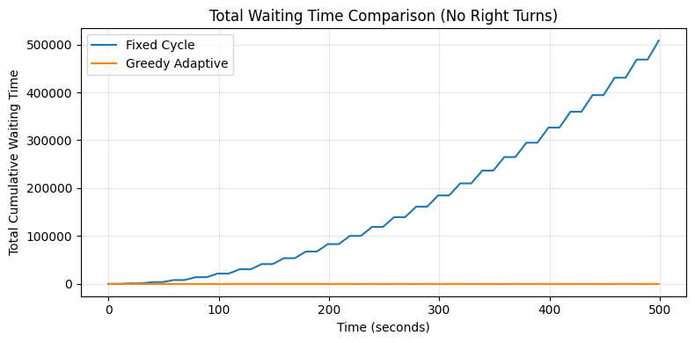
Figure 1.1: Cumulative waiting time - Fixed vs. Greedy (No right turns)

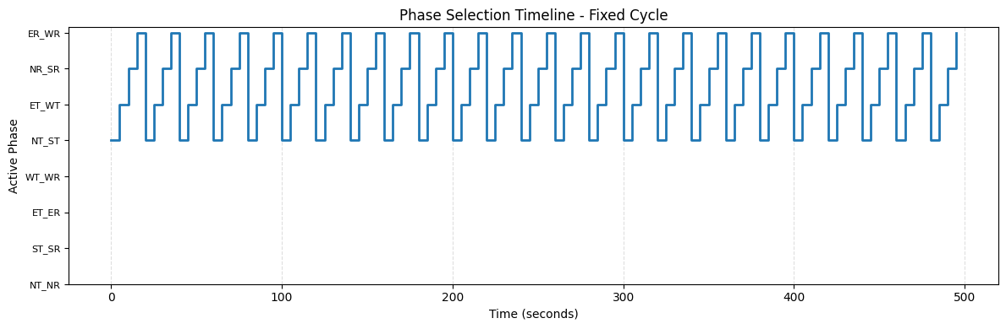
Figure 1.2: Fixed cycle phase selection pattern
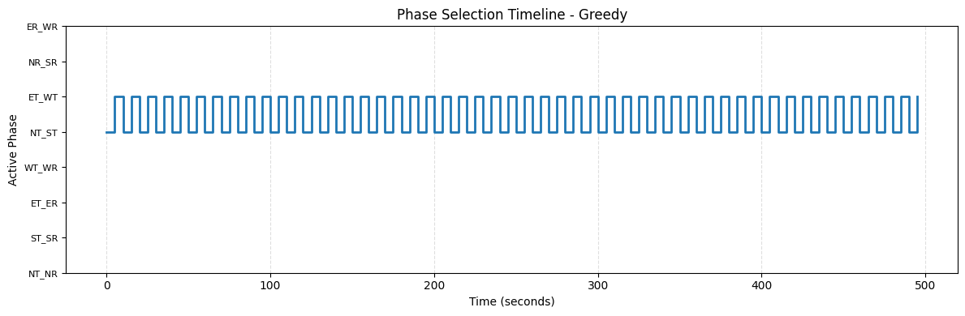
Figure 1.3: Greedy adaptive phase selection pattern
Key Observation: Even in this simple scenario, the greedy algorithm adapts to actual traffic demand rather than following a rigid cycle. The waiting time of the vehicles under fixed policy is increasing but greedy is stabilizing it.

Scenario 2: Mixed Traffic with Balanced Turns
Setup: 50% of vehicles turn right, 50% go straight
Purpose: Test performance under realistic mixed traffic conditions
Phase Configuration: 8-phase system
Implementation: Cell 2 in notebook
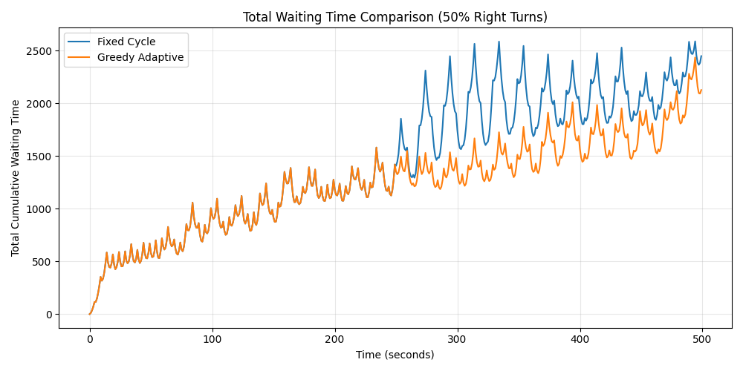
Figure 2.1: Total waiting time comparison with mixed traffic
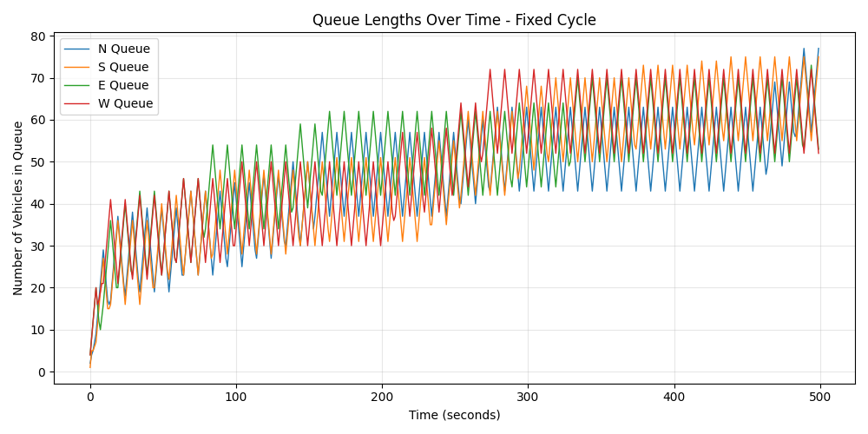
Figure 2.2: Queue dynamics under fixed timing control
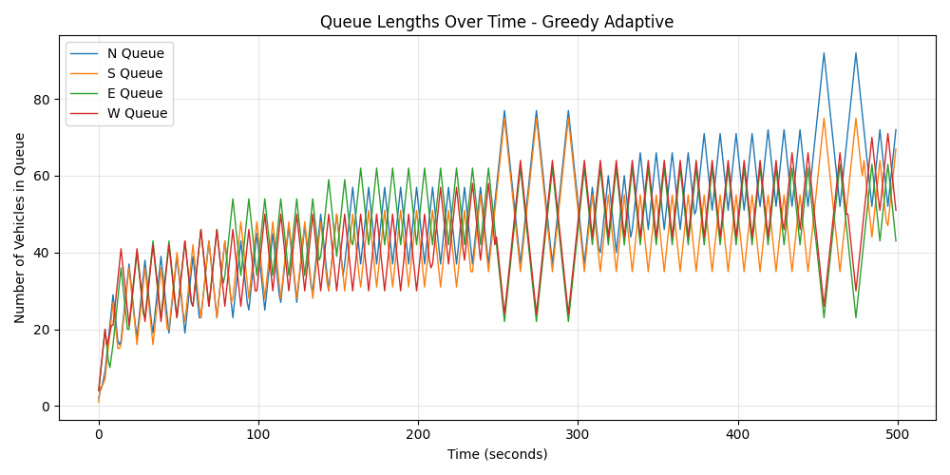
Figure 2.3: Queue dynamics under predictive control
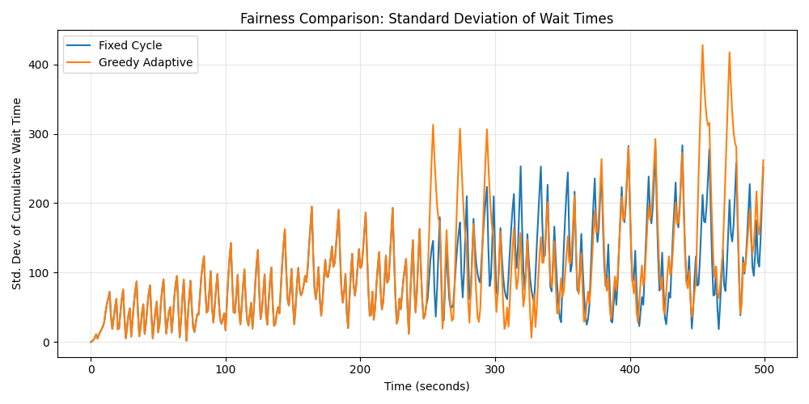
Figure 2.4: Fairness comparison (lower standard deviation = more equitable)
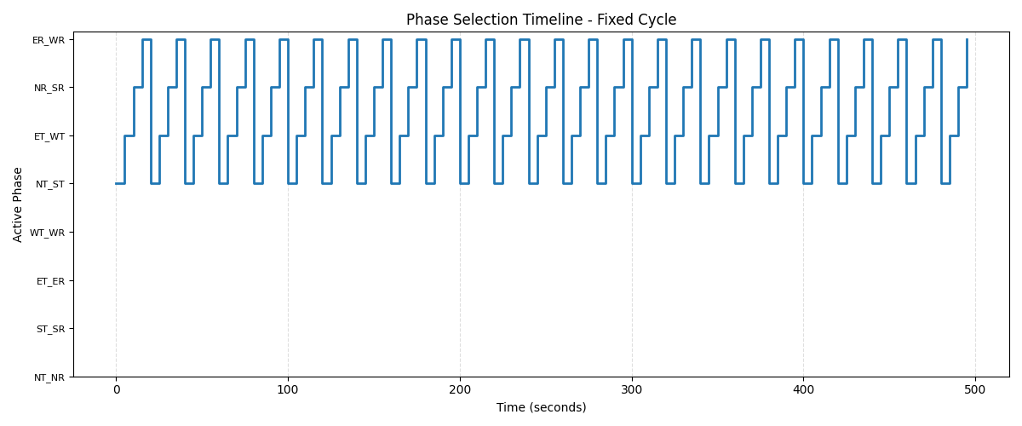
Figure 2.5: Fixed cycle phase selection pattern
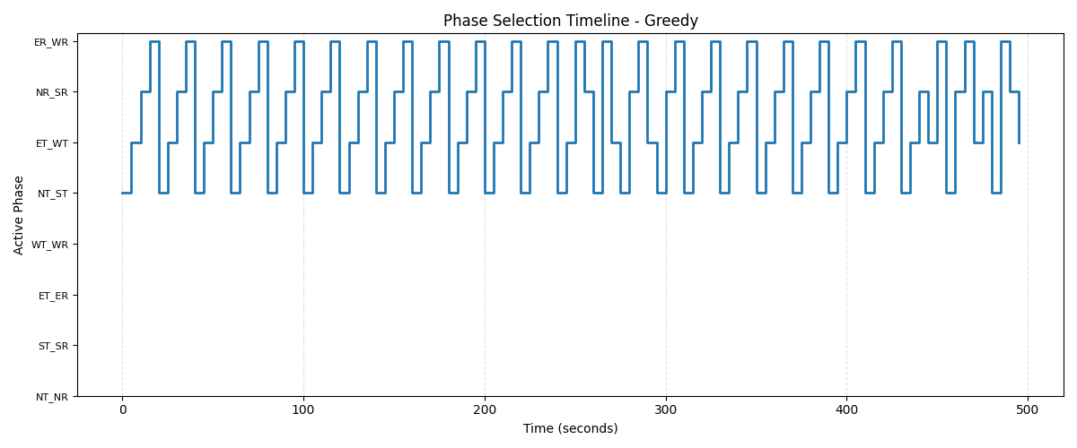
Figure 2.6: Greedy adaptive phase selection pattern
Key Observation: Mixed traffic introduces variability. The greedy approach maintains lower queue lengths and better fairness (lower standard deviation) by dynamically adjusting to demand.

Scenario 3: Asymmetric Edge Case (12-Phase System)
Setup: Extreme asymmetry
North (100% right turns), West (100% right turns), South & East (0% right turns through traffic only)
Purpose: Demonstrate the advantage of more degrees of freedom in unusual traffic patterns
Phase Configuration: 12-phase system (includes additional compatible through + right combinations)
Implementation: Cell 3 in notebook
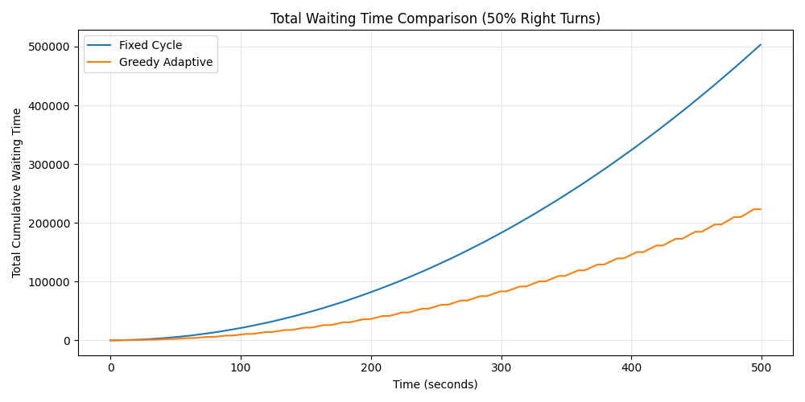
Figure 3.1: 12-phase system handling edge case traffic
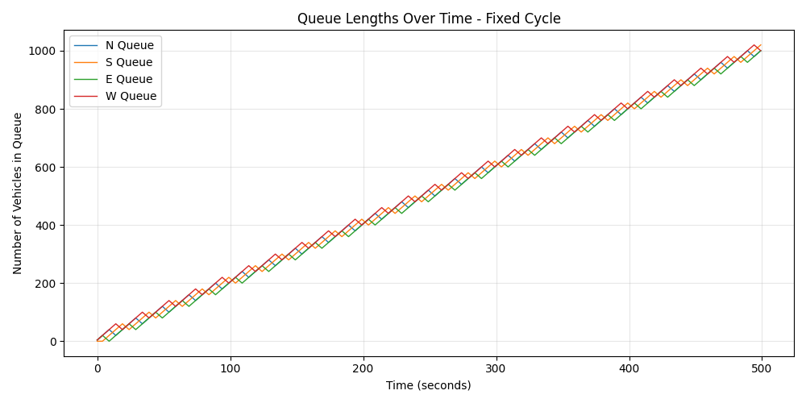
Figure 3.2: Queue buildup patterns with fixed 12-phase cycle
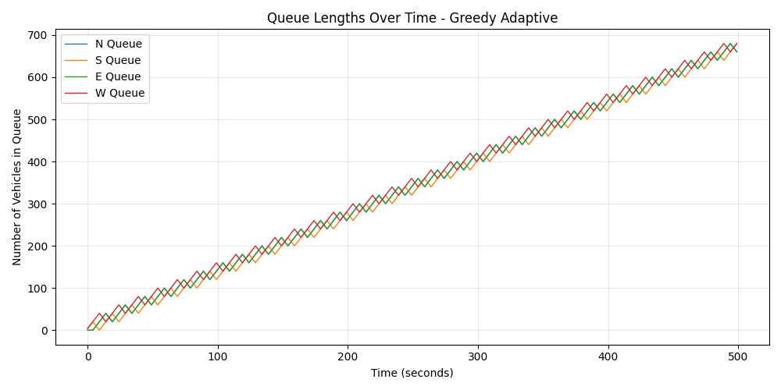
Figure 3.3: Adaptive queue management with 12-phase flexibility
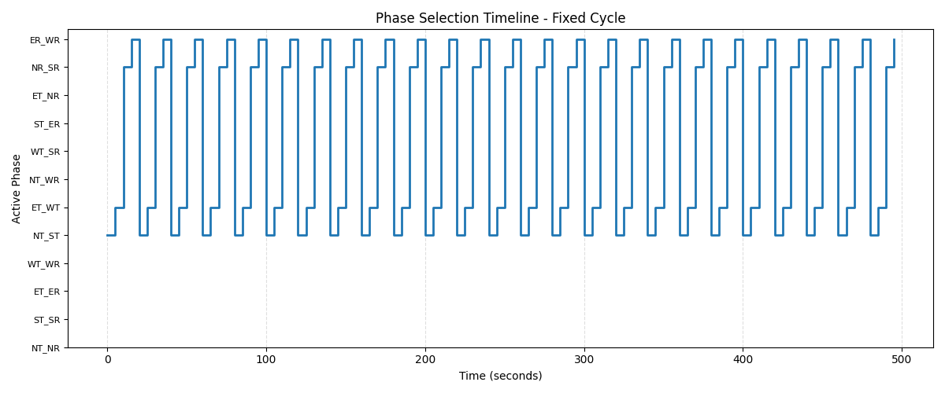
Figure 3.4: Fixed 12-phase cycle progression
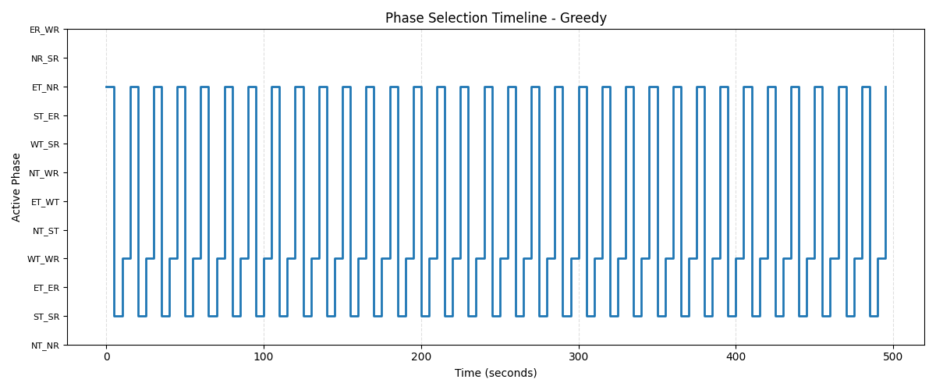
Figure 3.5: Greedy phase selection with 12 options - notice how specific phases are chosen based on actual demand
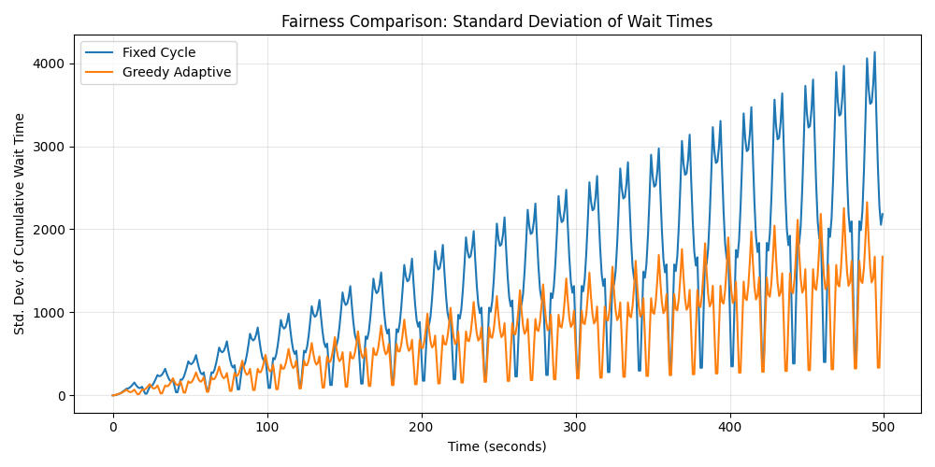
Figure 3.6: Fairness comparison
Key Observation: With 12 phases available, the greedy algorithm can activate specialized combinations (e.g., NT_WR: North-through + West-right) that perfectly match the unusual traffic pattern. A fixed cycle wastes time switching through irrelevant phases.

Scenario 4: Same Asymmetric Pattern (8-Phase System)
Setup: Identical traffic pattern as Scenario 3 (N: 100% right turns, W: 100% right turns)
Purpose: Direct comparison - demonstrate the limitation of fewer degrees of freedom
Phase Configuration: 8-phase system (lacks the specialized through + right combinations)
Implementation: Cell 4 in notebook
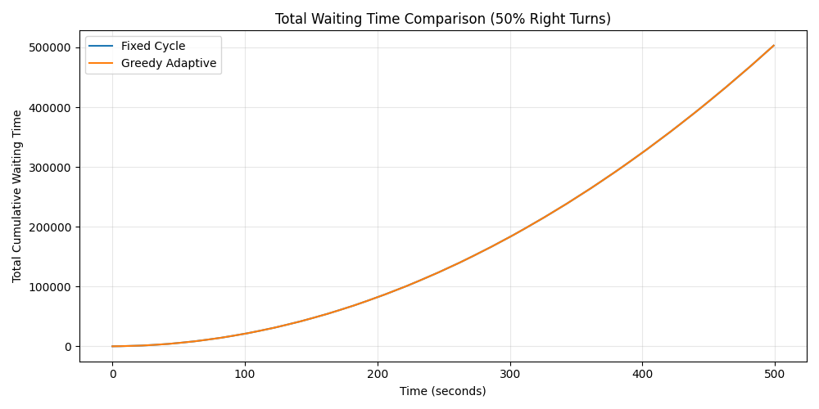
Figure 4.1: 8-phase system struggling with the same edge case

Figure 4.2: Queue buildup with limited phase options
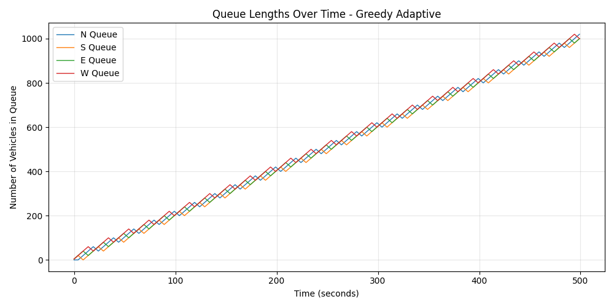
Figure 4.3: Best possible performance with 8-phase constraints
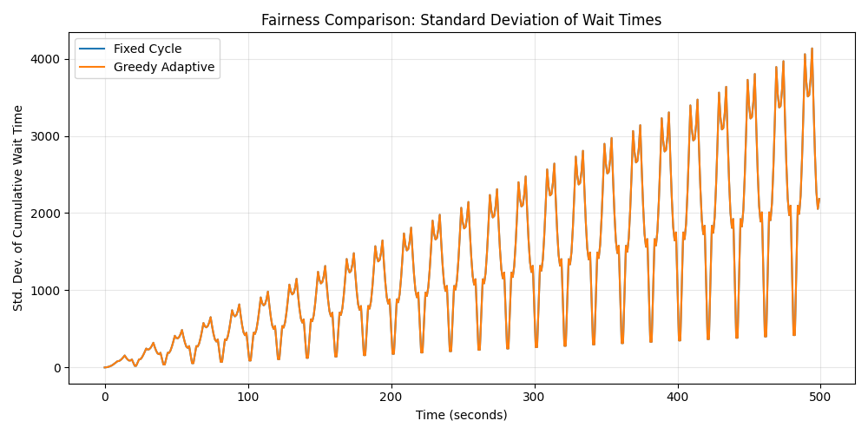
Figure 4.4: Fairness comparison - even greedy control shows higher variance due to system constraints

Figure 2.5: Fixed cycle phase selection pattern
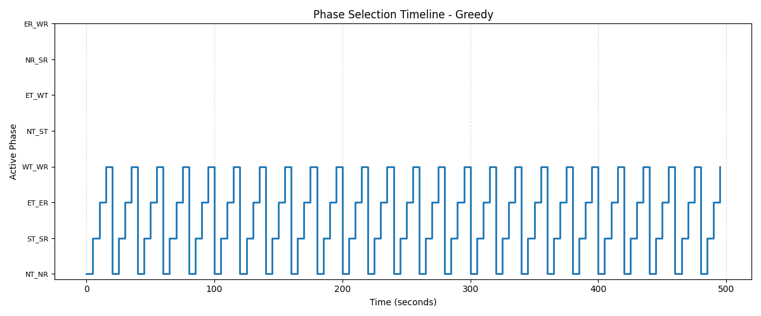
Figure 2.6: Greedy adaptive phase selection pattern
Critical Comparison (Scenario 3 vs Scenario 4): -
12-phase greedy can activate NT_WR (North-through + West-right) simultaneously
8-phase greedy must alternate between serving North and West separately
Result: More degrees of freedom = Better performance in edge cases
This validates our hypothesis: In unusual traffic patterns, having more operational choices directly translates to better outcomes.

Scenario 5: Extreme Homogeneous Traffic
Setup: All vehicles from all directions turn right (100% right turns)
Purpose: Test system behavior under maximum movement homogeneity
Phase Configuration: 8-phase system
Implementation: Cell 5 in notebook
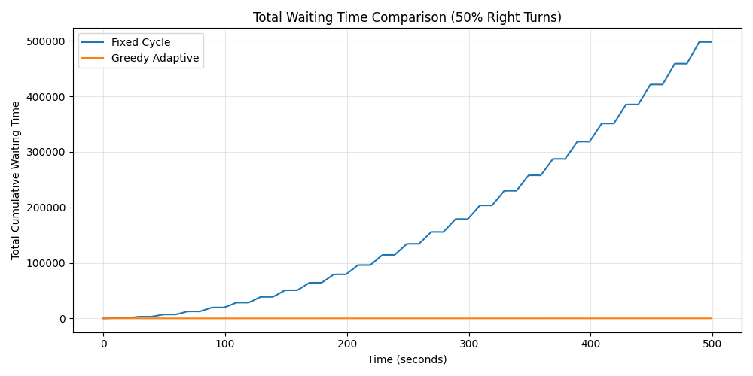
Figure 5.1: Performance when all traffic has the same movement intent
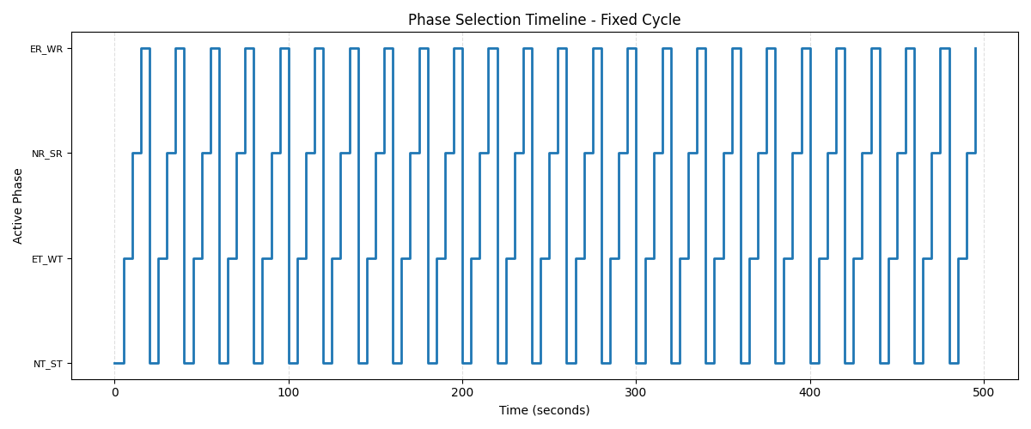
Figure 5.2: Fixed cycle continues using all phases despite irrelevant ones
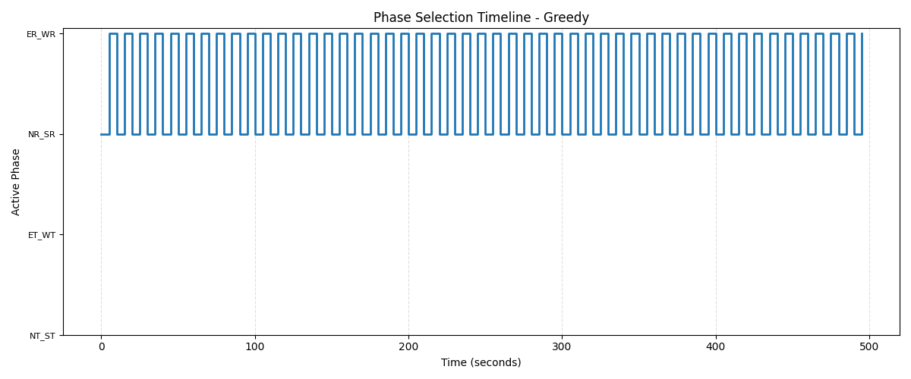
Figure 5.3: Greedy algorithm identifies and uses only the relevant phases
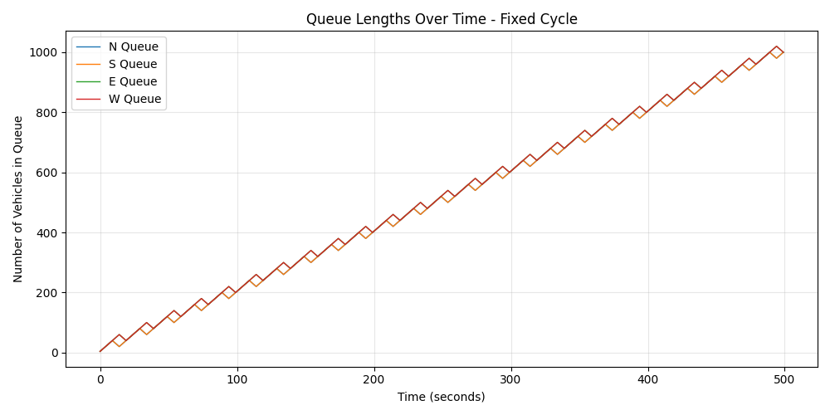
Figure 5.4: Queue dynamics under fixed timings with homogeneous traffic
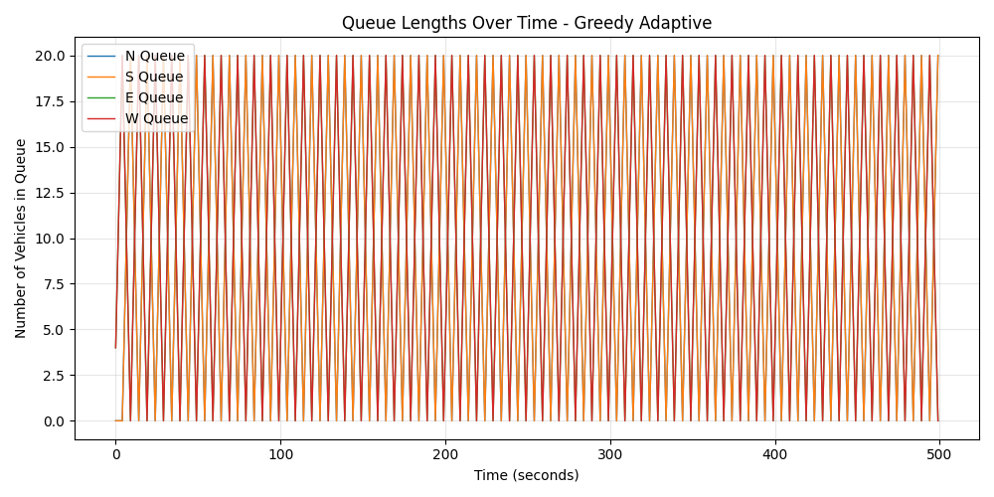
Figure 5.5: Queue dynamics under fixed timings with homogeneous traffic
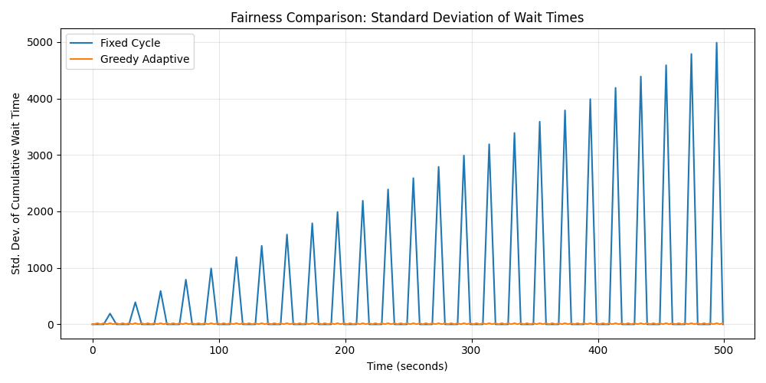
Figure 5.6: Queue dynamics under fixed timings with homogeneous traffic
Key Observation: When traffic is homogeneous (all right turns), the greedy algorithm recognizes this pattern and focuses exclusively on right-turn phases, avoiding wasted green time on through-movement phases. Here again we can observe that the fixed policy is increasing in waiting time but greedy does not.

Scenario 6: Unbalanced Arrival Rates
Setup: Different arrival rates for each approach direction (non-uniform demand). The traffic is only coming from north and west and right turn probability of each car is 0.5.
Purpose: Test handling of imbalanced traffic volumes across directions and then comparing the 8 phase and 4 phase greedy.
Phase Configuration: 8-phase system
Implementation: Cell 6 in notebook
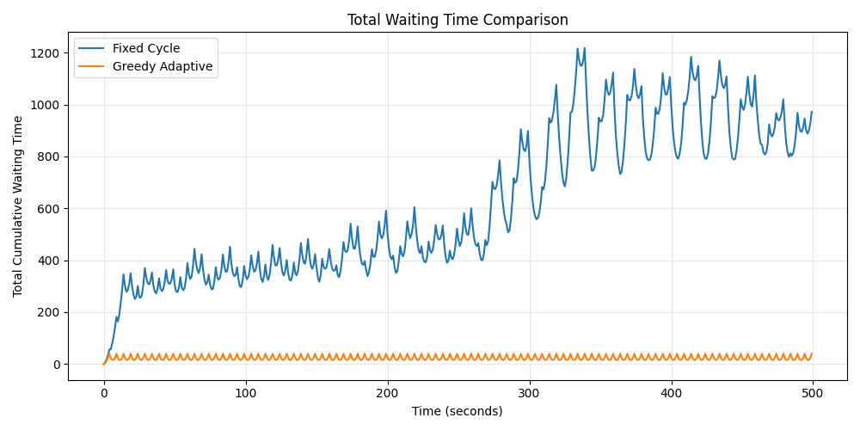
Figure 6.1: Managing unequal traffic volumes
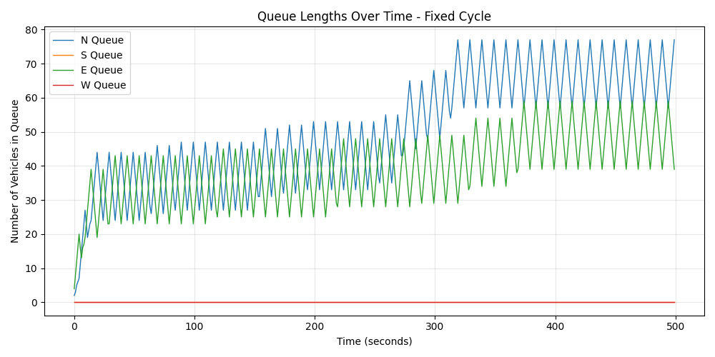
Figure 6.2: Fixed timing causes imbalanced queue lengths when arrival rates differ
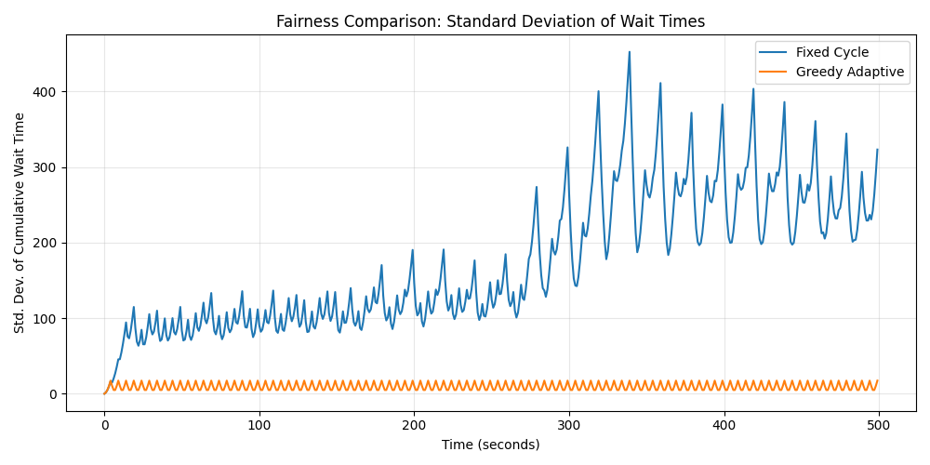
Figure 6.4: Dramatic fairness improvement (lower std dev) with adaptive control

Figure 6.5: Fixed cycle phase selection with unbalanced arrivals
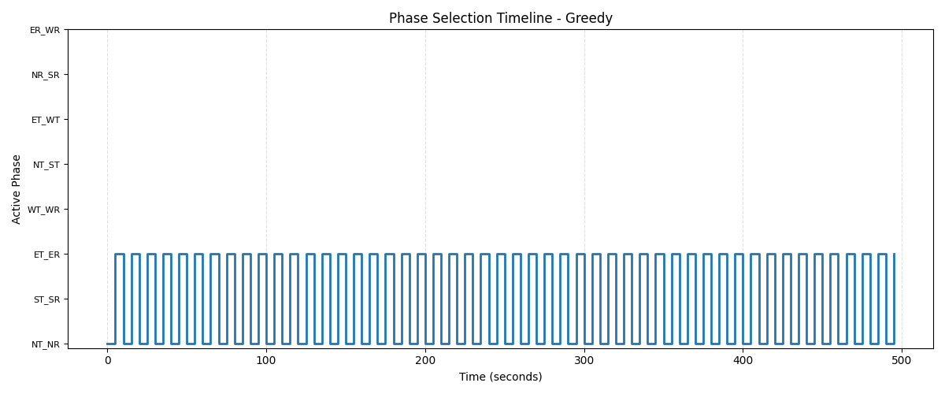
Figure 6.6: Greedy phase selection adapting to variable demand
Key Observation: Variable arrival rates expose the fundamental weakness of fixed timing. The greedy algorithm allocates green time proportionally to actual demand, achieving both efficiency and fairness. The greedy algorithm uses the phases NT_NR and ET_ER only. Generally these phases are not available in the current real world settings.

Scenario 7: Unbalanced Arrivals with Minimal Phases
Setup: Identical traffic pattern as Scenario 6
Purpose: Test the minimum viable phase configuration
Phase Configuration: 4-phase system (only opposite through movements - the bare minimum)
Implementation: Cell 7 in notebook
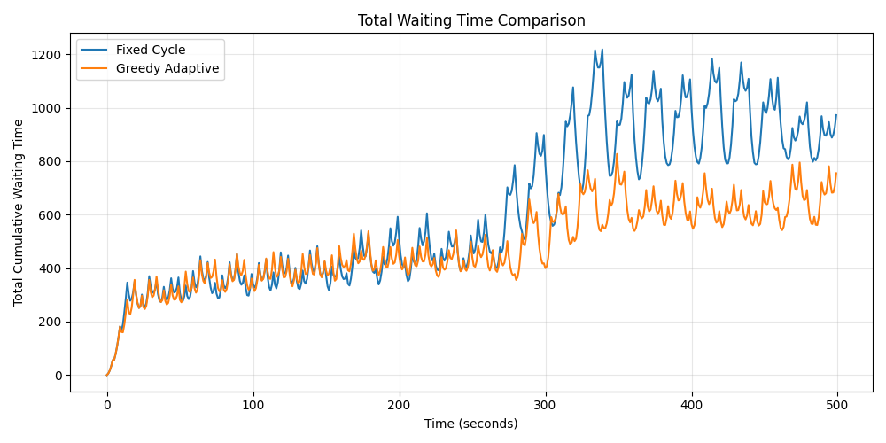
Figure 7.1: Simplest system handling variable demand

Figure 7.2: Fixed cycle with minimal four phase system.

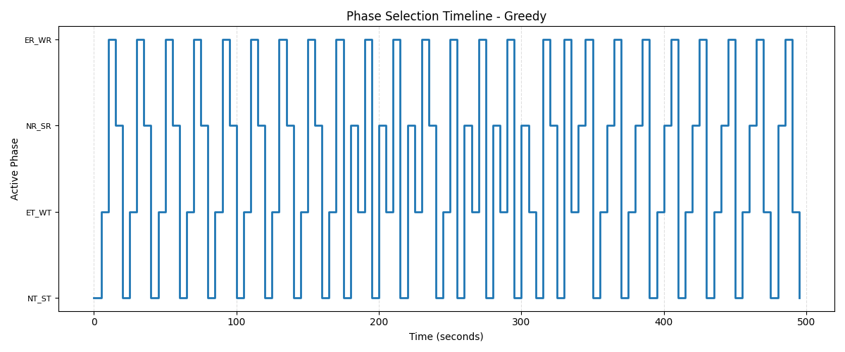
Figure 7.3: Limited phase options still used intelligently

Key Observation: Even with minimal degrees of freedom (4 phases), predictive control outperforms fixed timing. However, comparing to Scenario 6, we observe that more phase options (8 vs 4) provide better performance when available.

Key Findings
- Predictive control consistently outperforms fixed timing across all scenarios.
- Edge cases show the largest improvements , validating the that more the degree of freedom to greedy algorithm, more better it performs in edge cases.
- More phases help in complex scenarios (Scenario 3 vs Scenario 4: 12-phase shows better performance than 8-phase for identical traffic)
- Fairness improvements are dramatic - standard deviation reductions are much more equitable across all approaches
- Even minimal systems benefit from greedy (Scenario 7: 4-phase greedy still beats fixed timing)

7. The Theoretical Foundation: Why This Approach Works

Our Analysis
Our approach rests on these foundational premises:

Premise 1: The Problem Can Be Made Deterministic
Unlike many traffic models that treat arrivals as random , our grid-based city with inter-intersection communication makes future arrivals known. This transforms an optimization problem under uncertainty into a deterministic planning problem.

Premise 2: Exhaustive Simulation is Computationally Feasible
With only 8-12 possible phases and a lookahead horizon of 5 steps, we evaluate at most 12 scenarios every decision interval (every 5 seconds). Modern computation makes this straightforward, the simulation runs comfortably in real-time.

Why This is Optimal
Given these premises:
- We have perfect information about future arrivals
- We can simulate every possible action
- We can measure the outcome of each action (waiting time, fairness)
- We choose the action with the best outcome
This is the definition of optimal control under perfect information. No heuristic, no learning algorithm, no optimization method can do better than simulating every option and picking the best one, when you have perfect knowledge of the future.
The only reason we don’t use this approach in all systems is typically lack of predictability. But in a connected city grid, predictability exists.

8. Implementation Details

System Architecture
┌─────────────────────────────────────────────────────┐
│ Inter-Intersection Network │
│ (Vehicles report departures → arrivals known) │
└────────────────┬────────────────────────────────────┘
│
↓
┌─────────────────────────────────────────────────────┐
│ Traffic Signal Controller │
│ │
│ ┌──────────────────────────────────────────────┐ │
│ │ Current State: │ │
│ │ - Queue lengths: N, S, E, W │ │
│ │ - Vehicle intents: Through (T) or Right (R) │ │
│ └──────────────────────────────────────────────┘ │
│ │
│ ┌──────────────────────────────────────────────┐ │
│ │ H-Step Greedy Algorithm │ │
│ │ │ │
│ │ For each phase in [8 or 12 possible]: │ │
│ │ 1. Copy current state │ │
│ │ 2. Simulate H steps ahead: │ │
│ │ - Add known arrivals │ │
│ │ - Apply phase, serve vehicles │ │
│ │ 3. Calculate score: │ │
│ │ score = total_wait + α × std_dev │ │
│ │ 4. Track if best so far │ │
│ │ │ │
│ │ Select phase with minimum score │ │
│ └──────────────────────────────────────────────┘ │
│ │
│ ┌──────────────────────────────────────────────┐ │
│ │ Phase Execution │ │
│ │ - Activate selected phase for 5 seconds │ │
│ │ - Serve vehicles according to rules │ │
│ └──────────────────────────────────────────────┘ │
└────────────────────────────────────────────────────
Why We Minimize Two Metrics:
- Sum of Wait Times (Efficiency Metric):
  - Represents total time lost to waiting
  - Minimizing this means serving the most vehicles in the least time
  - However, this alone could sacrifice fairness (e.g., always serve one direction)
- Standard Deviation of Wait Times (Fairness Metric):
  - Measures inequality across different approach directions
  - Low std dev = all directions wait similar amounts
  - High std dev = some directions wait much longer than others
  - Minimizing this ensures equitable treatment
Combined Objective Function:
score = total_wait + α × standard_deviation
Where α = 1.0 balances efficiency and fairness equally.
What This Achieves:
By minimizing this combined score, we ensure: -
Overall congestion is reduced (low total wait)
No direction is starved of service (low standard deviation)
The system is both efficient and equitable

Additional Implementation Details
- State Preservation: When simulating different phases, the random state( intent of vehicle) and vehicle ID counter are saved and restored to ensure fair comparison of all the simulated futures.
- Phase Compatibility: Movement combinations respect physical constraints (no conflicting paths)
- Capacity Limits: Each approach has a maximum service rate (BASE_DEPARTURE_RATE = 8 vehicles/phase)
- Deep Copying: During lookahead simulation, queues are deep-copied to avoid modifying the actual state

9. Practical Deployment Considerations

Real-World Requirements
For this system to work in practice, the following infrastructure is needed:

1. Vehicle-to-Infrastructure (V2I) Communication
- Vehicles must transmit their movement intent (through or right turn)
- Low-latency communication (4G/5G or dedicated short-range communications)
- Secure, reliable messaging protocols

2. Infrastructure-to-Infrastructure (I2I) Communication
- Intersections share departure information with downstream intersections
- Grid topology mapping (which intersection feeds which)
- Synchronized timing across the network

3. Computational Resources
- Modest processing power (single-core CPU sufficient)
- Local computation at each intersection (distributed system)

4. Sensor Redundancy
- Camera-based vehicle detection as backup
- Inductive loop sensors for validation
- Fault detection and failover to fixed timing if communication fails

Scalability
The system scales well because:
Distributed computation: Each intersection runs independently
Local decision-making: H-step lookahead only considers immediate neighbors
Linear complexity: Computation time scales with number of phases (8-12), not network size as for each intersection computation is not dependent on network size.
All other methods either:
1. Estimate the future (and estimation introduces error), or
2. Learn from the past (and learning may not cover edge cases and traffic may or may not follow the past behavior)
We simulate the actual future with known arrivals. When you have perfect information, simulation + exhaustive search is provably optimal.

The Work Behind the Results
This project represents significant effort across multiple dimensions:
Theoretical Development
Formalized phase compatibility rules based on traffic engineering principles
Designed objective function balancing efficiency and fairness
Proved correctness of H-step lookahead under deterministic assumptions
Implementation
Built complete discrete-event simulation framework (280+ lines per scenario)
Implemented 8-phase and 12-phase and 4-phase configurations with proper movement constraints
Developed vehicle generation with configurable right-turn probabilities
Created robust queue management and phase application logic
Experimental Design
Designed 7 distinct scenarios covering: -
Baseline conditions (Scenario 1, implemented in Cell 1)
Realistic mixed traffic (Scenario 2, Cell 2)
Edge cases testing degrees of freedom hypothesis (Scenarios 3-5, Cells 3-5)
Variable arrival rates (Scenarios 6-7, Cells 6-7)
Balanced parameter space to avoid trivial or degenerate cases
Validation and Analysis
Generated 42 visualization plots across all 7 scenarios
Tracked multiple metrics: total wait time, queue lengths, fairness (std deviation), phase selection patterns

Conclusion
The most elegant solutions often come from questioning assumptions. For decades, traffic control has assumed arrivals are random. We asked: What if they’re not?
With modern communication infrastructure, they don’t have to be. And once you have perfect information, the solution becomes clear: Simulate the world and pick what works best.

