Unified Card Repository - High Level Design (HLD v2.3.1)

1. Introduction & Purpose
This HLD describes the architecture and major integration patterns for the Unified Card Repository (CardRepo) aligned with PRD v2.3.1. It focuses on system boundaries, component interactions, data flows, and operational considerations. CardRepo is internal-only; frontend access is via bank microservices (CardsService).

2. High-Level Architecture Overview
Key components and placement:
- External CMS platforms (issuers / networks) — produce card events to Kafka
- Kafka (Event Bus) — reliable transport, topics for card events, DLQ for invalid messages
- CardRepo Service — Kafka consumer, internal service exposing internal REST/gRPC, persistence layer
- Customer360 (C360) — authoritative customer identity and attributes; CardRepo pushes updates to C360
- Cards Microservice (API Layer) — public-facing APIs for frontend (GET /cards, GET /eligible-cards)
- Database (RDBMS) — primary storage for card metadata; read replicas for scalability
- Cache (Redis) — distributed cache for hot reads
Security & Network Boundary:
- CardRepo lives in a secured VPC/zone; internal APIs protected with mTLS and IAM policies.
- Microservices sit in the API layer zone, behind API Gateway.
- C360 APIs are reachable via internal network with service-level auth.

3. Logical Component Diagram (text)
Mermaid-style component diagram (paste into Mermaid-enabled tool):
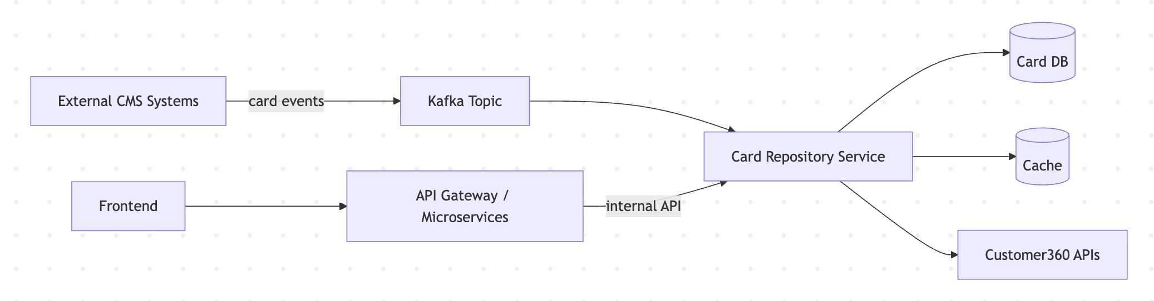
graph LR
CMS[External CMS Systems] -->|card events| Kafka[Kafka Topic]
Kafka --> CardRepo[Card Repository Service]
CardRepo --> DB[(Card DB)]
CardRepo --> Redis[(Cache)]
CardRepo --> C360[Customer360 APIs]
APIGW[API Gateway / Microservices] -->|internal API| CardRepo
Frontend --> APIGW

4. Major Interaction Journeys

4.1 Card Ingestion (CMS → Kafka → CardRepo)
Description: Card creation / update events are produced by external CMS into Kafka. CardRepo consumes, validates, normalizes, persists, and triggers C360 sync.
Mermaid sequence diagram:
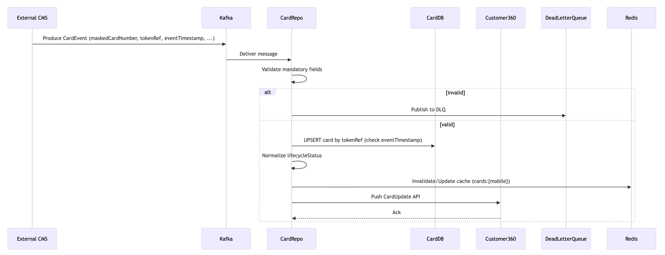
sequenceDiagram
participant CMS as External CMS
participant K as Kafka
participant CR as CardRepo
participant DB as CardDB
participant C360 as Customer360
participant DLQ as DeadLetterQueue
CMS->>K: Produce CardEvent (maskedCardNumber, tokenRef, eventTimestamp, ...)
K->>CR: Deliver message
CR->>CR: Validate mandatory fields
alt invalid
CR->>DLQ: Publish to DLQ
else valid
CR->>DB: UPSERT card by tokenRef (check eventTimestamp)
CR->>CR: Normalize lifecycleStatus
CR->>Redis: Invalidate/Update cache (cards:{mobile})
CR->>C360: Push CardUpdate API
C360-->>CR: Ack
end

4.2 C360 Sync Failure Handling
CardRepo must guarantee C360 sync within SLA (5s). On failure, it marks record syncPending and enqueues for reconciliation.
Mermaid sequence diagram (failure path):
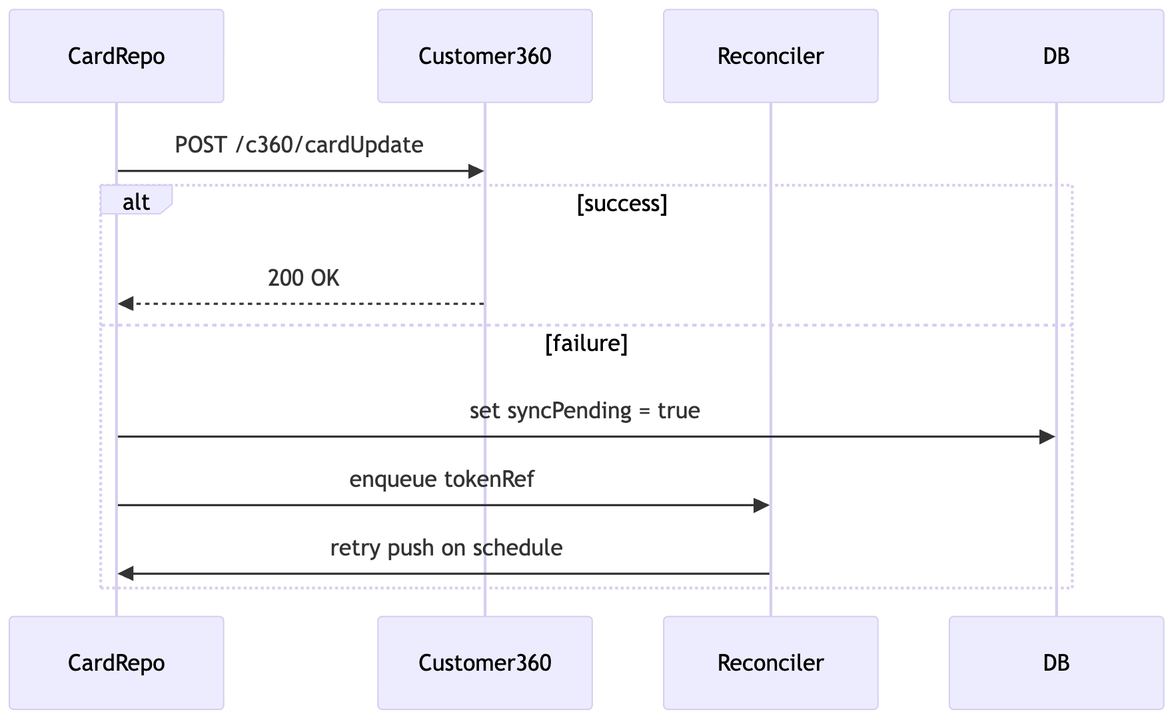
sequenceDiagram
participant CR as CardRepo
participant C360 as Customer360
participant Reconc as Reconciler
CR->>C360: POST /c360/cardUpdate
alt success
C360-->>CR: 200 OK
else failure
CR->>DB: set syncPending = true
CR->>Reconc: enqueue tokenRef
Reconc->>CR: retry push on schedule
end

4.3 Frontend Fetch (Frontend → CardsService → CardRepo)
Description: Frontend calls CardsService which authenticates user, applies rate-limits and caching, and calls CardRepo internal API to fetch card list or eligible programs.
Mermaid sequence diagram:
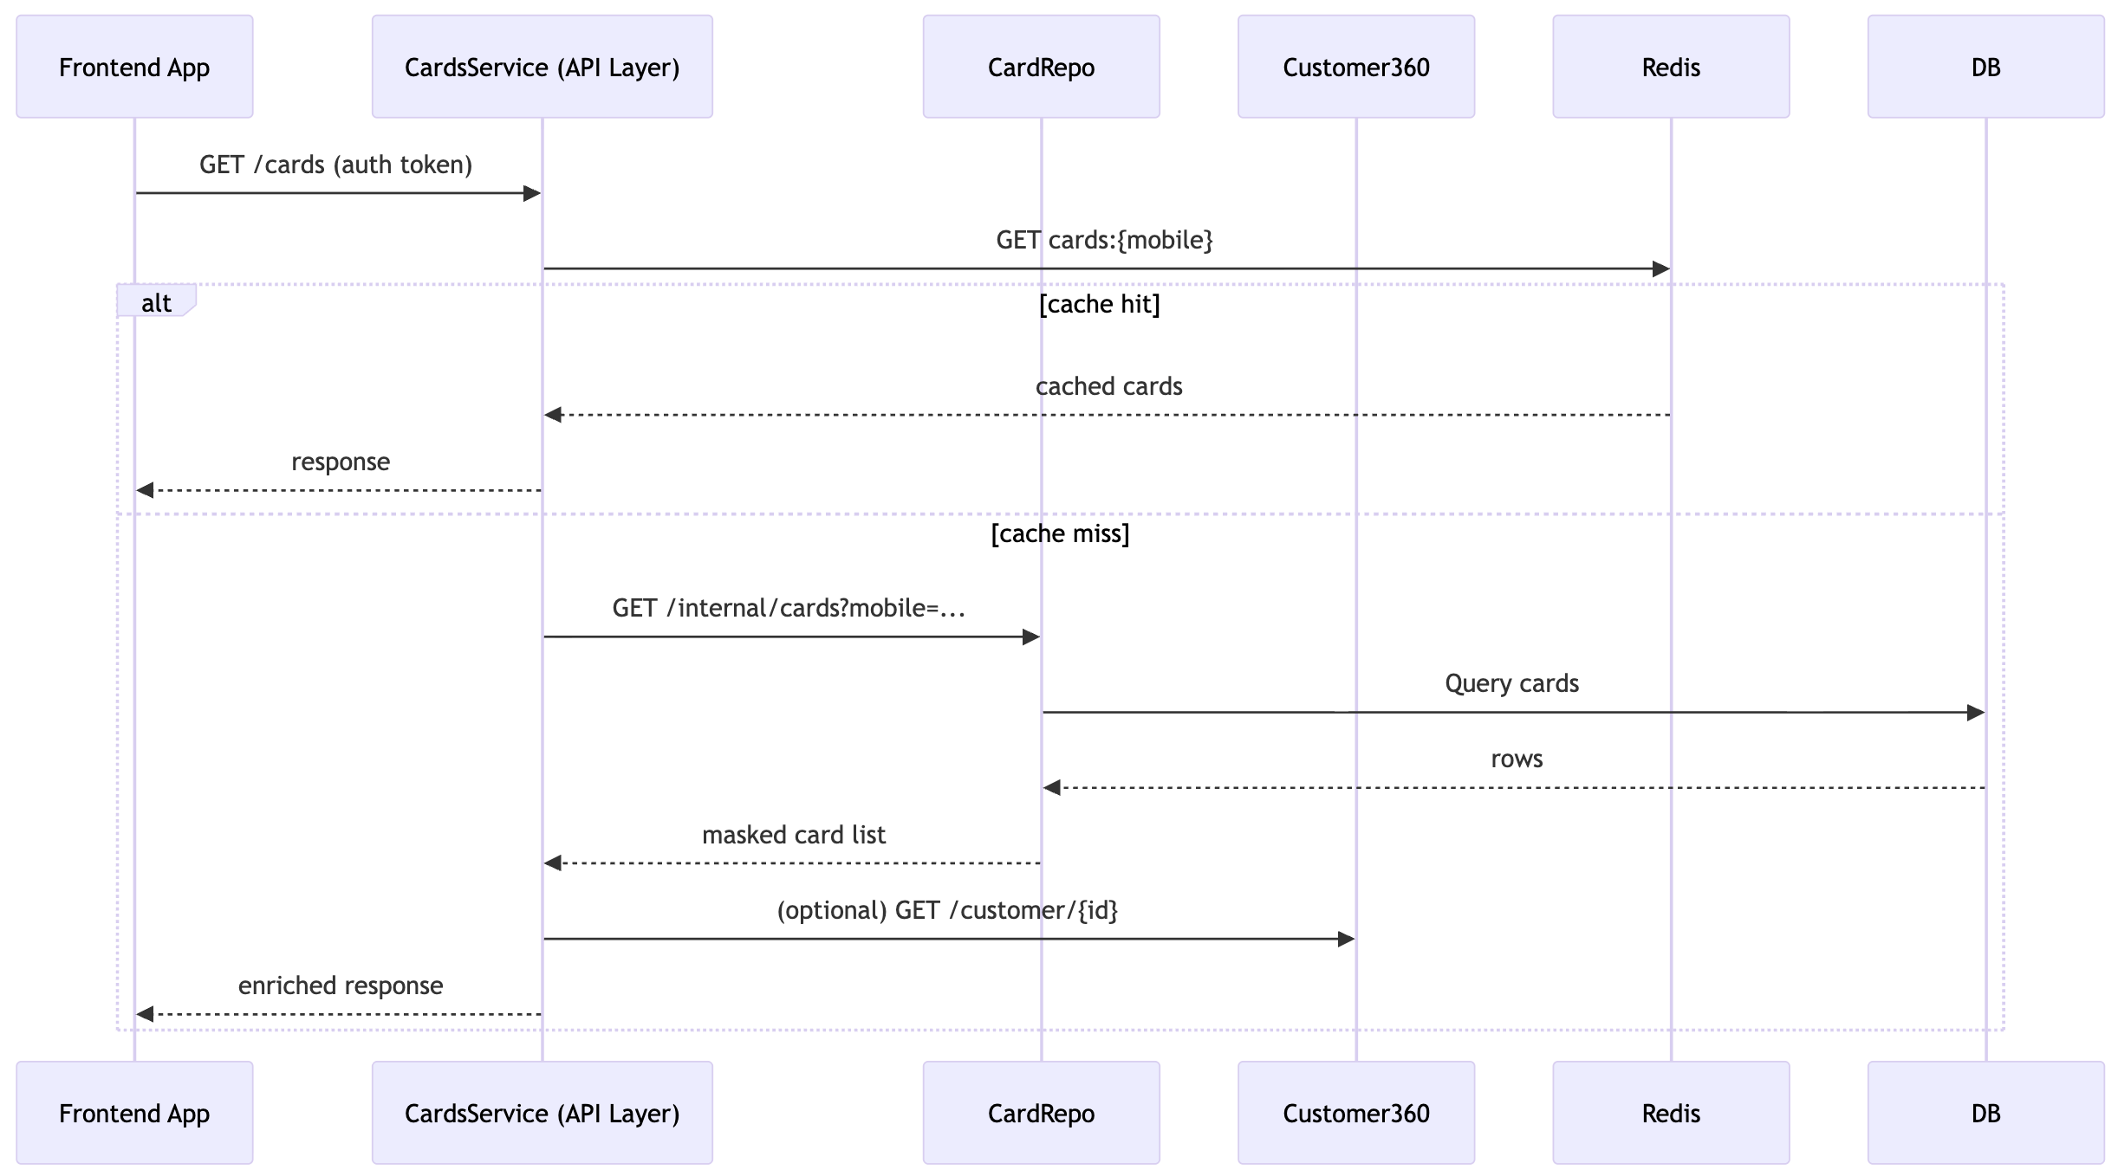
sequenceDiagram
participant App as Frontend App
participant MS as CardsService (API Layer)
participant CR as CardRepo
participant C360 as Customer360
participant Cache as Redis
App->>MS: GET /cards (auth token)
MS->>Cache: GET cards:{mobile}
alt cache hit
Cache-->>MS: cached cards
MS-->>App: response
else cache miss
MS->>CR: GET /internal/cards?mobile=...
CR->>DB: Query cards
DB-->>CR: rows
CR-->>MS: masked card list
MS->>C360: (optional) GET /customer/{id}
MS-->>App: enriched response
end

4.4 Eligibility Computation (Microservice or CardRepo)
Description: Eligibility can be computed by CardsService or CardRepo. Flow shows microservice initiating eligibility.
Mermaid sequence diagram:
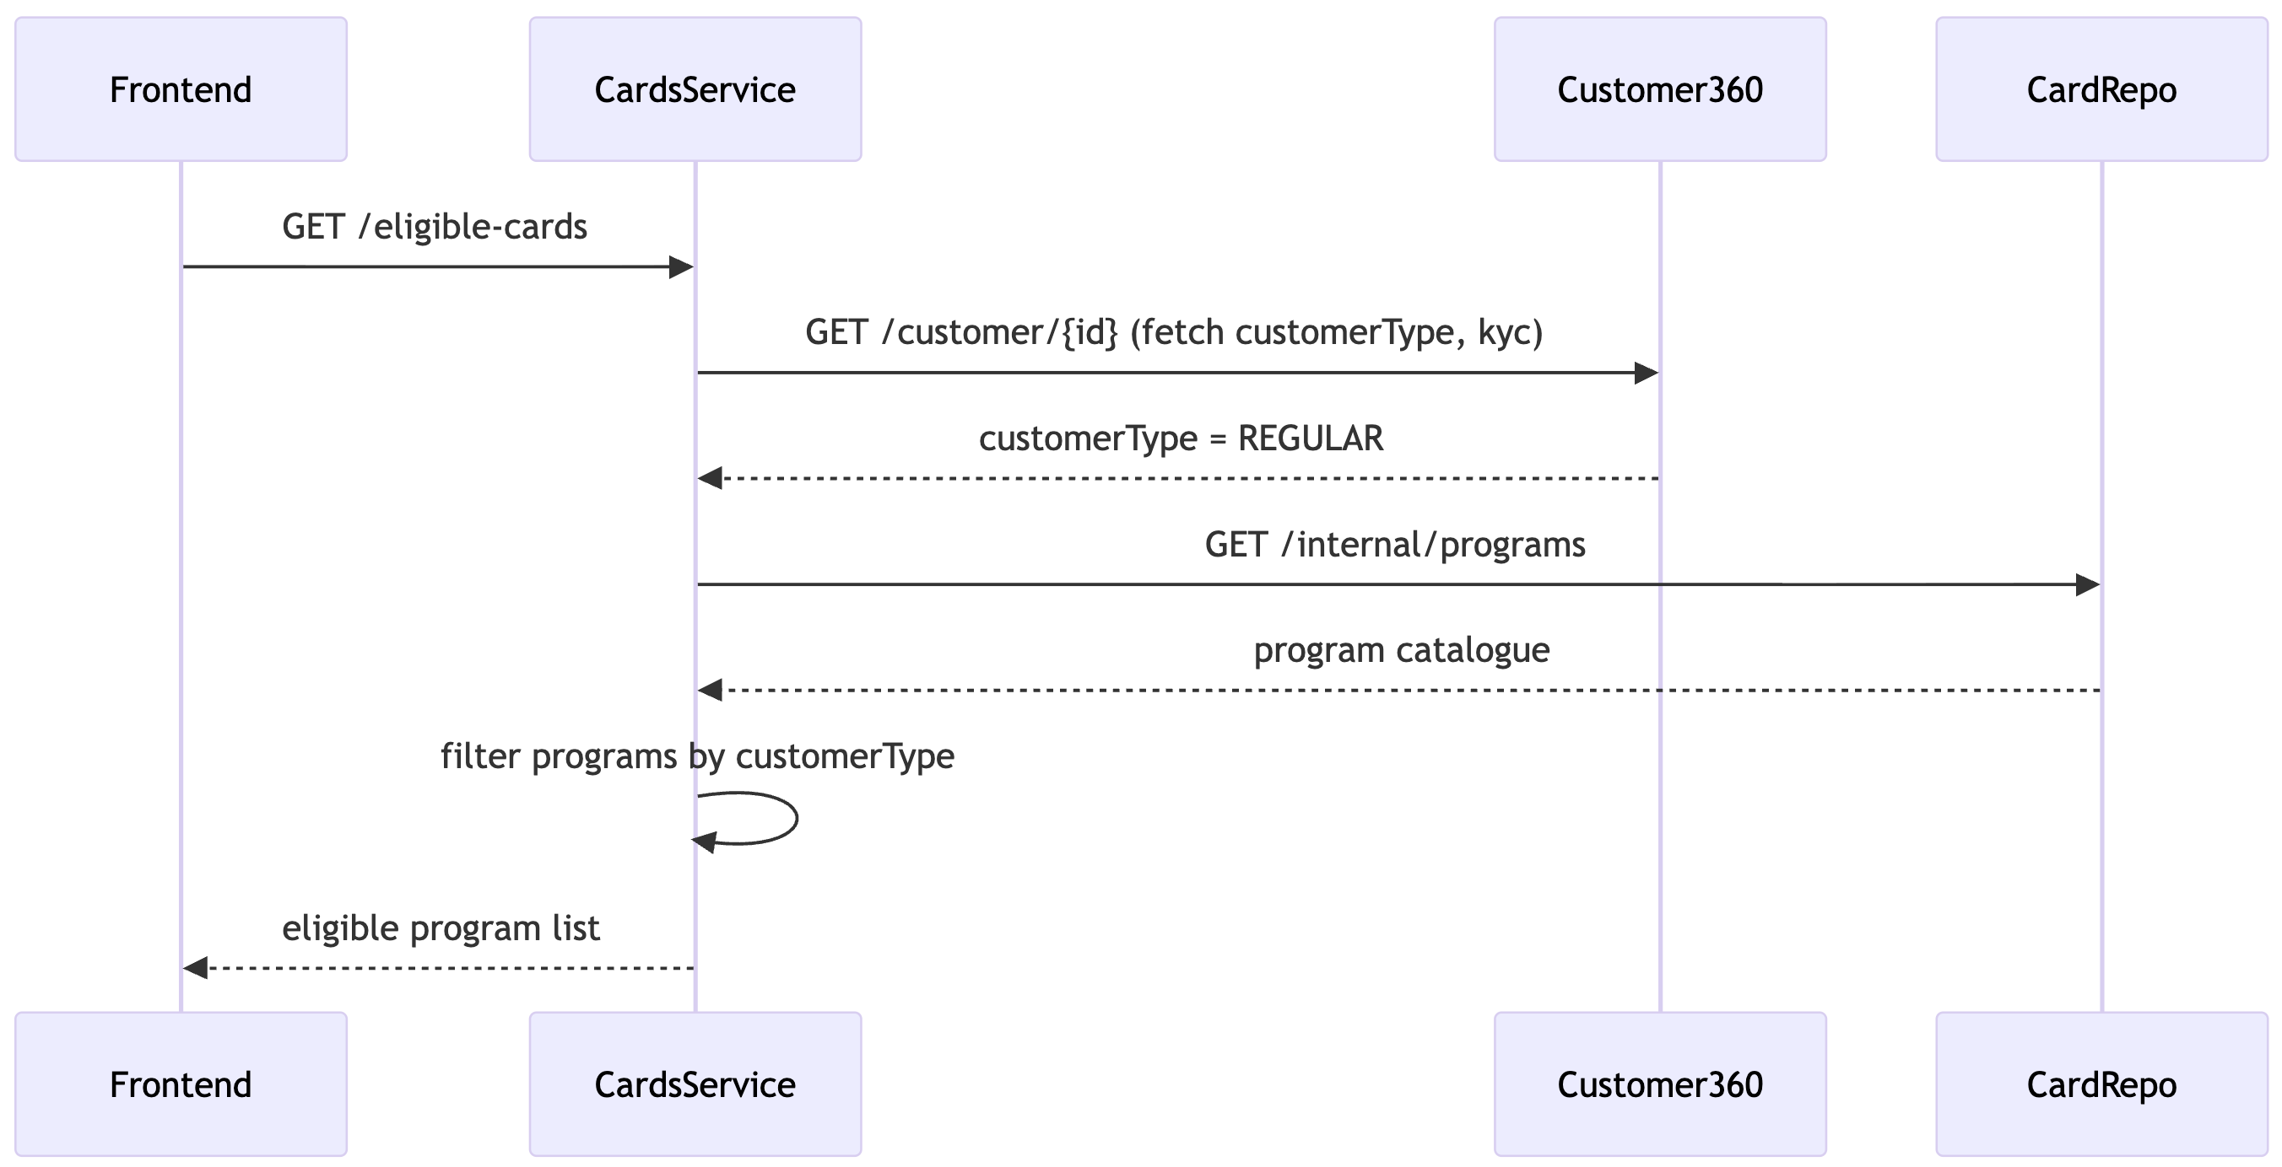
sequenceDiagram
participant App as Frontend
participant MS as CardsService
participant C360 as Customer360
participant CR as CardRepo
App->>MS: GET /eligible-cards
MS->>C360: GET /customer/{id} (fetch customerType, kyc)
C360-->>MS: customerType = REGULAR
MS->>CR: GET /internal/programs
CR-->>MS: program catalogue
MS->>MS: filter programs by customerType
MS-->>App: eligible program list

5. Non-Functional Requirements (Expanded)

Performance Requirements
- p95 latency < 200 ms for GET APIs
- p99 latency < 400 ms
- Internal CardRepo APIs should target p95 < 120 ms
- Kafka ingestion end-to-end < 500 ms
- Redis cache hit rate target > 85%

Reliability Requirements
- 99.95% service availability
- DLQ handling for ingestion failures
- Automatic consumer recovery

Capacity & Throughput
- Kafka ingestion up to 50,000 events per minute
- Frontend read APIs up to 10,000 requests per minute
- System should scale up to 5× peak loads

C360 Sync SLA
- All updates must be propagated to C360 within 5 seconds
- Retry intervals: 1 sec → 2 sec → 4 sec
- After failures, card marked as syncPending

Scalability
- Horizontal autoscaling for all microservices
- Read replicas for DB-offloaded reads
- Redis caching for high concurrency scenarios
- Multi-AZ deployment across all critical systems

Observability Requirements
- Mandatory requestId propagation
- Metrics: p50/p90/p95/p99, Kafka lag, DB query latency
- Redis hit/miss ratio monitoring
- Structured JSON logs (GROK parsable)

Resilience Requirements
- Circuit breakers for C360 and DB interactions
- Retry strategies with exponential backoff
- Graceful degradation when dependencies fail
- Stale reads allowed only for non-sensitive cases

Backup & Recovery Requirements
- Daily full backups
- PITR (Point-In-Time Recovery) enabled
- Redis snapshot every 5 minutes

6. Data Storage Model (Expanded)

Primary Database
- PostgreSQL (preferred) or MySQL
- JSONB for raw CMS payloads
- Write-optimized schema with proper indexing

Card Table (Logical Schema)
Column Name | Description
tokenRef | Primary unique reference for card
maskedCardNumber | Masked card number (only last4 visible)
last4 | Last four digits
programCode | Card program SKU
programCategory | Standard / Corporate / Prepaid
network | RuPay / Visa / Mastercard
bin | Issuer BIN
lifecycleStatus | Normalized lifecycle state
rawStatus | Status as received from CMS
customerMobileNumber | Customer mobile
custId | Core banking customer ID
accountNo | Account reference
issuedBySystem | Source CMS or issuer
issuanceChannel | Branch / Digital etc.
eventTimestamp | Event time from CMS
createdAt | Insert timestamp
updatedAt | Last update timestamp
syncPending | C360 synchronization status
auditPayload (JSONB) | Raw CMS event snapshot

Indexing Strategy
- Primary index: tokenRef
- Secondary indexes:
  - customerMobileNumber
  - last4
  - lifecycleStatus
  - programCode
  - eventTimestamp

Redis Caching
- cards:{mobile} → TTL = 120 seconds
- eligibility:{customerType} → TTL = 1 hour
- programs:{type} → TTL = 6 hours
- Invalidate customer card cache on any update

Data Retention
- Card data retained for card lifetime + 7 years
- Closed cards archived after 2 years

7. Integration APIs (Summary)

Internal APIs (mTLS-secured)
- GET /internal/cards?mobile={mobile}
- GET /internal/programs
- POST /internal/cards/ingest
- POST /internal/cards/status
- POST /internal/cards/permissions

Public APIs (via Cards Microservice)
- GET /cards
- GET /eligible-cards

API Security
- Internal → mTLS + IAM role-based access
- External → OAuth 2.0 / JWT tokens

8. Operational Runbooks (Expanded)

DLQ Handling
- DLQ size breach triggers alert
- Engineer inspects event metadata
- Repairable events → corrected + re-published
- Unrecoverable events → archived with reason + CMS notified

Sync Reconciliation
- Reconciliation job runs every 10 minutes
- Processes 200–500 pending records per batch
- Manual re-sync: POST /admin/cards/{tokenRef}/resync
- Dashboards monitor retry counts and syncPending backlog

CMS Onboarding Process
- JSON schema registration
- Contract testing (Pact/Postman)
- Canary ingestion into shadow tables (24–48 hrs)
- DLQ/mapping validation
- Gradual rollout to full ingestion

9. Security & Compliance (Expanded)

Card Number Handling
- Only masked card numbers stored
- No PAN exists inside CardRepo
- tokenRef must be non-reversible

Logging Standards
- Never log PAN, tokenRef, or sensitive identifiers
- Only last4 is allowed
- GROK-parseable structured JSON
- requestId mandatory

Audit Requirements
- All ingestion, updates, lifecycle changes, permission changes, and sync attempts logged
- Minimum audit retention: 7 years (WORM storage recommended)

Access Control
- Internal APIs: mTLS + IAM allowlist
- Public APIs: OAuth2/JWT
- Admin operations require RBAC + SSO approval

Threat Model Mitigation
- Replay protection via timestamp ordering
- Brute-force prevention with IP/user rate limiting
- Scraping detection with behavioral analytics

.

