AMBASSADOR INTERNATIONAL ACADEMY, DUBAI
Criterion A: Inquiring & Analysing — Student Summative Answer Booklet
Grade 9 · Design a Solution for a Community Problem
Name: | Teacher exemplar | Class: | Grade 9
Date: | 21 October 2026 | Unit: | Climate Action · SDG 13 · CA4

Teacher exemplar: the client and school are fictional; every statistic and product fact is from the cited sources (MLA 9, accessed 21 Oct. 2026). The three product images are the author's own labelled illustrations based on the cited sources; a student should replace them with a cited photo. Yellow highlighting marks where a student must add their own data.
📋 HOW TO SUBMIT: Type your answers directly into this document — this is your Criterion A summative submission. Complete Sections A1 to A4 in full sentences / paragraphs (unless a table is provided). Save your work as you go and submit via Google Classroom → Unit 1 → Criterion A → "My Criterion A Document".
A1 Design Need
Identify and explain the problem faced by your client and community.
📄 Write one continuous essay of connected paragraphs (250–400 words) about the PROBLEM, not about a solution. Explain who the client is and what they need, who is affected, why a solution is needed, and use images and statistics to show the problem is real. You may add a mind map to organise your ideas. Cite every source in MLA 9.
My client is the Marine Science Club of a Dubai school, represented by its teacher adviser. The club studies the coast near the school and wants to protect local coral. Its members have heard that warm summer seawater is damaging reefs in the Gulf, and the club needs the temperature of the water to be known and tracked so that warning signs of heat damage can be recognised early.
The people most affected are the corals and the reef animals that depend on them, because they cannot move away from warm water. Fishers and divers are a second group, because reefs support fish and tourism. Coastal communities are a third group, because reefs help to protect shorelines and are part of the UAE's natural heritage.
The need is real because the loss has already been large. Gulf News reported that more than 73% of the UAE's coral reefs were lost to the worst recorded bleaching, an event that followed over five weeks of low wind, with bleaching stretching about 200 km (Kumar). Khaleej Times reports that the Arabian Gulf is the warmest sea on Earth in summer, and that marine heatwaves occur when the Shamal winds weaken (Sircar). The first report is from 2018 and neither article gives temperature readings, so I need to measure the water near my school myself.
Figure 1 summarises the key numbers. The 2018 article is old and describes the whole UAE coast, so I treat it as a pattern and not as the state of one reef today. In my own words: coral cannot run away from heat, so people have to notice it for them. Figure 2 is my mind map of the problem.
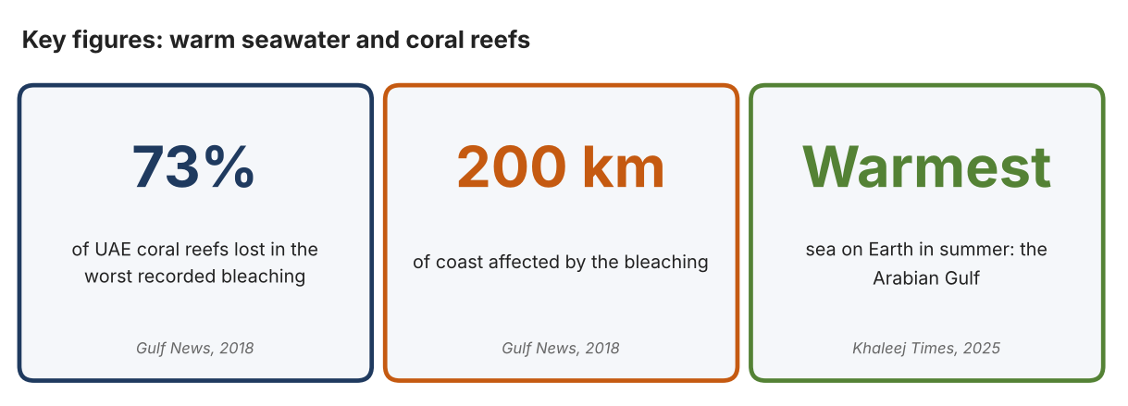
Fig. 1. Key figures on coral and sea heat. Data: Kumar, Anjana, “Worst-Recorded Bleaching Wipes out 73 per Cent of UAE's Coral Reefs,” Gulf News, 2018; Sircar, Nandini, Khaleej Times, 2025. Graphic by the author.
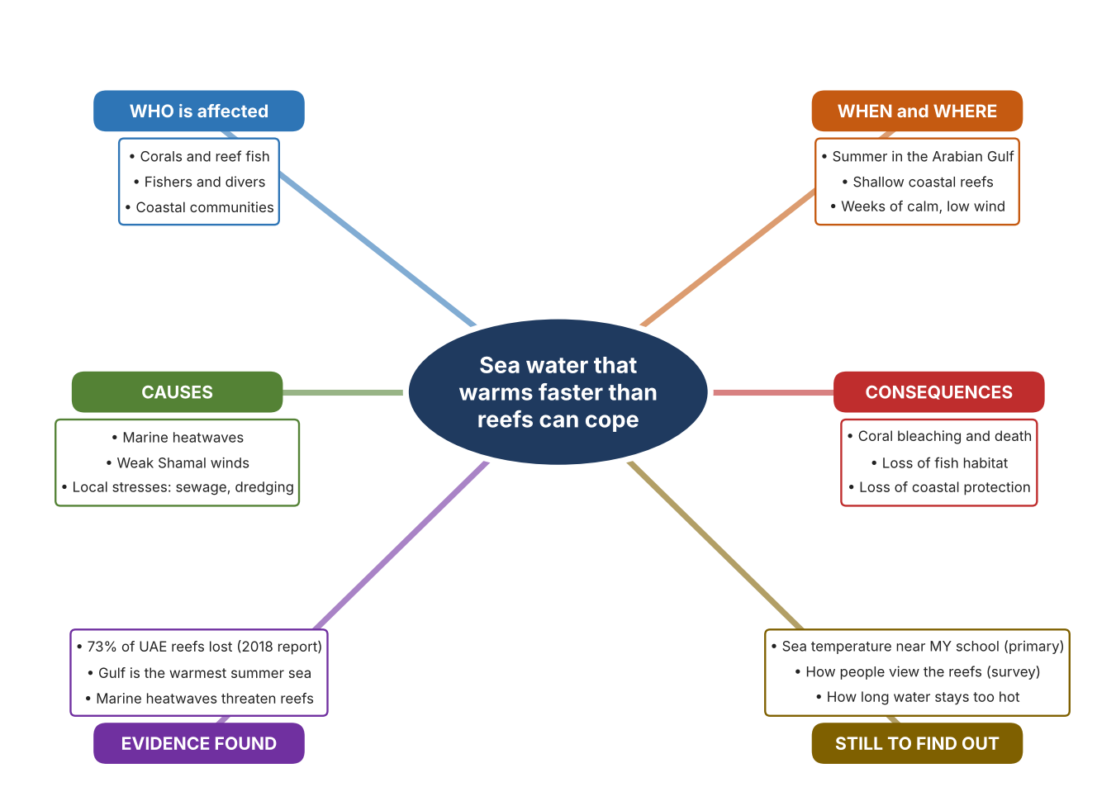
Fig. 2. Mind map of the problem. Sources are listed in Appendix A. Mind map by the author.
Target: 250–400 words across all four answers.

A2 Research Plan
Plan and record the research behind the problem you defined in A1.
📄 You need 6 research questions in total for your topic — a mix of Factual, Conceptual and Debatable questions (include at least one of each type). Complete every column for each question.
# | Question | Priority | Research Type (Primary or Secondary) | Research Link or Evidence | Brief Answer
1 | Factual: How much of the UAE's coral was lost in the worst recorded bleaching, and what led to it? | High | Secondary | Gulf News, 29 Oct. 2018 (Appendix A, Source 1) | More than 73% of reefs were lost; over five weeks of low wind and rising temperatures in almost every year of the previous decade contributed; local stresses added to it.
2 | Factual: Why is the Arabian Gulf so hot in summer, and what does that threaten? | High | Secondary | Khaleej Times, 29 Dec. 2025 (Appendix A, Source 2) | It is the warmest sea on Earth in summer; marine heatwaves occur when Shamal winds weaken and the monsoon strengthens, threatening reefs and fisheries.
3 | Conceptual: How is water temperature measured, and how can heat stress on coral be tracked from space? | Medium | Secondary | HOBO page (Source 3); NOAA page (Source 5) | A waterproof logger records temperature at intervals; satellites compute sea-surface temperature, hot spots and degree heating weeks every day on a 5 km grid.
4 | Debatable: Should reef heat be tracked by a logger in the water, by a hand probe, or by satellite data? | Medium | Secondary | Appendix A, Sources 3, 4 and 5 | Loggers record all day at one spot; a hand probe is cheap but gives only a moment; satellites cover wide areas but at 5 km resolution. My view: local readings matter for one reef.
5 | Debatable (challenges my assumption, UAE source): Coral reefs are far from schools, so is this really a problem for a school community? | High | Secondary | Gulf News, 2018 (Source 1); Khaleej Times, 2025 (Source 2) | The loss spans about 200 km of coast, and the same heat affects fisheries. It is a coastal problem that reaches fish, food and tourism, but I need local readings to see how it applies near my school.
6 | Factual (primary): What is the temperature of the sea water or of a school pool or tank at different times of day, and how do people feel about the reef? | High | Primary | Own temperature log and survey (Appendix A, Sources 6 and 7) | [Student data needed: write the temperature readings (with date, time and place) and survey averages, then two sentences on the pattern you see.]
Extension: make one of your debatable questions challenge your own design assumption, with a named UAE-specific source.

A3 Existing Products Analysis
Analyse 3 existing products or solutions that are significantly different from each other.
📄 Describe 3 existing products or solutions. For each, include an image (cited MLA 9), analyse against at least 4 ACCESS FM strands using specific cited evidence, and give a pro and a con.
Product names (and pasted image/screenshot for each — cite with MLA9):
Product 1 | Product 2 | Product 3
Product 1: Pendant water-temperature logger (HOBO MX2201)  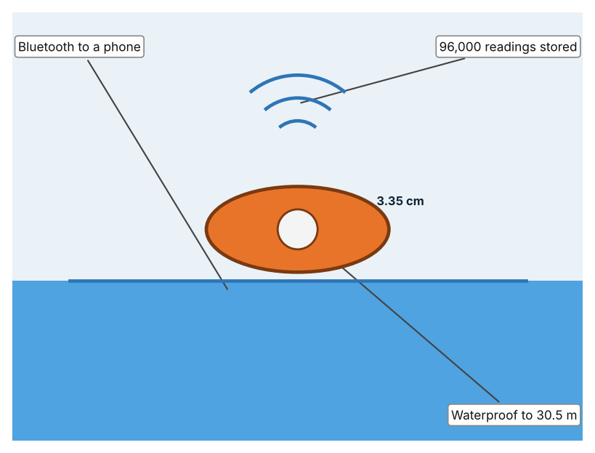  Illustration by the author based on the HOBO MX2201 page, RS Hydro (Appendix A, Source 3).  [Student: replace with a photo from the source, cited MLA 9] | Product 2: Hand-held probe thermometer (Hanna Checktemp HI98501)  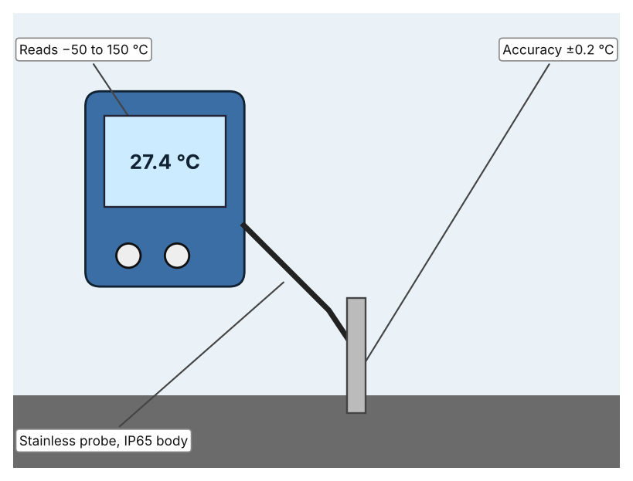  Illustration by the author based on “HI98501,” Poly (Appendix A, Source 4).  [Student: replace with a photo from the source, cited MLA 9] | Product 3: Satellite heat-stress maps (NOAA Coral Reef Watch)  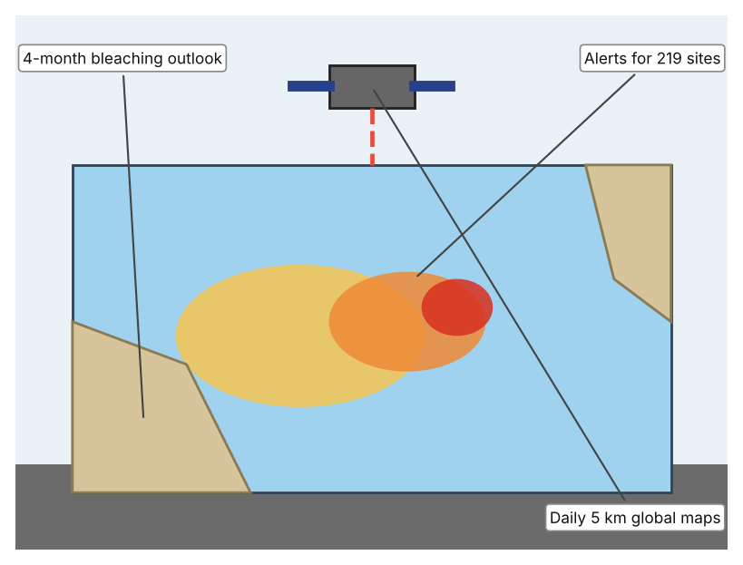  Illustration by the author based on “Coral Reef Watch Products,” NOAA (Appendix A, Source 5).  [Student: replace with a photo from the source, cited MLA 9]
ACCESS FM analysis — analyse at least 4 strands per product with specific, cited evidence:
ACCESS FM | Product 1 | Product 2 | Product 3
Aesthetics | Small pendant logger, 3.35 × 5.64 × 1.8 cm; looks are not described (RS Hydro). | Hand-held thermometer with a stainless probe; styling is not described (Poly). | Online maps and charts; design is not described (NOAA).
Cost | Price not listed (RS Hydro). | Price on request (Poly). | Cost terms are not stated (NOAA).
Customer | Scientists and monitoring teams who need a record in the water. | Anyone who needs a spot reading, such as a technician. | Reef managers and the public who need regional heat warnings.
Environment | CR2032 battery lasts about 1 year with Bluetooth on and 2 years with it off. | CR2032 battery; the page gives about 2,000 hours (and elsewhere 3,000 hours). | No device needed; satellite data are shared online.
Size | 12.75 g. | Body 70.4 × 50.5 × 22 mm and 51.3 g; probe 106 mm long. | Data cover the whole globe.
Safety | Waterproof to 30.5 m; low-voltage coin battery. | IP65 body; probe is not rated for immersion in the page text. | No physical risk.
Function | Records ±0.5 °C (resolution 0.04 °C) in water from −20 to 50 °C and sends data by Bluetooth LE. | Reads −50 to 150 °C with ±0.2 °C accuracy (−30 to 120 °C). | Maps of sea-surface temperature, anomaly and degree heating weeks every day; email alerts for 219 virtual stations.
Materials | Materials are not stated. | Stainless steel probe (Poly). | Not applicable.
Pros & Cons:
 | Product 1 | Product 2 | Product 3
Pro | Records day and night for a year or more and is waterproof. | Cheap, quick and accurate for a spot check. | Covers every reef in the world and gives warnings.
Con | Needs a phone or computer to read the data and only measures one place. | Gives one reading at one moment, so rises at night can be missed. | Resolution is 5 km, so it cannot show one small reef or tank.
Extension: analyse all 8 ACCESS FM strands per product, and evaluate each from the pedestrian/bystander's perspective, not just the buyer's.

A4 Design Brief + Appendix A
Bring A1–A3 together into one design brief, then compile your Appendix A.
📄 Write your design brief in PARAGRAPH FORM. Your brief must:
• Restate the client's need (from A1)
• Reference your research with sources (from A2)
• Summarise your A3 existing-products analysis for inspiration
• State your design intent, justified by the evidence you gathered
Write your design brief here (paragraph form):
My client, the Marine Science Club of a Dubai school, needs the temperature of coastal water to be known and tracked so that heat damage to coral can be spotted early. The problem is serious: more than 73% of the UAE's coral reefs were lost in the worst recorded bleaching, which stretched about 200 km (Appendix A, Source 1). The Gulf is the warmest sea on Earth in summer, and marine heatwaves threaten reefs and fisheries (Appendix A, Source 2).
My research shows that heat stress builds when calm, hot weather lasts for weeks, so a single reading is not enough (Appendix A, Sources 1 and 2). Neither news article gives temperature readings, so I need my own evidence. My debatable questions led me to decide that loggers, probes and satellites each cover only part of the problem, and my challenged assumption (that reefs are too far from a school to matter) showed me that the issue touches fish, food and coastal life. I will gather my own evidence with the temperature log and the survey, always with permission (Appendix A, Sources 6 and 7).
I analysed three very different existing solutions. A pendant logger records temperature in water for up to two years on a coin battery, but it measures only one spot and needs a phone to read the data (Appendix A, Source 3). A hand-held probe is accurate to ±0.2 °C and cheap to use, but it gives only a single moment (Appendix A, Source 4). Satellite heat-stress maps cover the globe daily, but at 5 km resolution they cannot show one small reef (Appendix A, Source 5). They give me three ideas for inspiration: continuous recording, quick checks, and wide-area warnings. Each has a weakness that another covers.
My design intent is therefore to create a solution that measures water temperature at a chosen place over time and shows when it becomes unsafe for marine life. It must be affordable for a school, simple to read, waterproof and safe to handle. I have deliberately not fixed what form it will take. That decision will be made in Criterion B, after I analyse my own log and survey against the evidence in Appendix A.
Target: 350–600 words. Extension: explicitly reference Appendix A within your brief (e.g. "see Appendix A, Source 2").
APPENDIX A
Paste in your full A2 research notes and sources here (Appendix A). Reference this appendix explicitly within your design brief above.
# | Source (MLA 9) | Key notes | How I used it
1 | Kumar, Anjana. “Worst-Recorded Bleaching Wipes out 73 per Cent of UAE's Coral Reefs.” Gulf News, 29 Oct. 2018, gulfnews.com/amp/story/uae%2Fweather%2Fworst-recorded-bleaching-wipes-out-73-per-cent-of-uaes-coral-reefs-1.2295261. Accessed 21 Oct. 2026. | More than 73% of reefs lost (NYU Abu Dhabi with the Emirates Environmental Agency); over five weeks of low wind; temperatures rose almost every year; local stresses; bleaching stretched about 200 km. Source is from 2018. | A1; A2 Q1 and Q5; A4.
2 | Sircar, Nandini. “UAE Scientists Discover Cause of Extreme Summer Heat in Arabian Gulf.” Khaleej Times, 29 Dec. 2025, www.khaleejtimes.com/uae/environment/uae-research-extreme-heat-arabian-gulf. Accessed 21 Oct. 2026. | Gulf is the warmest sea on Earth in summer; marine heatwaves when Shamal winds weaken and the monsoon strengthens; threatens reefs and fisheries; no temperature readings given. | A1; A2 Q2 and Q5; A4.
3 | “HOBO MX2201 Pendant Temperature Data Logger.” RS Hydro, rshydro.co.uk/water-quality-monitoring-equipment/water-quality-monitoring-parameters/measuring-water-temperature/mx2201/. Accessed 21 Oct. 2026. | ±0.5 °C, 0.04 °C resolution; in water −20 to 50 °C; CR2032 1 year (Bluetooth on) or 2 years (off); 96,000 readings; waterproof to 30.5 m; 3.35 × 5.64 × 1.8 cm; 12.75 g; price not listed. | A2 Q3 and Q4; A3 Product 1; A4.
4 | “HI98501.” Poly, poly.my/product/hi98501/. Accessed 21 Oct. 2026. | −50 to 150 °C; ±0.2 °C (−30 to 120 °C); IP65; CR2032, about 2,000 h; probe 106 mm; body 70.4 × 50.5 × 22 mm, 51.3 g; price on request. | A2 Q4; A3 Product 2; A4.
5 | “Coral Reef Watch Products.” NOAA, updated 15 Sept. 2023, coralreefwatch.noaa.gov/product. Accessed 21 Oct. 2026. | Daily global 5 km heat-stress products (SST, anomaly, HotSpot, Degree Heating Week); virtual stations with email alerts (219 sites); 4-month bleaching outlook; cost terms not stated. | A2 Q3 and Q4; A3 Product 3; A4.
6 | Own primary research: observation sheet (below). | Student measures temperature of seawater, a pool or a tank at set times, with permission and a teacher present. | A2 primary question; A4.
7 | Own primary research: short student survey (below). | Student asks at least 20 people and records the ratings. | A2 primary question; A4.
Source 6: water temperature log (blank instrument; student data needed)
Place | Date and time | Water temp (°C) | Air temp (°C) | Depth (cm) | Notes
Morning
Midday
Afternoon
Evening
Source 7: student survey (blank instrument; rate each statement from 1 = strongly disagree to 5 = strongly agree; student data needed)
Statement | 1 | 2 | 3 | 4 | 5
I know that warm sea water can harm coral.
I have seen coral or reefs near the UAE coast.
It is important to measure sea temperature near us.
I would be interested in a warning when water becomes too hot.
Total responses (tally)

✓ FINAL CHECKLIST — Tick Before Submitting
Review your complete Criterion A document against every point below.
☑ A1: client, need, target audience, why, one image + one statistic (evidence)
☑ A2: factual / conceptual / debatable questions — each prioritised, sourced, evidenced
☑ A3: 3 significantly different products, screenshots, ACCESS FM analysis, pros/cons
☑ A4: need restated, research referenced, Appendix A attached AND referenced, existing-products summary included
☑ All four sections written in full paragraphs — no bullet points
☑ Document proofread before final submission

