AMBASSADOR INTERNATIONAL ACADEMY, DUBAI
Criterion A: Inquiring & Analysing — Student Summative Answer Booklet
Grade 9 · Design a Solution for a Community Problem
Name: | Teacher exemplar | Class: | Grade 9
Date: | 21 October 2026 | Unit: | Good Health · SDG 3 · GH4

Teacher exemplar: the client and school are fictional; every statistic and product fact is from the cited sources (MLA 9, accessed 21 Oct. 2026). The three product images are the author's own labelled illustrations based on the cited sources; a student should replace them with a cited photo. Yellow highlighting marks where a student must add their own data.
📋 HOW TO SUBMIT: Type your answers directly into this document — this is your Criterion A summative submission. Complete Sections A1 to A4 in full sentences / paragraphs (unless a table is provided). Save your work as you go and submit via Google Classroom → Unit 1 → Criterion A → "My Criterion A Document".
A1 Design Need
Identify and explain the problem faced by your client and community.
📄 Write one continuous essay of connected paragraphs (250–400 words) about the PROBLEM, not about a solution. Explain who the client is and what they need, who is affected, why a solution is needed, and use images and statistics to show the problem is real. You may add a mind map to organise your ideas. Cite every source in MLA 9.
My client is the First Aid and Sports Safety Team of a Dubai school, represented by the school nurse. The team supports students who train and compete in school sport, and it wants to be sure that serious heart problems are noticed early and that help arrives fast if a student collapses. It needs the risk to student athletes to be reduced by checking basic health signs before hard exercise, and by preparing for emergencies.
The people most affected are student athletes, because intense exercise can bring out a hidden heart condition. Coaches and PE staff are a second group, because they are the first adults present and must act. The nurse and trained first-aiders are a third group, because they respond when something goes wrong.
The need is real because sudden cardiac arrest does happen in young athletes. A four-year US study confirmed 331 cases between 2014 and 2018, with 173 deaths, and found an average age of 16.7; the authors say that health history and physical examination before taking part has not identified many at-risk athletes, and recommend emergency action plans with access to a defibrillator (Peterson et al.). In the UAE, the Ministry of Interior states that a defibrillator should be used within five minutes of a cardiac arrest, because survival chances fall with each minute (Ministry of Interior). The US study describes American athletes, so I do not yet know how this applies to my school.
Figure 1 summarises the key numbers. The US study is large but does not describe the UAE, so I treat it as a pattern and not as a prediction for my school. In my own words: the event is rare, but when it happens there is very little time, so preparation cannot wait. Figure 2 is my mind map of the problem.
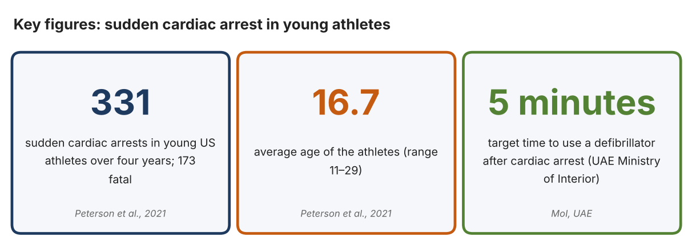
Fig. 1. Key figures on cardiac arrest in young athletes. Data: Peterson, Danielle F., et al., British Journal of Sports Medicine, 2021; Ministry of Interior, UAE. Graphic by the author.
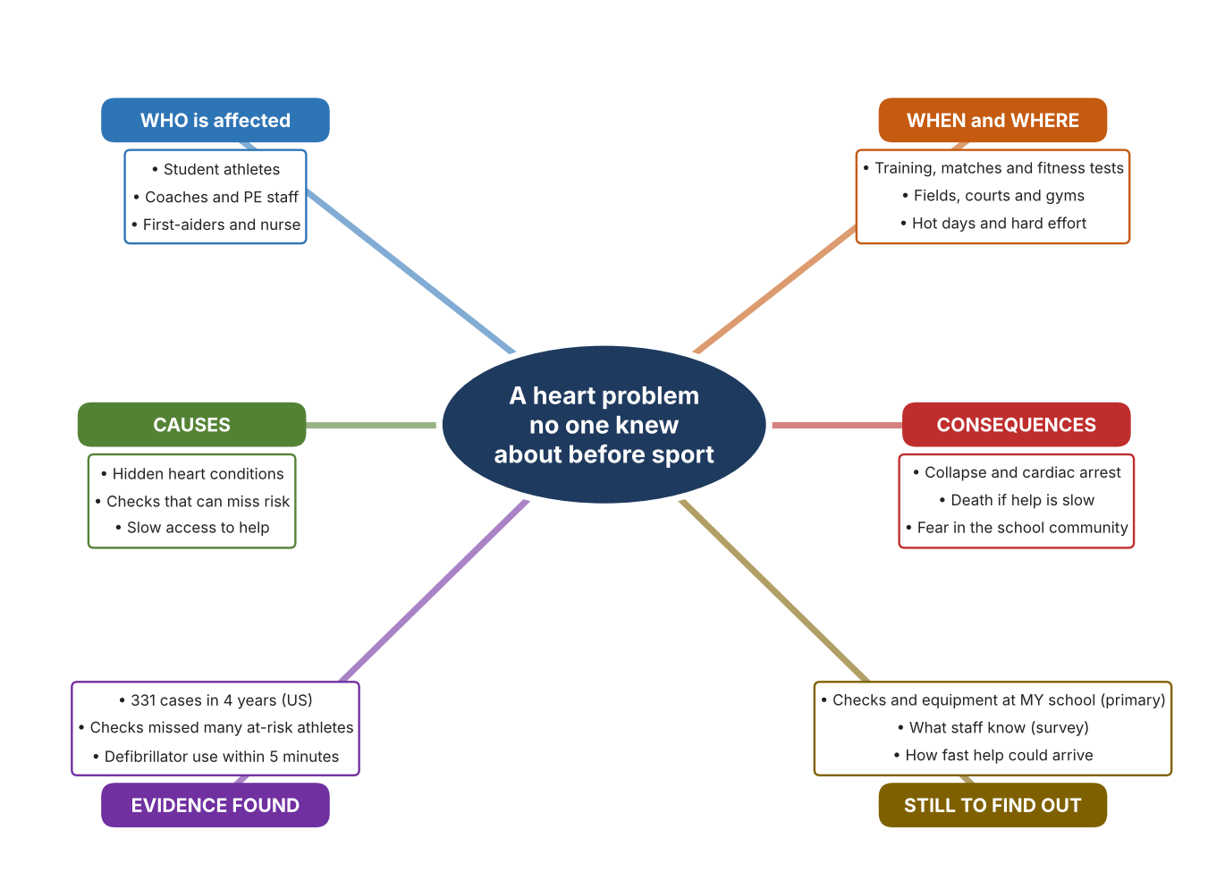
Fig. 2. Mind map of the problem. Sources are listed in Appendix A. Mind map by the author.
Target: 250–400 words across all four answers.

A2 Research Plan
Plan and record the research behind the problem you defined in A1.
📄 You need 6 research questions in total for your topic — a mix of Factual, Conceptual and Debatable questions (include at least one of each type). Complete every column for each question.
# | Question | Priority | Research Type (Primary or Secondary) | Research Link or Evidence | Brief Answer
1 | Factual: How many young athletes suffer sudden cardiac arrest, and how many survive? | High | Secondary | Peterson et al., 2021 (Appendix A, Source 1) | 331 confirmed cases in four years: 158 survivors and 173 deaths; average age 16.7; about 1 in 65,872 high-school athlete-years.
2 | Factual: What do UAE authorities say about response time and defibrillators? | High | Secondary | Gulf News, 26 Sept. 2019 (Source 2); Ministry of Interior (Source 3) | Dubai ambulance services aim for a 4-minute response, against an 8-minute international standard, and meet it in 40–50% of calls; the Ministry says to use a defibrillator within 5 minutes.
3 | Conceptual: What can be measured quickly before exercise, and what does a defibrillator do? | Medium | Secondary | Masimo page (Source 4); Polar page (Source 5); Philips page (Source 6) | Oxygen saturation and pulse can be read from a finger in seconds; a chest strap reads heart rhythm electrically; a defibrillator gives voice-guided instructions and a shock.
4 | Debatable: Should schools rely on health checks before exercise, on monitoring during exercise, or on rapid emergency equipment? | Medium | Secondary | Appendix A, Sources 1, 4, 5 and 6 | Checks can miss hidden risk, monitoring shows warning signs but cannot diagnose, and equipment saves lives only after a collapse. My view: all three are needed.
5 | Debatable (challenges my assumption, UAE source): Cardiac arrest in young athletes is so rare that a school does not need to prepare. | High | Secondary | Ministry of Interior (Source 3); Gulf News, 2019 (Source 2) | The US study counted 331 cases in four years. UAE authorities stress a 5-minute target and 4-minute ambulance goals met in only 40–50% of calls, so rare events still need preparation. I found no UAE school data.
6 | Factual (primary): What checks, equipment and trained staff does our school have for emergencies, and what do staff know about them? | High | Primary | Own preparedness checklist and staff survey (Appendix A, Sources 7 and 8) | [Student data needed: write the checklist results (with permission from the school) and survey averages, then two sentences on the pattern you see.]
Extension: make one of your debatable questions challenge your own design assumption, with a named UAE-specific source.

A3 Existing Products Analysis
Analyse 3 existing products or solutions that are significantly different from each other.
📄 Describe 3 existing products or solutions. For each, include an image (cited MLA 9), analyse against at least 4 ACCESS FM strands using specific cited evidence, and give a pro and a con.
Product names (and pasted image/screenshot for each — cite with MLA9):
Product 1 | Product 2 | Product 3
Product 1: Fingertip pulse oximeter (Masimo MightySat Rx)  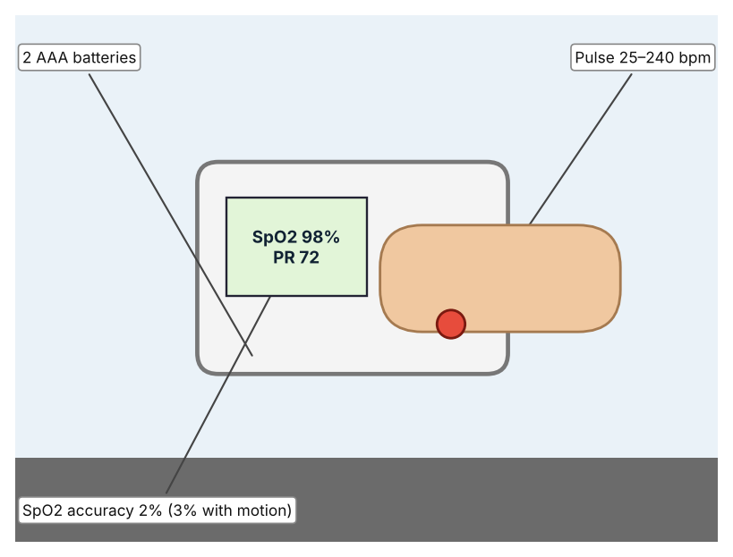  Illustration by the author based on the Masimo MightySat specifications, Medaval (Appendix A, Source 4).  [Student: replace with a photo from the source, cited MLA 9] | Product 2: Chest-strap heart-rate sensor (Polar H10)  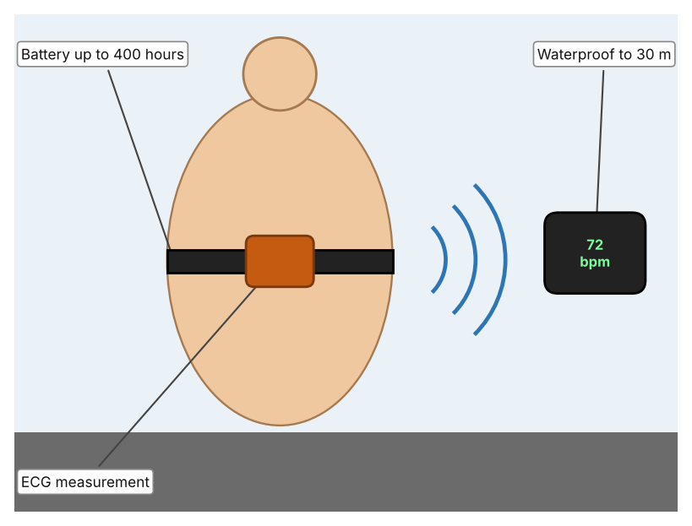  Illustration by the author based on the Polar H10 page, Polar (Appendix A, Source 5).  [Student: replace with a photo from the source, cited MLA 9] | Product 3: Defibrillator (Philips HeartStart FRx)  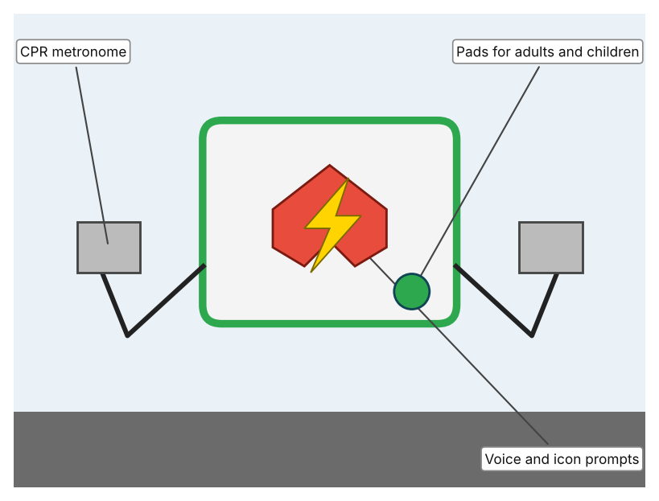  Illustration by the author based on the HeartStart FRx page, Philips Heartstream (Appendix A, Source 6).  [Student: replace with a photo from the source, cited MLA 9]
ACCESS FM analysis — analyse at least 4 strands per product with specific, cited evidence:
ACCESS FM | Product 1 | Product 2 | Product 3
Aesthetics | Small clip-on device; looks are not described (Medaval). | Chest strap with a pod; styling is not described (Polar). | Portable case; green On/Off button and orange Shock button (Philips).
Cost | Price not stated (Medaval). | R 2,299 on the South African Polar page. | Price not stated (Philips).
Customer | Clinicians and coaches who need a quick check. | Athletes and coaches who need exact heart data. | Lay rescuers with basic training.
Environment | Two AAA batteries give about 1,800 spot checks. | CR2025 coin cell lasts up to 400 hours; non-rechargeable. | Disposable battery with a five-year shelf life and about four years installed (page for the related battery).
Size | 7.4 × 4.1 × 3.0 cm; 73 g. | 60 g (21 g without the strap). | Size and weight not stated.
Safety | Reads SpO2 and pulse only; not a diagnostic device. | Waterproof to 30 m (WR30). | Daily self-tests check the pads and circuit; the page does not give an IP rating.
Function | Measures SpO2 0–100% and pulse 25–240 bpm; Bluetooth on some models. | Measures electrical heart signal; Bluetooth LE and ANT+ with 90 m range; memory for one session of 30 hours. | Gives voice instructions and CPR guidance and delivers a shock when advised.
Materials | Materials are not stated. | Strap and pod; materials are not stated. | Materials are not stated.
Pros & Cons:
 | Product 1 | Product 2 | Product 3
Pro | Fast, small and shows oxygen and pulse in seconds. | Gives heart-signal data during exercise and has a long battery life. | Is the only item here that treats a cardiac arrest.
Con | Does not show heart rhythm and does not warn during exercise. | Costs R 2,299 and does not treat or diagnose. | Only helps after a collapse and the page does not give size, weight or price.
Extension: analyse all 8 ACCESS FM strands per product, and evaluate each from the pedestrian/bystander's perspective, not just the buyer's.

A4 Design Brief + Appendix A
Bring A1–A3 together into one design brief, then compile your Appendix A.
📄 Write your design brief in PARAGRAPH FORM. Your brief must:
• Restate the client's need (from A1)
• Reference your research with sources (from A2)
• Summarise your A3 existing-products analysis for inspiration
• State your design intent, justified by the evidence you gathered
Write your design brief here (paragraph form):
My client, the First Aid and Sports Safety Team of a Dubai school, needs the risk to student athletes to be reduced through basic health checks before hard exercise and preparation for emergencies. The problem is real: a four-year US study confirmed 331 sudden cardiac arrests in young athletes, 173 of them fatal, with an average age of 16.7 (Appendix A, Source 1). UAE authorities state that a defibrillator should be used within five minutes (Appendix A, Source 3).
My research shows that checks before exercise do not identify every at-risk athlete, so planning for an emergency matters (Appendix A, Source 1). UAE ambulance services aim for a 4-minute response and meet it in about 40 to 50% of calls (Appendix A, Source 2). My debatable questions led me to decide that checks, monitoring and emergency equipment each cover only part of the problem, and my challenged assumption (that the event is too rare to prepare for) showed me that rarity does not remove the need. I will gather my own evidence with the preparedness checklist and the survey, always with permission (Appendix A, Sources 7 and 8).
I analysed three very different existing solutions. A fingertip oximeter reads oxygen and pulse in seconds, but it is not a diagnostic tool (Appendix A, Source 4). A chest-strap sensor records the heart's electrical signal for up to 400 hours on a battery, but it costs R 2,299 and does not treat anything (Appendix A, Source 5). A defibrillator guides a rescuer with voice prompts and delivers a shock, but it helps only after a collapse (Appendix A, Source 6). They give me three ideas for inspiration: a quick check, monitoring during effort, and emergency treatment. Each has a weakness that another covers.
My design intent is therefore to create a solution that measures simple health signs before and during exercise and helps staff recognise when a student should stop and get help. It must be affordable, easy for non-medical staff to use, safe and respectful of student privacy, and reliable in a busy sports setting. I have deliberately not fixed what form it will take. That decision will be made in Criterion B, after I analyse my own checklist and survey against the evidence in Appendix A.
Target: 350–600 words. Extension: explicitly reference Appendix A within your brief (e.g. "see Appendix A, Source 2").
APPENDIX A
Paste in your full A2 research notes and sources here (Appendix A). Reference this appendix explicitly within your design brief above.
# | Source (MLA 9) | Key notes | How I used it
1 | Peterson, Danielle F., et al. “Aetiology and Incidence of Sudden Cardiac Arrest and Death in Young Competitive Athletes in the USA: A 4-Year Prospective Study.” British Journal of Sports Medicine, vol. 55, no. 21, 2021, pp. 1196–1203, pmc.ncbi.nlm.nih.gov/articles/PMC8551972. Accessed 21 Oct. 2026. | 331 confirmed cases, July 2014–June 2018: 158 survivors, 173 deaths; mean age 16.7 (11–29); 61.6% high school; about 1 in 65,872 athlete-years in high school; the pre-participation history and examination inadequately identified at-risk athletes; recommends emergency action plans with AED access. US data. | A1; A2 Q1, Q4; A4.
2 | Saseendran, Sajila. “Dubai Gives out Life-Saving Device to Revive Cardiac Patients.” Gulf News, 26 Sept. 2019, gulfnews.com/uae/dubai-gives-out-life-saving-device-to-revive-cardiac-patients-1.66701952. Accessed 21 Oct. 2026. | Dubai Corporation for Ambulance Services planned 80 AEDs by the end of 2019; aims for 4-minute response against an 8-minute standard, met in 40–50% of calls; no cardiac arrest figures given. Source is from 2019. | A2 Q2 and Q5; A4.
3 | Ministry of Interior. “MoI to Install Automated External Defibrillators (AED) in Public Places.” Abu Dhabi Police, www.adpolice.gov.ae/en/Media-Center/News/2021/06/30/MoI-to-install-Automated-External-Defibrillators--AED--in-public-places. Accessed 21 Oct. 2026. | First AED at Marina Mall; defibrillators credited with reducing cardiac-arrest mortality from over 90% to under 30%; use within five minutes. The page body is dated 2013 while the address shows 2021, so the date is uncertain. | A1; A2 Q2 and Q5; A4.
4 | “Masimo MightySat Rx Specifications.” Medaval, www.medaval.ie/docs/specs/Masimo-MightySat-Specs.pdf. Accessed 21 Oct. 2026. | SpO2 0–100%, 2% accuracy (3% with motion); pulse 25–240 bpm, 3 bpm (5 with motion); 2 AAA, about 1,800 spot checks; 7.4 × 4.1 × 3.0 cm; 73 g; price not stated. | A2 Q3 and Q4; A3 Product 1; A4.
5 | “Polar H10 Heart Rate Sensor.” Polar South Africa, www.polar.com/za/products/accessories/H10_heart_rate_sensor. Accessed 21 Oct. 2026. | ECG; CR2025 battery up to 400 h; WR30; Bluetooth LE and ANT+, 90 m; memory one 30-hour session; 60 g; R 2,299; no numeric accuracy figure. | A2 Q3 and Q4; A3 Product 2; A4.
6 | “HeartStart FRx AED.” Philips Heartstream, www.heartstream.com/en-us/product/heartstart-frx/. Accessed 21 Oct. 2026. | Voice and icon prompts; CPR metronome; pre-connected pads for adults and children; daily self-tests; weight, size, IP rating and warranty not stated. | A2 Q3 and Q4; A3 Product 3; A4.
7 | Own primary research: observation sheet (below). | Student completes the checklist with the school nurse's permission and only records what exists, never any student's health details. | A2 primary question; A4.
8 | Own primary research: short student survey (below). | Student asks at least 20 people and records the ratings. | A2 primary question; A4.
Source 7: emergency preparedness checklist (blank instrument; student data needed)
Item | Present (Y/N) | Where is it? | Staff trained (number) | Last checked (date) | Notes
Defibrillator (AED)
First aid kit
Emergency action plan
Phone to call 999 or 997
Source 8: student survey (blank instrument; rate each statement from 1 = strongly disagree to 5 = strongly agree; student data needed)
Statement | 1 | 2 | 3 | 4 | 5
I know where the nearest defibrillator is.
I know what to do if someone collapses.
Students should have a basic check before intense sport.
I would like to learn first aid and CPR.
Total responses (tally)

✓ FINAL CHECKLIST — Tick Before Submitting
Review your complete Criterion A document against every point below.
☑ A1: client, need, target audience, why, one image + one statistic (evidence)
☑ A2: factual / conceptual / debatable questions — each prioritised, sourced, evidenced
☑ A3: 3 significantly different products, screenshots, ACCESS FM analysis, pros/cons
☑ A4: need restated, research referenced, Appendix A attached AND referenced, existing-products summary included
☑ All four sections written in full paragraphs — no bullet points
☑ Document proofread before final submission

