AMBASSADOR INTERNATIONAL ACADEMY, DUBAI
Criterion A: Inquiring & Analysing — Student Summative Answer Booklet
Grade 9 · Design a Solution for a Community Problem
Name: | Teacher exemplar | Class: | Grade 9
Date: | 21 October 2026 | Unit: | Good Health · SDG 3 · GH5

Teacher exemplar: the client and school are fictional; every statistic and product fact is from the cited sources (MLA 9, accessed 21 Oct. 2026). The three product images are the author's own labelled illustrations based on the cited sources; a student should replace them with a cited photo. Yellow highlighting marks where a student must add their own data.
📋 HOW TO SUBMIT: Type your answers directly into this document — this is your Criterion A summative submission. Complete Sections A1 to A4 in full sentences / paragraphs (unless a table is provided). Save your work as you go and submit via Google Classroom → Unit 1 → Criterion A → "My Criterion A Document".
A1 Design Need
Identify and explain the problem faced by your client and community.
📄 Write one continuous essay of connected paragraphs (250–400 words) about the PROBLEM, not about a solution. Explain who the client is and what they need, who is affected, why a solution is needed, and use images and statistics to show the problem is real. You may add a mind map to organise your ideas. Cite every source in MLA 9.
My client is the Facilities and Wellbeing Team of a Dubai school, represented by the Facilities Manager. Classrooms are air-conditioned with windows closed for most of the year, and teachers say that rooms feel stuffy and students become sleepy in the afternoon. The team needs the quality of the air inside classrooms to be known and kept healthy, using measurements and not guesses.
The people most affected are students and teachers who spend many hours in the same room, because they breathe the same air all day. Students with asthma or allergies are a second group, because indoor dust and mould can trigger their symptoms. The school nurse and parents are a third group, because they hear about headaches, tiredness and coughs.
The need is real because indoor air has health effects. A Khaleej Times report on a study of ten classrooms in Dubai and Sharjah over 265 days says that air conditioning, if not properly maintained, can circulate dust, mould and allergens, and that high carbon dioxide impairs concentration, memory and decision-making (Sircar). The World Health Organization reports 2.9 million deaths a year from household air pollution in 2021, including more than 309,000 children under five, although most of this comes from cooking with polluting fuels, which is not the situation in a UAE classroom (World Health Organization). The Khaleej Times article gives no carbon dioxide or dust figures, so I do not know the real levels in my school.
Figure 1 summarises the key numbers. The WHO figures describe a different cause of indoor pollution and the UAE report gives no measurements, so I treat them as a pattern and not as proof about my classrooms. In my own words: stale air is invisible, but people feel its effects. Figure 2 is my mind map of the problem.
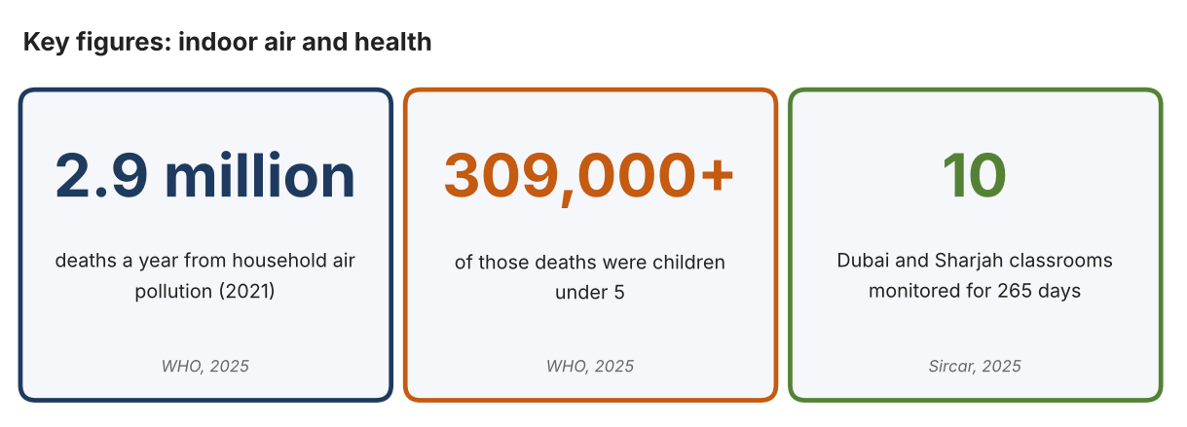
Fig. 1. Key figures on indoor air. Data: World Health Organization, “Household Air Pollution,” 2025; Sircar, Nandini, Khaleej Times, 2025. Graphic by the author.
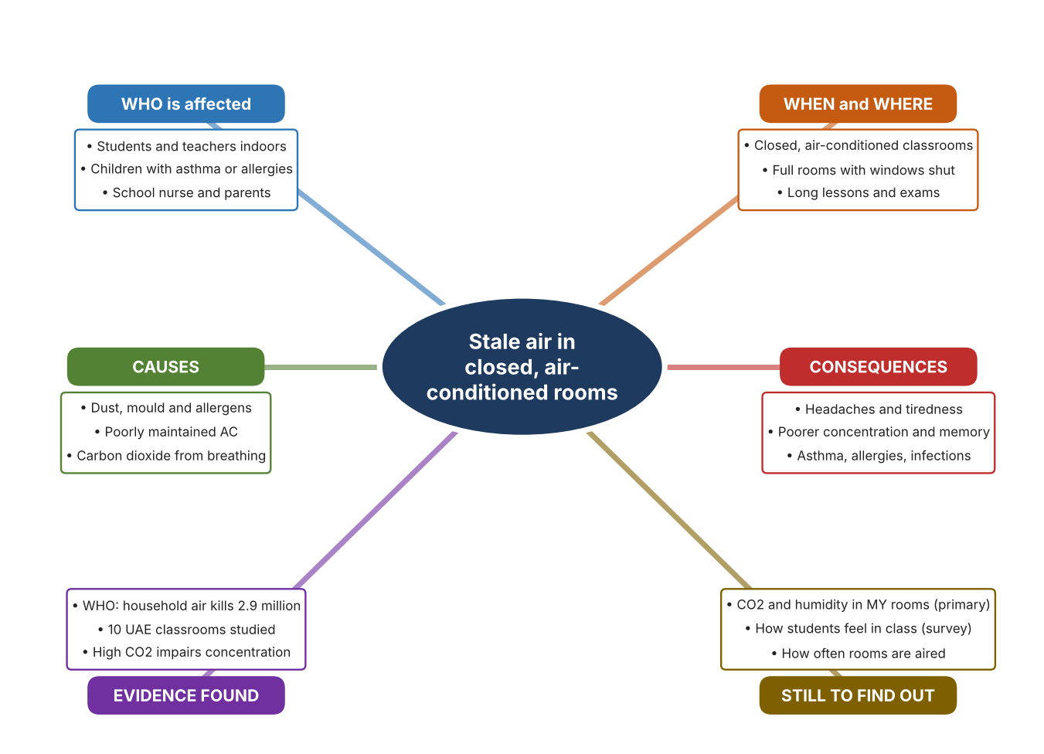
Fig. 2. Mind map of the problem. Sources are listed in Appendix A. Mind map by the author.
Target: 250–400 words across all four answers.

A2 Research Plan
Plan and record the research behind the problem you defined in A1.
📄 You need 6 research questions in total for your topic — a mix of Factual, Conceptual and Debatable questions (include at least one of each type). Complete every column for each question.
# | Question | Priority | Research Type (Primary or Secondary) | Research Link or Evidence | Brief Answer
1 | Factual: How many deaths are linked to household air pollution, and what causes it? | High | Secondary | WHO fact sheet, 2025 (Appendix A, Source 1) | 2.9 million deaths in 2021, including over 309,000 under five; about 2.1 billion people cook with open fires or inefficient stoves; linked to stroke, heart disease, COPD and lung cancer.
2 | Factual: What did a UAE classroom study report about indoor air in schools? | High | Secondary | Khaleej Times, 9 Sept. 2025 (Appendix A, Source 2) | Ten classrooms in Dubai and Sharjah were monitored for 265 days; poorly maintained AC can spread dust, mould and allergens; humidity encourages mould; high CO2 impairs concentration. No figures were given.
3 | Conceptual: How is indoor air quality measured, and what does CO2 tell us? | Medium | Secondary | Aranet page (Source 3) | A CO2 monitor reads parts per million, plus temperature, humidity and pressure; high CO2 shows that fresh air is not replacing breathed air.
4 | Debatable: Should schools improve indoor air by monitoring it, by cleaning it with a purifier, or by ventilating more? | Medium | Secondary | Appendix A, Sources 3, 4 and 5 | A monitor tells when action is needed; a purifier removes particles but not CO2; a fan exchanges air but uses energy and can bring in hot air. My view: monitor first so action is targeted.
5 | Debatable (challenges my assumption, UAE source): Air-conditioned rooms are clean because the air is filtered, so indoor air in UAE schools is not a problem. | High | Secondary | Khaleej Times, 2025 (Source 2) | The report says AC that is not properly maintained can circulate pollutants, dust, mould and allergens, and humidity can encourage mould. Whether my school has a problem depends on maintenance, so I must measure.
6 | Factual (primary): What CO2, temperature and humidity levels do our classrooms reach during a day, and how do students feel? | High | Primary | Own air log and student survey (Appendix A, Sources 6 and 7) | [Student data needed: write the CO2, temperature and humidity readings (with the time and number of people) and survey averages, then two sentences on the pattern you see.]
Extension: make one of your debatable questions challenge your own design assumption, with a named UAE-specific source.

A3 Existing Products Analysis
Analyse 3 existing products or solutions that are significantly different from each other.
📄 Describe 3 existing products or solutions. For each, include an image (cited MLA 9), analyse against at least 4 ACCESS FM strands using specific cited evidence, and give a pro and a con.
Product names (and pasted image/screenshot for each — cite with MLA9):
Product 1 | Product 2 | Product 3
Product 1: CO2 monitor (Aranet4 HOME)  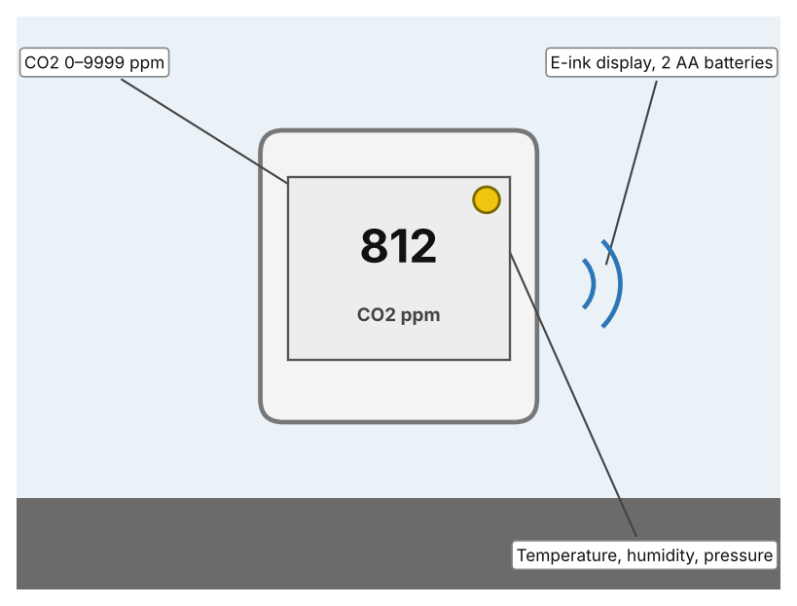  Illustration by the author based on the Aranet4 datasheet, Aranet (Appendix A, Source 3).  [Student: replace with a photo from the source, cited MLA 9] | Product 2: Air purifier (Philips 2000 Series AMF220/95)  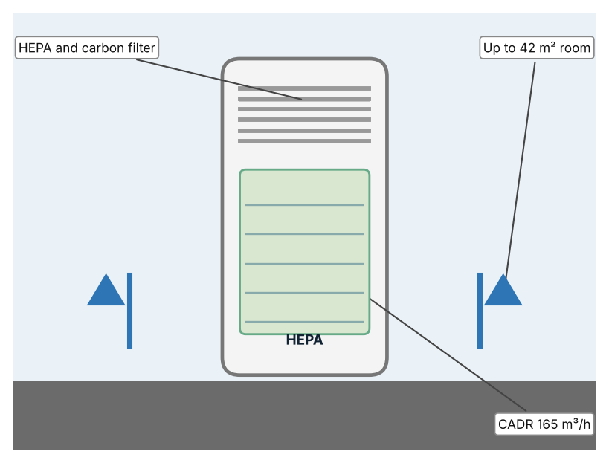  Illustration by the author based on the Philips AMF220/95 brochure, Philips (Appendix A, Source 4).  [Student: replace with a photo from the source, cited MLA 9] | Product 3: Humidity-sensing exhaust fan (Panasonic Whisper Thin RG-T810HA)  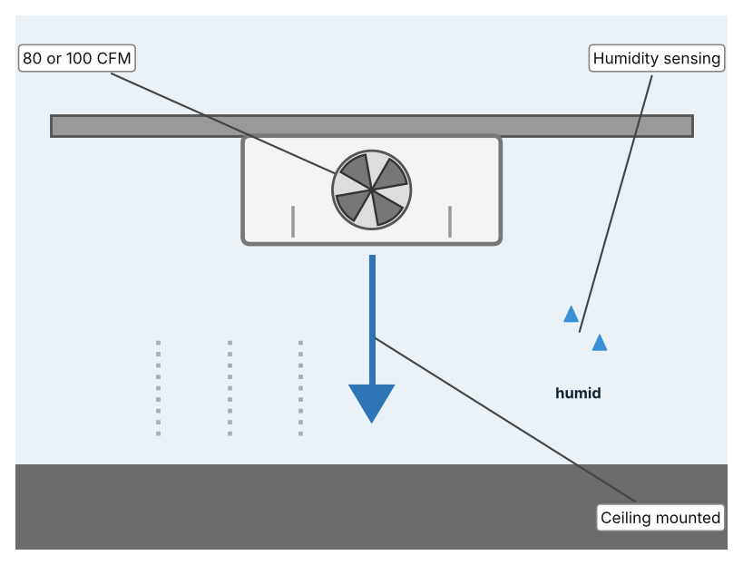  Illustration by the author based on the Panasonic RG-T810HA listing, Do it Best (Appendix A, Source 5).  [Student: replace with a photo from the source, cited MLA 9]
ACCESS FM analysis — analyse at least 4 strands per product with specific, cited evidence:
ACCESS FM | Product 1 | Product 2 | Product 3
Aesthetics | Small square monitor with an e-ink display; not otherwise described (Aranet). | Tall white tower; looks are not described (Philips). | Slim ceiling grille; looks are not described (Do it Best).
Cost | Price not in the datasheet (Aranet). | Price not in the brochure (Philips). | US$189.99 (Do it Best).
Customer | Anyone who wants to see CO2 and comfort data. | Rooms of up to 42 m² where dust or allergens are a concern. | Bathrooms or small rooms where humidity builds up.
Environment | Two AA batteries last 1.4–1.8 years at a one-minute interval. | 47–61 dB(A) sound; filter replacement is needed (my inference). | Uses mains power; energy use is not described.
Size | 71 × 71 × 24 mm; 104 g. | 25 × 25 × 59 cm. | Size is not listed.
Safety | No hazard stated; IP20 rating. | Pre-filter, HEPA and carbon filters; 99.95% of particles as small as 0.003 µm. | Not stated.
Function | Measures CO2 to ±(30 ppm + 3%), temperature to ±0.3 °C and humidity to ±3%; Bluetooth to 10 m. | Cleans air at CADR 165 m³/h; also a fan heater. | Moves air at 80 or 100 CFM with humidity sensing; detail is limited.
Materials | Materials are not stated. | Materials are not stated. | Materials are not stated.
Pros & Cons:
 | Product 1 | Product 2 | Product 3
Pro | Shows the real CO2 level so action can be targeted. | Removes fine particles, dust and smells with a HEPA filter. | Removes humid air automatically.
Con | Only measures; it does nothing to improve the air. | Does not lower CO2 and covers only 42 m². | Designed for bathrooms and gives limited detail on how it senses humidity.
Extension: analyse all 8 ACCESS FM strands per product, and evaluate each from the pedestrian/bystander's perspective, not just the buyer's.

A4 Design Brief + Appendix A
Bring A1–A3 together into one design brief, then compile your Appendix A.
📄 Write your design brief in PARAGRAPH FORM. Your brief must:
• Restate the client's need (from A1)
• Reference your research with sources (from A2)
• Summarise your A3 existing-products analysis for inspiration
• State your design intent, justified by the evidence you gathered
Write your design brief here (paragraph form):
My client, the Facilities and Wellbeing Team of a Dubai school, needs the quality of classroom air to be known and kept healthy, using measurements. The problem is real: a study of ten Dubai and Sharjah classrooms over 265 days warns that poorly maintained air conditioning can circulate dust, mould and allergens, and that high carbon dioxide impairs concentration and memory (Appendix A, Source 2). The WHO reports 2.9 million deaths a year from household air pollution, though mainly from cooking fuels (Appendix A, Source 1).
My research shows that the risks come from invisible things, so measurement is needed (Appendix A, Sources 2 and 3). The report I found gives no numbers, so I need my own evidence. My debatable questions led me to decide that monitoring, purifying and ventilating each cover only part of the problem, and my challenged assumption (that air-conditioned air is automatically clean) showed me that maintenance matters. I will gather my own evidence with the air log and the survey, always with permission (Appendix A, Sources 6 and 7).
I analysed three very different existing solutions. A CO2 monitor reads CO2, temperature and humidity and runs on two AA batteries for more than a year, but it does nothing to improve the air (Appendix A, Source 3). An air purifier filters 99.95% of fine particles with a HEPA filter, but it does not lower CO2 and covers only 42 m² (Appendix A, Source 4). A humidity-sensing exhaust fan removes humid air at 80 or 100 CFM, but it is designed for bathrooms and the page gives limited detail (Appendix A, Source 5). They give me three ideas for inspiration: measuring, cleaning and exchanging the air. Each has a weakness that another covers.
My design intent is therefore to create a solution that measures the quality of the air in a classroom and tells people clearly when it needs attention. It must be affordable, simple to read at a glance, safe in a classroom, and reliable through the school day. I have deliberately not fixed what form it will take. That decision will be made in Criterion B, after I analyse my own log and survey against the evidence in Appendix A.
Target: 350–600 words. Extension: explicitly reference Appendix A within your brief (e.g. "see Appendix A, Source 2").
APPENDIX A
Paste in your full A2 research notes and sources here (Appendix A). Reference this appendix explicitly within your design brief above.
# | Source (MLA 9) | Key notes | How I used it
1 | World Health Organization. “Household Air Pollution.” WHO, 16 Dec. 2025, www.who.int/en/news-room/fact-sheets/detail/household-air-pollution-and-health. Accessed 21 Oct. 2026. | 2.9 million deaths a year in 2021, including over 309,000 under five; ambient plus household air pollution 6.7 million premature deaths; 2.1 billion cook with open fires or inefficient stoves; mostly about cooking fuels, not UAE classrooms. | A1; A2 Q1; A4.
2 | Sircar, Nandini. “Are UAE Students Breathing Clean Air? Schools Face Hidden Pollution Risks.” Khaleej Times, 9 Sept. 2025, www.khaleejtimes.com/lifestyle/health/uae-classroom-air-quality-study-health-risks. Accessed 21 Oct. 2026. | Goumbook report “Take a Breath: Improving Indoor Air Quality”: ten classrooms in Dubai and Sharjah over 265 days; schools built 1970–2021; AC can circulate dust, mould and allergens; humidity encourages mould; VOCs; high CO2 impairs concentration; no PM or CO2 numbers. | A1; A2 Q2 and Q5; A4.
3 | “Aranet4 HOME Datasheet.” Aranet, shop.aranet.com/attachment/267/Aranet4_datasheet_v25_WEB.pdf. Accessed 21 Oct. 2026. | CO2 0–9999 ppm ±(30 ppm + 3%); temperature 0–50 °C ±0.3; humidity 0–85% ±3%; pressure; e-ink; 2 AA, 1.4–1.8 years; 71 × 71 × 24 mm, 104 g; Bluetooth 10 m; IP20; price not stated. | A2 Q3 and Q4; A3 Product 1; A4.
4 | “Philips 2000 Series 3-in-1 Purifier Fan Heater AMF220/95.” Philips, documents.philips.com/assets/20210528/ecb269bd0c474ddb95c3ad36012114d4.pdf. Accessed 21 Oct. 2026. | CADR 165 m³/h; up to 42 m²; pre-filter, HEPA and carbon; 99.95% of particles as small as 0.003 µm; 47–61 dB(A); 25 × 25 × 59 cm; price not stated. | A2 Q4; A3 Product 2; A4.
5 | “Panasonic Whisper Thin 80/100 CFM Bathroom Fan with Humidity Sensing RG-T810HA.” Do it Best, www.doitbest.com (product 512933; search the product name). Accessed 21 Oct. 2026. | US$189.99; 80 or 100 CFM; humidity sensing with no detail given; sones and size not listed. The full page address is shortened, so search the site for the model name. | A2 Q4; A3 Product 3; A4.
6 | Own primary research: observation sheet (below). | Student records readings with a CO2 monitor or the school's building system, with permission and a teacher present. | A2 primary question; A4.
7 | Own primary research: short student survey (below). | Student asks at least 20 people and records the ratings. | A2 primary question; A4.
Source 6: classroom air log (blank instrument; student data needed)
Room and time | People in room | CO2 (ppm) | Temp (°C) | Humidity (%) | Stuffy? (Y/N)
Classroom, morning
Classroom, midday
Classroom, afternoon
Library
Source 7: student survey (blank instrument; rate each statement from 1 = strongly disagree to 5 = strongly agree; student data needed)
Statement | 1 | 2 | 3 | 4 | 5
The air in my classroom feels stuffy by the end of a lesson.
I feel sleepy or get headaches in class.
Windows or doors are opened to refresh the air.
I would like to see the air quality in my classroom on a display.
Total responses (tally)

✓ FINAL CHECKLIST — Tick Before Submitting
Review your complete Criterion A document against every point below.
☑ A1: client, need, target audience, why, one image + one statistic (evidence)
☑ A2: factual / conceptual / debatable questions — each prioritised, sourced, evidenced
☑ A3: 3 significantly different products, screenshots, ACCESS FM analysis, pros/cons
☑ A4: need restated, research referenced, Appendix A attached AND referenced, existing-products summary included
☑ All four sections written in full paragraphs — no bullet points
☑ Document proofread before final submission

