AMBASSADOR INTERNATIONAL ACADEMY, DUBAI
Criterion A: Inquiring & Analysing — Student Summative Answer Booklet
Grade 9 · Design a Solution for a Community Problem
Name: | Teacher exemplar | Class: | Grade 9
Date: | 21 October 2026 | Unit: | Zero Hunger · SDG 2 · ZH6

Teacher exemplar: the client and school are fictional; every statistic and product fact is from the cited sources (MLA 9, accessed 21 Oct. 2026). The three product images are the author's own labelled illustrations based on the cited sources; a student should replace them with a cited photo. Yellow highlighting marks where a student must add their own data.
📋 HOW TO SUBMIT: Type your answers directly into this document — this is your Criterion A summative submission. Complete Sections A1 to A4 in full sentences / paragraphs (unless a table is provided). Save your work as you go and submit via Google Classroom → Unit 1 → Criterion A → "My Criterion A Document".
A1 Design Need
Identify and explain the problem faced by your client and community.
📄 Write one continuous essay of connected paragraphs (250–400 words) about the PROBLEM, not about a solution. Explain who the client is and what they need, who is affected, why a solution is needed, and use images and statistics to show the problem is real. You may add a mind map to organise your ideas. Cite every source in MLA 9.
My client is the Science Department of a Dubai school, represented by the Head of Science, which looks after a small greenhouse and a school growing project. The department wants students to grow food that does not spoil or wilt in the heat. It needs high temperature and humidity inside growing spaces to be understood and kept under control, so that crops stay healthy and food is not wasted.
The people most affected are growers and greenhouse workers, because heat reduces how well plants grow. Shoppers and families are a second group, because spoiled food costs money and reduces what is available. Students who run the school growing project are a third group.
The need is real because food is lost between the farm and the plate in a hot country. Khalifa University researchers reported a trial with 27 Abu Dhabi farms in which greenhouses saw a 14 percent drop in energy use, especially for cooling, as part of work on reducing post-harvest loss (Khalifa University Explorer). HortiDaily reported that the UAE is mostly desert and imports around 90 percent of its food, which is why local greenhouses matter (HortiDaily). The first article does not name an author and neither source gives temperature figures for a greenhouse, so I need to find out about my own school.
Figure 1 summarises the key numbers. The articles describe projects and national food facts, not conditions inside a greenhouse, so I treat them as a pattern and not as proof about my school. In my own words: heat damages crops both while they grow and after they are picked, so I need to know what the conditions really are. Figure 2 is my mind map of the problem.
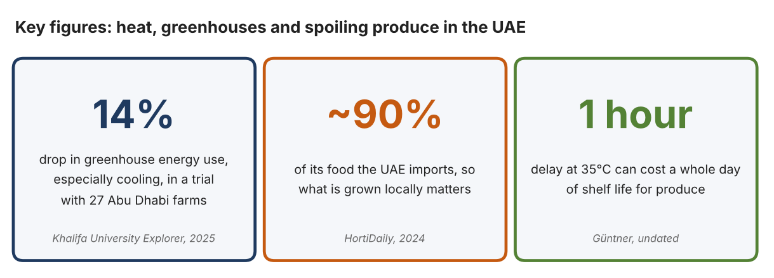
Fig. 1. Key figures on heat and food loss. Data: Khalifa University Explorer, 2025; HortiDaily, 2024; Güntner, undated (95°F converted by the author). Graphic by the author.
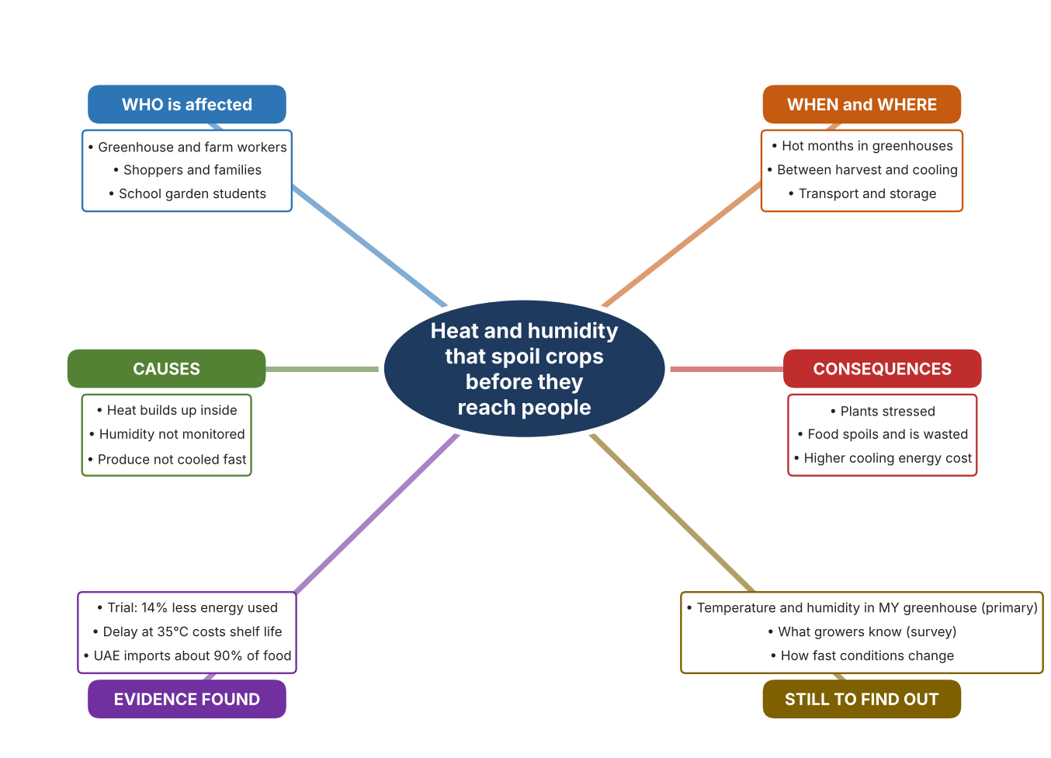
Fig. 2. Mind map of the problem. Sources are listed in Appendix A. Mind map by the author.
Target: 250–400 words across all four answers.

A2 Research Plan
Plan and record the research behind the problem you defined in A1.
📄 You need 6 research questions in total for your topic — a mix of Factual, Conceptual and Debatable questions (include at least one of each type). Complete every column for each question.
# | Question | Priority | Research Type (Primary or Secondary) | Research Link or Evidence | Brief Answer
1 | Factual: How much food is wasted after harvest in the UAE, and what is being done? | High | Secondary | Khalifa University Explorer, 4 Dec. 2025 (Appendix A, Source 1) | A trial with 27 Abu Dhabi farms, with ADAFSA, aims to reduce post-harvest loss; greenhouses saw a 14% drop in energy use, especially cooling.
2 | Factual: Why does the UAE need local greenhouses, and how are they cooled? | High | Secondary | HortiDaily, 20 Sept. 2024 (Appendix A, Source 2) | About 80% desert and importing about 90% of food; one desert greenhouse has been given an electrified cooling and heating plant. No temperatures given.
3 | Conceptual: How can temperature and humidity be measured, shaded and cooled? | Medium | Secondary | Govee page (Source 3); Garware page (Source 4); Güntner page (Source 5) | A sensor measures temperature and humidity; shade net blocks sunlight; a pre-cooling container removes field heat from picked produce.
4 | Debatable: Should growers monitor conditions, shade their crops, or cool produce after harvest? | Medium | Secondary | Appendix A, Sources 3, 4 and 5 | Monitoring shows the problem but fixes nothing; shade reduces sunlight but gives no figure for cooling; pre-cooling saves shelf life but only after harvest. My view: monitoring first shows which of the others is needed.
5 | Debatable (challenges my assumption, UAE source): Greenhouses in the desert can only be kept cool with expensive air conditioning, so monitoring cannot save energy. | High | Secondary | Khalifa University Explorer, 2025 (Source 1); HortiDaily, 2024 (Source 2) | One desert greenhouse invested in an electrified plant, but the trial reported a 14% energy drop, especially cooling, at 27 farms. The report does not say what caused the drop, so I cannot assume monitoring did it.
6 | Factual (primary): What are the temperature and humidity in our greenhouse during the school day, and what do students and growers know? | High | Primary | Own readings and survey (Appendix A, Sources 6 and 7) | [Student data needed: write the readings (time, °C, % RH) and survey averages, then two sentences on the pattern you see.]
Extension: make one of your debatable questions challenge your own design assumption, with a named UAE-specific source.

A3 Existing Products Analysis
Analyse 3 existing products or solutions that are significantly different from each other.
📄 Describe 3 existing products or solutions. For each, include an image (cited MLA 9), analyse against at least 4 ACCESS FM strands using specific cited evidence, and give a pro and a con.
Product names (and pasted image/screenshot for each — cite with MLA9):
Product 1 | Product 2 | Product 3
Product 1: Wireless thermo-hygrometer set (Govee 2s Lite)  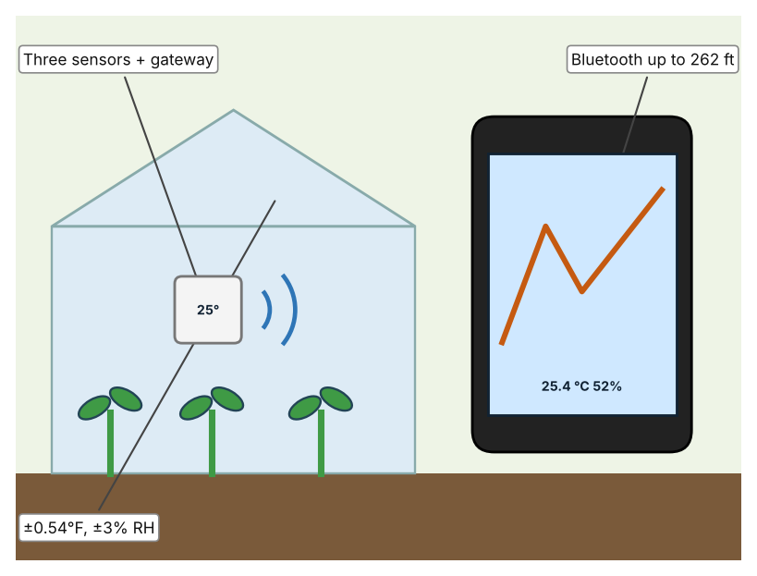  Illustration by the author based on the Govee 2s Lite page, Govee (Appendix A, Source 3).  [Student: replace with a photo from the source, cited MLA 9] | Product 2: Shade net (Garware V5)  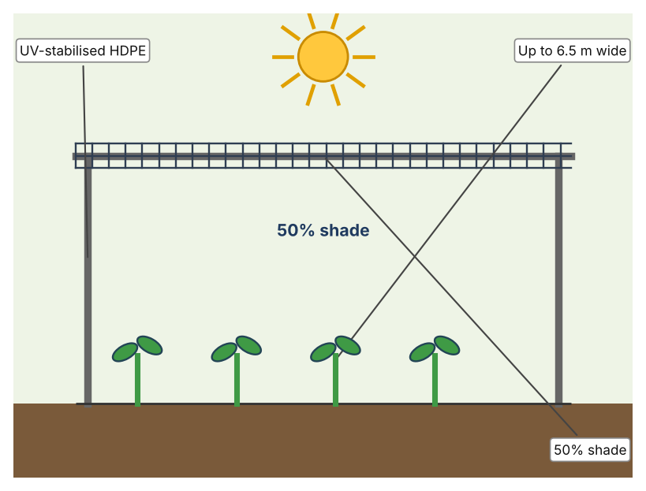  Illustration by the author based on the Garware V5 page, Garware (Appendix A, Source 4).  [Student: replace with a photo from the source, cited MLA 9] | Product 3: Pre-cooling container (Güntner)  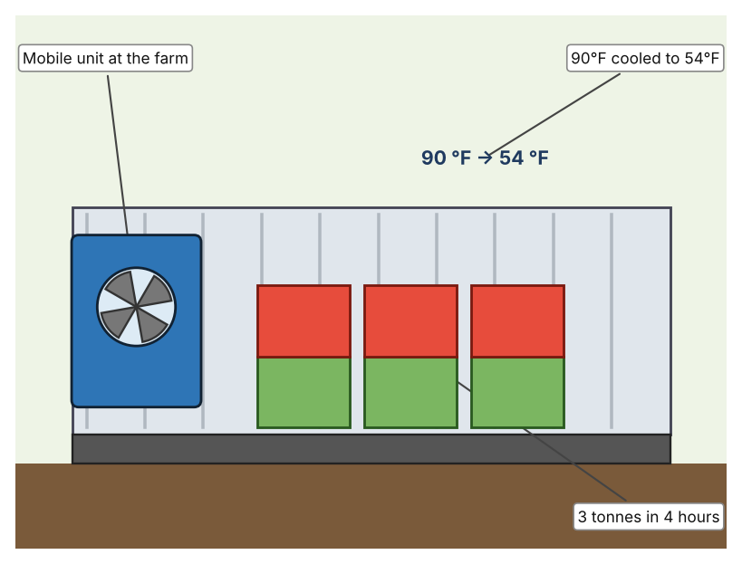  Illustration by the author based on the Güntner case study (Appendix A, Source 5).  [Student: replace with a photo from the source, cited MLA 9]
ACCESS FM analysis — analyse at least 4 strands per product with specific, cited evidence:
ACCESS FM | Product 1 | Product 2 | Product 3
Aesthetics | Small white sensors with a display; no more is described (Govee). | Black mesh sheet; look not described beyond the net (Garware). | Metal shipping container; look not described (Güntner).
Cost | US$49.99 for gateway and three sensors (Govee). | Price not stated. | Price not stated.
Customer | Growers and households who want to watch conditions. | Greenhouse and nursery growers. | Farms that sell fresh vegetables.
Environment | Battery type is not stated. | UV stabilised so it lasts in strong sun; no recycling information. | Uses electricity to cool; size of energy use not stated.
Size | Bluetooth range up to 262 ft; sensor size not stated. | Rolls of 100 m length, up to 6.5 m wide. | A 20-foot container.
Safety | Not described. | Not described. | Not described.
Function | Measures temperature and humidity every 2 seconds. | Blocks about half of the sunlight. | Cools 3 tonnes of vegetables from 90°F to 54°F in 4 hours.
Materials | Materials are not stated. | HDPE monofilament. | Materials are not stated.
Pros & Cons:
 | Product 1 | Product 2 | Product 3
Pro | Shows live temperature and humidity at low cost. | Cheap way to lower sunlight and heat and needs no power. | Saves shelf life by cooling produce quickly.
Con | Only measures; it does not cool anything. | The page gives no figure for how much it cools. | Works only after harvest and the price is not stated.
Extension: analyse all 8 ACCESS FM strands per product, and evaluate each from the pedestrian/bystander's perspective, not just the buyer's.

A4 Design Brief + Appendix A
Bring A1–A3 together into one design brief, then compile your Appendix A.
📄 Write your design brief in PARAGRAPH FORM. Your brief must:
• Restate the client's need (from A1)
• Reference your research with sources (from A2)
• Summarise your A3 existing-products analysis for inspiration
• State your design intent, justified by the evidence you gathered
Write your design brief here (paragraph form):
My client, the Science Department of a Dubai school, needs high temperature and humidity in growing spaces to be understood and kept under control, so that crops stay healthy and food is not wasted. The problem is real: a trial with 27 Abu Dhabi farms reported a 14 percent drop in greenhouse energy use, especially cooling (Appendix A, Source 1). The UAE imports around 90 percent of its food, so local growing matters (Appendix A, Source 2).
My research shows that heat affects food both in the greenhouse and after harvest, and that cooling takes energy (Appendix A, Sources 1 and 2). Neither source gives temperatures inside a greenhouse, so I need my own evidence. My debatable questions led me to decide that monitoring, shading and cooling each cover only part of the problem, and my challenged assumption (that desert greenhouses can only be cooled with costly air conditioning) showed me that the sources do not prove what causes energy savings. I will gather my own evidence with readings in our greenhouse and a survey, always with permission (Appendix A, Sources 6 and 7).
I analysed three very different existing solutions. A wireless thermo-hygrometer set shows temperature and humidity every 2 seconds, but it only measures (Appendix A, Source 3). A shade net blocks about half of the sunlight and needs no power, but the page gives no figure for how much it cools (Appendix A, Source 4). A pre-cooling container cools three tonnes of vegetables in four hours, but it works only after harvest and its price is not stated (Appendix A, Source 5). They give me three ideas for inspiration: measuring, reducing the heat source, and cooling the product. Each has a weakness that another covers.
My design intent is therefore to create a solution that shows temperature and humidity in a growing space clearly, so that people can act before crops are harmed. It must be affordable, easy to read, durable in heat and humidity, and accurate. I have deliberately not fixed what form it will take. That decision will be made in Criterion B, after I analyse my own readings and survey against the evidence in Appendix A.
Target: 350–600 words. Extension: explicitly reference Appendix A within your brief (e.g. "see Appendix A, Source 2").
APPENDIX A
Paste in your full A2 research notes and sources here (Appendix A). Reference this appendix explicitly within your design brief above.
# | Source (MLA 9) | Key notes | How I used it
1 | “From Desert to Table: Saving Fresh Food from Going to Waste.” Khalifa University Explorer, 4 Dec. 2025, kuexplorer.ku.ac.ae/2025/12/04/from-desert-to-table-saving-fresh-food-from-going-to-waste. Accessed 21 Oct. 2026. | Post-harvest loss; trial with 27 Abu Dhabi farms; greenhouses saw a 14% drop in energy use, especially cooling; partnership with ADAFSA; runs through 2026. Author not stated. | A1; A2 Q1 and Q5; A4.
2 | “UAE: Desert Greenhouse Gets Electrified Cooling and Heating Plant.” HortiDaily, 20 Sept. 2024, hortidaily.com/article/9661010/uae-desert-greenhouse-gets-electrified-cooling-and-heating-plant. Accessed 21 Oct. 2026. | UAE about 80% desert and imports about 90% of its food; a Pure Harvest greenhouse with a Trane plant; no temperature figures. | A1; A2 Q2 and Q5; A4.
3 | “GoveeLife Smart Thermo-Hygrometer 2s Lite.” Govee, us.govee.com/products/goveelife-smart-thermo-hygrometer-2s-lite. Accessed 21 Oct. 2026. | Gateway and three sensors; US$49.99; Bluetooth range 262 ft; ±0.54°F and ±3% RH; 2-second sampling. | A2 Q3 and Q4; A3 Product 1; A4.
4 | “V5 Shade Net.” Garware Technical Fibres, www.garwarefibres.com/products/shade-nets-solutions/v5. Accessed 21 Oct. 2026. | 50% shade; HDPE monofilament; UV stabilised; 100 m length up to 6.5 m wide; no figure for temperature reduction. | A2 Q3 and Q4; A3 Product 2; A4.
5 | “Pre-Cooling Containers Prolong the Shelf-Life of Fruit and Vegetables.” Güntner, guntner.com/our-impact/case-studies/reducing-food-waste-uae. Accessed 21 Oct. 2026. | Six 20-foot containers delivered to UAE farms; each cools 3 tonnes of vegetables in 4 hours from 90°F to 54°F; a one-hour delay at 95°F can cost a full day of shelf life; undated; a company case study. | A2 Q3 and Q4; A3 Product 3; A4.
6 | Own primary research: observation sheet (below). | Student records readings in the school greenhouse with the teacher present, using school equipment, and avoids touching electrical parts. | A2 primary question; A4.
7 | Own primary research: short student survey (below). | Student asks at least 20 people and records the ratings. | A2 primary question; A4.
Source 6: greenhouse readings (blank instrument; student data needed)
Time | Location | Temp (°C) | Humidity (%RH) | Sun or shade | Notes
Morning
Midday
Afternoon
Evening
Source 7: student survey (blank instrument; rate each statement from 1 = strongly disagree to 5 = strongly agree; student data needed)
Statement | 1 | 2 | 3 | 4 | 5
I know how hot and humid our greenhouse becomes.
Plants in the greenhouse look stressed on hot days.
I know how long fresh food can stay out in the heat.
I would use a live reading to decide when to ventilate.
Total responses (tally)

✓ FINAL CHECKLIST — Tick Before Submitting
Review your complete Criterion A document against every point below.
☑ A1: client, need, target audience, why, one image + one statistic (evidence)
☑ A2: factual / conceptual / debatable questions — each prioritised, sourced, evidenced
☑ A3: 3 significantly different products, screenshots, ACCESS FM analysis, pros/cons
☑ A4: need restated, research referenced, Appendix A attached AND referenced, existing-products summary included
☑ All four sections written in full paragraphs — no bullet points
☑ Document proofread before final submission

