Criterion B: Developing ideas
Sample completed example · Wave & Sea frame

About this sample
This is a short worked example of a Criterion B response for a Year 1 frame. Read it to see what a clear answer looks like. Your own frame, ideas and wording must be different.

B1 · Success criteria
# | The frame must… | How I will test it
1 | have a photo window 120 mm × 170 mm so a 5 × 7 inch photo fits | Measure the window with a ruler. Slide a photo in.
2 | stand on a table for one minute without falling | Stand it up and time it for 60 seconds.
3 | use at least half recycled materials, such as card and bottle caps | Count the materials. Compare recycled and bought.
4 | have no sharp edges or splinters | Run a finger gently along every edge.
5 | show the theme “The sea” | Ask two classmates what the theme is.

B2 · Design ideas
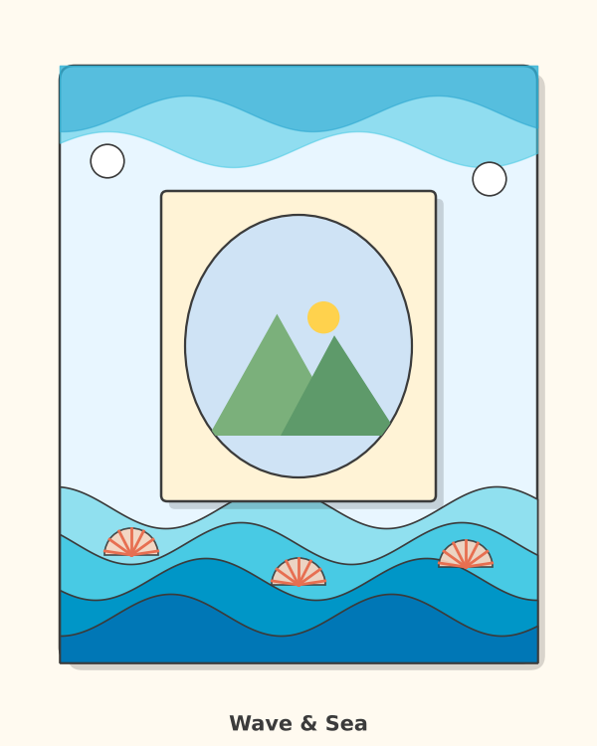  Idea A: Wave & Sea  Theme: The sea  Key features: four wave layers, shells at the top, blue colours  Materials: cereal-box card, paint, shells | 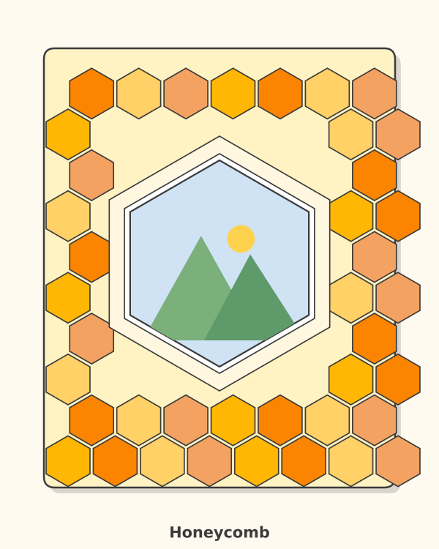  Idea B: Honeycomb  Theme: Teamwork  Key features: repeating hexagons, warm colours, dark base  Materials: coloured card, paint, glue | 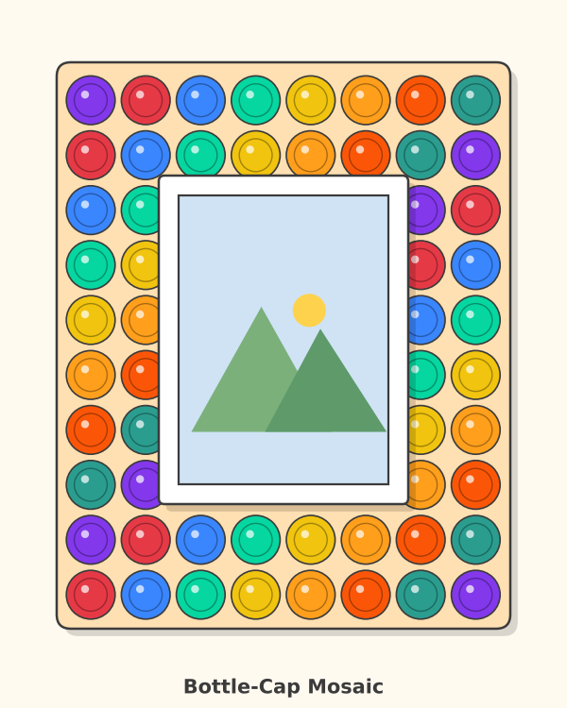  Idea C: Bottle-Cap Mosaic  Theme: Recycling  Key features: caps round the border, bead gaps, bright colours  Materials: bottle caps, beads, paint
Each idea is labelled with its key features so that another student can understand it.

B3 · Chosen design
Criterion | Idea A | Idea B | Idea C
Looks good and fits my theme | 3 | 2 | 3
Easy to make with my tools | 2 | 2 | 2
Uses recycled materials | 3 | 2 | 3
Stands up well | 3 | 3 | 2
Total | 11 | 9 | 10

I chose Idea A: Wave & Sea.
Key features: four wave layers from light blue at the back to dark blue at the front, small spacers between the layers, shells along the top, a clear photo window.
Why I chose it: It scored the highest total (11). It matches my theme “The sea” (success criterion 5). It uses cereal-box card and paint, so more than half of the materials are recycled (criterion 3). The layers are made from card, so it is light and it stands well (criterion 2). Idea B was slower to make because I would need about 70 cells. Idea C was heavy and might not stand well.

B4 · Planning drawing
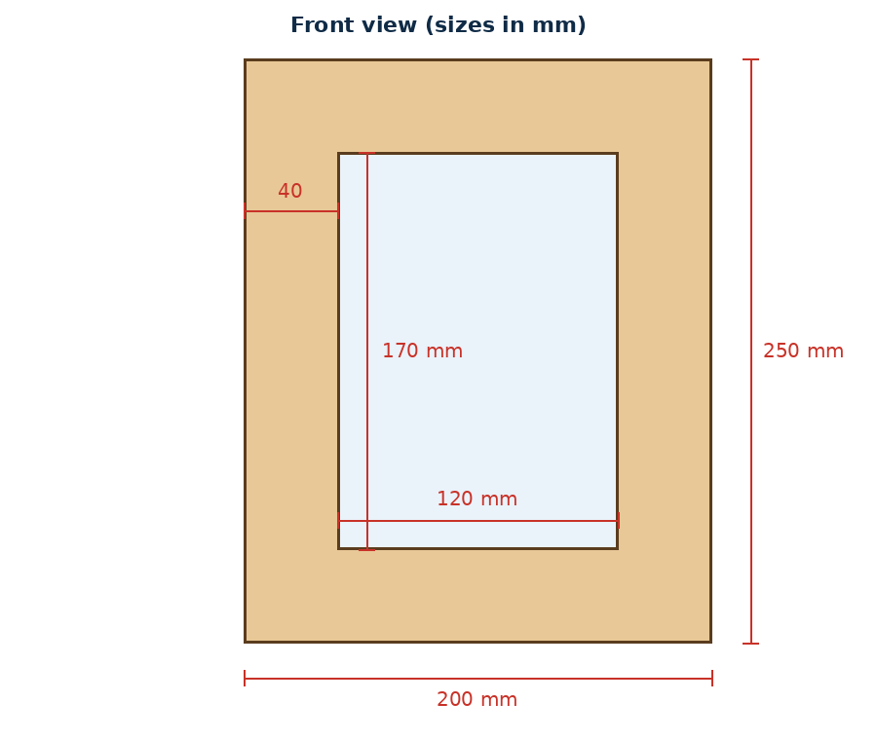

Material or tool | How many | What it is for
MDF frame base 200 × 250 mm | 1 | Main frame
Cereal-box card | 3 pieces | Wave layers and spacers
Blue paint (3 shades) | 3 tubes | Colour the layers
Shells or paper shapes | 6 | Decoration along the top
Scissors, pencil, ruler | 1 each | Cutting and measuring
PVA glue | 1 bottle | Join the layers

Step | What I will do | Tools I need
1 | Sand the edges of the frame base and wipe off the dust | Sanding block
2 | Paint the base sand-colour and let it dry | Brush, paint
3 | Draw four wave strips on card, 38, 31, 24 and 17 mm high | Pencil, ruler
4 | Cut out the strips and colour them from light to dark blue | Scissors, paint
5 | Make 5 mm spacers by gluing three card squares together | Scissors, glue
6 | Glue the back layer, then add spacers and the other layers | PVA glue
7 | Glue shells along the top and check that the window is clear | PVA glue
8 | Add the photo, backing board and easel leg | Tape, glue

Safety: Cut away from my body. Only an adult uses the hot glue gun.

