AMBASSADOR INTERNATIONAL ACADEMY, DUBAI
Criterion A: Inquiring & Analysing — Student Summative Answer Booklet
Grade 10 · Design a Solution for a Community Problem
Name: | Teacher exemplar | Class: | Grade 10
Date: | 21 October 2026 | Unit: | Unit 1 · Community Problem 04

Teacher exemplar: the client and school are fictional; every statistic and product fact is from the cited sources (MLA 9, accessed 21 Oct. 2026). The three product images are the author's own labelled illustrations based on the cited sources; a student should replace them with a cited photo. Yellow highlighting marks where a student must add their own data.
📋 HOW TO SUBMIT: Type your answers directly into this document — this is your Criterion A summative submission. Complete Sections A1 to A4 in full sentences / paragraphs (unless a table is provided). Save your work as you go and submit via Google Classroom → Unit 1 → Criterion A → "My Criterion A Document".
A1 Design Need
Identify and explain the problem faced by your client and community.
📄 Write one continuous essay of connected paragraphs (250–400 words) about the PROBLEM, not about a solution. Explain who the client is and what they need, who is affected, why a solution is needed, and use images and statistics to show the problem is real. You may add a mind map to organise your ideas. Cite every source in MLA 9.
My client is the Aquatics and Water Safety Committee of a Dubai school, represented by its Head of Physical Education. Students swim in the school pool, visit beaches and water parks on trips and spend summer holidays near water. The committee is concerned that a child can get into serious trouble in water in a few seconds, in front of people who may not notice, and it needs the risk of drowning and the danger to anyone who tries to help to be reduced.
The people most affected are children and teenagers who swim, play or work near water. Younger children are at most risk, and they are rarely strong swimmers. Teachers, lifeguards and parents are a second group because they are responsible for supervision and may put themselves in danger when they try to help someone who is struggling.
The need is real because drowning is common and fast. The World Health Organization reports that around 300,000 people drown each year, children under 5 account for nearly a quarter of these deaths, and drowning is the third leading cause of death for children aged 5 to 14 (World Health Organization, “Drowning”). The WHO also says the risk rises when children are in water without active adult supervision. Dubai Police warn that children can drown silently within seconds, often without people nearby noticing, and that parents should not rely only on lifeguards or flotation devices (Borbon). In 2019 police in the UAE said negligence is a major reason for children drowning and advised fencing pools, locking doors and never leaving a child unattended (Ahmad).
Figure 1 summarises the key numbers. The WHO figures are global, so I still need evidence from my own school's water activities. In my own words: because drowning is quiet and quick, a child's safety cannot depend only on someone happening to look at the right moment. Figure 2 is my mind map of the problem.
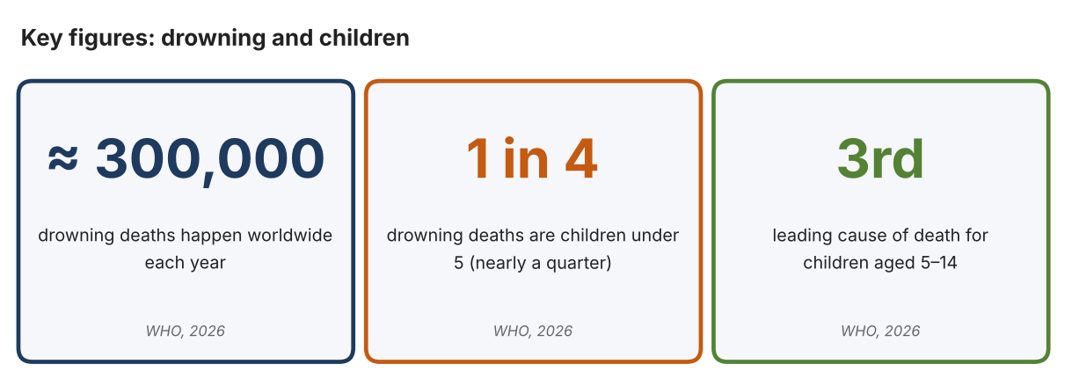
Fig. 1. Key figures on drowning. Data: World Health Organization, “Drowning,” 1 May 2026. Graphic by the author.
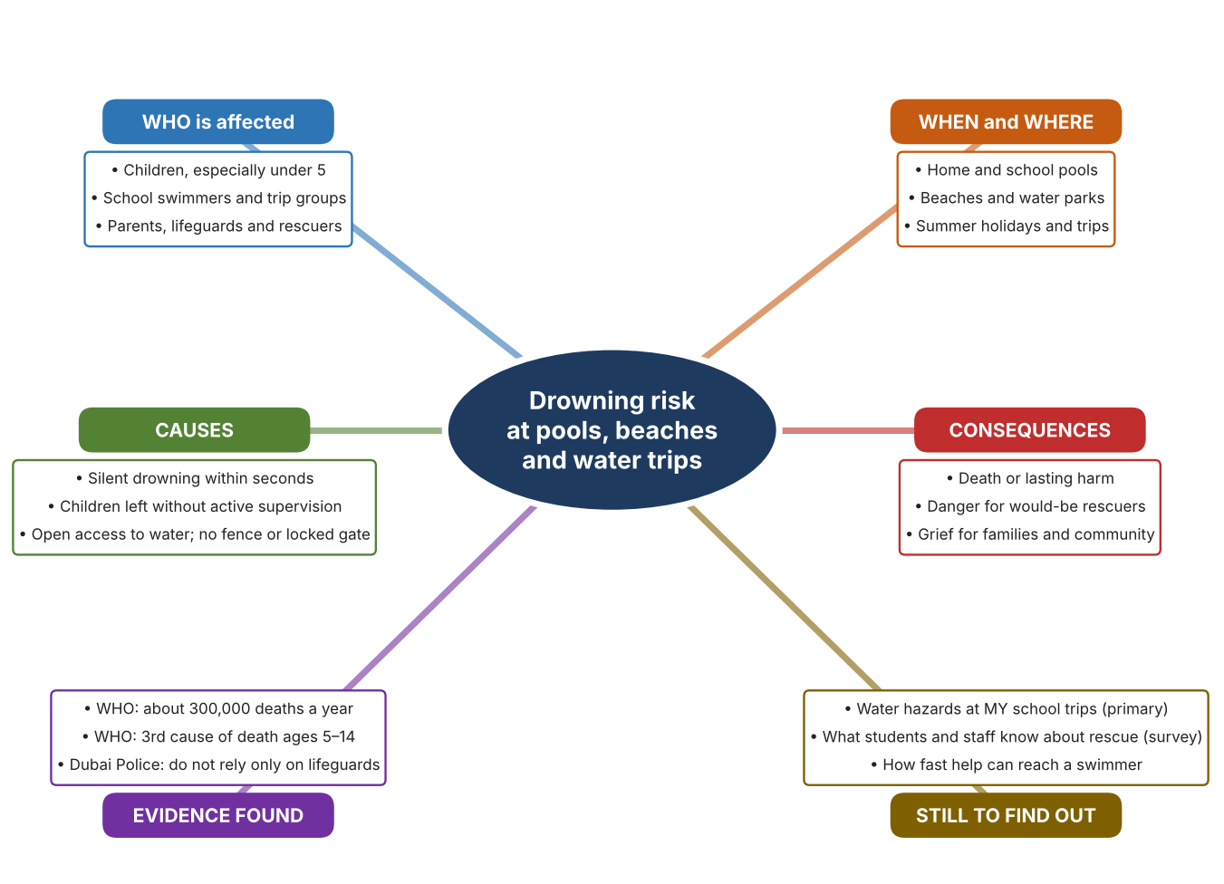
Fig. 2. Mind map of the problem. Sources are listed in Appendix A. Mind map by the author.
Target: 250–400 words across all four answers.

A2 Research Plan
Plan and record the research behind the problem you defined in A1.
📄 You need 6 research questions in total for your topic — a mix of Factual, Conceptual and Debatable questions (include at least one of each type). Complete every column for each question.
# | Question | Priority | Research Type (Primary or Secondary) | Research Link or Evidence | Brief Answer
1 | Factual: How many people drown each year, and which age groups are most at risk? | High | Secondary | WHO fact sheet, 1 May 2026 (Appendix A, Source 1) | About 300,000 deaths a year. Under-5s are nearly a quarter; drowning is the 4th cause of death for ages 1–4 and the 3rd for ages 5–14.
2 | Factual: What do UAE police advise to prevent child drowning at pools and beaches? | High | Secondary | Gulf News, 12 July 2026 (Appendix A, Source 3); Gulf News, 11 June 2019 (Source 2) | Constant direct supervision within reach; fence pools and lock doors; life jackets; a competent swimmer with rescue skills present; never leave a child unattended.
3 | Conceptual: Why can a person drown silently and quickly, and why is it dangerous for a bystander to try to rescue them? | Medium | Secondary | Gulf News, 12 July 2026 (Appendix A, Source 3); WHO, 2026 (Source 1) | Children can drown within seconds, often unnoticed. The WHO lists safe rescue skills as a prevention measure, which implies that unprepared rescue is risky. This last point is my interpretation.
4 | Debatable: Should drowning prevention rely mainly on supervision by adults, physical barriers such as fences, or equipment for rescue? | Medium | Secondary | Appendix A, Sources 1, 2, 3, 4, 5 and 6 | Supervision is essential but can lapse; barriers work at all times but only where installed; rescue equipment helps only after trouble starts. My view: prevention (barriers and supervision) first, rescue second.
5 | Debatable (challenges my assumption, UAE source): Lifeguards and flotation devices make water safe, so is any more needed? | High | Secondary | Gulf News, 12 July 2026 (Appendix A, Source 3) | Dubai Police say parents should not rely solely on lifeguards or flotation devices because drowning is silent and fast. Conclusion: these are helpful but not enough on their own.
6 | Factual (primary): What water hazards and rescue equipment exist at our own pool and on school trips, and how confident are people to help? | High | Primary | Own water-safety audit and student survey (Appendix A, Sources 7 and 8) | [Student data needed: write the audit findings and survey averages, then two sentences on the main pattern. Audit from the poolside only; never enter water alone.]
Extension: make one of your debatable questions challenge your own design assumption, with a named UAE-specific source.

A3 Existing Products Analysis
Analyse 3 existing products or solutions that are significantly different from each other.
📄 Describe 3 existing products or solutions. For each, include an image (cited MLA 9), analyse against at least 4 ACCESS FM strands using specific cited evidence, and give a pro and a con.
Product names (and pasted image/screenshot for each — cite with MLA9):
Product 1 | Product 2 | Product 3
Product 1: Remote-control rescue buoy (EMILY)  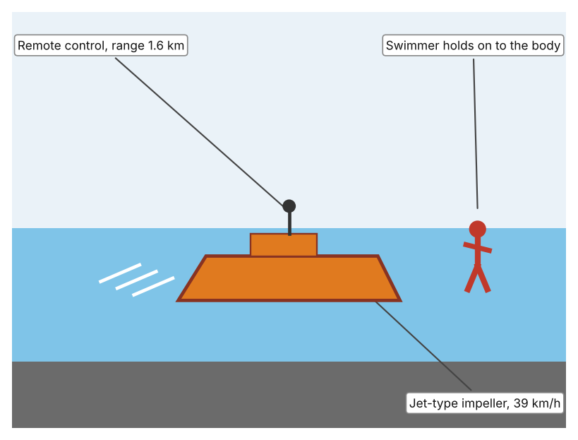  Illustration by the author based on “Emily” rescue buoy, New Atlas (Appendix A, Source 4).  [Student: replace with a photo from the source, cited MLA 9] | Product 2: Ring buoy throw bag with 90 ft rope (Mustang)  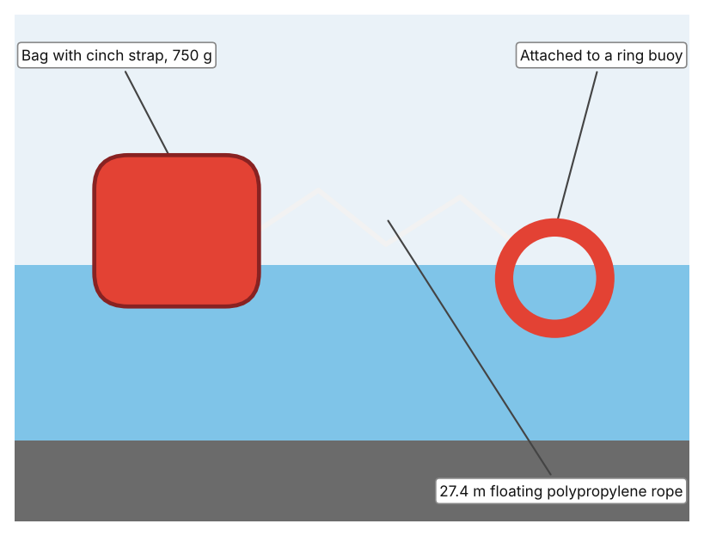  Illustration by the author based on “Mustang Ring Buoy Throw Bag,” NavStore (Appendix A, Source 5).  [Student: replace with a photo from the source, cited MLA 9] | Product 3: Self-closing pool safety gate (Leslie's)  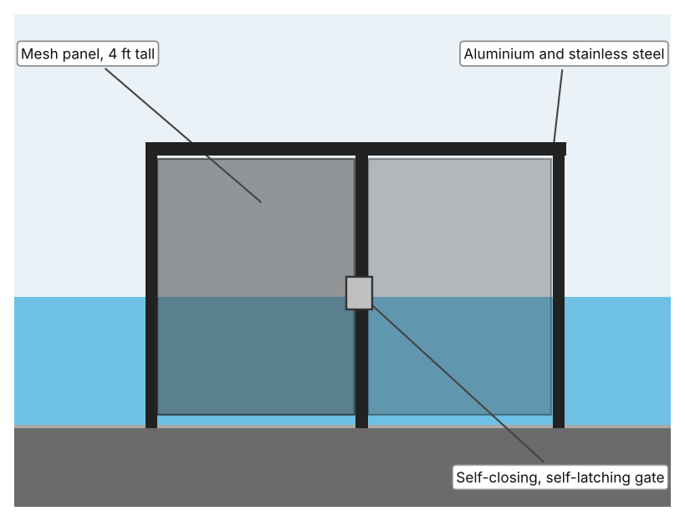  Illustration by the author based on “DIY Square Gate – 48 in Black,” Leslie's (Appendix A, Source 6).  [Student: replace with a photo from the source, cited MLA 9]
ACCESS FM analysis — analyse at least 4 strands per product with specific, cited evidence:
ACCESS FM | Product 1 | Product 2 | Product 3
Aesthetics | Orange or red body designed to be seen in the water; the article gives no colour (New Atlas). | Bag with a cinch strap; colour is not listed (NavStore). | Black powder-coated frame with mesh, designed to blend into a pool fence (Leslie's).
Cost | US$3,500 in 2010, with battery options costing from about $1,400 (New Atlas). | $47.95 on sale (was $59.53); sold out (NavStore). | $449.99; out of stock and for members only (Leslie's).
Customer | Lifeguards who reach swimmers caught in riptides without putting more rescuers in danger. | Anyone near water who can throw a line to a person in trouble. | Pool owners who want to keep young children from entering the pool area.
Environment | Electric; the first unit was built for NOAA in 2009. Run time is up to 15 minutes (New Atlas). | Polypropylene rope floats; the page gives no information on environmental impact. | Aluminium and stainless steel; UV-resistant mesh (Leslie's).
Size | 11 kg (24 lb); size not stated (New Atlas). | 750 g with the bag; box 3 × 7 × 14 in (NavStore). | 30 in wide and 48 in tall (Leslie's).
Safety | Can right itself if capsized; one version carries a camera and radio. Bystander view: a swimmer can hold on without a rescuer entering the water. | Rope tensile strength 862 kg. Bystander view: the rescuer stays out of the water but must throw accurately. | Meets CPSC recommendations for 4 ft height and 30 in opening; self-latching. Bystander view: works all the time, with no one needing to watch.
Function | Reaches swimmers at up to 39 km/h and 1.6 km from shore; returns them or is towed back; deploys in about 30 seconds. | Throws a line out to a person who can then be pulled in. | Closes and latches itself to keep a child away from the pool.
Materials | Impeller body; materials are not stated (New Atlas). | Polypropylene rope in a cinch-strap bag (NavStore). | Powder-coated aluminium frame and Textilene PVC-coated nylon mesh (Leslie's).
Pros & Cons:
 | Product 1 | Product 2 | Product 3
Pro | Fast, keeps rescuers out of danger and can carry a camera or sonar. | Very cheap, light and simple, with a strong floating rope. | Works around the clock without staff, and stops access before there is an emergency.
Con | Costs thousands, is heavy and needs a trained operator and a short run time. | Needs a person who can throw accurately and stay calm; range limited to the rope. | Does nothing once a child is in the water, and the page shows it out of stock.
Extension: analyse all 8 ACCESS FM strands per product, and evaluate each from the pedestrian/bystander's perspective, not just the buyer's.

A4 Design Brief + Appendix A
Bring A1–A3 together into one design brief, then compile your Appendix A.
📄 Write your design brief in PARAGRAPH FORM. Your brief must:
• Restate the client's need (from A1)
• Reference your research with sources (from A2)
• Summarise your A3 existing-products analysis for inspiration
• State your design intent, justified by the evidence you gathered
Write your design brief here (paragraph form):
My client, the Aquatics and Water Safety Committee of a Dubai school, needs the risk of drowning, and the danger to anyone who tries to help, to be reduced for students at the school pool, on trips and near water. The problem is serious: about 300,000 people drown every year, under-5s account for nearly a quarter of deaths, and drowning is the third leading cause of death for ages 5 to 14 (Appendix A, Source 1).
My research shows that drowning is silent and fast. Dubai Police say children can drown within seconds, often without people nearby noticing, and parents should not rely solely on lifeguards or flotation devices (Appendix A, Source 3). UAE police also advise fences, locked doors, life jackets and never leaving a child unattended (Appendix A, Source 2), and the WHO lists fencing and basic rescue skills among prevention measures (Appendix A, Source 1). My debatable questions led me to decide that prevention comes before rescue, and my challenged assumption (that lifeguards and floats are enough) was shown to be wrong. I still need evidence from my own school, which I will collect with my audit and survey (Appendix A, Sources 7 and 8).
I analysed three very different existing solutions. A remote-control rescue buoy travels at up to 39 km/h for 1.6 km, so a rescuer need not enter the water, but it cost US$3,500 in 2010 and has a run time of about 15 minutes (Appendix A, Source 4). A throw bag with 27.4 m of floating rope costs $47.95 and weighs 750 g, but it needs a person who can throw accurately (Appendix A, Source 5). A self-closing, self-latching gate 4 ft tall works all the time to keep children away from a pool, but costs $449.99 and does nothing once a child is in the water (Appendix A, Source 6). They give me three ideas for inspiration: reach a swimmer from a distance, pull someone in from the shore, and stop access in the first place. Each has a weakness that another covers.
My design intent is therefore to create a solution that reduces the chance of a child drowning, or helps someone to be reached safely if they get into trouble, without putting a rescuer at risk. It must be affordable for a school, simple enough for staff and students to use with brief training, dependable in hot and wet conditions, and safe in itself. I have deliberately not fixed what form it will take. That decision will be made in Criterion B, after I analyse my own audit and survey against the evidence in Appendix A.
Target: 350–600 words. Extension: explicitly reference Appendix A within your brief (e.g. "see Appendix A, Source 2").
APPENDIX A
Paste in your full A2 research notes and sources here (Appendix A). Reference this appendix explicitly within your design brief above.
# | Source (MLA 9) | Key notes | How I used it
1 | World Health Organization. “Drowning.” WHO, 1 May 2026, www.who.int/news-room/fact-sheets/detail/drowning. Accessed 21 Oct. 2026. | About 300,000 deaths a year; under-5s nearly a quarter; 4th cause of death ages 1–4 and 3rd ages 5–14; risk rises outside active adult supervision; prevention includes fencing and safe rescue skills. | A1; A2 Q1, Q3 and Q4; A4.
2 | Ahmad, Anwar. “Abu Dhabi Police: Parental Negligence Major Cause of Children Drowning.” Gulf News, updated 11 June 2019, gulfnews.com/uae/abu-dhabi-police-parental-negligence-major-cause-of-children-drowning-1.64513868. Accessed 21 Oct. 2026. | Negligence is a major reason for child drowning. Advice: fence pools, lock doors, life jackets, never leave a child unattended, a competent swimmer with rescue skills present. No statistics given. | A1; A2 Q2; A4.
3 | Borbon, Christian. “Dubai Police Urge Parents to Closely Supervise Children at Pools and Beaches.” Gulf News, updated 12 July 2026, gulfnews.com/amp/story/uae%2Fdubai-police-urge-parents-to-closely-supervise-children-at-pools-and-beaches-1.500605316. Accessed 21 Oct. 2026. | Children can drown silently within seconds. Constant direct supervision within reach. Do not rely solely on lifeguards or flotation devices. | A1; A2 Q2, Q3 and Q5; A4.
4 | “Emily: The Emergency Rescue Buoy.” New Atlas, 19 Dec. 2010, newatlas.com/emily-motorized-rescue-buoy/17297/. Accessed 21 Oct. 2026. | 11 kg; 39 km/h; up to 15 minutes; 1.6 km radio range; about 30 seconds to deploy; US$3,500 (2010); camera or sonar versions. Article is from 2010. | A2 Q4; A3 Product 1; A4.
5 | “Mustang Ring Buoy Throw Bag – 90' Rope.” NavStore, navstore.com/products/mustang-ring-buoy-throw-bag-90-rope-mrd190-0-0-215. Accessed 21 Oct. 2026. | $47.95; 90 ft (27.4 m) floating polypropylene rope; 750 g; tensile strength 862 kg; cinch-strap bag. | A2 Q4; A3 Product 2; A4.
6 | “DIY Square Gate – 48" Black.” Leslie's, lesliespool.com/diy-square-gate---48-black/24009.html. Accessed 21 Oct. 2026. | $449.99; 4 ft × 30 in; aluminium and stainless steel with Textilene mesh; self-closing, self-latching; meets CPSC recommendations; out of stock. | A2 Q4; A3 Product 3; A4.
7 | Own primary research: observation sheet (below). | Student audits the poolside and trip plans without entering the water. | A2 primary question; A4.
8 | Own primary research: short student survey (below). | Student asks at least 20 people and records the ratings. | A2 primary question; A4.
Source 7: water-safety audit sheet (blank instrument; student data needed)
Location | Fence or locked gate (Y/N) | Rescue equipment visible (Y/N) | Supervising adults in reach | Warning signs (Y/N) | Notes
School pool
Pool entrance
Beach or water-park trip plan
Changing area
Source 8: student survey (blank instrument; rate each statement from 1 = strongly disagree to 5 = strongly agree; student data needed)
Statement | 1 | 2 | 3 | 4 | 5
I know how to help someone in trouble in water without putting myself in danger.
I know where rescue equipment is kept at our pool or on trips.
Adults at the pool or beach watch us closely all the time.
I feel confident about my swimming skills.
Total responses (tally)

✓ FINAL CHECKLIST — Tick Before Submitting
Review your complete Criterion A document against every point below.
☑ A1: client, need, target audience, why, one image + one statistic (evidence)
☑ A2: factual / conceptual / debatable questions — each prioritised, sourced, evidenced
☑ A3: 3 significantly different products, screenshots, ACCESS FM analysis, pros/cons
☑ A4: need restated, research referenced, Appendix A attached AND referenced, existing-products summary included
☑ All four sections written in full paragraphs — no bullet points
☑ Document proofread before final submission

