**Programming Assignment-3 Logistic Regression - Part II[1]**

**First Name1: ____________ Last Name1: _________________**

**First Name2:____________ Last Name 2: _________________**

**Introduction**

In this part of the assignment, you will implement regularized logistic regression to predict whether microchips from a fabrication plant passes quality assurance (QA). During QA, each microchip goes through various tests to ensure it is functioning correctly.

Suppose you are the product manager of the factory and you have the test results for some microchips on two different tests. From these two tests, you would like to determine whether the microchips should be accepted or rejected. To help you make the decision, you have a dataset of test results on past microchips (pa3-data2-polynomial.csv), from which you can build a logistic regression model.

**Note that the first two columns** (i.e., *x*1 and *x*2) represent the two tests. The rest of the columns are the polynomial terms, e.g., *x*1 * *x*2, *x*12, *x*22, *x*13 , *x*12*x*2, …

**2.1. Plot the training data**

From the visualized data, you can see that this data set is not linearly separable. Please attach the image of data visualization here.

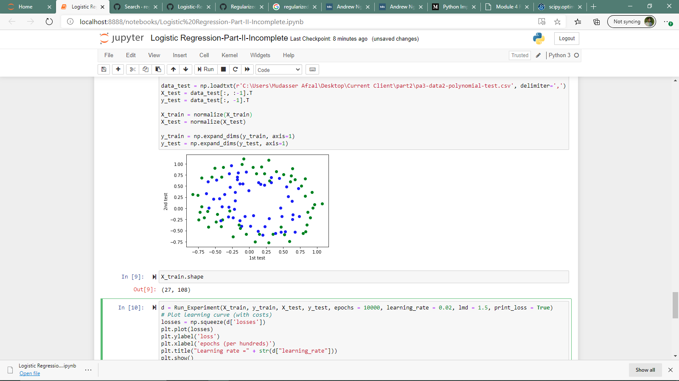

**2.2. Regularized Cost Function and Gradient**

***L*(*W*) = ] +**

***wj = wj − α \** [ ]**

* 1. **Learning the parameters based on the file pa3-data2-polynomial.csv (Set $λ=1$)**

Please attach the image of the decision boundary.

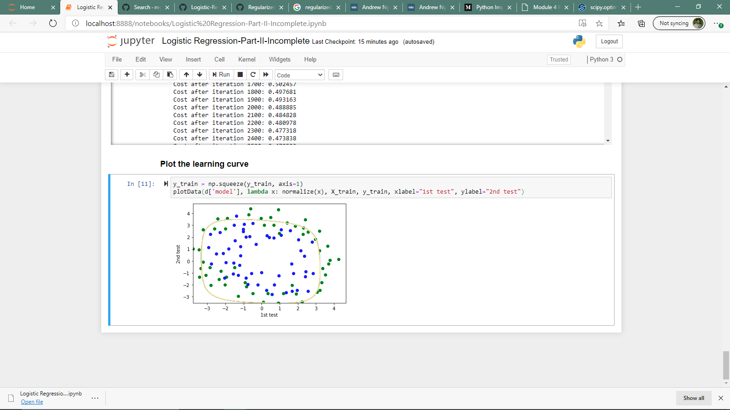

**Submission:**

* **Rule1:**
  + If you work with a partner, please name your zipped file as follows:

PA3_LNAME1_LNAME2.Zip for folder and PA3_LNAME1_LNAME2.docx for a word document, i.e., the file names should include both LAST NAMEs.

* + If you work on your own, the format should be

PA3_LNAME.Zip for folder and PA3_LNAME.docx for a word document.

* **Rule2:**
  + Put your FULL names whether working in a group or individual in the word document that answers all the questions.
* **Rule3:**
  + **EVERYONE** in the class should submit this Assignment, which should provide all files (like test excel files etc.. ) that are necessary for the execution of code in the submission folder.
* **Rule4:**
  + Please submit two Jupyter files, each of which is corresponding to Part I and Part II, respectively.

1. Part of the materials are from Dr. Andrew Ng’s course.