Q.1: Create two integer variables length and breadth and assign values then check if they are square values or rectangle values.  
ie: if both values are equal then it's square otherwise rectangle

import 'dart:io';

void main(){

  var l=5; //lenght

  var b=5; //breadth

  if(l==b){

    print("It is square");

  }

  else{

    print("It is rectangular");

  }

}

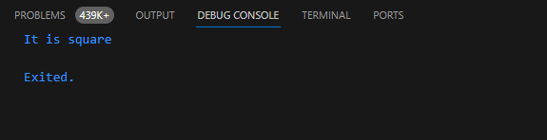Output

Q.2: Take two variables and store age then using if/else condition to determine oldest and youngest among them.

import 'dart:io';

void main(){

  var name1="Mudassir";

  var age1= 24;

  var name2="Ijlal";

  var age2=22;

  if(age1>age2){

    print("Mudassir is older than ijlal");

  }

  else if(age1==age2){

    print("Mudassir age is same as ijlal");

  }

  else{

    print("Mudassir is younger than ijlal");

  }

}

Output

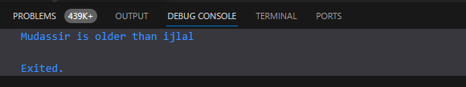

Q.3: A student will not be allowed to sit in exam if his/her attendance is less than 75%. Create integer variables and assign value:  
Number of classes held = 16,  
Number of classes attended = 10,  
and print percentage of class attended.  
Is student is allowed to sit in exam or not?

void main(){

  var c1=16; //classes held

  var c2=10; //classes attended

  var c3= (c2/c1)*100;

  print(c3);

  if(c3>=75){

    print("Student is allowed to sit in exam");

  }

  else{

    print("Student is not allowed to sit in exam");

  }

}

Output

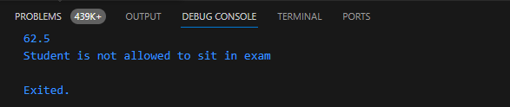

Q.4: Create integer variable assign any year to it and check if a year is leap year or not.  
If a year is divisible by 4 then it is leap year but if the year is century year like 2000, 1900, 2100 then it must be divisible by 400.  
i.e: Use % ( modulus ) operator.

import 'dart:io';

void main(){

  stdout.write("Enter Year: ");

  double? year = double.parse(stdin.readLineSync()!);

  if((year%4==0 && year%100 !=0) || (year%400==0)){

  print('It is leap year');

  }

  else{

    print("It is not a leap year");

  }

}

Output

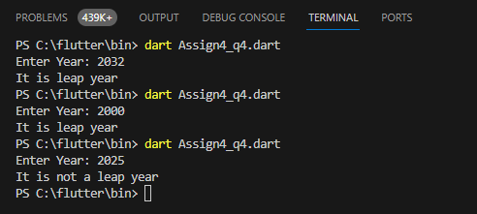

Q.5  Write a program to read temperature in centigrade and display a suitable message according to temperature:  
You have num variable temperature = 42;  
Now print the message according to temperature:  
temp < 0 then Freezing weather  
temp 0-10 then Very Cold weather  
temp 10-20 then Cold weather  
temp 20-30 then Normal in Temp  
temp 30-40 then Its Hot  
temp >=40 then Its Very Hot

import 'dart:io';

void main(){

  stdout.write("Enter the Temperature in Centigrade: ");

  double? temp = double.parse(stdin.readLineSync()!);

  if(temp>=40){print("Its very Hot");}

  else if(temp>=30){print("Its Hot");}

  else if(temp>=20){print("Normal Temp");}

  else if(temp>=10){print("cold weather");}

  else if(temp>=0){print("Very Cold Weather");}

  else{print("Freezing Weather");}

}

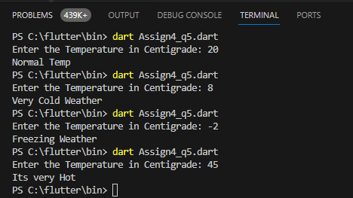Output

Q.6 Write a Dart program that prompts the user to input their age. Based on their age, the program should print whether they are a child (0-12 years), teenager (13-19 years), adult (20-59 years), or senior (60+ years) using if-else statements

import 'dart:io';

void main(){

  stdout.write("Enter Your Age: ");

  double? age = double.parse(stdin.readLineSync()!);

  if(age>=60){print("You are senior");}

  else if(age>=20){print("You are Adult");}

  else if(age>=13){print("You are Teenager");}

  else if(age>=0){print("You are child");}

  else{print("Incorrect Age");}

}

Output

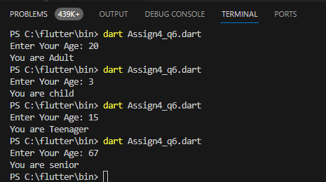

Q.7 Create a Dart program that acts as a basic ATM machine. Ask the user for their current balance and the amount they wish to withdraw. Ensure the withdrawal amount doesn't exceed the balance and display the remaining balance using if-else statements.

import 'dart:io';

void main(){

  stdout.write("Enter Your Current Balance : ");

  double? c_amount = double.parse(stdin.readLineSync()!); //current balance

  stdout.write("Enter the withdraw amount : ");

 double? w_amount = double.parse(stdin.readLineSync()!);  //withdraw amount

 double rem_balance = c_amount - w_amount;

 if(w_amount<c_amount){print("The Remaining Balance : $rem_balance"+"\n");}

 else{print("The withdraw Amount can not the greater than current balance\n");}

}

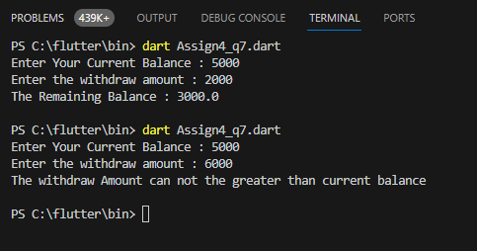**Output**

Q.8 : Create a list of names and print all names using list

void main(){

  var name=["Mudassir","Muzamil","Ijlal","Hassan"];

  print(name[0]);

  print(name[1]);

  print(name[2]);

  print(name[3]);

}

Output

