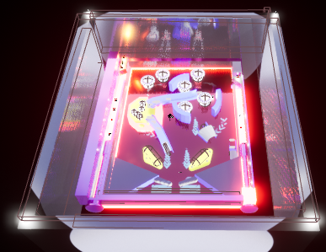

Change 1:Borders

Approach:

1.)Add 4 box brushes from geometry

2.)Merge them using brush mode

3.)Add materials to it

4.)Add some lights

Difficulties

1.)Using subtractive brushes

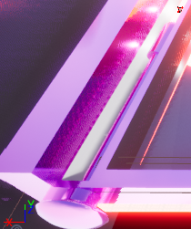

Change 2:Second Plunger

Approach:

1.)Add BP_Plunger into the scene

2.)Use subtractive box brushes to fit the plunger into the void.

3.) Use subtractive box brushes to make ball entry

4.)Use for loop for getting 2 plunger in array of plungers.

5.)Use for loop in player control mode for pressed and released controls

6.)Adjust balls to be spawned

Diffculties:

1.)Using brushes

2.)Moving both plungers at the same time

3.)Making Ball entry

4.)Spawning Changes

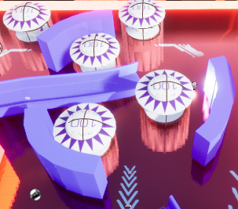

Change 3:Central Region

Approach:

1.)Add three BP_bumpers

2.)Use Box Brush to make three such parts and rotate to form an arc make sure 3 arcs are in sync.

3.)Add materials to them

Difficulty

1.)Adjusting bumpers and box brushes

2.)Rotating boxes properly.

Change 4:Bonus Region

1.)Add Additive cylinder from geometry

2.)Scale it properly

3.)Add subtractive cylinder from geometry and mold it into 1st cylinder

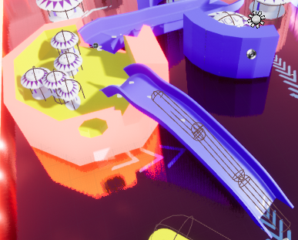

4.)Add 5 bumpers scale them small

5.) Add subtractive cylinder from geometry and scale it small

6.)Fit it for ball’s exit

7)Add 2 Ramps shown in the image ,make space for them make sure they only allow ball in upward direction.

8.)Make sure ball goes up only and for that add capsule collisions which adds impulse inn upward direction only

Difficulties:

1.)Adjusting spaces for bumpers

2.)Bumper collsions

3.)Ball was not going into the ramp initially

4.)Adjusting proper impulse for upward movement.

5.)Making hole for exit

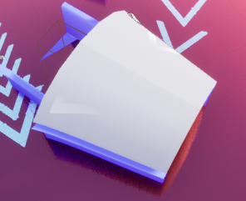

Change 5:Cannon

Approach:

1.)Use splines add plastic Ramp with top(Logic used in construction script)

2.)Scale plastic asset using Scale Start and End in the construction script.

3.)Use box Collision

4.) Cast ball to it add impulse.

Difficulties:

1.)Adjusting Collisions for ramp and plastic

2.)Ball got stuck

2.)TOO much impulse was applied and ball flew off .

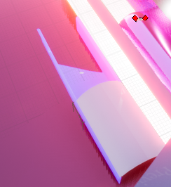

Change 6:Teleport Zone

Approach:

1.)Use splines add plastic Ramp with top(Logic used in construction script)

2.) Use box Collision

3.) Cast it to bp ball

4.)Destroy actor

5.)Add a Sound cue

6.)Spawn it at the bonus region

For that enable 3d widget for ramp

Add teleport location

7.)Make a function to transform ball position to world location

8.)Now use that in another spawn function used in pinballgamemode

Diifficulties:

1.)Adjusting collision

2.)Making teleport function

3.)Spawning it at the right place

4.)It shows a glitch which is that when the ball reaches this region it shows main menu