Project Report On
AGENTIFY: DESIGN AND IMPLEMENTATION OF MULTI-AGENT AUTONOMOUS SYSTEM FOR INTELLIGENT TASK AUTOMATION
Submitted to
JAWAHARLAL NEHRU TECHNOLOGICAL UNIVERSITY ANANTHAPUR, ANANTHAPURAMU
In Partial Fulfillment of the Requirements for the Award of the Degree of
BACHELOR OF TECHNOLOGY
In
COMPUTER SCIENCE AND TECHNOLOGY
Submitted By

T MUDASSIR KHAN - (22691A28B2)
S SHABEER - (22691A28A7)
B JAYA SAI - (22691A2876)
D NAGESWAR REDDY - (22691A28B3)
Under the Guidance of
Mr. Ashok K
Assistant Professor
DEPARTMENT OF COMPUTER SCIENCE AND TECHNOLOGY


MADANAPALLE INSTITUTE OF TECHNOLOGY & SCIENCE (UGC – AUTONOMOUS)
(Affiliated to JNTUA, Ananthapuramu) Accredited by NAAC, Approved by AICTE, New Delhi
AN ISO 21001:2018 Certified Institution
P. B. No: 14, Angallu, Madanapalle – 517325
2022-2026



DEPARTMENT OF COMPUTER SCIENCE AND TECHNOLOGY

BONAFIDE CERTIFICATE

This is to certify that the Project Work and Internship (20CST703) work entitled “Design and Implementation of Multi-Agent Autonomous Systems for Intelligent Task Automation” is a bonafide work carried out by

T MUDASSIR KHAN - (22691A28B2)
S SHABEER - (22691A28A7)
B JAYA SAI - (22691A2876)
D NAGESWAR REDDY - (22691A28B3)

Submitted in partial fulfillment of the requirements for the award of degree Bachelor of Technology in the stream of Computer Science and Technology in Madanapalle Institute of Technology & Science, Madanapalle, affiliated to Jawaharlal Nehru Technological University Ananthapur, Ananthapuramu during the academic year 2025-2026.

Guide Head of the Department
Mr. Ashok K Dr. K. Dinesh
Assistant Professor Assoc. Professor and Head Department of CST Department of CST
Submitted for the university examinations held on

Internal Examiner External Examiner
Date: Date:

ACKNOWLEDGEMENT

We would like to express our sincere gratitude to the Management of Madanapalle Institute of Technology & Science for providing exceptional infrastructure and laboratory facilities that were instrumental in enabling us to successfully complete our project. The excellent resources and support provided by the institution played a vital role in helping us achieve our academic goals.
We express our sincere gratitude to Dr. P. Ramanathan, M.E., Ph.D., Principal, for his invaluable guidance and unwavering support that enabled us to successfully complete our project at Madanapalle Institute of Technology & Science, Madanapalle.
We are deeply grateful to Dr. K. Dinesh, M.Tech., Ph.D., Associate Professor and Head, Department of CST, for his steadfast support and tireless efforts that contributed to the successful completion of our project.
We are immensely grateful to Mr. Abdul Jaleel D, M.E., (Ph.D.), Assistant Professor, Project Coordinator, Department of CST for his invaluable guidance, encouragement, and support that enabled us to successfully complete this project.
We would like to express our profound gratitude to our guide, Mr. Ashok K, M.S., Assistant Professor, Department of CST, for his invaluable guidance and unwavering encouragement that played a pivotal role in the successful completion of our project. His expertise, in sights, and mentorship were crucial in navigating the intricacies of the project and achieving our objectives.
We express our sincere thanks to Mr. V. Naveen, M.E., (Ph.D.), Assistant Professor, Internship Coordinator, Department of CST for his tremendous support for the successful completion of the Project.
We would also like to express our gratitude to the other faculty members of the Department of CST and our parents for their invaluable help and support during our project work.

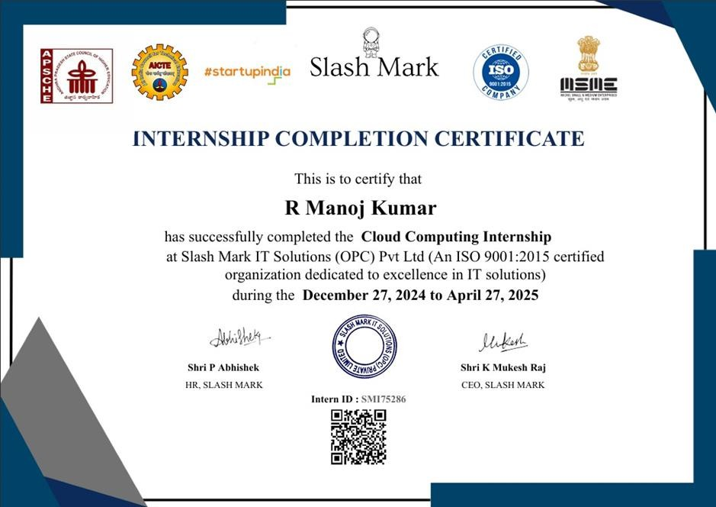
INTERNSHIP CERTIFICATE

INTERNSHIP CERTIFICATE
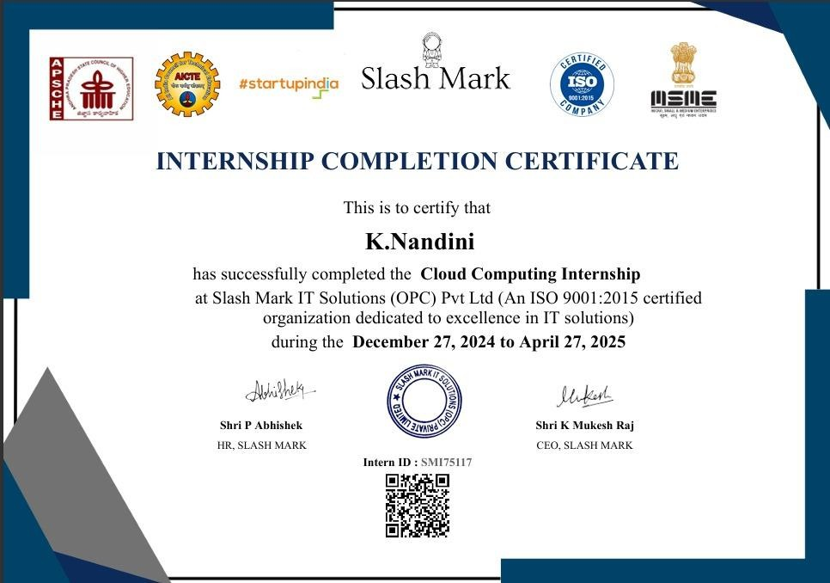

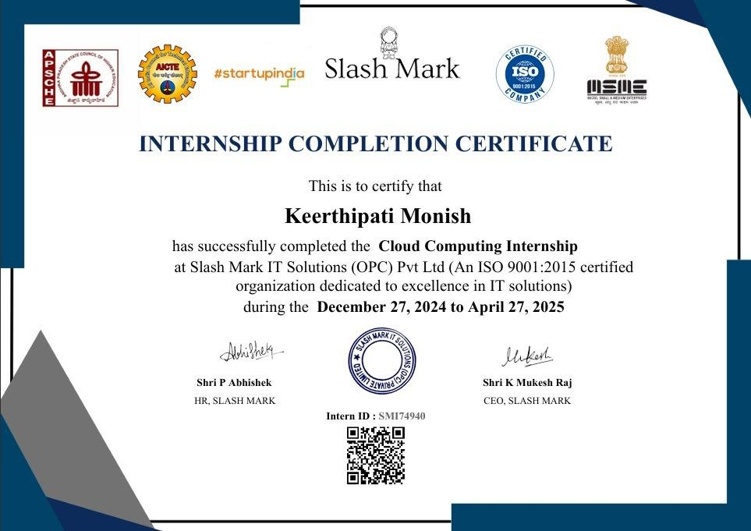
INTERNSHIP CERTIFICATE

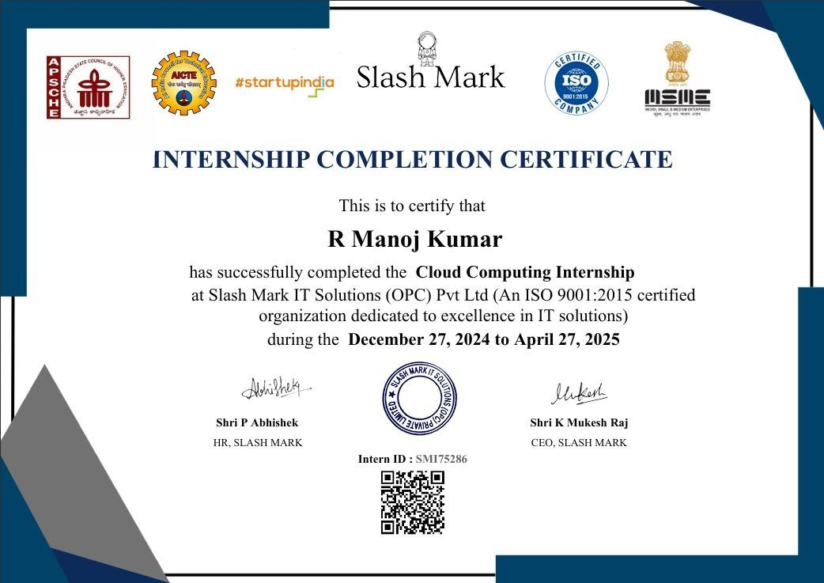
INTERNSHIP CERTIFICATE


DEPARTMENT OF COMPUTER SCIENCE AND TECHNOLOGY
Plagiarism Verification Certificate
This is to certify that the B. Tech Project Work and Internship (20CST703) work report titled, “Design and Implementation of Multi-Agent Autonomous Systems for Intelligent Task Automation” submitted by T MUDASSIR KHAN - (22691A28B2) S SHABEER - (22691A28A7) B JAYA SAI - (22691A2876) D NAGESWAR REDDY - (22691A28B3) has been
evaluated using Anti- Plagiarism Software, Turnitin and based on the analysis report generated by the software, the report’s similarity index is found to be 8%.
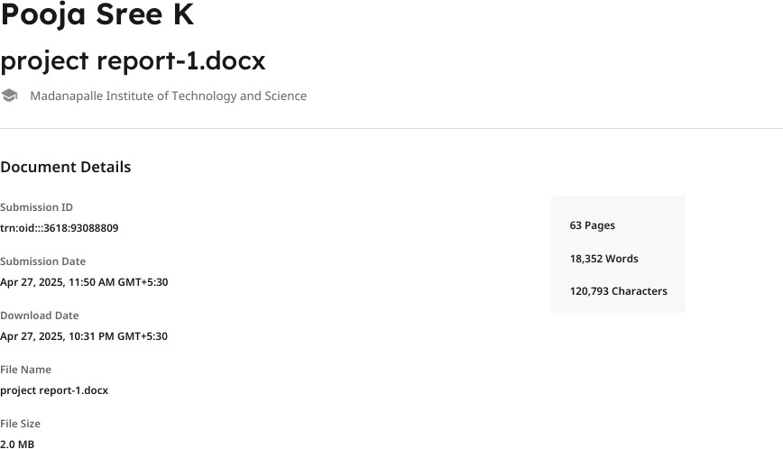
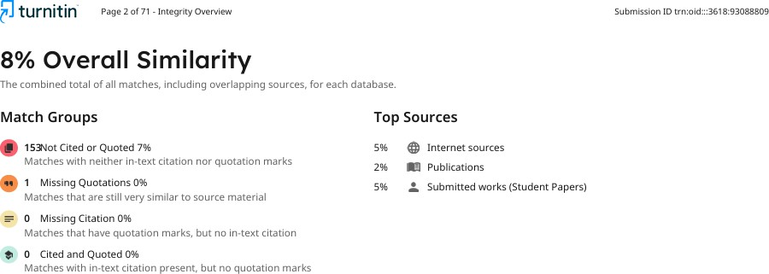

HOD-CST

DECLARATION
We hereby declare that the results embodied in this Project Work and Internship (20CST703) work “Design and Implementation of Multi-Agent Autonomous Systems for Intelligent Task Automation” by us under the guidance of Mr. Ashok K, M.S.,Assistant Professor, Department of CST in partial fulfillment of the award of Bachelor of Technology in Computer Science and Technology from Jawaharlal Nehru Technological University Anantapur, Ananthapuramu and we have not submitted the same to any other University/institute for award of any other degree.

Date:
Place:

PROJECT ASSOCIATES

T MUDASSIR KHAN
S SHABEER
B JAYA SAI
D NAGESWAR REDDY

I certify that the above statement made by the students is correct to the best of my knowledge.

Date: Guide
Mr. Ashok K
Assistant Professor
Department of CST

ABSTRACT

The Multi-Agent Autonomous System project aims to provide an intelligent, modular, and scalable task automation platform leveraging collaborative AI agent architecture and real-time API integration. With the increasing complexity of real-world automation demands, traditional single-agent frameworks and rule-based automation tools expose users to significant operational limitations, including rigid execution logic, inability to handle dynamic multi-step tasks, and the absence of contextual reasoning across interdependent workflow stages. By implementing a Multi-Agent Autonomous System within a structured node-based workflow execution environment, this project ensures an adaptive and reliable automation pipeline where multiple specialized AI agents collaborate to perform tasks autonomously with minimal human intervention. The architecture integrates modern technologies such as React.js and Next.js for the visual frontend interface, Node.js for the backend execution engine, Convex for real-time database management, Clerk for secure user authentication, Google Gemini and OpenAI for AI-powered agent reasoning, Arcjet for system-level security enforcement, and React Flow for interactive visual workflow construction, ensuring a streamlined and intelligent automation framework that prioritizes modularity, reliability, and scalability at every stage of design and deployment. This paper explores the technical implementation, agent collaboration mechanisms, workflow execution design, and potential applications of the Multi-Agent Autonomous System concept across enterprise, research, and individual automation domains. Furthermore, it discusses how embedding intelligent agent reasoning and real-time API integration into the workflow execution pipeline enhances operational efficiency and eliminates the bottlenecks associated with conventional automation approaches. Through continuous agent coordination, real-time state synchronization, and human-in-the-loop approval mechanisms, the system remains adaptable to diverse and evolving real-world task requirements, making it an effective and future-ready solution for intelligent autonomous task automation in modern AI-driven operations.
Keywords: Multi-Agent Systems, Autonomous Task Automation, Large Language Models, Intelligent Workflow Execution, Real-Time API Integration, Agent Collaboration, Visual Workflow Builder, React Flow, Convex Database, AI-Powered Reasoning.

TABLE OF CONTENTS

CHAPTER NO | TITLE | PAGE NO
 | ACKNOWLEDGEMENT | iii
 | DECLARATION | ix
 | ABSTRACT | x
 | LIST OF FIGURES | xiv
 | LIST OF ABBREVATIONS | xv
1 | INTRODUCTION | 1
 | 1.1 Motivation | 3
 | 1.2 Problem Definition | 5
 | 1.3 Objective of the Project | 5
 | 1.4 Scope of the Project | 6
2 | LITERATURE SURVEY | 8
 | 2.1 Overview | 9
 | 2.2 Related Work | 10
 | 2.3 Virtual Browsers | 11
 | 2.4 Extract from Literature | 13
 | 2.5 Summary | 15
3 | PROBLEM ANALYSIS | 17
 | 3.1 Existing System | 18
 | 3.2 Proposed System | 20

 | 3.3 System Specification | 23
 | 3.3.1 Hardware Configuration | 23
 | 3.3.2 Software Configuration | 23
 | 3.3.3 Functional Requirements | 23
 | 3.3.4 Non-Functional Requirements | 26
4 | SYSTEM DESIGN  - System Architecture  - Methodology of the Proposed Work  - UML Design  - Usecase Diagram  - Class Diagram  - Sequence Diagram  - Activity Diagram  - DFD Diagram | 29  30  32  39  39  40  41  42  43
5 | IMPLEMENTATION & RESULTS | 45
 | - Parameter Settings | 46
 | 5.2 Method of Implementation | 47
 | 5.3 Source code | 48
 | 5.4 Output | 53
 | 5.5 Result Analysis | 54
6 | SYSTEM TESTING | 57
 | 6.1 Testing Methodology | 58

7 | CONCLUSION  - Conclusion  - Future Scope | 62  63  64
 | REFERENCES | 68

LIST OF FIGURES

FIGURE  NO. | NAME OF THE FIGURE | PAGE  NO.
4.1  4.2 | System Architecture  Use Case Diagram | 31  40
5.1 | Flow Diagram | 48
5.2 | AWS Instance Interface | 48
5.3 | Instance Launch Log | 49
5.4 | Instance Details | 49
5.5 | Mobexterm Interface | 50
5.6 | Mobexrterm Scripting | 50
5.7 | Jenkins Initialization | 51
5.8 | Jenkins Interface | 51
5.9 | Jenkins Plugins | 52
5.10 | SonarQube Login | 52
5.11 | Browser Interface | 53
5.12 | Final Browser Output | 53

LIST OF ABBREVIATIONS
Abbreviation | Full Form
AI | Artificial Intelligence
LLM | Large Language Model
API | Application Programming Interface
REST | Representational State Transfer
JSON | JavaScript Object Notation
UI | User Interface
UX | User Experience
AWS | Amazon Web Services
CI/CD | Continuous Integration / Continuous Deployment
HTTPS | Hypertext Transfer Protocol Secure
SSL/TLS | Secure Socket Layer / Transport Layer Security
JWT | JSON Web Token
UML | Unified Modelling Language
STLC | Software Testing Life Cycle
UAT | User Acceptance Testing
DB | Database
SDK | Software Development Kit

