Functional Requirement Document
Application Name: Zuply
Marketplace for Local Retailers
INTQEA26SD002- POD2
Team- Lampart

Table of Contents
- Introduction
1.1 Purpose
1.2 Intended Audience
- Functional Requirements
2.1 Home Page
2.2 Sign In / Login
2.3 Login Page
2.4 Customer Search
2.5 Search Result Page
2.6 Wishlist Feature
2.7 Wishlist Page
2.8 Customer Cart
2.9 Checkout Page
2.10 Customer Orders
2.11 Customer Profile
2.12 Seller Dashboard
2.13 Product Upload
2.14 Seller Products
2.15 Seller Orders
2.16 Admin Dashboard
2.17 Admin Sellers
2.18 Admin Products
2.19 Admin Reports
- Non-Functional Requirements
3.1 Performance
3.2 Security
3.3 Usability
3.4 Validation
3.5 Scalability
- Transaction Flow
4.1 Customer Purchase Flow
4.2 Seller Product Upload Flow
- Future Enhancements

1. Introduction
This Functional Requirement Document (FRD) explains how users interact with the application and how the system responds to those interactions.
Zuply is a local retail marketplace designed to connect customers with nearby retailers such as kirana shops and small local businesses. The platform allows sellers to list products and customers to search, browse, and purchase products from retailers within their locality.
1.1 Purpose
The purpose of this document provides a clear understanding of system behaviour and expected outputs for different user interactions.
1.2 Intended Audience
This document is intended for:
• Development Team
• Quality Assurance Team
• Business Analysts
• Database Team
• Project Stakeholders
2. Functional Requirements
The Zuply platform supports three primary user roles:
• Customer
• Seller
• Administrator
When a user enters the Zuply website URL, the system should navigate to the Home Page.

2.1 Home Page
The Home Page should be the landing page of the Zuply application.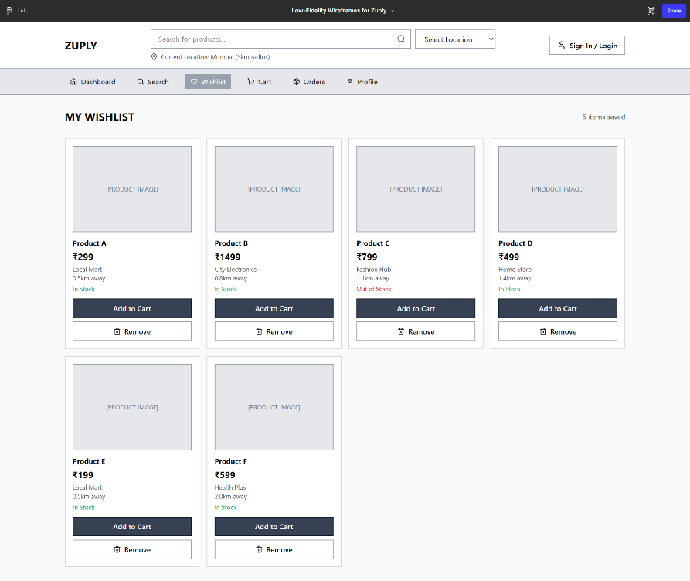
The top section of the Home Page should include:
• Zuply Logo
• Product Search Bar
• Location Selector
• Sign In / Login icon (top-right corner)
The Home Page should contain the following sections.
- Category Section
Displays supported product categories:
• Food & Beverage
• Grocery
• Fashion & Footwear
• Home & Kitchen
• Electronics
• Beauty & Personal Care
• Health & Wellness
• Agriculture
- Featured Products Section
Displays product cards uploaded by sellers.
Each product card should display:
• Product Image
• Wishlist / Like (Heart) icon
• Product Name
• Product Price
• Seller Name
• Add to Cart button
- Nearby Sellers Section
Displays sellers located within the selected locality.
2.2 Sign In / Login
The Sign In / Login icon should be available on the top-right corner of the Home Page.
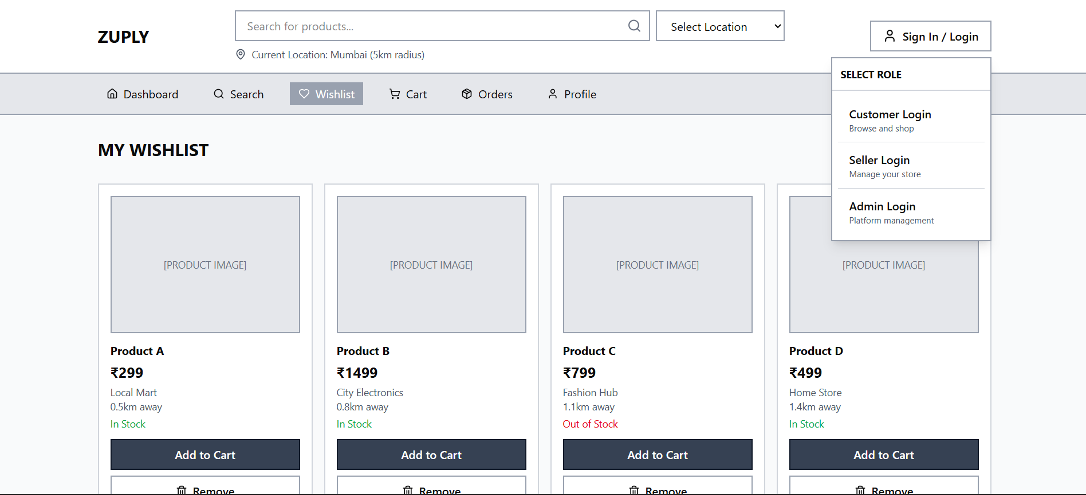
When the user clicks the icon, the system should display role selection options:
• Customer Login
• Seller Login
• Admin Login
Selecting a role should redirect the user to the respective login page.
2.3 Login Page
The login page should contain the following fields:
• Role Selection (Customer / Seller / Admin)
• Email Address
• Password
The page should contain the following buttons:
• Login
• Reset
• Cancel
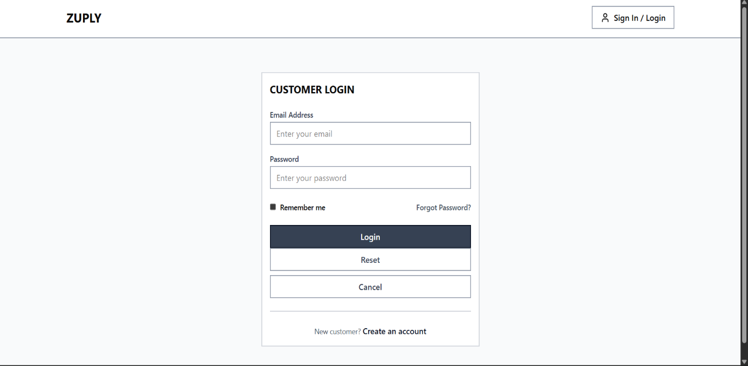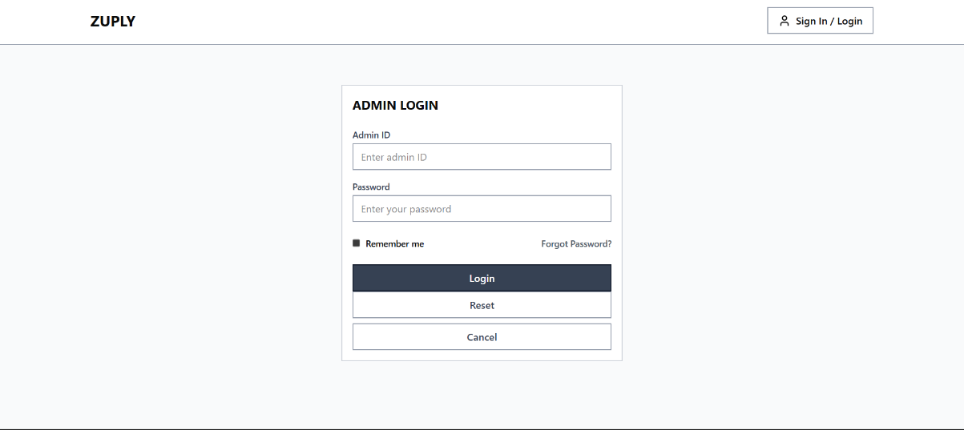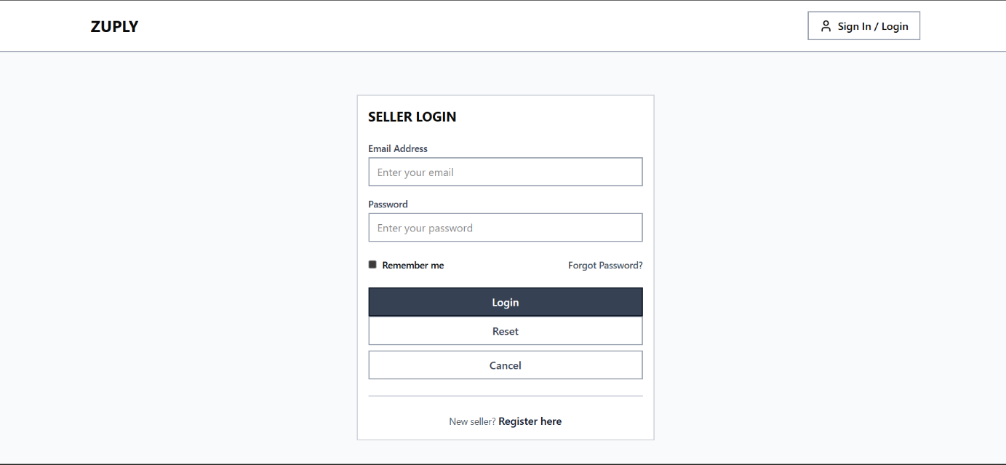
If login credentials are valid, the user should be redirected to the respective dashboard.
If invalid credentials are entered, the system should display the message:
“Invalid username or password.”
2.4 Customer Search
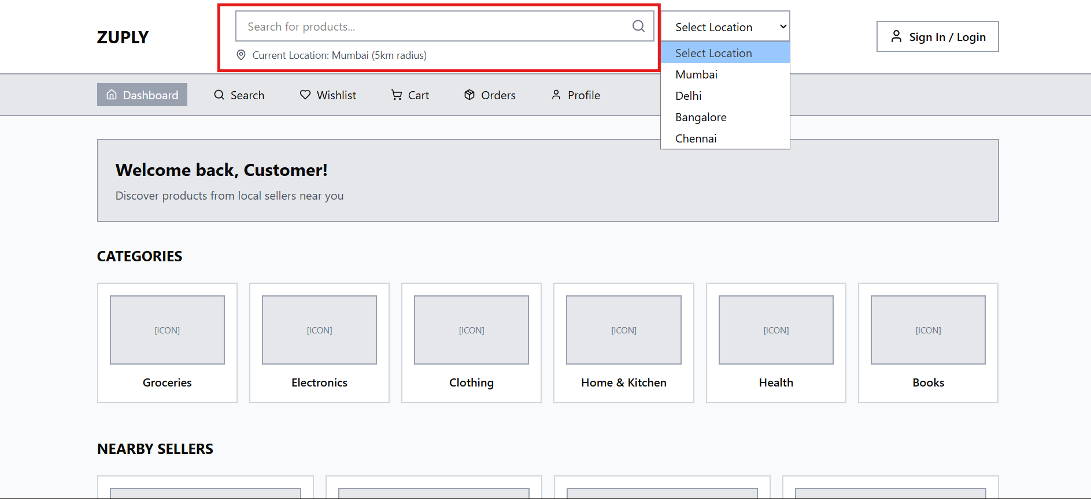
The Home Page should allow customers to search for products.
Search inputs:
• Location textbox
• Product textbox
• Search button

Example search:
Location: Chennai
Product: Rice
If the product is available in the specified location, the system should display search results.
If no results are found, the system should display the message:
“No products available in this location.”
2.5 Search Result Page
The Search Result Page should display product cards matching the search criteria.
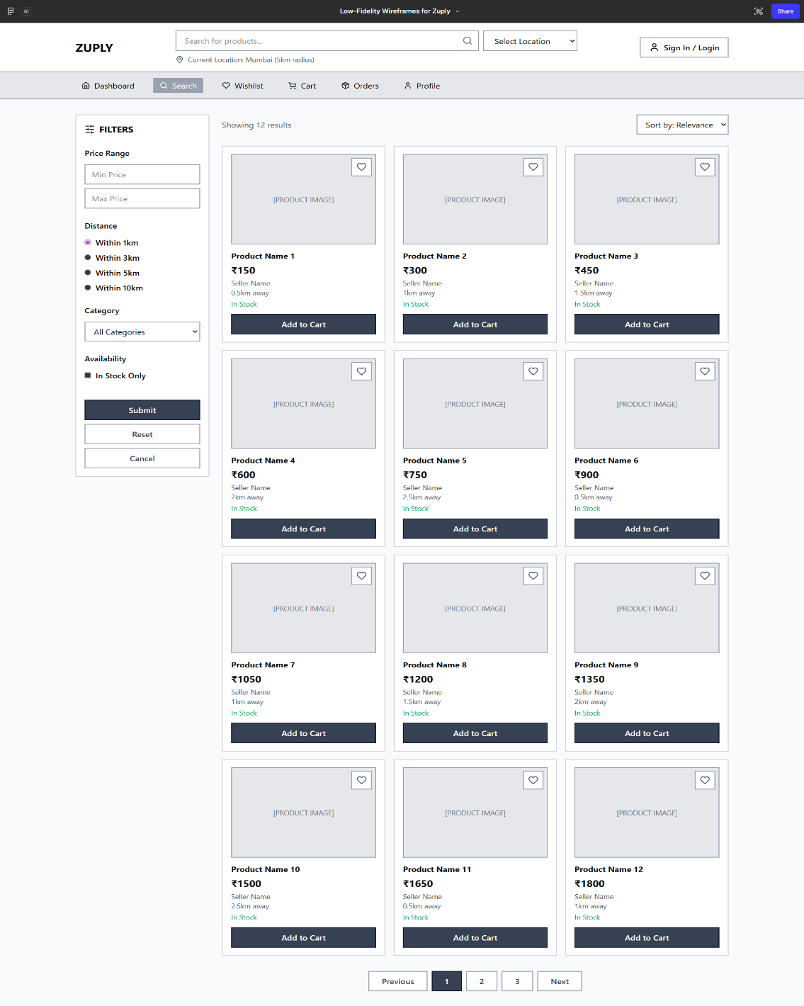

Each product card should display:
• Product Image
• Wishlist / Like (Heart) icon
• Product Name
• Product Price
• Seller Name
• Add to Cart button
Sorting options available:
• Price (Low to High)
• Price (High to Low)
• Distance from Seller
• Popular Products
2.6 Wishlist Feature
The Wishlist feature allows customers to save products for future purchase.
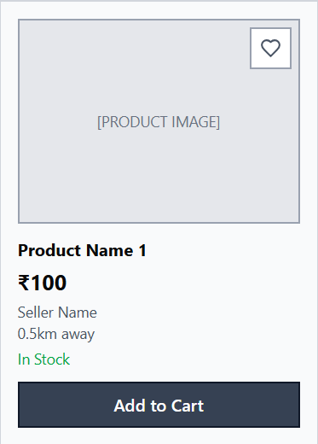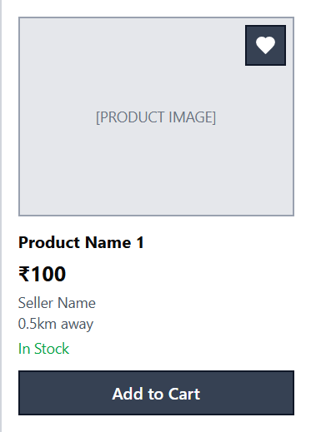
Each product card should contain a heart icon.
When the user clicks the heart icon:
• The product should be added to the user's wishlist
• The icon state should change to indicate the product is saved
If the user is not logged in, the system should display:
“Please login to add items to wishlist.”
2.7 Wishlist Page
The Wishlist Page should display all products saved by the customer.
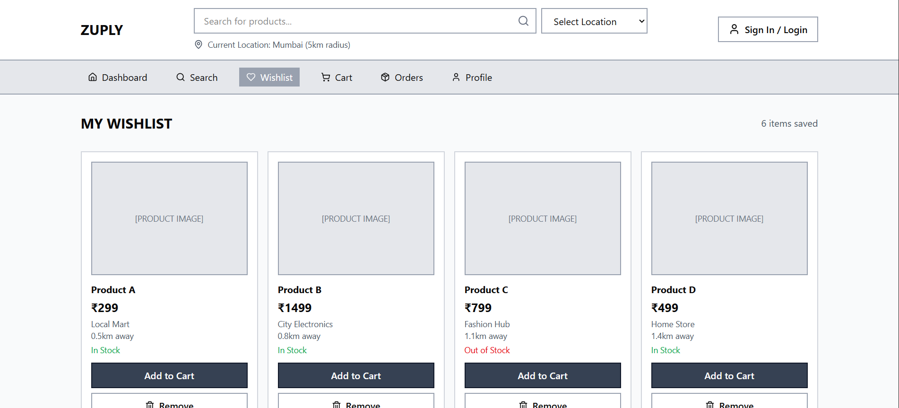
Each wishlist item should display:
• Product Image
• Product Name
• Product Price
• Seller Name
Available actions:
• Remove from Wishlist
• Add to Cart
2.8 Customer Cart
The Cart page should display products selected by the customer.
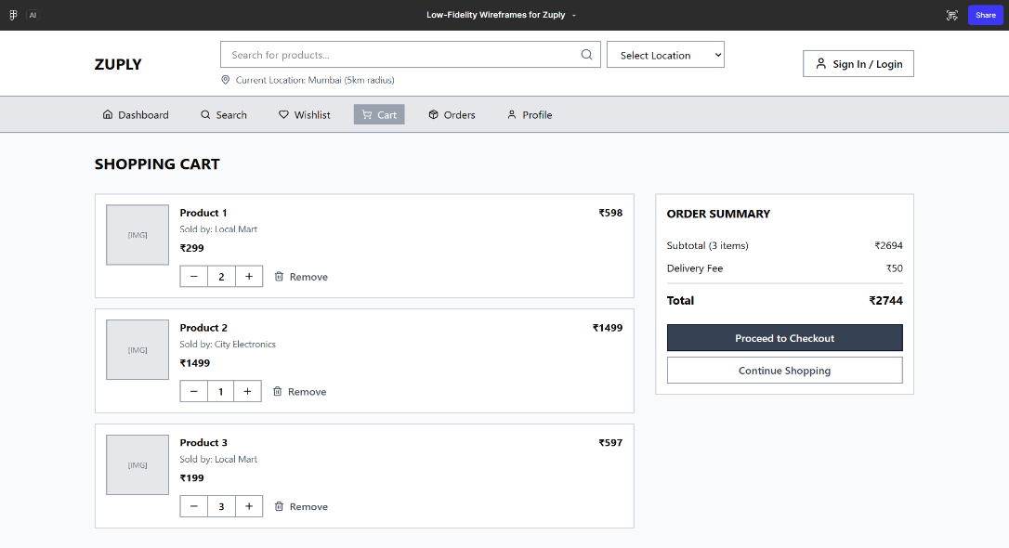
Each cart item should include:
• Product Image
• Product Name
• Quantity Selector
• Price per unit
• Total price
The page should display the total order amount.
Available actions:
• Increase quantity
• Decrease quantity
• Remove item
Buttons:
• Continue Shopping
• Checkout
2.9 Checkout Page
The Checkout page should allow customers to place orders.
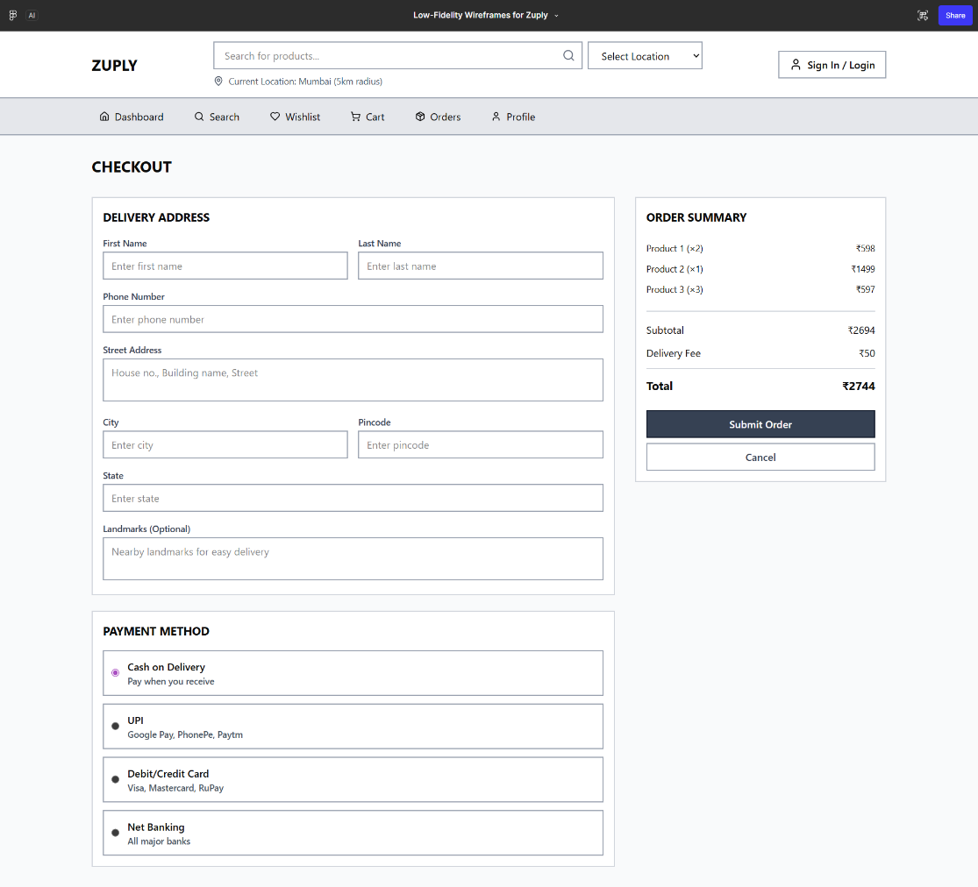
Sections included:
Delivery Address Form
Fields:
• Customer Name
• Phone Number
• Address
• City
• Pincode
Payment Methods
• UPI
• Card Payment
• Cash on Delivery
Order Summary
Displays selected products and total order amount.
Buttons available:
• Submit Order
• Reset
• Cancel
The system should validate the order amount before submission.
2.10 Customer Orders
The Orders page should display order history.
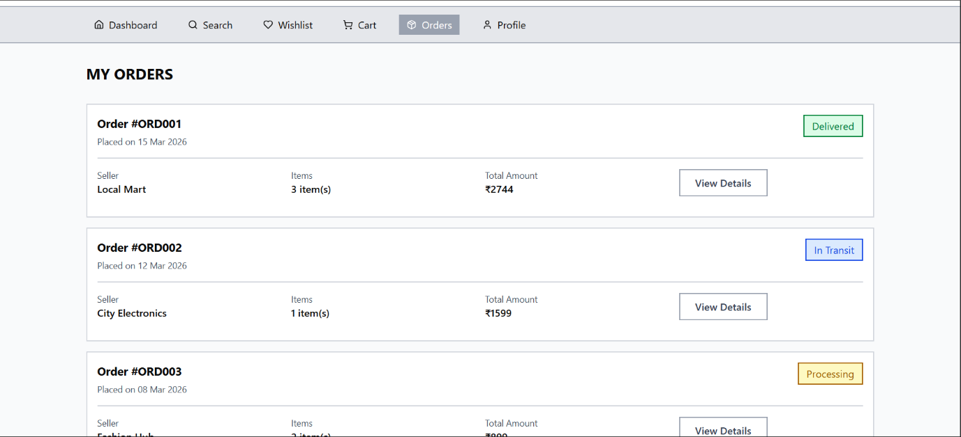
Each order should contain:
• Order ID
• Order Date
• Product Name
• Quantity
• Order Amount
• Order Status
Order status values:
• Placed
• Processing
• Delivered
2.11 Customer Profile
Allows customers to manage personal information.
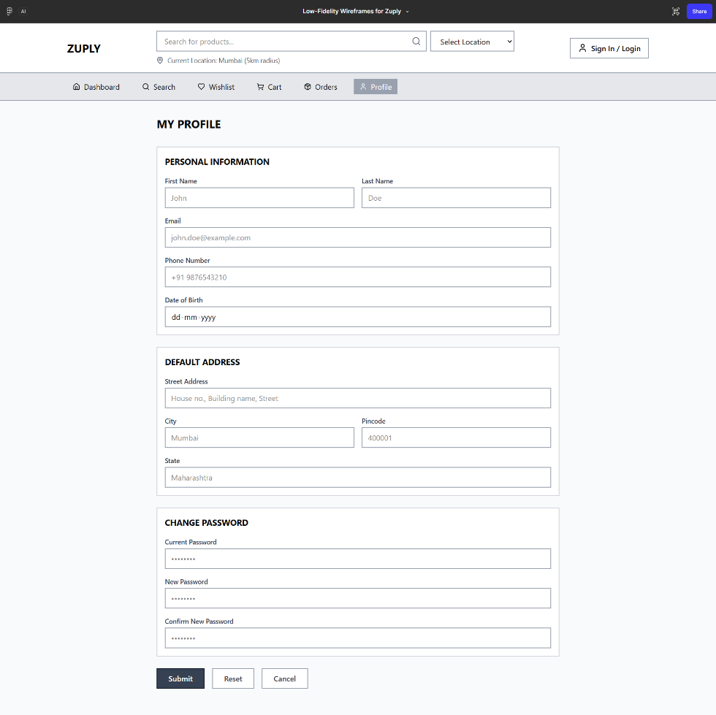
Fields include:
• Name
• Email
• Phone Number
• Address
• Location / Pincode
Buttons:
• Submit
• Reset
• Cancel
2.12 Seller Dashboard
The Seller Dashboard should display an overview of seller activities.
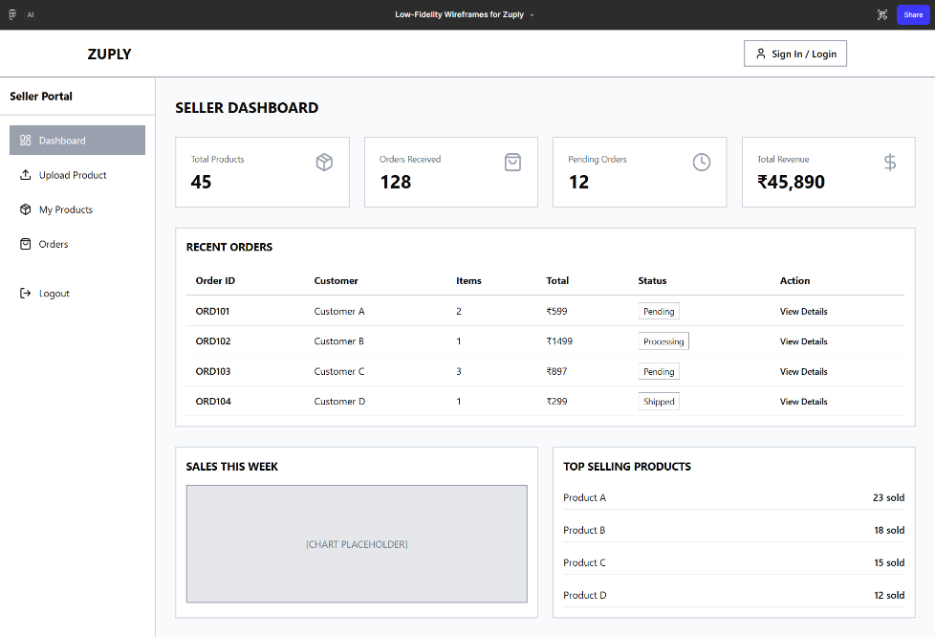
Information displayed:
• Total Products Uploaded
• Total Orders Received
• Pending Orders
Navigation options:
• Upload Product
• Manage Products
• View Orders
2.13 Product Upload
Allows sellers to upload products.
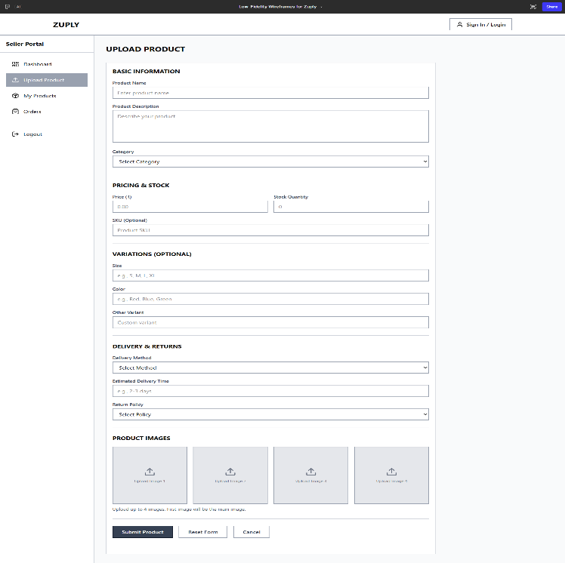

Form fields:
• Product Name
• Category
• Price
• Stock Quantity
• Product Variations
• Delivery Method
• Return Policy
• Product Image Upload
Buttons:
• Submit
• Reset
• Cancel
The system should validate mandatory fields before submission.
2.14 Seller Products
Displays all products uploaded by the seller.
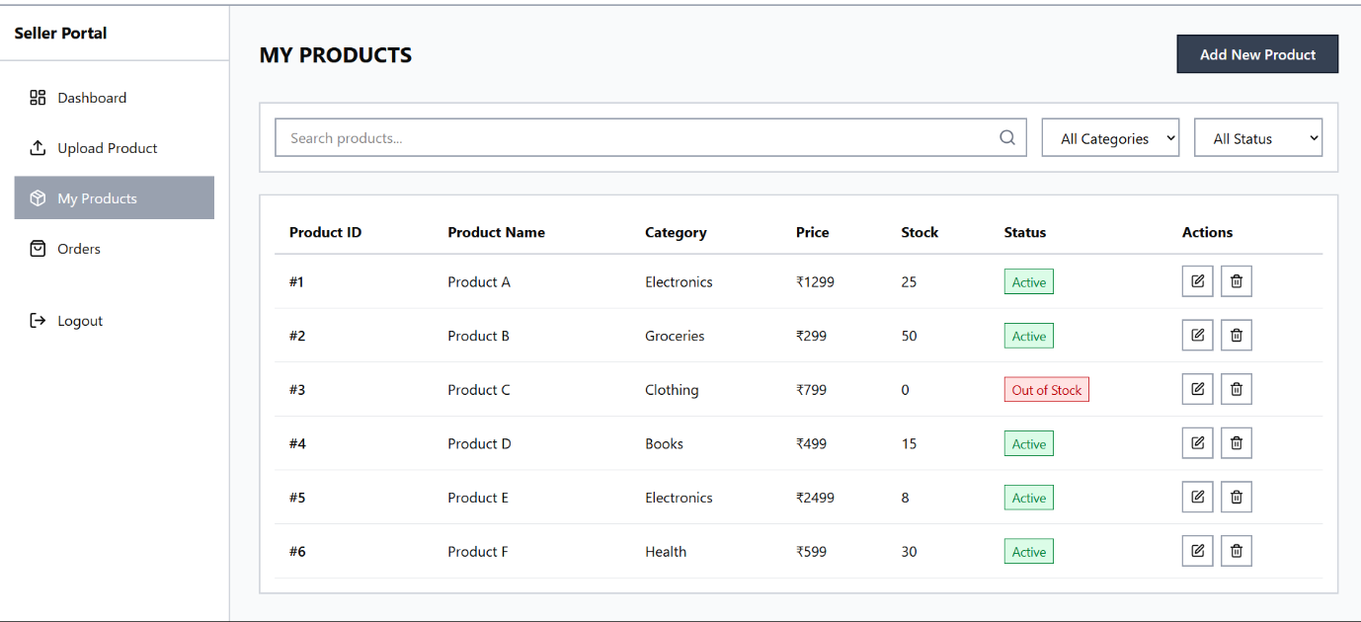
Each product entry should display:
• Product ID
• Product Name
• Category
• Price
• Stock
• Status
• Edit option
• Delete option

2.15 Seller Orders
Displays orders received for seller products.
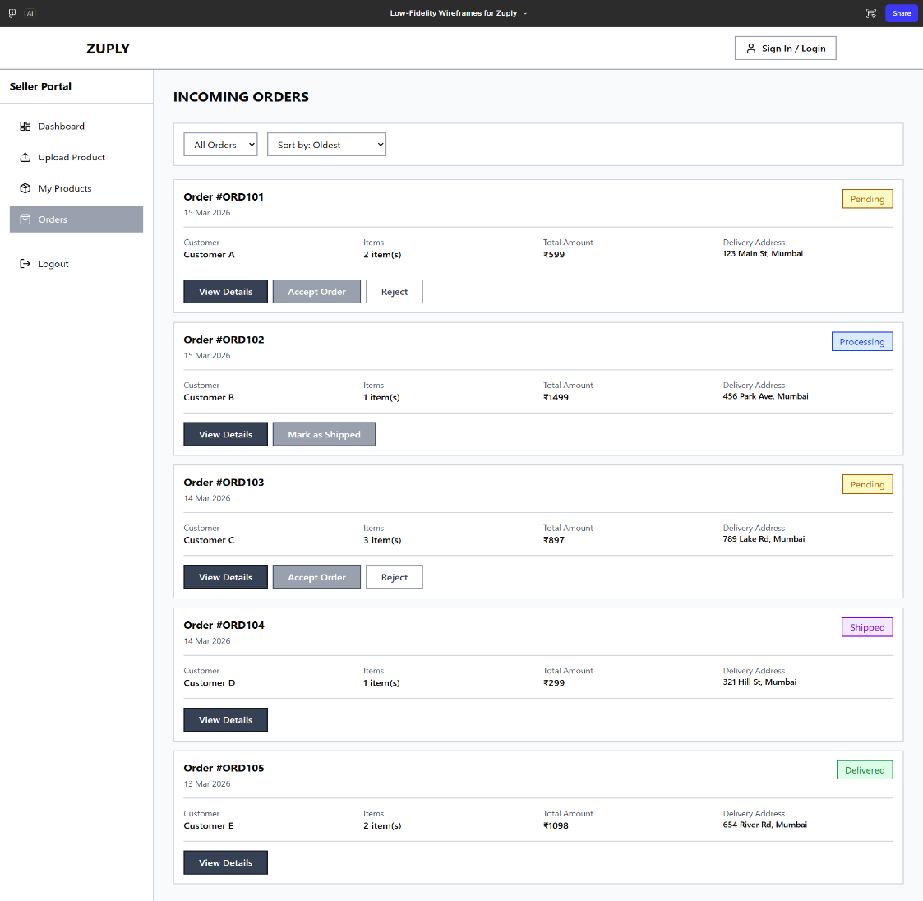
Each order record should display:
• Order ID
• Customer Name
• Product Name
• Quantity
• Order Status
2.16 Admin Dashboard
The Admin Dashboard should display platform statistics.
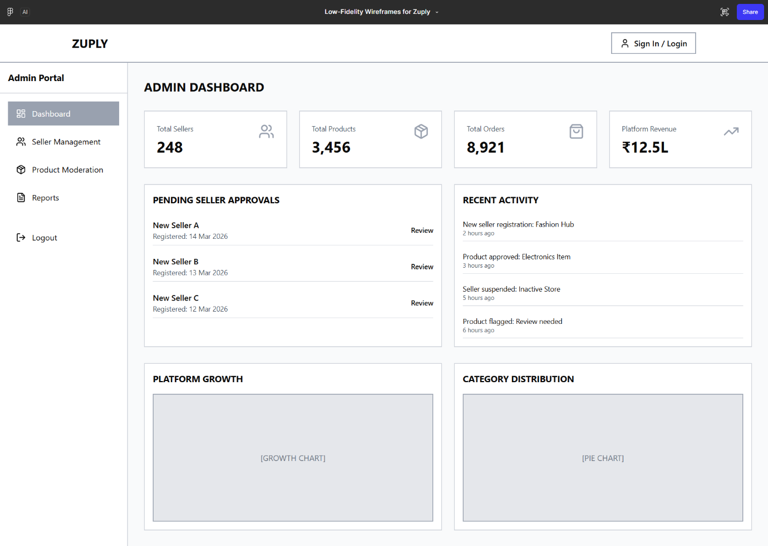
Information displayed:
• Total Sellers
• Total Products
• Total Orders
Navigation options:
• Manage Sellers
• Manage Products
• Reports
2.17 Admin Sellers
Displays registered sellers.
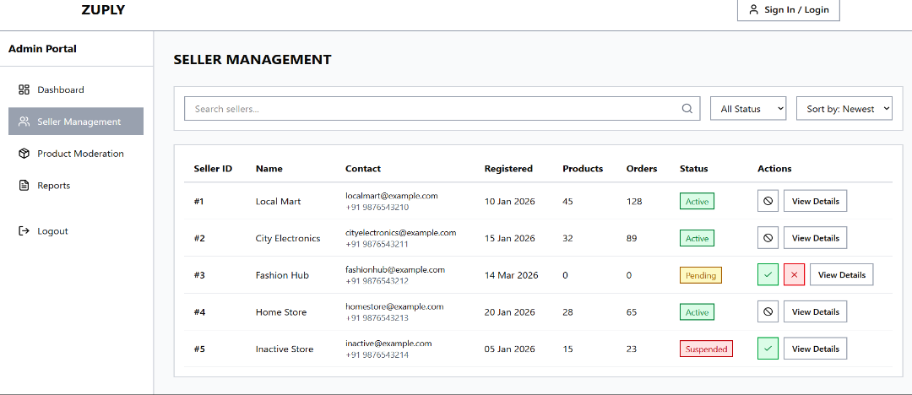
Each record contains:
• Seller Name
• Store Name
• Contact
• Verification Status
Admin actions:
• Approve Seller
• Suspend Seller
2.18 Admin Products
Displays all products uploaded by sellers.
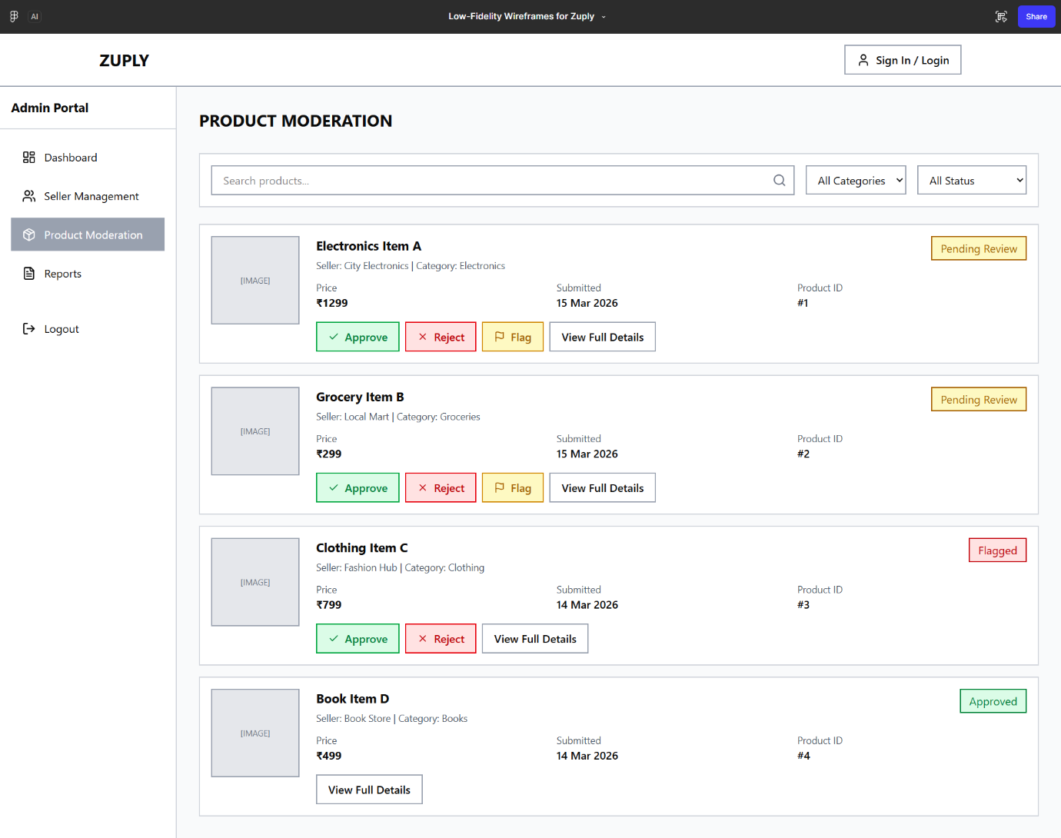
Each product entry includes:
• Product Name
• Seller Name
• Category
• Status
Admin actions:
• Approve Product
• Reject Product
2.19 Admin Reports
Displays platform analytics such as:
• Total Sales
• Number of Sellers
• Number of Customers
• Product Distribution by Category
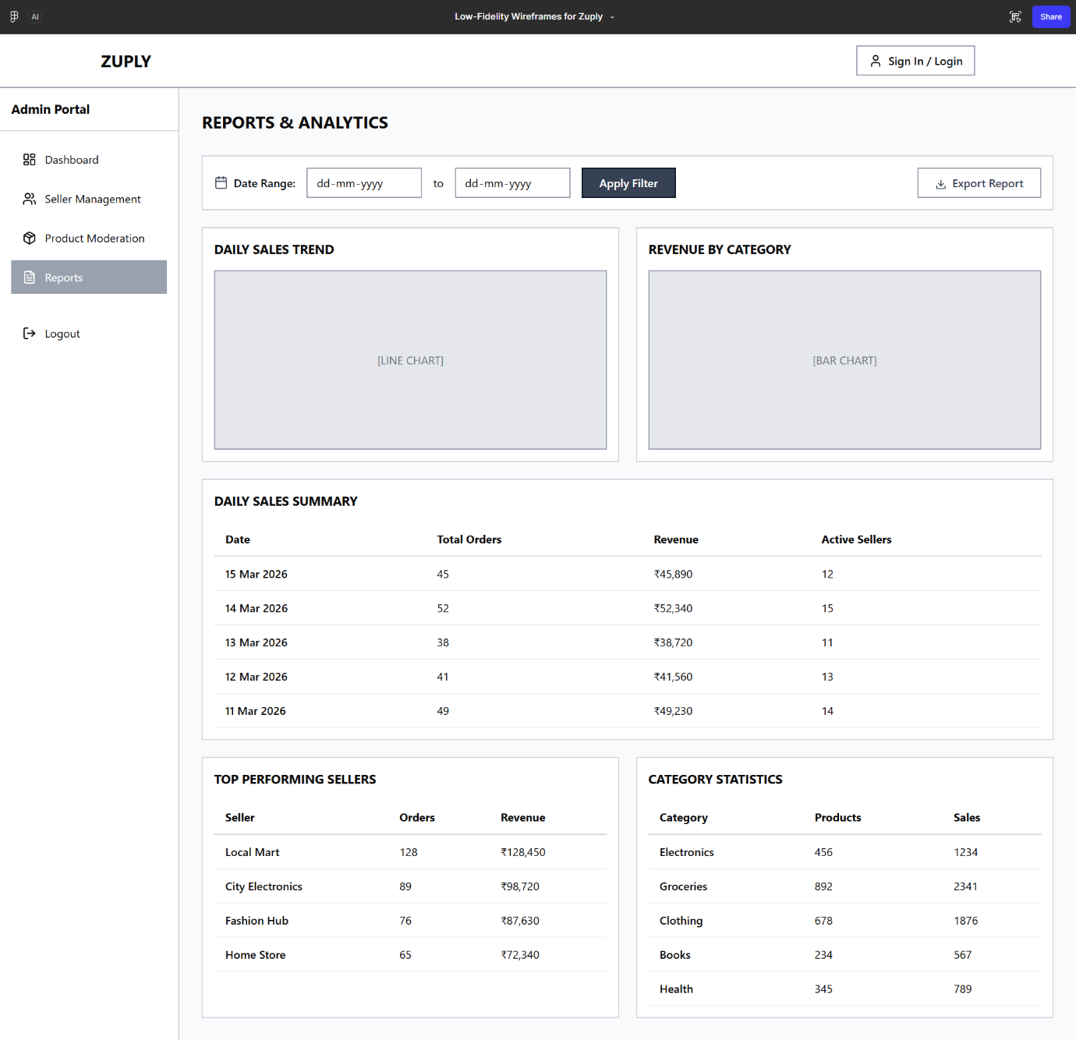

3. Non-Functional Requirements
- Performance
The system should load pages within three seconds under normal conditions.
- Security
Role-based authentication must be implemented for all users.
- Usability
The system should provide a simple interface suitable for non-technical users.
- Validation
Both client-side and server-side validation must be implemented.
- Scalability
The architecture should support increasing users and product listings.
4. Transaction Flow
Customer Purchase Flow
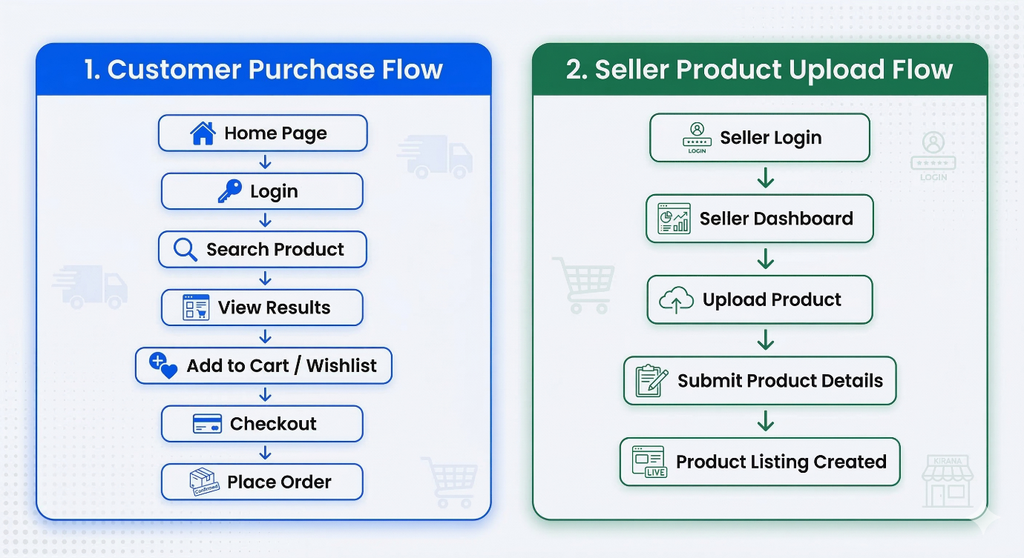

Seller Product Upload Flow


5. Future Enhancements
Future sprints may include:
• AI Image Enhancement
• Automatic Product Tag Generation
• Product Description Generator
• Delivery Tracking
• Chatbot Integration
• Advanced Analytics

