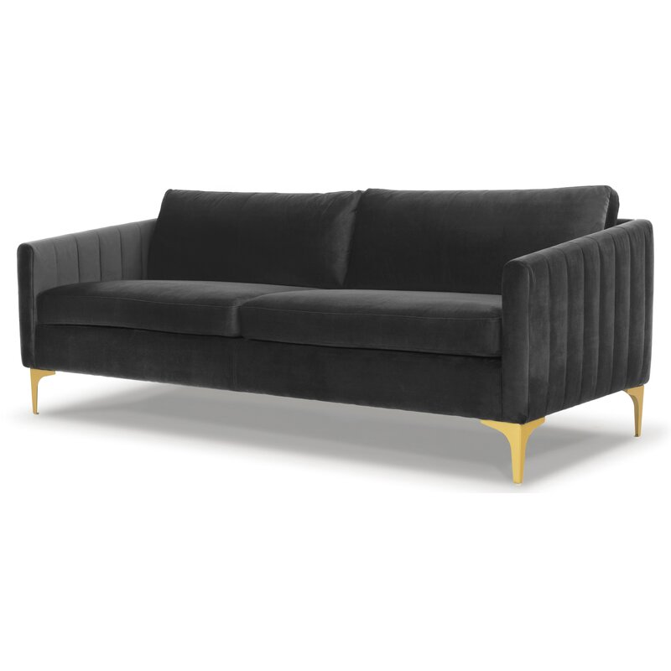

**Laci 81'' Velvet Sofa**

Rated 4.6 out of 5 stars.

4.630 Reviews

**$940**

$79/mo. for 12 mos - Total $9401 [with an AllModern credit card](https://www.allmodern.com/allmoderncard?from=pdp)

Free Shipping

Get it in 2-3 weeks

Ship To:

67346 - Grenola

Top of Form

**Fabric:**

Dark Gray

Dark Gray

Dark Gray

Navy Blue

Navy Blue

Rust

Rust is out of stock

Cream

Cream is out of stock

Emerald Green

Emerald Green is out of stock

Select QuantityMinusPlus

Save this item to your list

Add to Cart

Bottom of Form

**What We Offer**

**Full Service Delivery + Assembly (Limited Contact)**

Available in checkout for $119.99.

Full Service Delivery + Assembly (Limited Contact)Learn More

**Product Details**

* 

Solid Wood

* 

Reversible Cushions

* 

Removable Seat Cushions

* 

Removable Back Cushions

* 

Solid Wood

* 

Seat Depth: Standard (21"-28")

* 

Seat Height (inches): 18.5

* 

Weight Capacity (lbs): 1000

* 

Commercial Use: Yes

* 

Features: Tear Resistant

* Seats 3
* Seat Depth

Standard (21"-28")

* Commercial Use

No

* Overall Depth

35 ''

* Overall Height

31 ''

* Overall Width

81 ''

* **Description**

Drawing on retro designs, this sofa pairs its clean-lined silhouette with bold channel tufting on the arms for a truly iconic look. It's made with a solid wood frame, and has a resilient velvet upholstery. That upholstery is designed to resist fading, tears, and stains, so it can hold up to regular use. Plus, with sinuous springs and a blend of synthetic fiber and foam filling, it's both supportive and plush. And with tapering track arms and gold-finished bracket feet to go with the channel tufting, its definitely a mid-century statement piece.

**Features**

* + Sustainable, kiln-dried hardwood to prevent warping
  + Ideal for TV rooms, living rooms, entertainment rooms
  + Seat platform coil suspension enhances comfort and resists sagging
  + Thick medium-firm and comfortable cushion made from three layers of eco-friendly medium density foam with loose fibers
  + Arrives fully assembled, just attach the legs
  + just attach the legs

**Product Details**

* + Leg Material: Metal
  + Cushion Construction: Fiber Wrapped Foam
  + Design: Standard
  + Weight Capacity: 1000 lb.
  + Adult Assembly Required: Yes

See More