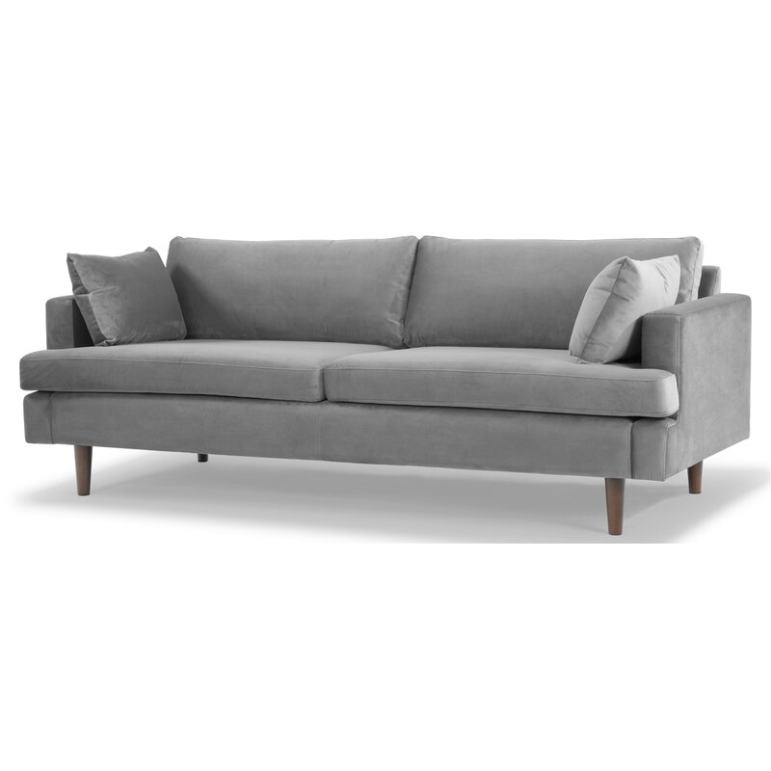

**Laguna 83'' Velvet Sofa**

Rated 4.75 out of 5 stars.

4.851 Reviews

**$930**~~$1,180.99~~21% Off

On Sale

$78/mo. for 12 mos - Total $9301 [with an AllModern credit card](https://www.allmodern.com/allmoderncard?from=pdp)

Only 3 Left in Stock. Buy Soon!

Free Shipping

Get it between Mon, Sep 27 - Mon, Oct 4

Ship To:

67346 - Grenola

Top of Form

**Fabric:**

Light Gray

Light Gray

Light Gray

Cream

Cream

Navy Blue

Navy Blue is out of stock

Rust

Rust is out of stock

Select QuantityMinusPlus

Save this item to your list

Add to Cart

Bottom of Form

**What We Offer**

**Full Service Delivery + Assembly (Limited Contact)**

Available in checkout for $119.99.

Full Service Delivery + Assembly (Limited Contact)Learn More

**Product Details**

* 

Solid Wood

* 

Removable Seat Cushions

* 

Removable Back Cushions

* 

Solid Wood

* 

Seat Depth: Standard (21"-28")

* 

Seat Height (inches): 18.5

* 

Weight Capacity (lbs): 1000

* 

Features: Tear Resistant

* Seats 3
* Seat Depth

Standard (21"-28")

* Commercial Use

No

* Overall Depth

35 ''

* Overall Height

31 ''

* Overall Width

83 ''

* **Description**

Recessed arms, tapered dowel legs, and a clean-lined silhouette give this sofa an unmistakably mid-century look. But our favorite thing about it? The way it's designed to hold up to regular use. It's made with a solid wood frame, and is upholstered in a polyester velvet fabric. That fabric can resist stains, tears, and water, so you can kick back day after day without worrying. Sinuous spring seat construction and foam and synthetic fiber filling add the right balance of padding and cushioning. This piece requires 26'' of doorway clearance.

**What's Included?**

* + Toss Pillow

**Features**

* + Sustainable, kiln-dried to prevent warping
  + Ideal for TV rooms, living rooms, entertainment rooms
  + Seat platform coil suspension enhances comfort and resists sagging
  + Thick medium firm and comfortable cushion made from three layers of eco-friendly medium density foam with loose fibers
  + just attach the legs

**Product Details**

* + Leg Material: Solid Wood
  + Cushion Construction: Fiber Wrapped Foam
  + Design: Standard
  + Weight Capacity: 700 lb.
  + Adult Assembly Required: Yes

See More