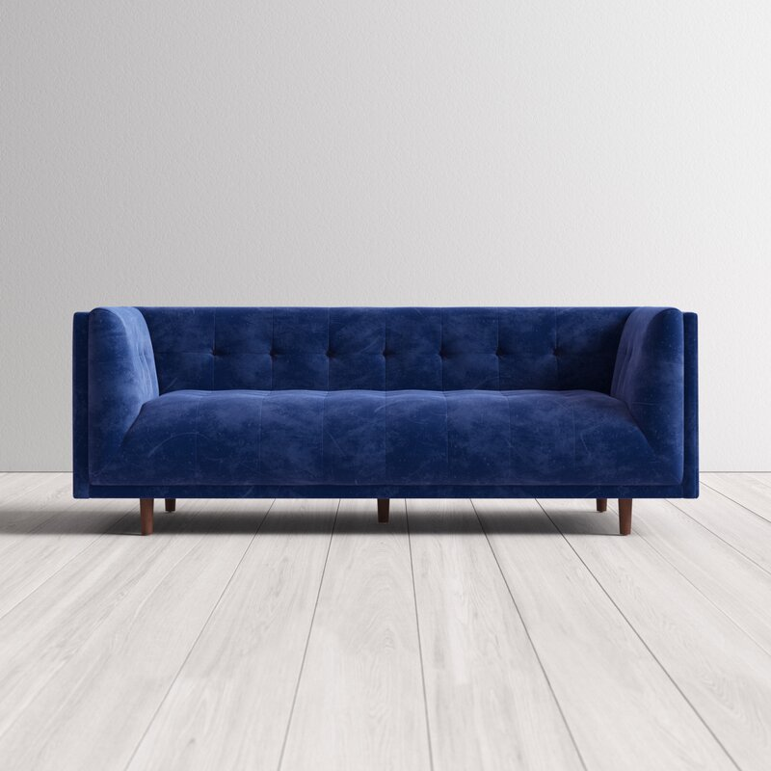

**Jayda 82'' Velvet Sofa**

Rated 4.6 out of 5 stars.

4.61010 Reviews

**$700**~~$1,350~~48% Off

On Sale

$59/mo. for 12 mos - Total $7001 [with an AllModern credit card](https://www.allmodern.com/allmoderncard?from=pdp)

Only 6 Left in Stock. Buy Soon!

Free Shipping

Get it between Thu, Sep 30 - Thu, Oct 7

Ship To:

67346 - Grenola

Shopping for a business? Unlock insider pricing

Top of Form

**Fabric:**

Sapphire Velvet

Sapphire Velvet

Sapphire Velvet

Blush Velvet

Blush Velvet

Copen Blue Velvet

Copen Blue Velvet is out of stock

Emerald Velvet

Emerald Velvet is out of stock

Olive Green Velvet

Olive Green Velvet is out of stock

Platinum Velvet

Platinum Velvet is out of stock

Select QuantityMinusPlus

Save this item to your list

Add to Cart

Bottom of Form

**What We Offer**

**Full Service Delivery + Assembly (Limited Contact)**

Available in checkout for $119.99.

Full Service Delivery + Assembly (Limited Contact)Learn More

**Product Details**

* 

Solid Wood

* 

Solid Wood

* 

Seat Depth: Standard (21"-28")

* 

Seat Height (inches): 18

* 

Weight Capacity (lbs): 750

* Seats 4
* Seat Depth

Standard (21"-28")

* Commercial Use

No

* Features

Low

* Overall Depth

32 ''

* Overall Height

30 ''

* Overall Width

82 ''

* **Description**

An eye-catching design with a vintage vibe, this streamlined Chesterfield sofa anchors your living room layout in statement-making style. Founded atop conical legs in a warm pecan finish, its wooden frame is padded with foam and upholstered with polyester velvet fabric for a design that promotes a medium seating firmness. Though its clean lines and solid hue may seem understated at first, tufted details complete the look with a tasteful touch of texture. Assembly is required.

**Product Details**

* + Leg Material: Solid Wood
  + Design: Standard
  + Weight Capacity: 750 lb.
  + Adult Assembly Required: Yes

See More