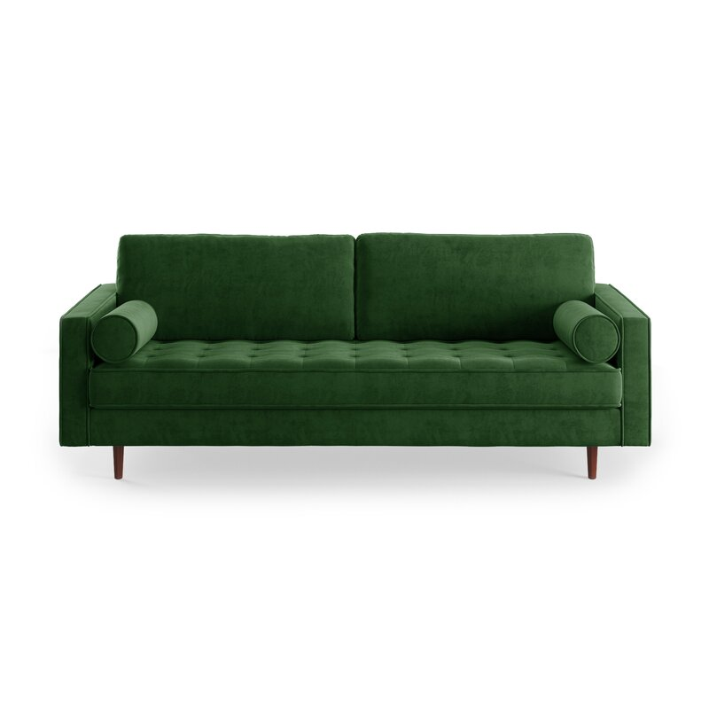

**Lark 84'' Sofa**

Rated 4.7 out of 5 stars.

4.74281 Reviews

**$830**~~$1,350~~39% Off

On Sale

$70/mo. for 12 mos - Total $8301 [with an AllModern credit card](https://www.allmodern.com/allmoderncard?from=pdp)

Free Shipping

Get it between Sat, Oct 2 - Sat, Oct 9

Ship To:

67346 - Grenola

Top of Form

**Fabric:**

Emerald Green Velvet

Emerald Green Velvet

Emerald Green Velvet

Beige Fabric

Beige Fabric

Blush Pink Velvet

Blush Pink Velvet

Copen Blue Velvet

Copen Blue Velvet

Gold Velvet

Gold Velvet

Grey Fabric

Grey Fabric

+ 4

Select QuantityMinusPlus

Save this item to your list

Add to Cart

Bottom of Form

**What We Offer**

**Full Service Delivery + Assembly (Limited Contact)**

Available in checkout for $119.99.

Full Service Delivery + Assembly (Limited Contact)Learn More

**Product Details**

* 

Solid Wood

* 

Removable Seat Cushions

* 

Removable Back Cushions

* 

Solid Wood

* 

Seat Depth: Standard (21"-28")

* 

Seat Height (inches): 18

* 

Weight Capacity (lbs): 700

* Seats 3
* Seat Depth

Standard (21"-28")

* Commercial Use

No

* Overall Depth

37 ''

* Overall Height

34 ''

* Overall Width

84 ''

* **Description**

A stylish sofa is an easy way to elevate the entire look of your room – and this sofa is the perfect candidate for the job. Upholstered in plush velvet and supported by a sturdy wood frame, it features a button-tufted seat for a touch of tailored detail. Both the seat and back cushions are filled with foam for a more comfortable lounging experience, and are secured to the frame so you never have to worry about them shifting out of place. Slim, tapered legs made from pecan wood give just the right amount of warmth to the look, and both bolster pillows are included.

**What's Included?**

* + Toss Pillow

**Product Details**

* + Leg Material: Solid Wood
  + Cushion Construction: Foam
  + Design: Standard
  + Weight Capacity: 700 lb.
  + Adult Assembly Required: Yes

See More