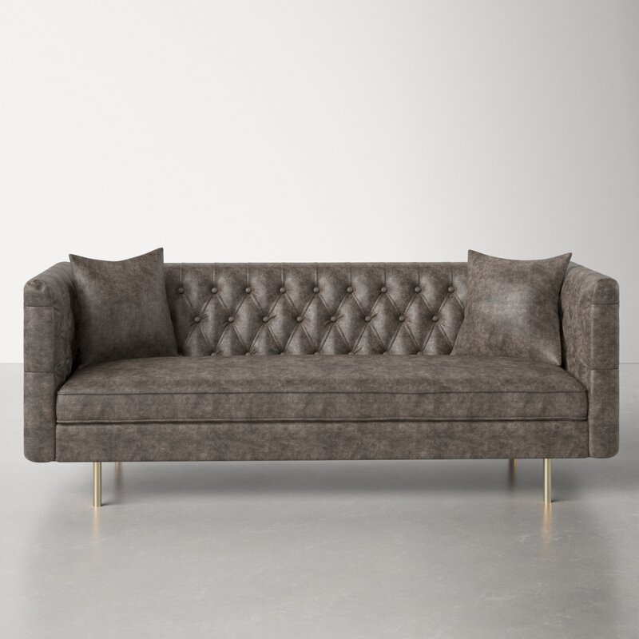

**Jenkin 79'' Chesterfield Sofa**

Rated 4.6 out of 5 stars.

4.6173 Reviews

**$1,030**~~$1,317~~22% Off

On Sale

$86/mo. for 12 mos - Total $1,0301 [with an AllModern credit card](https://www.allmodern.com/allmoderncard?from=pdp)

Only 2 Left in Stock. Buy Soon!

Free Shipping

Get it in 2-3 weeks

Ship To:

67346 - Grenola

Top of Form

**Fabric:**

Vintage Gray Faux Leather

Vintage Gray Faux Leather

Vintage Gray Faux Leather

Honey Tan Faux Leather

Honey Tan Faux Leather is out of stock

Select QuantityMinusPlus

Save this item to your list

Add to Cart

Bottom of Form

**What We Offer**

**Full Service Delivery + Assembly (Limited Contact)**

Available in checkout for $119.99.

Full Service Delivery + Assembly (Limited Contact)Learn More