10 4 TMS Specification Evidence Review
Problems identified in the original functional specification and the evidence behind each finding.
Prepared for 10-4 Global Logistics | November 2, 2026
Six findings directly conflict with documented observations. The remaining items concern a missing UI detail, scope or evidence limits, inconsistent rules, or the incomplete supplied file. They should not all be treated as proven software defects.
This report traces the originally reviewed v0.1 passages. The current Markdown already contains corrections and additional review notes from the earlier validation. Each finding states its current status so an original problem is not mistaken for an unchanged current error.
Source priority is docs/main, especially Quote Factory Quote Workflow Guide.md. Existing screenshots come from that folder. No specification edits or live operational submissions were made while preparing this report.
ID | Finding | Classification
F01 | Factoring tab incorrectly described as absent | Source conflict
F02 | Carrier payment default incorrectly described as blank | Source conflict
F03 | Updated rate confirmation default overstated as off | Source conflict
F04 | Carrier name hiding settings incorrectly described as both off | Source conflict
F05 | LTL bill of lading fields incorrectly described as omitted | Source conflict
F06 | Direct LTL booking gate missing from the screen description | Missing UI detail
F07 | Carrier inventory and direct account design need separation | Scope distinction
F08 | Customer visibility no effect claim exceeds the evidence | UI description needs qualification
F09 | Tracking completion incorrectly equated with delivery | Source conflict
F10 | Support wording does not reflect the documented interface | Source coverage question
F11 | Address template creation rules contradict each other | Internal inconsistency
F12 | Customer transfer restrictions are described inconsistently | Rule ambiguity
F13 | Original file is incomplete | Document completeness defect

Accounting tab evidence

F01 Factoring tab incorrectly described as absent
Source conflict | BIL-002 and section 1.7 | Original Markdown line 4940
Original passage There is no "Invoices to Factor" tab, because 10-4 does not factor its own invoices.
Source evidence The guide records an Invoices to Factor queue. It opened to “No bills or invoices yet.” Accounting settings separately said “Not factoring.”
Finding An empty or unused queue was described as a feature that does not exist.
Correction supported by the evidence Include the Invoices to Factor tab in the current-system description. State its observed empty state separately from whether factoring is in the new TMS release.
Source S1, 17.3 and Deep3, line 1953; evidence reference: E-151 and E-152.
Current copy: The current Markdown now includes the factoring tab and corrects the absence claim.
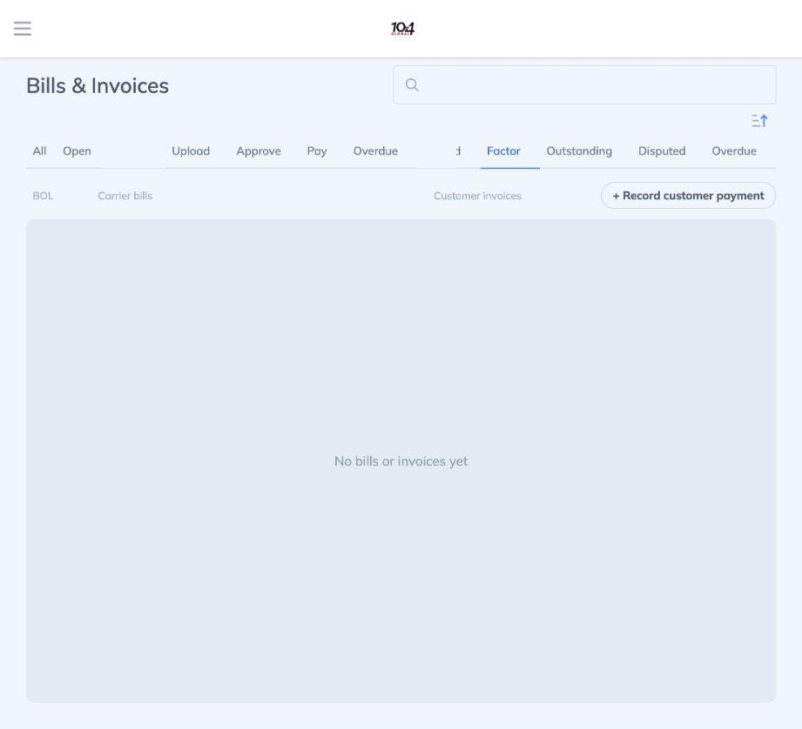
Figure 1 Existing Factor tab selected with No bills or invoices yet. Source screenshot, November 1, 2026. This proves the tab is present, not that factoring was used.

Payment and document setting conflicts

F02 Carrier payment default incorrectly described as blank
Source conflict | BIL-024 | Original Markdown line 5218
Original passage The Method default is “None”; “the system never assumes one.”
Source evidence The provider bill payment form had Amount 500 prefilled and Method ACH. The invoice customer-payment form had a blank method; the forms have different initial states.
Finding The document applied a blank-method rule to the carrier payment form despite a recorded ACH default.
Correction supported by the evidence Document ACH as the observed provider-form default. Keep invoice and workspace customer-payment defaults separate. Do not infer payment processing from the method label.
Source S1, Deep3 payment entry points, line 2036; evidence reference: E-157.
Current copy: The current Markdown distinguishes the observed provider ACH default from the blank customer-payment method.

F03 Updated rate confirmation default overstated as off
Source conflict | WF-009 SHP-048 and TRK-010 | Original Markdown line 1222
Original passage The check box “Send updated Rate con” is off by default.
Where shown in the inspected assigned shipment and appointment forms, ‘Send updated Rate con’ was checked. The option is not present in every shipment editor.

Finding A universal Off default conflicts with the sampled assigned-shipment and appointment states.
Correction supported by the evidence Describe the checked default in those observed contexts. Do not generalize it to every inline editor or assume that an update cannot send email; actual sends were not tested.
Source S1, 16.5 and 16.7 with Deep2, line 1824; evidence reference: E-140 and E-141.
Current copy: The current Markdown corrects the universal Off claim and describes the observed variants.

F04 Carrier name hiding settings incorrectly described as both off
Source conflict | SET-018 | Original Markdown line 9005
Original passage “Done” closes. Both are off for 10-4.
Source evidence Hide LTL Carrier Names was unchecked and disabled. Hide TL carrier names was checked and disabled. Help says the LTL option affects shared quotes while the TL option hides name USDOT and MC on the BOL.
Finding The document combined two different settings into one incorrect account-state statement.
Correction supported by the evidence Record LTL hiding as unchecked and TL hiding as checked in the inspected configuration. Keep the two modes and their documented effects separate.
Source S1, 19.3, line 2164; evidence reference: E-102.
Current copy: The current Markdown now records the two different switch states.

Direct LTL booking evidence

F06 Direct LTL booking gate missing from the screen description
Missing UI detail | Section 4.2 Part B and SHP-027 | Original Markdown line 2330
Original passage LTL shipments are created from an LTL quote (section 4.6).
Source evidence Selecting LTL in the new-shipment equipment selector shows “LTL direct booking coming soon” and a Get LTL quotes link. The downstream form is gated and Book shipment is disabled. The link opens the LTL quote form.
Finding The quote-based narrative was broadly consistent, but it omitted the actual message, disabled state and handoff visible when LTL is selected.
Correction supported by the evidence Add the LTL gate and quote-form handoff to the screen description. Treat any new direct manual LTL capability as an intentional product decision, not an existing feature.
Source S1, Deep2 equipment branches, line 1338; evidence reference: E-132 and E-133.
Current copy: The current Markdown now describes the direct-LTL gate and handoff.
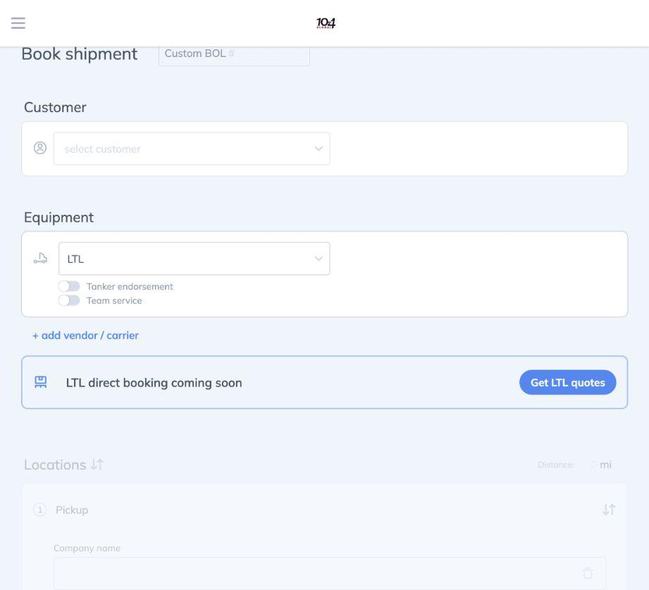
Figure 2 LTL selected in Book shipment shows LTL direct booking coming soon and Get LTL quotes. Source screenshot, November 1, 2026. This is an omitted screen detail, not proof the original quote-based workflow was wrong.

Document fields and configuration distinctions

F05 LTL bill of lading fields incorrectly described as omitted
Source conflict | DOC-003 and section 1.7 Documents | Original Markdown line 10730
Original passage Freight class, NMFC and per-piece weights are not printed.
Source evidence The visually inspected LTL BOL has NMFC and Class columns plus account and quote references. The example shows Class 60 and a blank NMFC cell. The guide separately identifies 04821J as Acct.
Finding The blanket omission of freight class and NMFC is incorrect for the inspected LTL template. The draft also lists printing account and quote numbers as later work.
Correction supported by the evidence Include NMFC Class and account/quote-reference fields for the observed LTL BOL. Do not infer that every carrier or TL template is identical. The source does not settle the per-piece-weight claim.
Source S1, 17.2, line 1935; evidence reference: E-88.
Current copy: The current Markdown corrects the LTL field list and the account/quote-reference deferral.

F07 Carrier inventory and direct account design need separation
Scope distinction | Section 4.6 introduction | Original Markdown line 6033
Original passage Every LTL rate comes from a direct connection to each of 10-4's own LTL carrier accounts. There is no rate network in between.
Source evidence The source records 17 cards and a separate displayed count of 12. Its inventory includes FedEx Freight Double D and Sunset Pacific; it does not include Peninsula. Existing results contain both carrier and Xtended Network offers.
Finding The draft mixes a proposed direct-only clone design with statements about current Quote Factory inventory and account routing. A carrier card does not establish direct-account entitlement or prove network-only access.
Correction supported by the evidence Use the observed inventory when describing the current app. Preserve a direct-only new-system design if that is intentional, but identify it as the intended design rather than evidence that Quote Factory has no network rates.
Source S1, 18.3 with 14.7, line 2096; evidence reference: E-93 and E-118.
Current copy: The current Markdown includes the source inventory and separates observed rate sources from the proposed design.

F08 Customer visibility no effect claim exceeds the evidence
UI description needs qualification | ROL-019 CUS-053 and SET-021 | Original Markdown line 7529
Original passage The Owner setting “Customer visibility” can be switched on and is saved, but it is not enforced.
Source evidence Help describes enabled visibility as limiting viewing and running quotes to customer reps; disabled gives access to all customer records. The checkbox was disabled in the sampled Member session.
Finding The no-effect claim conflicts with the UI-described purpose. However, help text alone does not prove that restriction is enforced by the server.
Correction supported by the evidence Describe the stated restriction and remove the unsupported assertion that the switch does nothing. Keep actual enforcement and team inheritance as validation questions; do not report them as passed tests.
Source S1, 19.3, line 2167; evidence reference: E-103.
Current copy: The current Markdown replaces the no-op assertion with the source description and its enforcement limit.

Tracking support and template rules

F09 Tracking completion incorrectly equated with delivery
Source conflict | TRK-055 | Original Markdown line 4645
Original passage “Tracking completed” means “Delivered; tracking ended normally.”
Source evidence The guide records Tracking completed and Off route together on BOL 1046693 while the shipment is In transit.
Finding A tracking-service label was used as proof of the shipment delivery state.
Correction supported by the evidence Keep tracking status separate from shipment status. Do not infer delivery from Tracking completed; use the shipment lifecycle and actual delivery evidence.
Source S1, 15.9, line 1691; evidence reference: E-65 (reference shipment inspection).
Current copy: The current Markdown corrects the pill explanation and preserves the observed In transit example.

F10 Support wording does not reflect the documented interface
Source coverage question | Section 1.1 Support | Original Markdown line 348
Original passage Support: help is slower (the chat was removed; support is by e-mail only).
Source evidence Contact support opens Help Scout Beacon with Search and Ask Us. Ask Us exposes Subject How can we help attachment and Send a message. No message was sent.
Finding The source documents an in-app support entry and message form. It does not establish response quality or whether live chat was removed. An Ask Us form does not itself prove live chat exists.
Correction supported by the evidence Describe the available Support/Search/Ask Us interface. Retain historical claims about chat removal or slower support only if separately confirmed by the client.
Source S1, 19.6, line 2225; evidence reference: E-107.
Current copy: The current Markdown replaces the unsupported business-rationale paragraph with an evidence-qualified account.

F11 Address template creation rules contradict each other
Internal inconsistency | SHP-032 and CUS-042 | Original Markdown line 2545
Original passage SHP-032 says booking does not create address book entries. CUS-042 says templates normally appear when a shipment is booked with a new address.
Source evidence The guide distinguishes templates from shipment stops and leaves copy/update semantics unverified. It records different shipment/template closing times without establishing what caused them.
Finding The same draft gives opposite booking-time template creation rules. The source does not select either as the tested rule.
Correction supported by the evidence Use one agreed creation/propagation rule after a controlled new-address booking test or a client answer. Do not silently choose either version based on these observations.
Source S1, 13.5 and 16.3, line 771; evidence reference: E-43 and E-77.
Current copy: The current Markdown flags both creation and non-creation as unresolved rather than claiming one was verified.

Transfer rules and missing original content

F12 Customer transfer restrictions are described inconsistently
Rule ambiguity | SHP-071 and INV-019 | Original Markdown line 3270
Original passage SHP-071 blocks changing the customer after an invoice was sent. INV-019 describes refusal while the invoice has payments.
Source evidence The guide explicitly leaves post-invoicing changes and correction behavior open. Change customer was an observed menu entry, not a submitted transfer.
Finding The document does not give a single complete rule for sent but unpaid invoices versus invoices with payments. These conditions could coexist; the wording does not prove which is decisive.
Correction supported by the evidence State the transfer rule separately for drafts sent/unpaid invoices and partly/fully paid invoices, including accounting and document consequences. Validate before selecting a rule.
Source S1, 17.5 and 16.9, line 1980; evidence reference: Not applicable: source explicitly records an open question.
Current copy: The current Markdown identifies the unresolved contract. It does not establish that a transfer was tested.

F13 Original file is incomplete
Document completeness defect | Contents and DOC-015 | Original Markdown line 10985
Original passage The original file ends partway through the accessible name for the Download control in DOC-015.
Source evidence The original file lists sections 7 and 8 and Appendices B and C in Contents, but has no corresponding body sections. Its final line stops in the middle of DOC-015. The main guide contains integration and reporting material, while migration remains a decision area.
Finding The supplied Markdown was not a complete copy of the specification promised by its own contents.
Correction supported by the evidence Obtain the missing original remainder if available. Reconstructed content must be identified separately rather than presented as recovered original wording.
Source S1, 23 and the source folder inventory, line 2463; evidence reference: File comparison.
Current copy: The current Markdown completes DOC-015 and adds reconstructed sections/appendices. Those additions are not the missing original source text.

Details that remain unverified rather than proven wrong
The source does not settle many precise permissions, authentication-link lifetimes, retry schedules, equipment limits, government-data refresh schedules, pricing precedence, payment allocation or accounting-sync rules. Lack of verification is not evidence that those intended requirements are incorrect. Preserve intended requirements unless a source conflict or an agreed product change justifies an edit.

Sources and review traceability

S1 Main workflow guide
docs/main/Quote Factory Quote Workflow Guide.md
Primary source for the observations cited in this review. Section names and Markdown line numbers are supplied with each finding. They identify the source copy read on November 2, 2026; future edits can shift line numbers.

S2 Evidence register
docs/main/Documentation Evidence Register.md
The E references identify the documented date, route or action and its limitations. They are discovery observations, not successful operational acceptance tests.

S3 Specification versions
docs/documents_to_be_verify/10-4-TMS-Functional-Specification-v0.1.md
Original passages were checked against the original supplied Markdown retained in local version history. Current-copy status statements were checked against the present working file. Original line numbers refer to that earlier draft, including its printed-page artifacts.

S4 Screenshot evidence
Figure 1: docs/main/screenshots/deep-03-accounting-factor-empty-2026-11-01.jpg
Figure 2: docs/main/screenshots/deep-02-equipment-01-2026-11-01.jpg
Both figures are embedded original source screenshots. No screenshot was substituted for another claim and no visual was generated to imitate system evidence. Findings without a matching source screenshot use the documented textual observation.

Review boundary
The document identifies which passages have source contradictions, which have incomplete descriptions and which still need a business or system answer. It does not approve release scope, establish hidden backend behavior, prove email delivery or certify accounting transactions.

