Email Monitor
UI Direction Questionnaire

Purpose: This questionnaire is designed to help translate your instincts about the UI into concrete, actionable direction for the front-end team. Each section targets a specific design dimension. Answer as many or as few questions as feel relevant. Where you have a strong opinion, be specific. Where you don’t, say so — that’s useful information too.
How to use: For each question, write your answer in the space provided. If a question includes options, pick the closest match and then elaborate if needed. If you can reference a specific app, website, or screenshot that captures what you mean, include it — visual references are worth more than adjectives.

1. Overall Personality & Mood
These questions establish the emotional register of the product. They’re the hardest to articulate but the most impactful on every downstream decision.
- When you open the app, what should the first 3 seconds feel like?
Examples: “Calm and in control” / “Sharp and efficient” / “Like opening a well-organized briefcase” / “Like a Bloomberg terminal but cleaner”
It should be clean, simple, intuitive. The dashboard is clear, there aren’t too many tabs to select from, and the next steps are immediately clear.
- Name 2–3 apps or websites whose visual feel you’d want to borrow from.
These don’t need to be email tools. Could be a banking app, a project management tool, a news reader — anything where the UI felt “right.” For each one, try to say what specifically you liked.
Grammarly, Granola. These sites are clean and easy to follow. I know right where I am and what I’m looking for is immediately available.
- Name 1–2 apps or websites whose visual feel you actively dislike.
Again, say what specifically bothered you. “Too busy,” “Too playful,” “Felt cheap,” “Too much whitespace” — all useful.
I don’t like cramped, cluttered website. It needs to be clean. Like Apple Health. Intuitive to understand, but depth below the surface. Users should have a sense of calm when they are on the site, not confusion or uncertainty. The visual appeal is critical to ensuring this comes across right when the user opens the site. Right now, it feels like an early 2000s website.
- Which of these words should describe the UI? Pick up to 3.
Professional / Minimal / Dense / Warm / Dark / Light / Playful / Corporate / Technical / Premium / Clean / Bold / Understated / Futuristic / Classic
Minimal, Clean, Understated.
- Which of these words should NOT describe the UI? Pick up to 3.
Same list. This is often more revealing than the positive picks.
Dense, Technical, Futuristic.

2. Information Density & Layout
These questions determine how much the interface shows at once versus how much it tucks away behind clicks and scrolling.
- Do you want the dashboard to feel like a dense command center or a clean summary?
Command center: lots of data visible at once, multiple panels, minimal whitespace. Think Bloomberg, Grafana, or Jira boards. Clean summary: key numbers and status, lots of breathing room, focus on what’s actionable. Think Linear, Notion, or Apple’s apps.
Clean summary. Like Apple Health or Grammarly.
- On the Emails list page, how many rows should be visible without scrolling?
This determines row height, padding, and font size. 8–10 rows = comfortable spacing. 15–20 rows = compact/dense. 25+ = spreadsheet-like.
I’m not sure I like the rows idea. It feels just like email at that point. Perhaps it’s metrics or cards the user can click on for more info.
- Should the sidebar navigation be always visible, or collapsed/hidden by default?
Always visible = faster navigation, less content width. Collapsible = more content area, one extra click to navigate. Current plan uses a top navbar.
Always visible.
- When viewing an email detail, should the draft response be visible immediately or behind a tab/expand?
Immediately visible means a longer page but no hidden information. Tabbed/expandable keeps the page short but requires a click.
This goes back to the apple health idea. All of the information is immediately available to the user. Not ALL the detail, but they know where to go if they want more. This website needs to feel the same. Simple. Clean. And the user can dig in where they’d like.
- How do you feel about the current card-based layout for settings groups?
Cards with borders around each settings section (Outlook, Output, Feature Toggles, etc.) vs. a flat form with section headers and dividers vs. a tabbed interface with one section per tab.
I think cards could work, it’s got to be clean and easy to absorb.

3. Color, Typography & Visual Style
These questions pin down the visual palette and typographic choices that define how the app looks at a glance.
- Dark mode, light mode, or both?
If both: which is default? Does the app respect the system setting, or is it a manual toggle?
Light mode.
- What’s your instinct on accent color?
Bootstrap default blue is functional but generic. Common alternatives: navy/slate for corporate, teal/green for productivity tools, orange/amber for urgency-focused tools. Or name a specific color you’re drawn to.
I like a navy or slate grey color. Again, simple. I don’t want overkill of colors.
- Should the color palette be monochromatic or use distinct colors for different meanings?
Monochromatic: one accent color, shades of gray for everything else. Multi-color: red for urgent, green for sent, blue for generated, amber for warnings. The current plan uses Bootstrap’s badge colors for draft status.
My gut says monochromatic. I don’t want it to look like a Christmas tree with a bunch of different blinking lights and colors. Again, it needs to instill peace and calm.
- How do you feel about the current Bootstrap 5 styling?
Bootstrap is fast to build with but looks “default” out of the box. Is the Bootstrap look acceptable as a foundation with custom overrides, or does the whole thing need a different design system (e.g., Tailwind, custom CSS, a premium UI kit)?
No, I do NOT like the default out of the box look. We need to enhance the style, and it’s going to take a full reboot to get it looking the way it needs to.
- Font preference?
System fonts (fast, native feel) / A specific sans-serif like Inter, Geist, or Helvetica / A monospace accent for data (email subjects, action items) / Do you have a font in mind from a product you like?
No, I don’t have an immediate font in mind. The users of this will be professionals, so I don’t want a silly font, or overly playful. But it shouldn’t be overly formal either.
- Should tables use alternating row colors, hover highlights, both, or neither?
Alternating rows (zebra striping) helps scan dense tables. Hover highlights give feedback on clickable rows. Some designs use neither and rely on spacing alone.
Yes, this alternating color scheme could work. It will need to be soft variations between rows. I don’t want it to look like a ‘zebra’

4. Dashboard
The dashboard is the first thing you see. These questions determine what it prioritizes.
- What’s the single most important thing the dashboard should communicate at a glance?
Examples: "How many things need my attention right now" / "What did the last run produce" / "Is the pipeline running and healthy" / "What’s the most urgent email I haven’t dealt with"
The first thing the user sees should be a simple overview of what the app is doing. It’s running all their emails for them, providing summaries, responding to emails via drafts. The User should think ‘wow. All this and I haven’t even touched it?’
- Should the dashboard show aggregate stats (emails processed, drafts generated, response rate) or just the latest run?
Stats over time suggest a reporting/analytics dashboard. Latest-run-only suggests a command center. You could also do both — stats at the top, latest action items below.
Perhaps the push would be for the user to view their email summaries or review the drafts currently waiting their feedback.
- The current plan shows a table of recent action items on the dashboard. Is a table the right format?
Alternatives: a card per action item (more visual, less dense), a grouped list by project, a Kanban-style column view (needs response / drafted / sent), or a simple count summary with a link to the full Emails page.
I think card is better, perhaps kanban? But a simple kanban. I personally hate them, but if done correctly, it could be a highly efficient way to show the pipeline. 100 emails have come in, 20 are important and are summarized, 3 request a response and the email is drafted.
- Should the “Run Now” button be prominent on the dashboard or tucked away on the Schedule page?
Prominent = easy to trigger, but might encourage manual runs over trusting the scheduler. Tucked away = cleaner dashboard, scheduler is the primary path.
It’s fine to have it available so the user can hit it whenever they need.

5. Emails List & Detail Pages
These are the pages where you’ll spend the most time reviewing what the pipeline produced.
- On the Emails list, which columns matter most? Rank these or remove any that feel unnecessary.
Subject / From / Project / Priority / Draft Status / Date / Folder / Run # / Action summary
From / subject / date / summary snippet / draft response
- Should the email detail page show the full original email body, or just the Claude-generated summary?
Full body: lets you verify Claude’s analysis against the source. Summary only: cleaner, trusts the pipeline. Expandable: summary by default with a “Show original” toggle.
Needs the full email. But only upon the user clicking in for more detail.
- When reviewing a draft response, what actions do you want available?
Current plan has “Mark as Sent” and “Dismiss.” Would you also want: “Edit draft” (inline text editing before saving back to Outlook), “Regenerate” (re-run Claude on this email), “Copy to clipboard”, or “Open in Outlook”?
Only have edit or delete. The system will refresh what emails remain in drafts through the users draft inbox in outlook.
- Should the draft response be displayed in a monospace/code-like font or in a styled email preview?
Monospace = honest about what it is (raw text). Styled preview = looks like a real email, which helps you evaluate tone. Could also render it in a mock email template.
Look like a real email. This is important, it needs to look like an email would.
- How should urgent/high-priority emails stand out on the list page?
Options: colored badge only, full row highlight, bold text, left border accent, icon, or pinned to top of list regardless of sort order.
Not as of now.

6. Settings & Configuration Pages
These pages are used during setup and occasionally for tuning. They don’t need to be beautiful, but they need to be clear.
- How technical should the settings pages feel?
Friendly with descriptions and help text for every field (like a consumer SaaS onboarding flow) vs. compact and label-only (like a developer config panel). This matters a lot for eventual external users.
They need to be VERY user friendly to the non-technical. The settings should give the high points the users will likely be toggling more often (draft email tone, level of summay detail, etc.) then put an advanced setting button where the far more detailed technical components come in.
- The Prompts page has two large text areas for system prompts. Should these feel like a code editor or a document editor?
Code editor: monospace font, syntax highlighting, line numbers, dark background. Document editor: proportional font, clean white area, feels like writing a note. This sets user expectations about what they’re editing.
NO. This is critical. We need to assume the user isn’t well versed in prompt engineering and needs more simple toggles. Like Grammarly does when crafting the tone of how text should sound. Professional vs casual. Business vs. personal. Aggressive vs. passive. Etc.
- Should filter rules be manageable inline (add/delete right on the page) or through a modal/dialog?
Inline is faster but can get cluttered with many rules. Modal keeps the page clean but adds a click.
There should be a toggle on the emails page where the user can choose if an email should have been summarized or not.
- How much do you want settings validated and guarded in the UI?
Strict: disable the save button until all fields are valid, show real-time validation errors, confirm before destructive actions. Loose: save whatever the user enters, flash an error if something breaks. The current plan takes a middle ground (server-side validation + flash messages).
Loose. Put the power in the users hands, we won’t give them any options that blow everything up.

7. Pipeline Status & Run History
These questions address how visible and detailed the pipeline’s operational state should be.
- When a pipeline run is in progress, how visible should that be?
Subtle indicator (spinning icon in the nav) vs. prominent banner across the top vs. a live-updating log view you can watch. The current plan auto-refreshes the page every 10 seconds during a run.
Yes, there needs to be a progress bar showing how long until the run is complete.
- The run history page shows a table of past runs. Is a table sufficient, or would a timeline/chart be more useful?
Table = good for detail, easy to filter. Timeline = visual pattern recognition (when do most emails come in, how long do runs take). Chart = shows trends over time (emails processed per day, draft generation rate).
Table is fine.
- How much log detail should be visible?
None (just stats and status) / Summary (key events like “3 emails analyzed, 1 draft saved”) / Full log (every line the pipeline emitted, like a terminal view). The current plan stores full logs and displays them on the detail page.
Summary, not overkill, but they should be able to see what’s been accomplished.
- Should failed runs be visually alarming or quietly noted?
Red banner with error details vs. red status badge in the history table vs. a subtle warning. Depends on how often you expect failures and how urgent they feel.
Include them visually for now.

8. Interactions, Animations & Responsiveness
These questions cover how the interface responds to user actions and whether it feels static or alive.
- How do you feel about animations and transitions?
None (instant state changes, feels fast and no-nonsense) / Subtle (fade-ins, smooth transitions on page changes, 200ms) / Noticeable (slide-ins, expanding panels, micro-interactions on buttons). This is a strong taste preference.
Subtle animations. Nothing drastic.
- Does the app need to work well on mobile/tablet, or is it desktop-only?
Desktop-only means you can use wider tables, side-by-side layouts, and hover states freely. Mobile-responsive means the layout needs to collapse gracefully, tables need to scroll or reformat, and touch targets need to be larger.
Desktop only for now.
- Should actions (save, delete, run now) give immediate visual feedback?
Flash messages at top of page (current plan) vs. inline confirmation next to the button vs. toast notifications that slide in from a corner vs. the button itself changing state (loading spinner, checkmark).
Yes, a toast notification
- How should destructive actions (delete a filter rule, reset a prompt) be confirmed?
No confirmation (just do it, can undo) / Inline confirmation (“Are you sure?” replaces the button) / Modal dialog / Red button with a second click required. The current plan uses modal confirmations.
Just delete. No second prompt to confirm.

9. Visual References
If a picture is worth a thousand words, a screenshot is worth a thousand adjectives. This section asks you to collect examples.
- Find 1–2 screenshots of a dashboard layout you like. Paste or link them here and describe what works.
Could be from any app — analytics, finance, project management, anything.
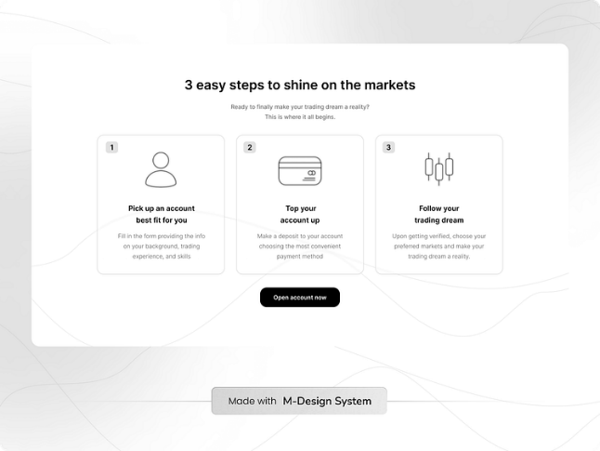
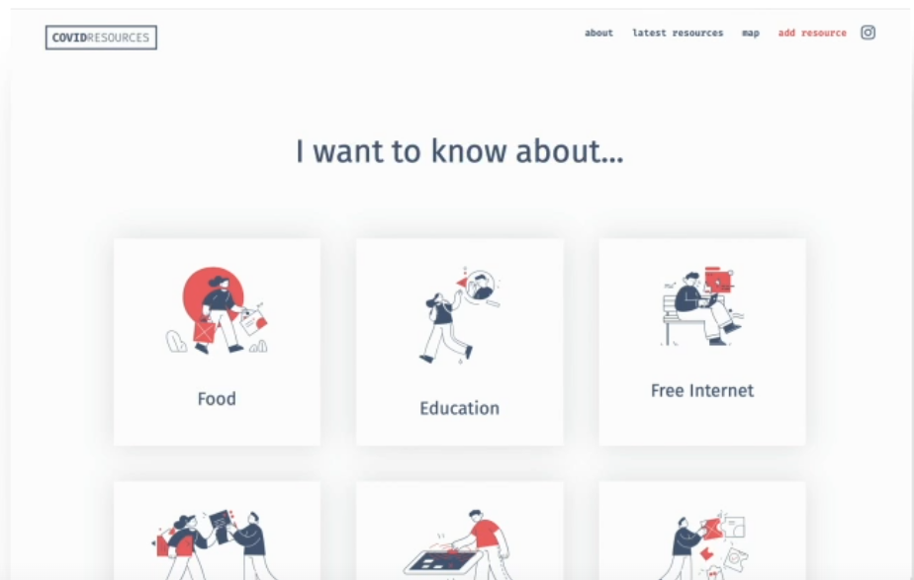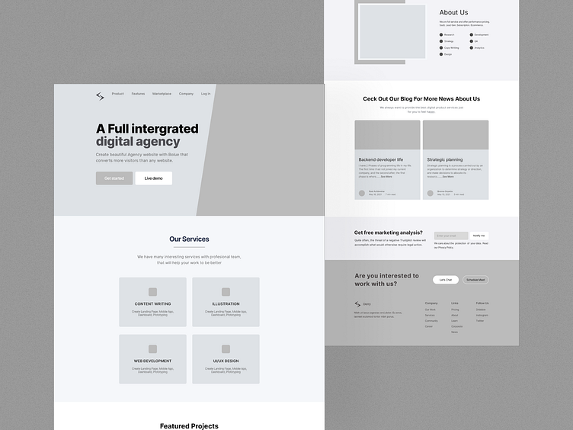

10. Dealbreakers & Non-Negotiables
These are the things that would make you look at the screen and immediately feel wrong. They’re often easier to identify than positive preferences.
- List anything you’ve seen in the current UI (or mockups) that you specifically want changed.
Even vague feedback like “the settings page feels cluttered” or “the table looks like a spreadsheet from 2005” is useful here. Be honest.
It looks like something out of a 2000s hacker movie. Purely technical in it’s functions. Like a developer built it. Only purpose is to serve the task, not to make the experience enjoyable.

