# 3D-FAST: User Manual

Document version: 1.0.0

Valid for 3D-FAST version: 2.0.1

## Introduction

3D-FAST (Facial Analysis for Clinical Translation) is a desktop application that allows users to import 3D facial images stored in a variety of different formats, visualise, manipulate, and analyse those images via an easy to use interface, and then export the images (along with salient landmark information about the face) into a standard portable format. In addition, PDF reports which incorporate facial images as a fully manipulable 3D objects can be generated to facilitate the easy sharing of 3D facial information. 3D-FAST can be run straight from a flash-drive and so does not need a user to have administrator rights since it does not require installation.

In its default configuration, 3D-FAST includes several features to assist in the analysis of 3D faces. These features include:

* Automated facial detection and landmark identification
* Automated cleaning (hole detection and filling, smoothing, density standardisation)
* Up to three different concurrent views of the same face
* Automated facial alignment and comparison
* Semi-automated cropping at the face boundary
* “Calipers” tool for measuring direct and surface distance between points
* Six different surface curvature visualisation modes
* Configurable colour and range mapping of surface visualisations
* Texture, Surface, Wireframe, and Vertex visualisations
* Generation of 2D snapshots
* Persistent user defined landmarks
* Import from > 20 different standard file formats
* Export to standard Wavefront OBJ format with associated metadata
* Export to PDF (Adobe Reader required)

## Interface

3D-FAST’s main interface is shown in figure 1 with a newly loaded 3D image. Along the top row underneath the menu bar are the main tool icons. These icons duplicate entries in the menus and are provided for convenience. Tools not currently available are greyed out. Underneath the top row is the visualisations toolbar which shows the available visualisations for the currently selected model. If no model is selected (or if no model is loaded), the visualisations are greyed out. Models can be selected for loading from the *File🡪Open* menu option or by selecting the *Open* toolbar 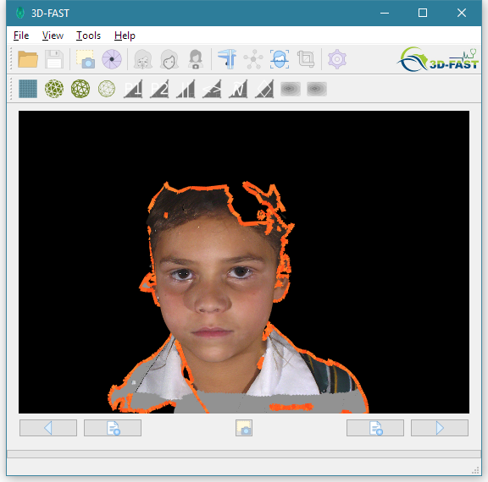button at the left of the toolbar. In the view pane (the black area), the currently selected face model is shown with a red outline around its border (*NB* 3D-FAST is not guaranteed to work correctly with models not having boundaries). Underneath the view pane are five icons. The centre icon is the snapshot tool which allows the user to save an image of that view pane (whatever its contents). On the left and right of this are icon pairs which move/copy the selected face left or right. The inner of the pair creates a copy of the face in a new view pane while the outer of the pair moves the selected face to that view pane. All newly loaded images are initially shown in the centre view area.

Figure 1:3D-FAST after loading an initial model

Figure 2 shows the interface after pressing the left *copy* button under the main view pane in figure 1. A new view of the model has been created in a new view pane on the left, and the selection boundary placed around this new view. Note that this represents a new view and *not a new model*. This means that actions taken on one selected view that affect the geometry or meta-data of the model will be reflected on the underlying model and therefore all views of it. However, different visualisations (user manipulations of the view, or selections of different visualisations of the model’s representation) will only be shown for the currently selected view(s). Only a single view of a model is allowed per view pane; moving a view back into a view pane where a view of the model already exists will consolidate the views within the target move view pane. In figure 2, to remove the newly created view – consolidating it with the original view –the move button underneath the left view pane is pressed. Note that the copy button is greyed out (disabled) since its not possible to make a new copy of the view in the main view pane since one is already present. Also note that within the main view pane (on the right), because the view is no longer selected within that view pane, the corresponding move/copy buttons underneath the view pane are disabled. In general, across 3D-FAST’s interface, tools/actions will only be available and act upon the currently selected view(s)/model(s).

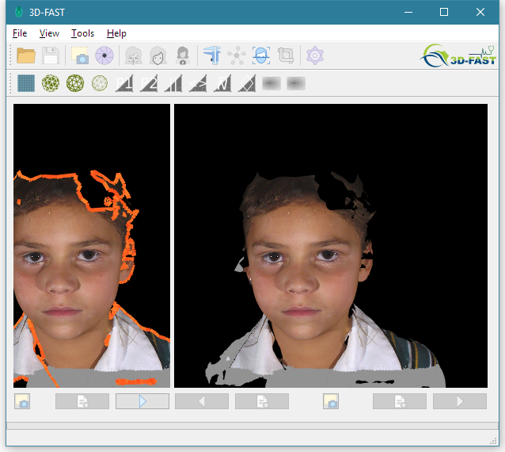

Figure 2: 3D-FAST after making a copy of the selected view

Multiple models of the same or different individuals can be loaded and displayed within the same view pane to facilitate comparison through overlay (such overlay comparisons are made possible using visualisations that allow for semi-transparency). Within a single view pane, multiple views can be selected at once, and actions taken will be applied to all currently selected views. Within a view pane, toggling the selection of an individual view is effected via double-clicking the left mouse button on the desired view/model. To toggle selection/deselection of all views/models within the view pane, the left mouse button should be double-clicked in the black area outside the bounds of any of the models shown. Figure 3 shows 3D-FAST after loading a second model of a different individual – both the original and the newly loaded model are selected. 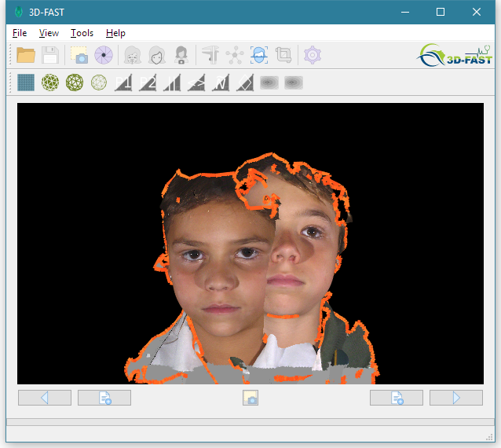

Figure 3: 3D-FAST after loading a second model within the main view pane

Underneath the view pane icons are the progress and status bars which give feedback to the user on some long running actions.

## Manipulating the View

Within a single view pane, the view camera can be moved around to see different parts of the models displayed in the view pane. The focal point of the camera is fixed by default and clicking and dragging with the left mouse button anywhere within the view pane rotates the camera around this point at a fixed distance from it. The camera can be panned horizontally and vertically by clicking and dragging with the right mouse button. Panning also has the effect of moving the camera focal point. The camera can also be moved closer to and further away from the focal point by using the mouse wheel. For viewing detail, the camera focal point can be set exactly by single right clicking the desired location on a model and selecting *Set Camera Focus* from the context menu that appears. The camera view can be reset at any point by clicking *View🡪Reset Camera* from the menu bar or by clicking the corresponding tool icon.

## Facial Detection

Facial detection allows for the automated placement of facial landmarks and orientation of faces for comparison. Facial detection is also required to extract facial orientation data required for the visualisation of curvature through colour mapping. To carry out facial detection, ensure the desired face is currently selected (with a red boundary) and select *Tools🡪Detect Face*, or press the corresponding tool button. After a few moments, the face is realigned, a base set of landmarks identified and mapped to the face, and a blue boundary shown demarcating an estimate of the facial region. During this process, detected holes are filled in, the surface mesh smoothed slightly to remove high gradient surface spikes which can sometimes be present due to the image capture process, and extraneous parts of the model not connected to the face removed. Figure 4 shows the result of facial detection on the subject originally shown in figure 1. Note that the subject’s right shoulder has been removed since it was found to be a model component completely disconnected from the detected face.

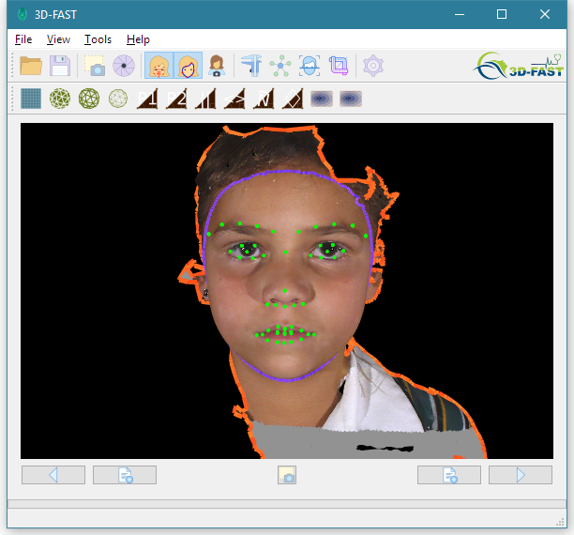

Figure 4: 3D-FAST after undertaking facial detection on the subject in figure 1

Note that facial detection can be undertaken on several selected faces at once, but the operation will take significantly longer.

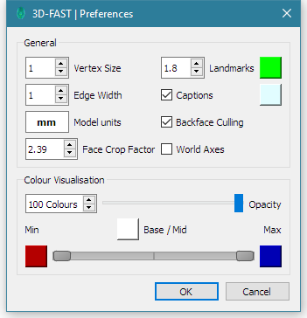Subsequent to facial detection, further extraneous parts of the model can be removed by cropping all regions of the model outside the given blue boundary. The extent of the boundary can first be adjusted through the options dialog (accessible via the toolbar ”cog” or via *Tools🡪Options)* as shown in figure 5, and adjusting the *Face Crop Factor* value. This Face Crop Factor value represents the number of times the blue boundary extends out from the face from behind the nose tip to a point midway between the eyes and can be used as a standard measure for demarcating the facial region.

Figure 5: 3D-FAST's preferences from where the facial boundary (Face Crop Factor) can be adjusted

Once happy with the selected facial boundary, click the *Crop Face* tool button or select the option from the *Tools* menu to finish processing the facial region. This will conduct further processing to standardise the density of the vertex data used to represent the model so that it can be compared effectively against models generated from different hardware platforms. (NB texture information may be corrupted slightly after facial cropping due to the way in which different data formats require texture mapping to be carried out). The result of facial cropping on the underlying surface mesh is shown in figure 6.

After facial detection, an option to restore the selected view(s) detected facial orientation becomes available. This is selected from the *View* menu as the *Orient Camera to Face* action. The *Reset Camera* option remains available and this will continue to reset the view to the image capture orientation.

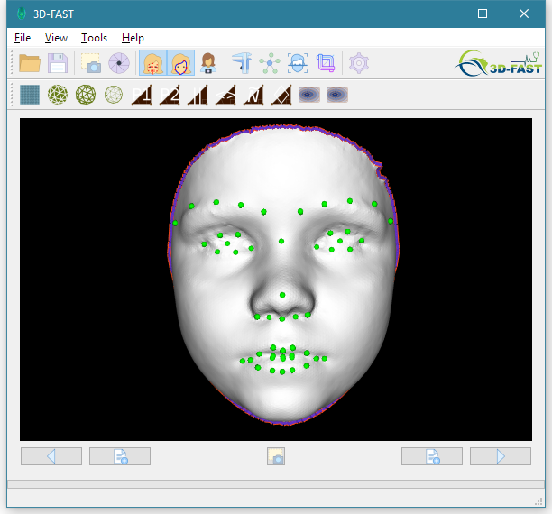

Figure 6: The finished mesh after facial detection, cropping, and mesh processing

## Visualisations

3D-FAST provides several of basic visualisations of the surface geometry accessible from the visualisations tool bar underneath the main tool bar. The first four on the left of the tool bar allow the user to select from one of four underlying representations: the texture mapped surface, the non-texture mapped surface (as shown in figure 6), the wireframe model, and the vertex model.

The following set of six visualisations relate to surface curvature. These are curvature along the first and second principal components of curvature, absolute curvature, mean curvature, Gaussian curvature, and curvature derived from local matrix determinants. The formulae for these six types of curvature are all different and therefore are sensitive to curvature in different ways. The user should experiment with all six to find the visualisations best for any particular case.

For use by researchers, a set of two further visualisations of surface distance information from the nose tip are provided; the first a distance map generated using a constant traversal speed, the second a distance map with surface traversal speed modelled as a function of mean surface curvature. All of the curvature and distance map visualisations use a colour mapping to indicate the degree of the selected measure. The colours and the range over which the colours should be mapped can be changed in the preferences (figure 5). Note that in the case of the absolute curvature and the distance mapping visualisations, mapping the minimum colour not undertaken since all values are positive.

For comparing different faces against one another, it is often useful to set the surface colour of the faces to be semi-transparent. Once facial detection and orientation of the desired faces has been carried out, ensure the faces are selected and select the surface mesh visualisation. From here, use the *opacity* sliderin the *Colour Visualisation* section of the preferences dialog (figure 5) to set the desired surface opacity. This can be helpful when evaluating the change in a face at two different points in time, or even for comparing between two similar faces. Figure 7 shows example output of this process for two different faces with corresponding landmarks.

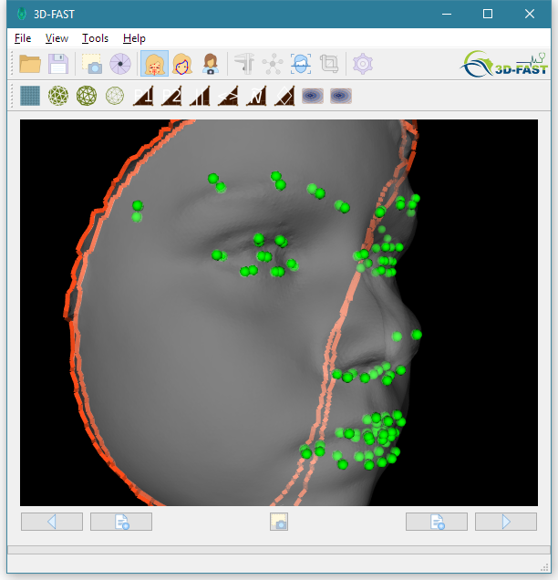

Figure 7: Showing the surface correspondence between two different faces

## Landmarks

As well as the automatic detection of landmarks, 3D-FAST allows the user to add and delete their own landmarks and relocate existing landmarks – which can also be useful if the accuracy of the placement for the automatically detected landmarks is not adequate. To move landmarks, the face must be selected and landmarks currently in view (*View🡪Show Landmarks*) (*NB* if the menu option or corresponding tool bar button is disabled, and the face is selected (with a red boundary), then facial detection has not yet been carried out!). Selecting the *Tools->Move Landmarks* option (or the corresponding tool bar button) then allows the landmarks to be moved around the face by clicking and dragging them. To “relock” the landmark positions, deselect the *Move Landmarks* button or option from the *Tools* menu*.* Note that the landmarks are uniquely defined and each has its own label shown whenever the mouse cursor hovers over the landmark.

The full list of landmarks and their positions can be seen in the dialog accessible through the *Tools* menu. This list is for viewing purposes only currently; landmark label renaming is not currently supported but will be available in a future release.

To add a new landmark, right click on the desired part of the face and select *Add Landmark* from the context menu that appears. Not that it is not intended that landmark labels contain more than a few words and every landmark label on a face must be unique. To delete a landmark, hover the mouse over the landmark, right click to bring up the context menu and select *Delete Landmark*.

## Surface Measurements

3D-FAST provides a set of virtual callipers to allow the user to make distance measurements between arbitrary points on the face. The units are set to millimetres by default in accordance with the units used to define the model’s geometry. If importing models that define a geometry using different units, set the unit type in the preferences dialog (figure 5). To use the callipers, select the *Use Callipers* tool bar button or select the option from the *Tools* menu. With the callipers enabled, left clicking and dragging on the model no longer causes the view to change, but will dynamically draw a line over the surface of the model between the point at which the mouse button is clicked down and the point at which it is released. Upon releasing the mouse button, the drawn line segment remains on the face with endpoints that can be moved by clicking and dragging them. The distance caption on the line is the direct straight line distance between the two points, but the line shown is the shortest path over the surface between the two points (which estimates a geodesic segment). In the bottom right corner of the view pane, an estimate of the geodesic distance is shown underneath the point-to-point distance.

After drawing the measurement line, clicking and dragging anywhere other than the measurement endpoints will result in the original behaviour of the camera view rotating. Deselect and select the tool bar button again to draw a new line.

## Saving Models and PDF Generation

To save the currently selected model, select *File🡪Save As* to save into the default .3df format which allows for all landmark and metadata (e.g. orientation information) concerning the model to be saved as well. The .3df format is actually an XML file format with reference out to the model file which is saved in the Wavefront .obj file format. If the user does not require the model’s 3D-FAST metadata to be saved, but only requires the .obj file, this can be selected from the drop down file type. Note that when moving .3df format files, the associated files for the .obj file format must be kept alongside it (including the .obj file itself, the .mtl file, and the .png file containing the texture data).

To generate a PDF which embeds the 3D model, select *File🡪Export PDF* and select the location to export the PDF to. After some moments, 3D-FAST will advise that generation is complete and the newly created PDF can be opened in a PDF viewer. Note that Currently, the ability to view 3D models within PDFs is only well supported by Adobe Reader. The format of the PDF itself is not currently modifiable and is meant only to provide a means to transmit 3D facial data between individuals not having 3D-FAST or some other 3D image capable viewer. Further reporting templates will be included in future releases.

## Reporting Issues

3D-FAST is in continued development and while every effort is made to ensure a bug-free user experience, users may still encounter problems. If you believe you have encountered a bug, or unexpected behaviour of some kind, or even if you have a good idea for how to improve the application, we encourage you to contact the developer directly who will then make every effort to rectify the issue for the next version, or attempt to include your suggestion for improvement in the next major release! The developer may be contacted directly at [r.l.palmer@curtin.edu.au](mailto:r.l.palmer@curtin.edu.au).

## Plugin Extensions

3D-FAST has been designed for use by regular users of 3D facial images, but also for use by researchers in 3D facial analysis. As such, 3D-FAST utilises a plugin approach to support the ongoing integration of new features which may be developed by third parties. Examples of such features include new kinds of visualisation, new tools for interacting with the images, new 3D image processing capabilities, or new reporting functions. Plugins can be developed as standalone shared binary objects and placed into the *plugins* directory within the main 3D-FAST application directory for loading by 3D-FAST at start-up. Within the application, a list of loaded plugins can be found in the Help🡪About Plugins menu. If functionality that you expect to be present isn’t available, it’s likely that the associated plugin was not found by the application – ensure the requisite .dll is present in the *plugins* directory and try restarting the application. If you are interested in extending the functionality of 3D-FAST, please contact the developer for further information ([r.l.palmer@curtin.edu.au](mailto:r.l.palmer@curtin.edu.au)).