Burp Suite Interception and Intruder Fuzzing Report
DVWA Security Configuration:
DVWA security level was configured to Low to allow testing of authentication weaknesses.
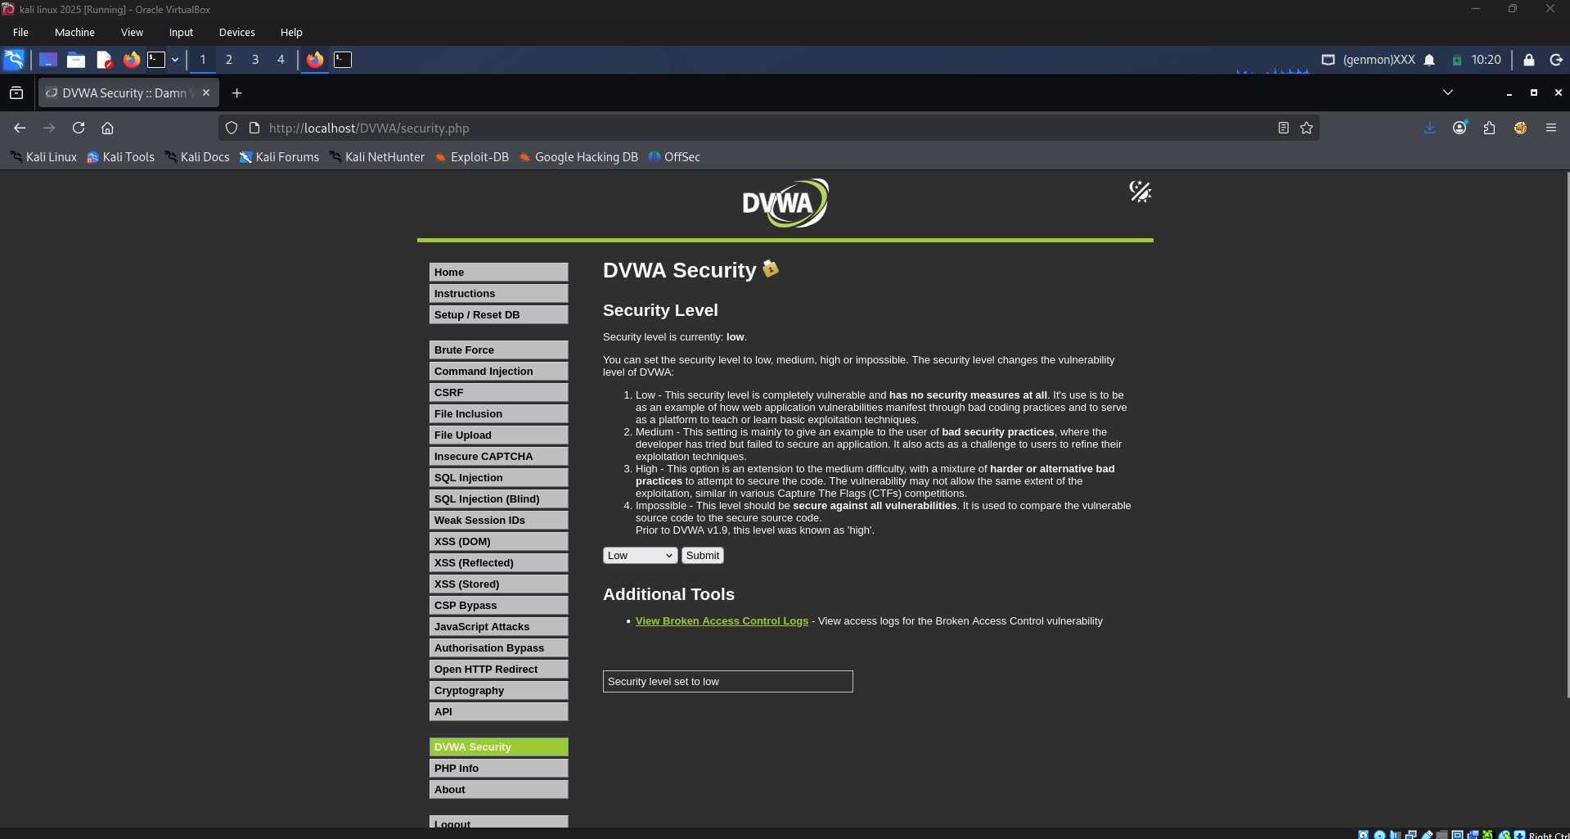
Observation: The screenshot confirms successful execution of the corresponding phase of the task.
Selection of Brute Force Testing Module:
The DVWA Brute Force module was selected as the target application for testing.
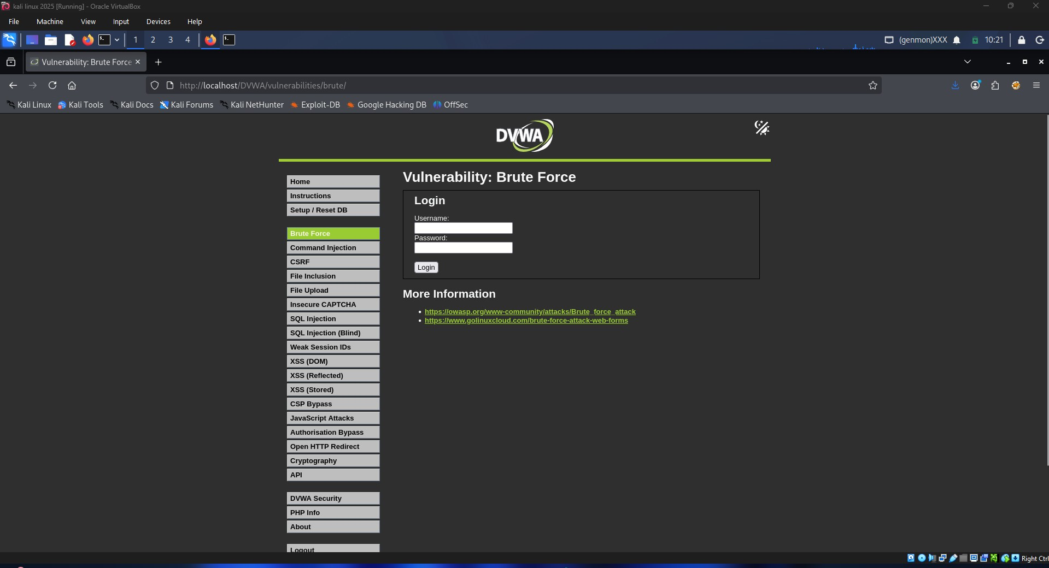
Observation: The screenshot confirms successful execution of the corresponding phase of the task.
FoxyProxy Proxy Configuration:
FoxyProxy was configured to route browser traffic through Burp Suite on localhost:8080.
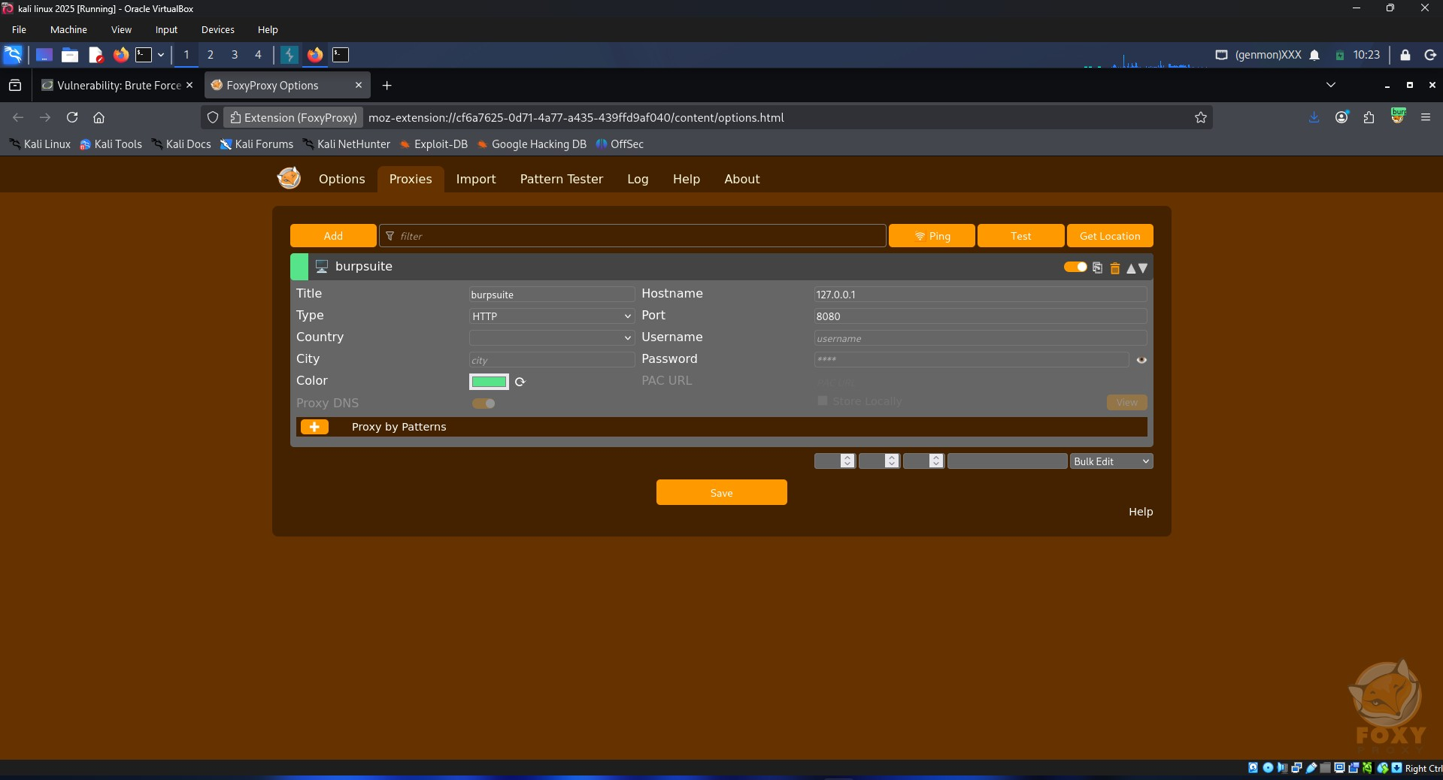
Observation: The screenshot confirms successful execution of the corresponding phase of the task.
Enabling Burp Suite Request Interception:
Burp Suite Proxy Intercept was enabled to capture HTTP requests from the browser.
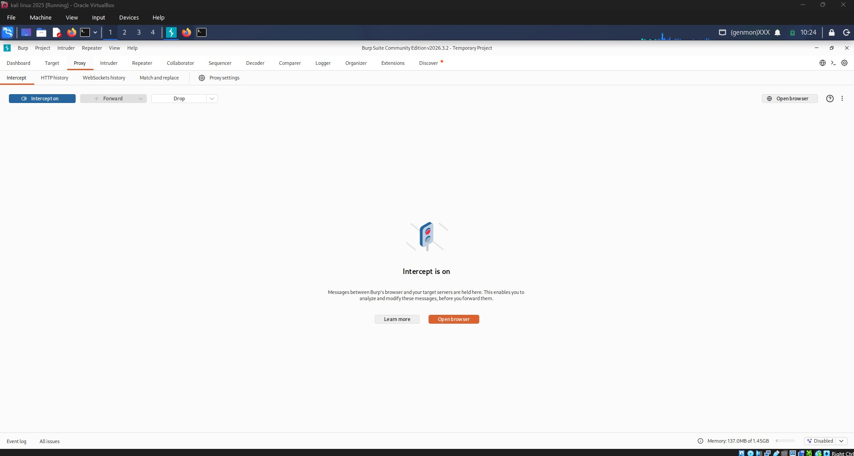
Observation: The screenshot confirms successful execution of the corresponding phase of the task.
Capturing the Authentication Request:
A login request was captured successfully and examined within Burp Suite.
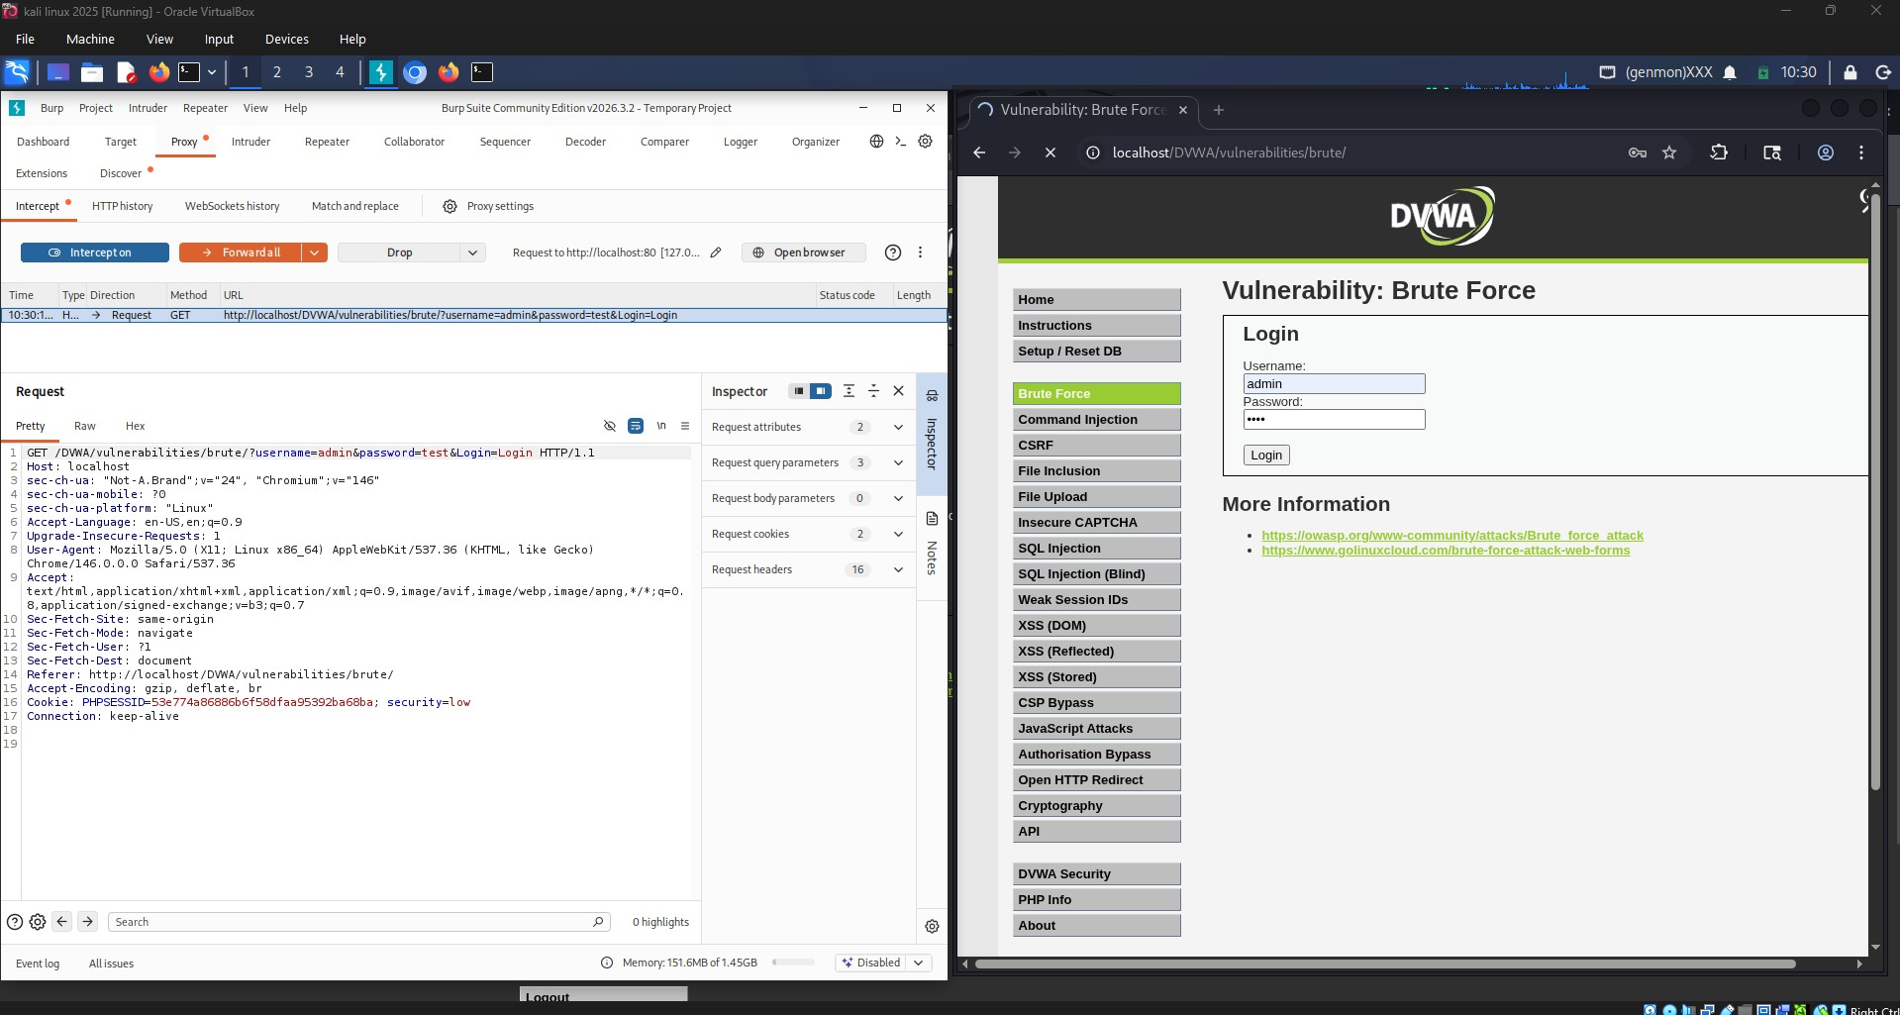
Observation: The screenshot confirms successful execution of the corresponding phase of the task.
Modifying Intercepted Request Parameters:
The intercepted request parameters were modified to demonstrate request manipulation.
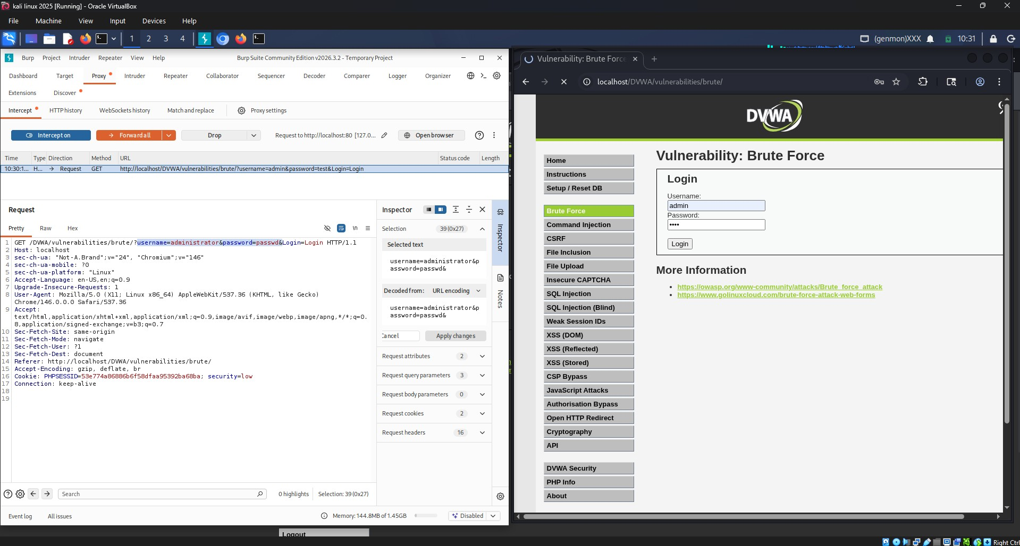
Observation: The screenshot confirms successful execution of the corresponding phase of the task.
Analyzing Application Response Behavior:
The server response was reviewed to observe how the application handled the submitted credentials.
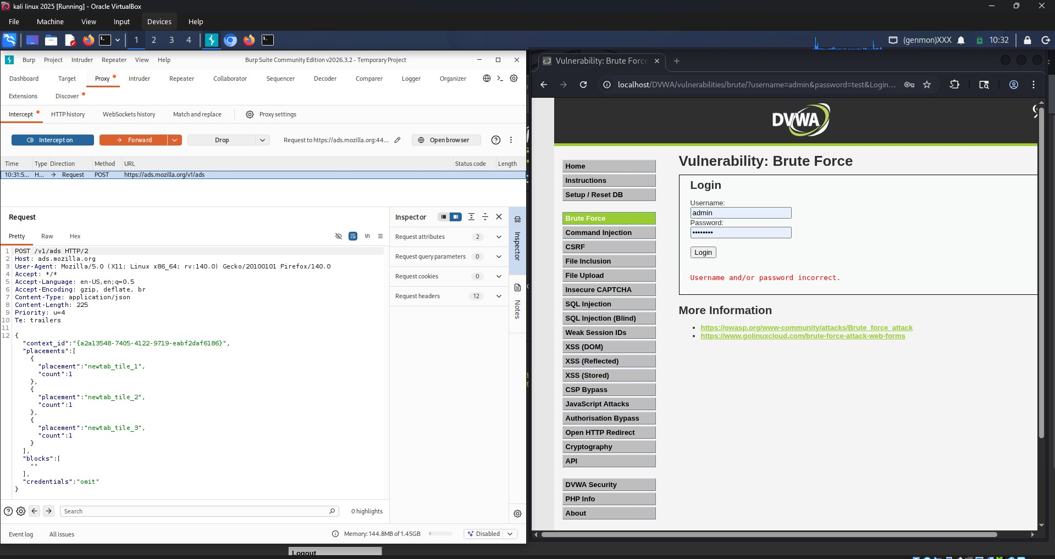
Observation: The screenshot confirms successful execution of the corresponding phase of the task.
Forwarding Request to Burp Intruder:
The captured request was forwarded to Burp Intruder for fuzzing and payload testing.
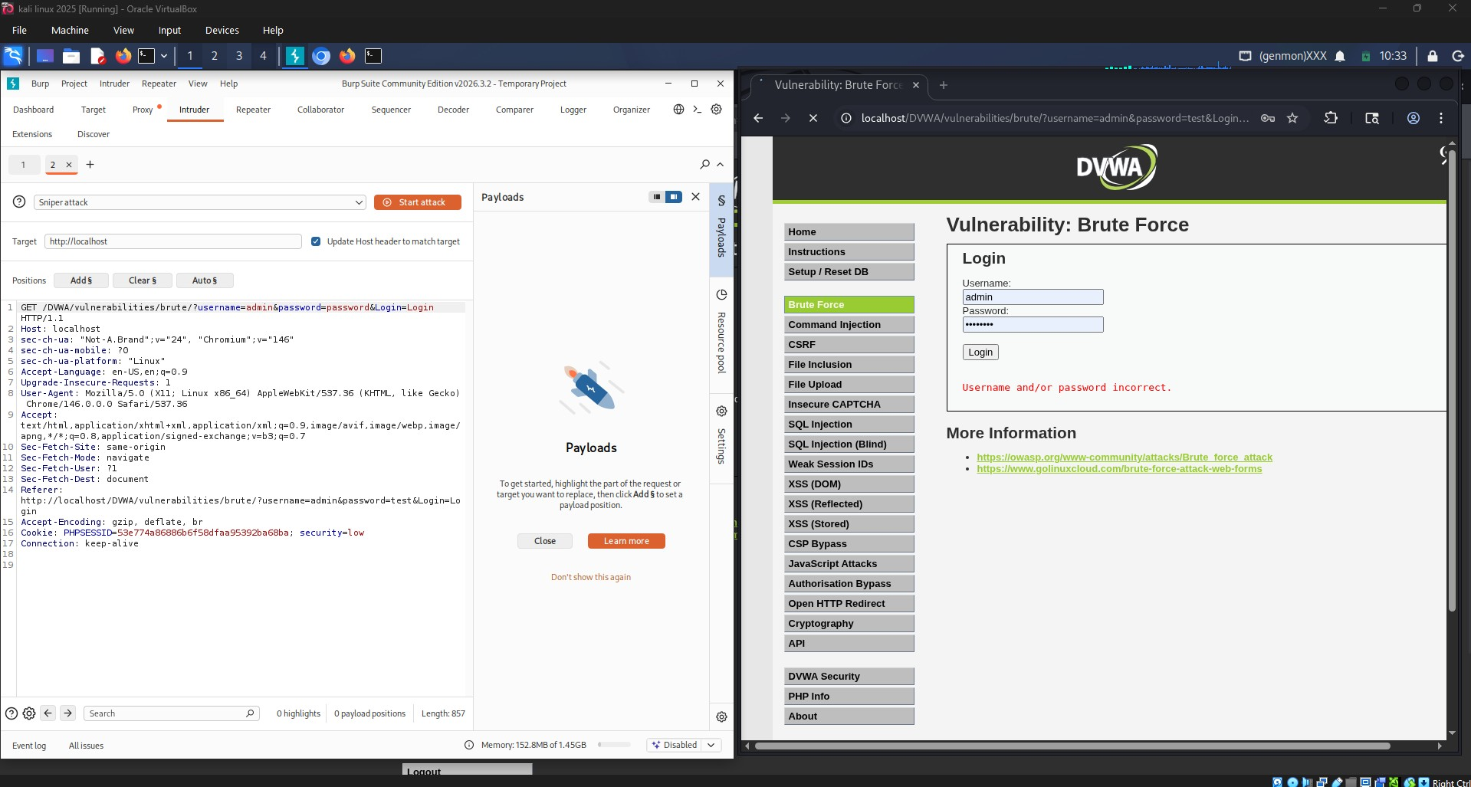
Observation: The screenshot confirms successful execution of the corresponding phase of the task.
Configuring Payload Positions and Wordlist:
Payload positions and a custom wordlist were configured in Intruder.
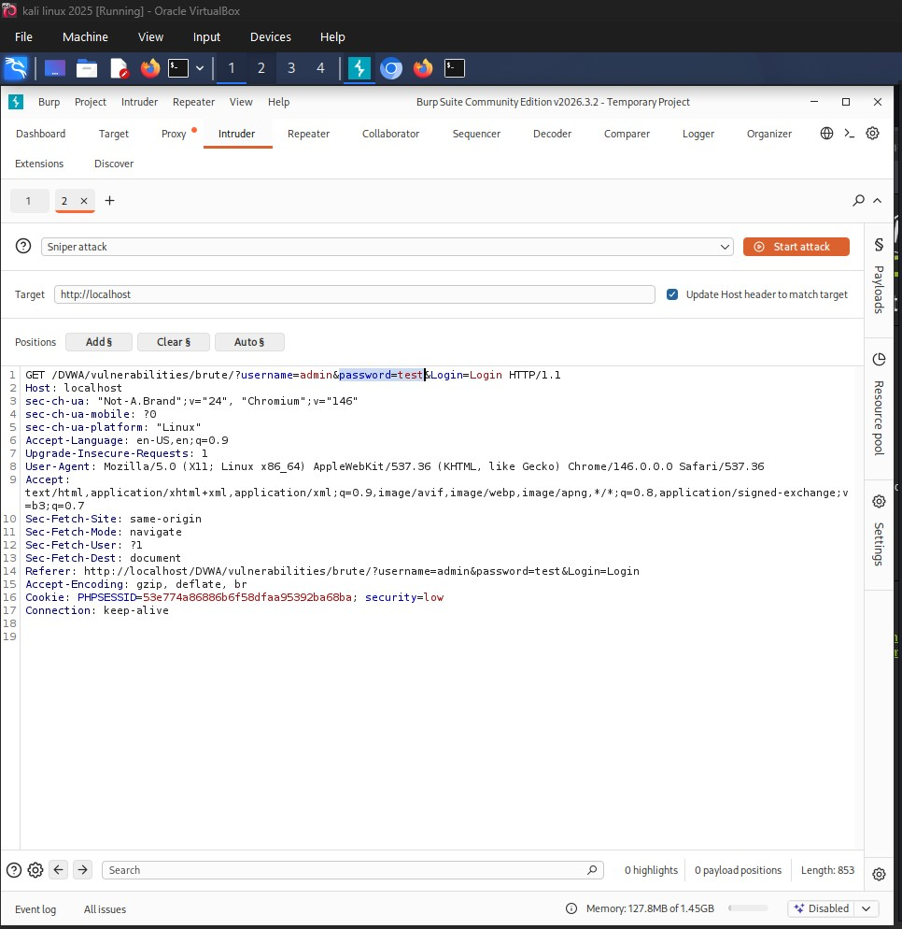
Observation: The screenshot confirms successful execution of the corresponding phase of the task.

Executing the Intruder Fuzzing Attack:
The Intruder attack was launched using the configured payload set.
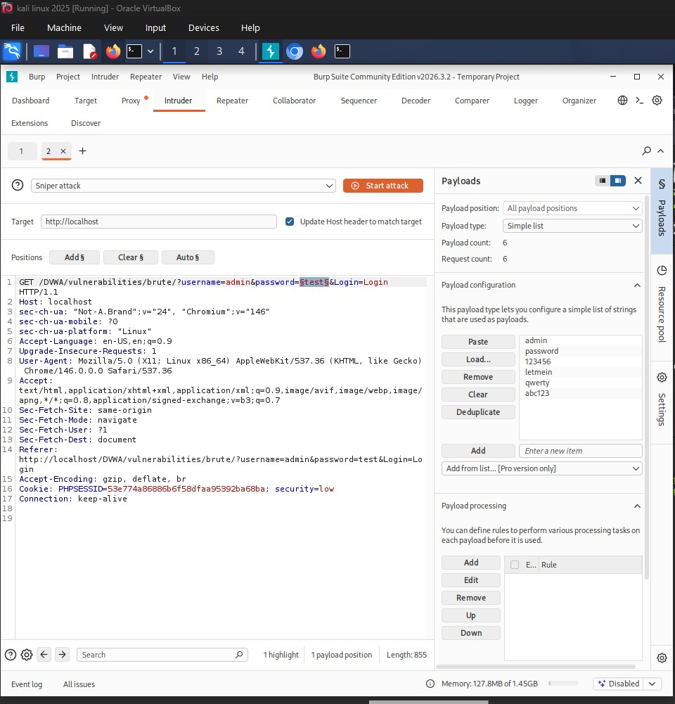
Observation: The screenshot confirms successful execution of the corresponding phase of the task.

Reviewing and Analyzing Intruder Results:
Results were analyzed by comparing status codes, response lengths, and response times.
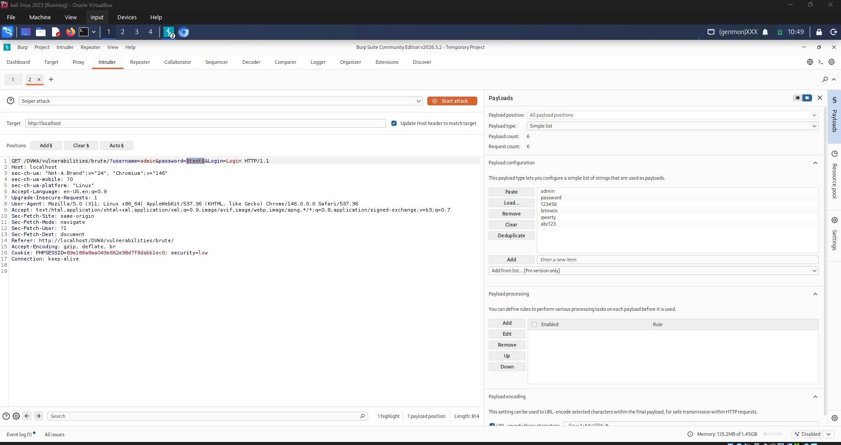
Observation: The screenshot confirms successful execution of the corresponding phase of the task.

Analysis of Fuzzing Results:
The results generated by Burp Intruder were analyzed by comparing response lengths, status codes, and response times to identify differences in application behavior for each tested payload.
