CAPSTONE PROJECT
VULNERABILITY ASSESSMENT OF TEST NETWORK
Professional Cybersecurity Assessment Report
ApexPlanet Software Pvt. Ltd.
Prepared as part of the Cyber Security & Ethical Hacking Capstone Project

Table of Contents

1. Executive Summary
2. Introduction
3. Objectives
4. Scope and Limitations
5. Lab Environment
6. Network Architecture
7. Methodology
8. Reconnaissance
9. Vulnerability Assessment
10. Controlled Exploitation
11. Incident Response
12. Log Analysis
13. Findings and Risk Assessment
14. Mitigation Strategies
15. Lessons Learned
16. Conclusion
17. Evidence and Deliverables

1. Executive Summary
This capstone project assessed an intentionally vulnerable test network using an isolated Oracle VirtualBox laboratory. Kali Linux was used as the attacker and assessment system, while Metasploitable 2 was used as the vulnerable target. The assessment followed a structured workflow covering reconnaissance, vulnerability assessment, controlled exploitation, incident response, and post-incident analysis.
Reconnaissance with Nmap identified the target at 192.168.56.101 and revealed 23 open TCP ports and numerous exposed services. Service enumeration identified outdated services including vsFTPd 2.3.4, OpenSSH 4.7p1, Apache HTTP Server 2.2.8, Samba 3.x, MySQL 5.0.51a, PostgreSQL 8.3 and UnrealIRCd. 
Greenbone OpenVAS was then used for vulnerability assessment. The supplied report recorded 14 Critical, 9 High, 40 Medium and 6 Low results for the target, with 69 displayed results after the report filtering criteria.
A controlled exploitation was performed against the UnrealIRCd 3.2.8.1 backdoor vulnerability. The exploit established a Meterpreter session and root privileges were confirmed during post-exploitation verification. 
The incident response phase then identified the active session, terminated it, and verified that no active sessions remained. Log analysis was also performed on the target system. The reviewed authentication, system and Apache logs did not contain direct evidence of the UnrealIRCd exploit, so the active Meterpreter session was used as the primary indicator of compromise.

2. Introduction
A vulnerability assessment identifies weaknesses in systems and services so that they can be prioritized and remediated before they are exploited. This capstone extends that process into a controlled penetration test and incident response simulation. All activities were performed within the designated virtual laboratory and were limited to the configured test machines.
The project scope specifically included Oracle VirtualBox, Kali Linux, Metasploitable 2, the Host-Only network, Nmap scanning, OpenVAS assessment, controlled exploitation and incident response simulation. Public Internet systems, production servers, third-party networks, wireless testing, social engineering and physical security testing were out of scope.

3. Objectives
- Build a secure virtual penetration testing laboratory using Oracle VM VirtualBox.
- Configure Kali Linux as the attacker/assessment machine and Metasploitable 2 as the vulnerable target.
- Perform reconnaissance and information gathering.
- Identify open ports and running services using Nmap.
- Conduct vulnerability assessment using OpenVAS.
- Verify selected vulnerabilities through controlled exploitation.
- Collect evidence and document findings.
- Recommend mitigation strategies.
- Simulate an incident response process.
- Prepare a professional cybersecurity assessment report.
These objectives are consistent with the project planning document.



4. Scope and Limitations
The assessment was limited to the isolated virtual laboratory. No production or third-party systems were tested. Exploitation was performed for educational purposes and the results apply specifically to the configured laboratory environment.

5. Lab Environment
The laboratory used Oracle VM VirtualBox with two guest systems: Kali Linux as the attacker and assessment platform, and Metasploitable 2 as the intentionally vulnerable target. Kali Linux was configured with 6 GB RAM, 6 CPU cores and a 60 GB disk. Metasploitable 2 was configured with 512 MB RAM, 1 CPU core and an 8 GB disk.

The network configuration used a Host-Only Adapter (vboxnet0) for communication between Kali Linux and Metasploitable 2. Kali Linux also used a NAT adapter for Internet access, while Metasploitable 2 remained isolated from the Internet.

6. Network Architecture
The project uses a network architecture diagram rather than a database-style ER diagram. The diagram represents the relationships between the Windows 11 host, Oracle VirtualBox, Kali Linux, Metasploitable 2 and the Host-Only/NAT network paths.
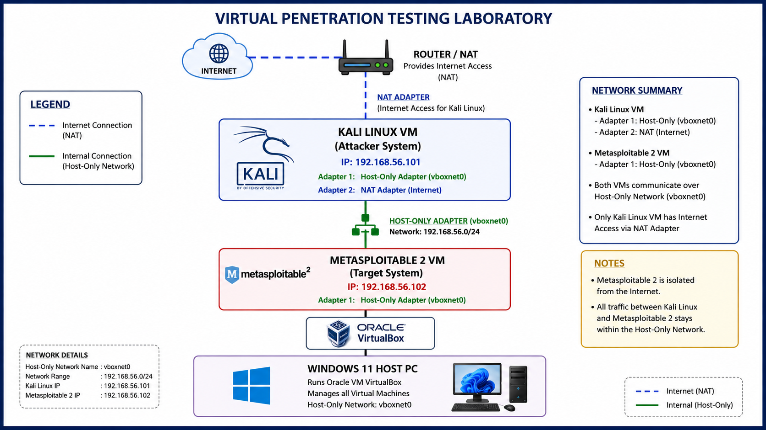
Figure 1. Virtual Penetration Testing Laboratory Network Diagram

7. Methodology
The assessment followed a sequential security testing methodology:
- Project planning and definition of scope.
- Virtual laboratory setup and network verification.
- Reconnaissance using Ping and Nmap.
- Vulnerability assessment using Greenbone OpenVAS.
- Selection and controlled validation of an identified vulnerability using Metasploit.
- Post-exploitation verification in the isolated target.
- Incident detection, containment, eradication and verification.
- Log analysis and post-incident documentation.
- Compilation of findings and mitigation recommendations.

8. Reconnaissance
Reconnaissance was performed from Kali Linux against Metasploitable 2 at 192.168.56.101 over the Host-Only network. A TCP SYN scan discovered 23 open TCP ports, indicating a large attack surface.
Service enumeration identified several legacy services and versions, including vsFTPd 2.3.4, OpenSSH 4.7p1, Apache HTTP Server 2.2.8, Samba 3.x, MySQL 5.0.51a, PostgreSQL 8.3 and UnrealIRCd. 
Operating-system detection and an aggressive Nmap scan were also performed. The OS detection identified a Linux 2.6.x environment, while the aggressive scan combined OS detection, service enumeration, default NSE scripts and traceroute. 
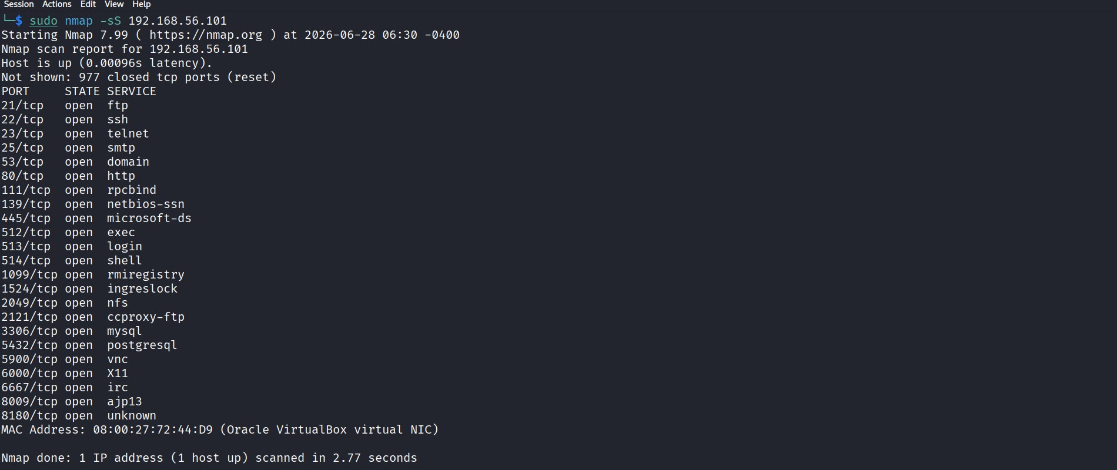
Figure 2. TCP SYN Port Scan
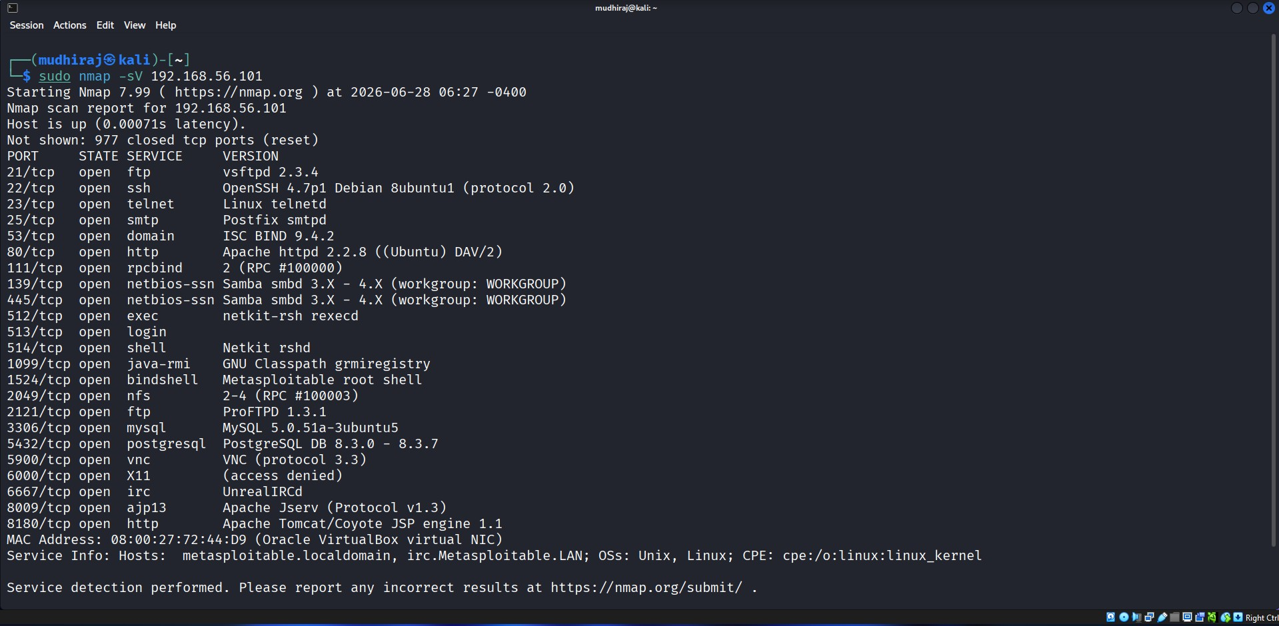
Figure 3. Service Enumeration
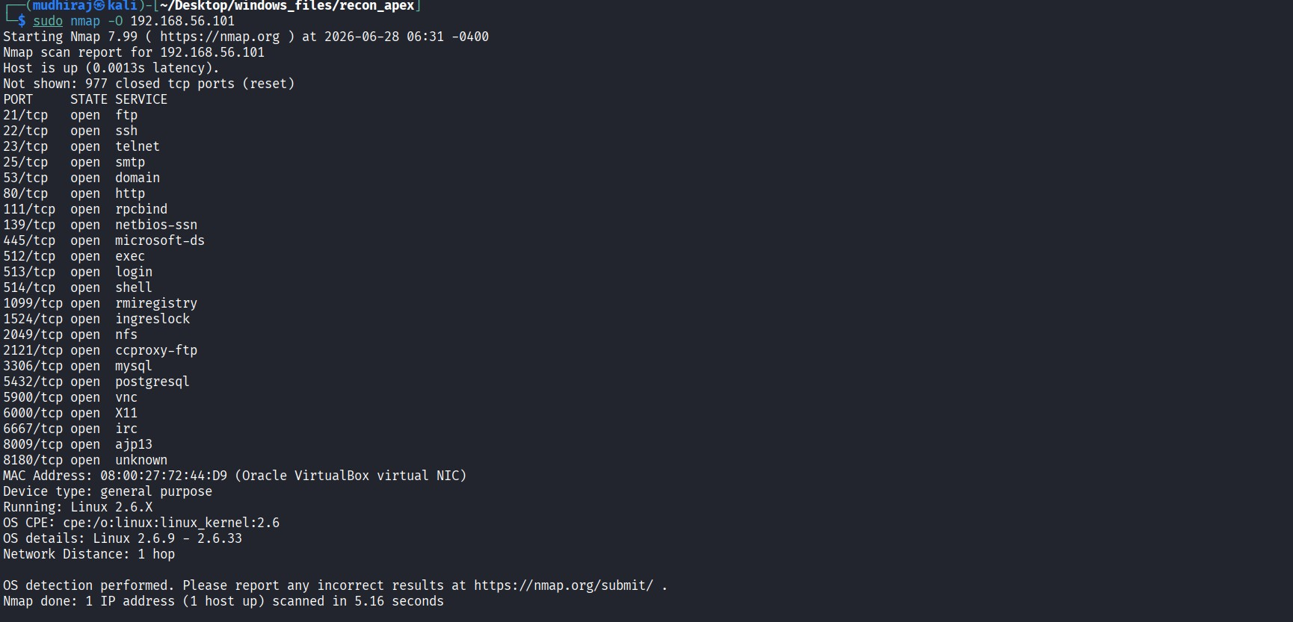
Figure 4. Operating System Detection
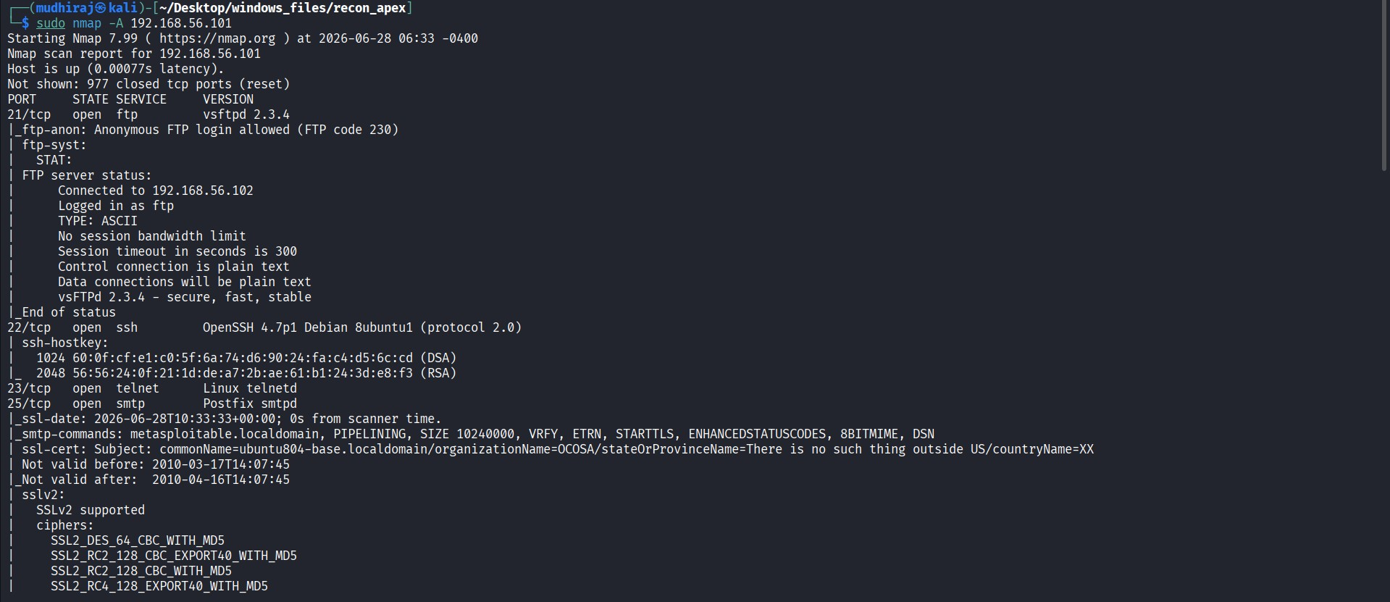
Figure 5. Aggressive Scan

9. Vulnerability Assessment
Greenbone OpenVAS was configured against 192.168.56.101 using the Full and Fast scan profile. The scan completed successfully and the generated report was exported for analysis.
The OpenVAS report recorded 14 Critical, 9 High, 40 Medium and 6 Low findings for the target. The report states that 69 results were selected by its filtering criteria from 633 results before filtering.
Examples of Critical findings included an Apache Tomcat AJP RCE (Ghostcat) finding with CVSS 9.8, a vsFTPd backdoor finding with CVSS 9.8, and other critical service weaknesses.
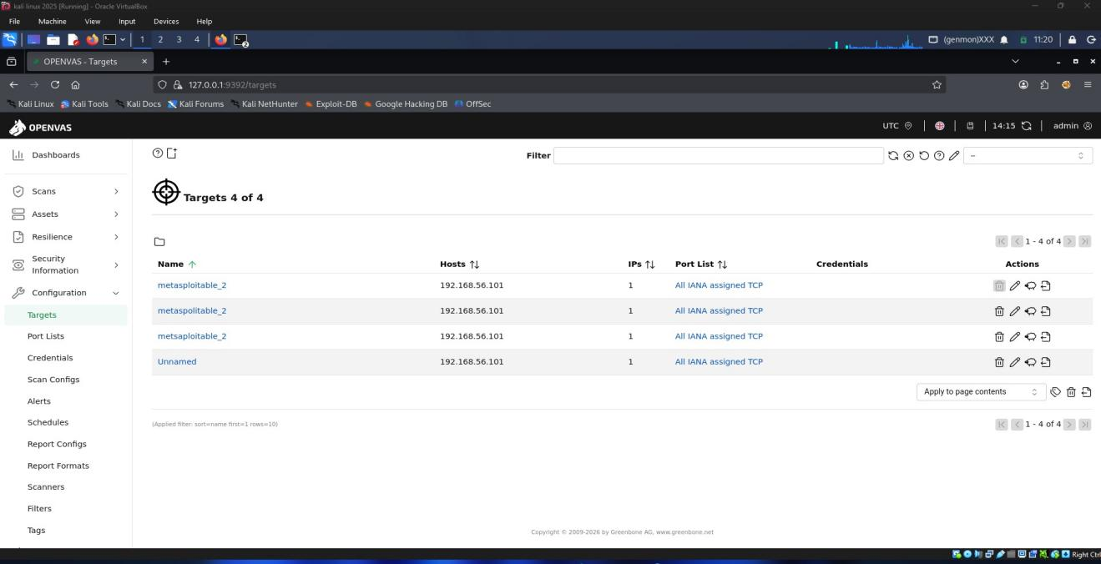
Figure 6. OpenVAS Dashboard
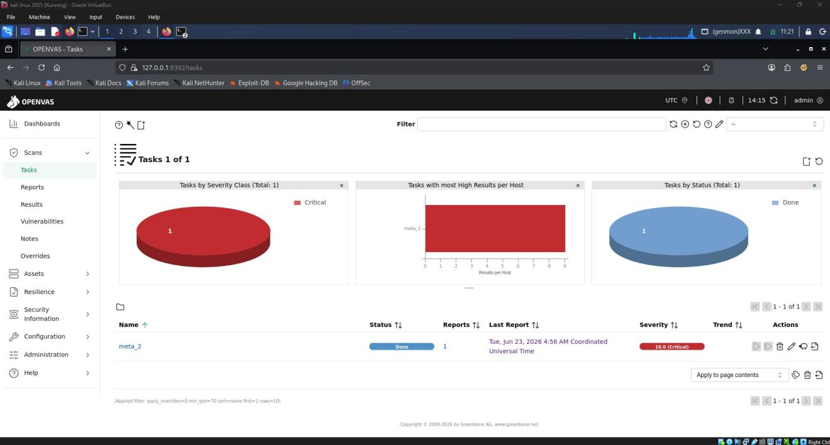
Figure 7. OpenVAS Target Configuration
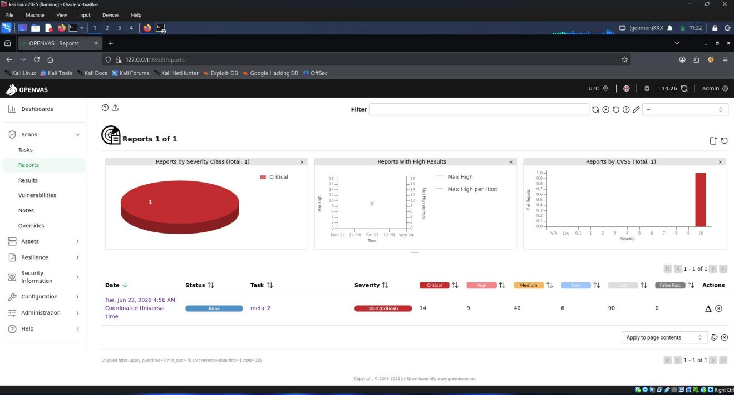
Figure 8. OpenVAS Scan Task
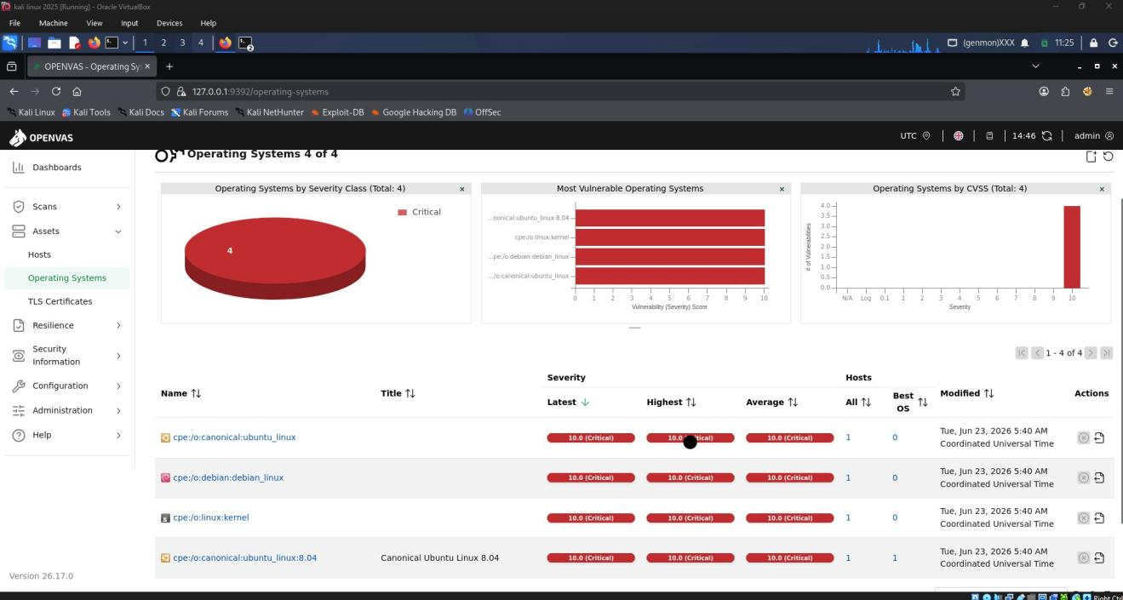
Figure 9. OpenVAS Scan Summary

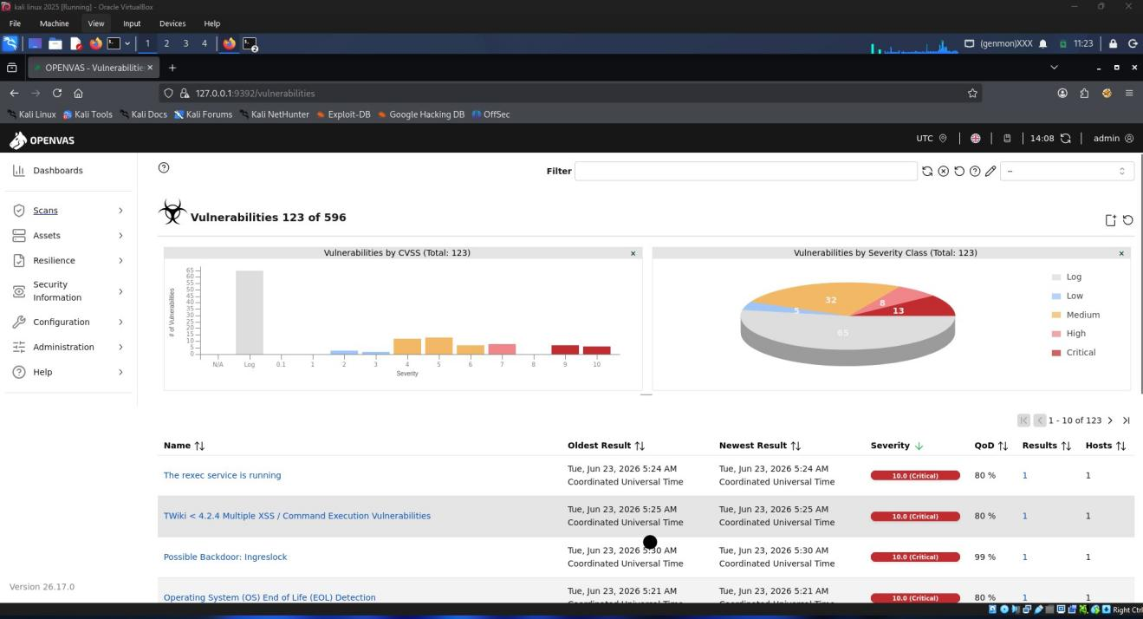
Figure 10. OpenVAS Vulnerability Findings

10. Controlled Exploitation
Based on the reconnaissance and vulnerability assessment results, the UnrealIRCd 3.2.8.1 backdoor vulnerability was selected for controlled validation. The Metasploit module exploit/unix/irc/unreal_ircd_3281_backdoor was configured against 192.168.56.101 on TCP port 6667, with Kali Linux at 192.168.56.102 as the listener.

The exploit successfully established a Meterpreter session. Post-exploitation commands including sysinfo, getuid, shell, whoami, hostname, uname -a and id were used to verify system information and root-level access. 
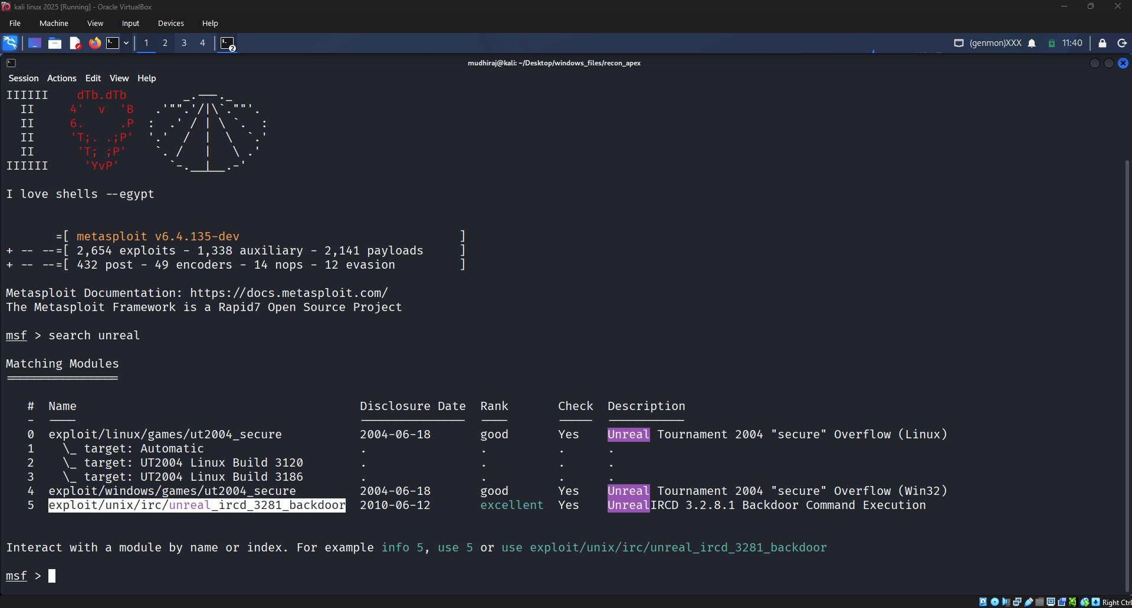
Figure 12. Metasploit Exploit Search
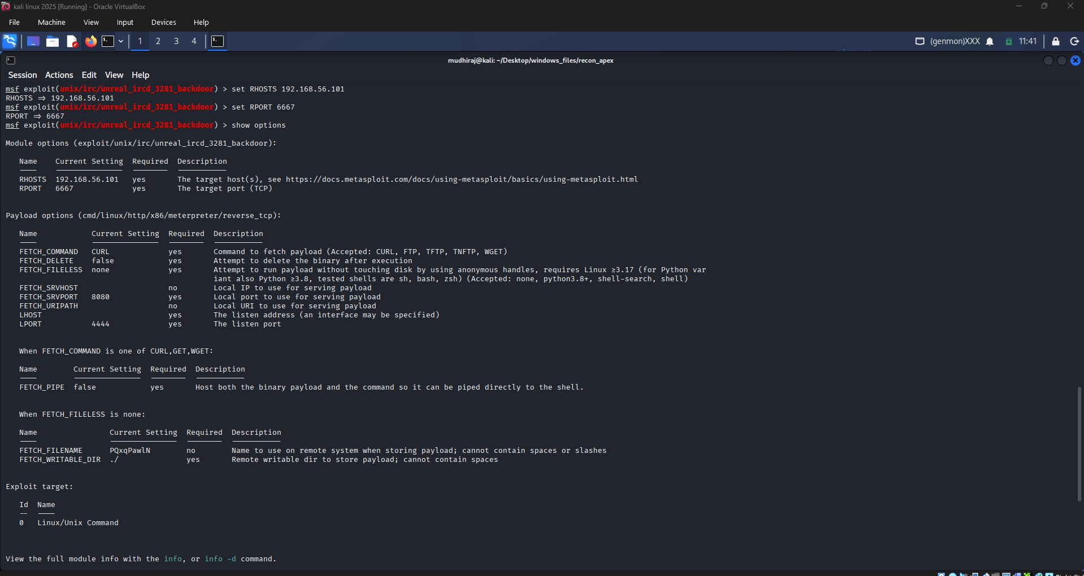
Figure 13. Exploit Configuration
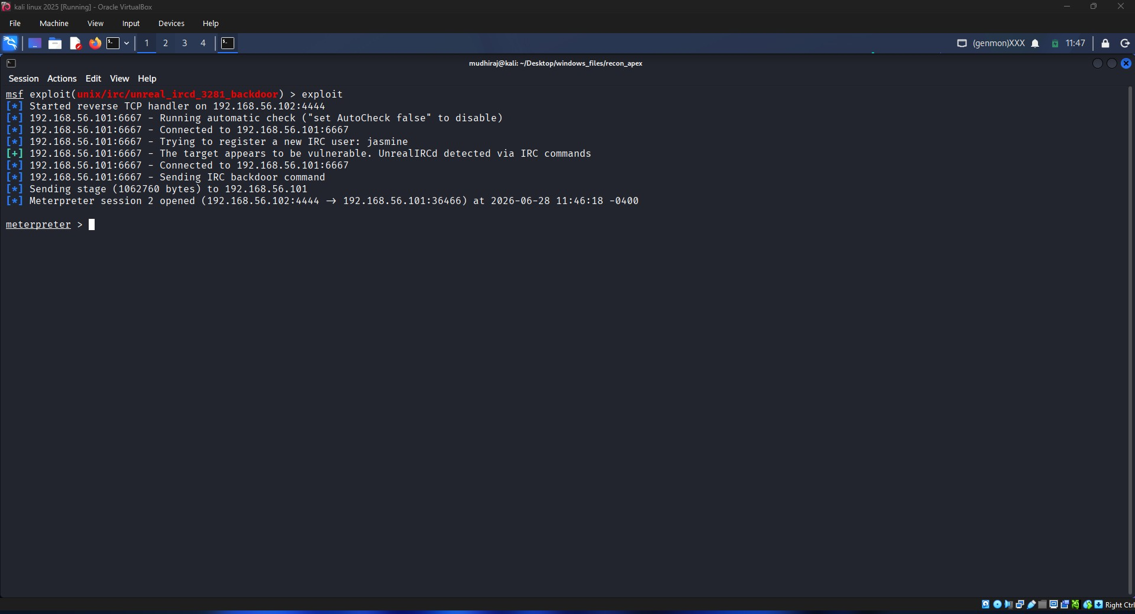
Figure 14. Successful Meterpreter Session
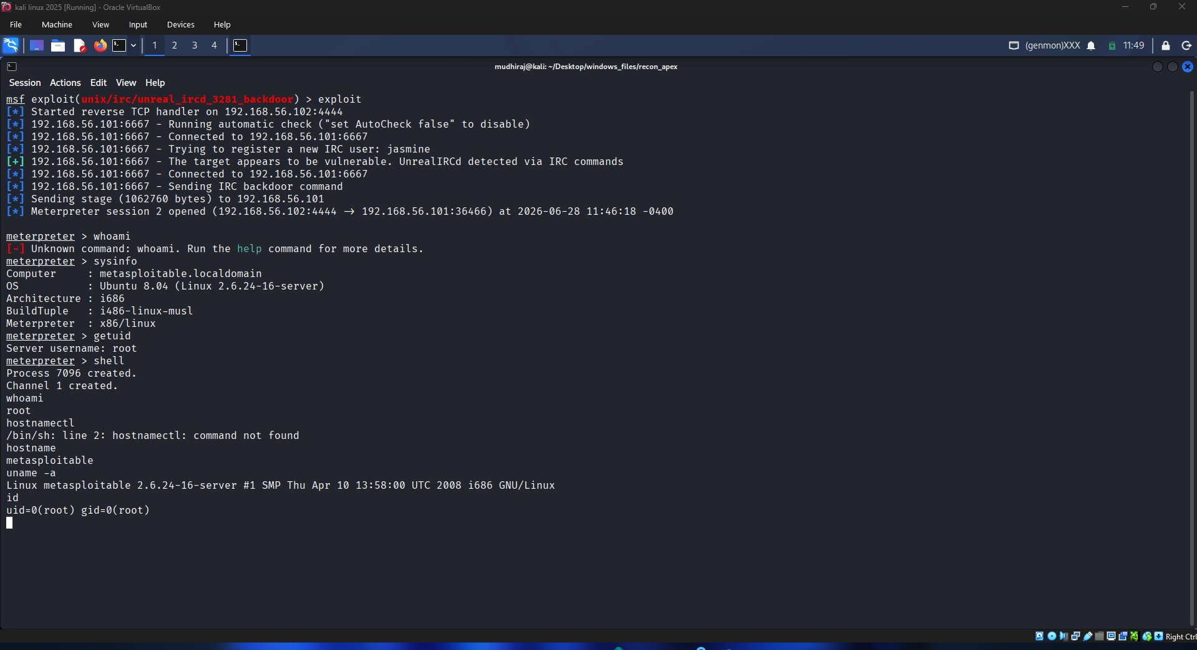
Figure 15. Post-Exploitation System Information

11. Incident Response
After controlled exploitation, an incident response simulation was performed. The active Meterpreter session was identified using Metasploit session management, terminated using sessions -k 1, and then checked again to confirm that no active sessions remained. The incident response report records detection, identification, containment, eradication and verification as completed.
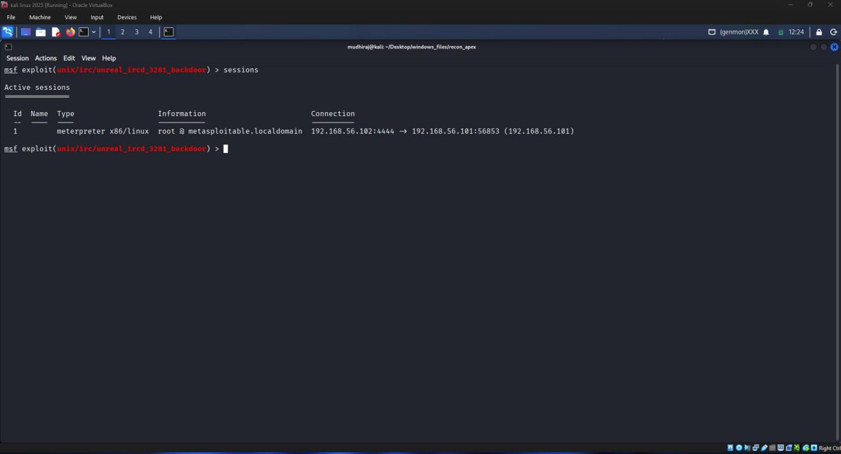
Figure 17. Incident Detection
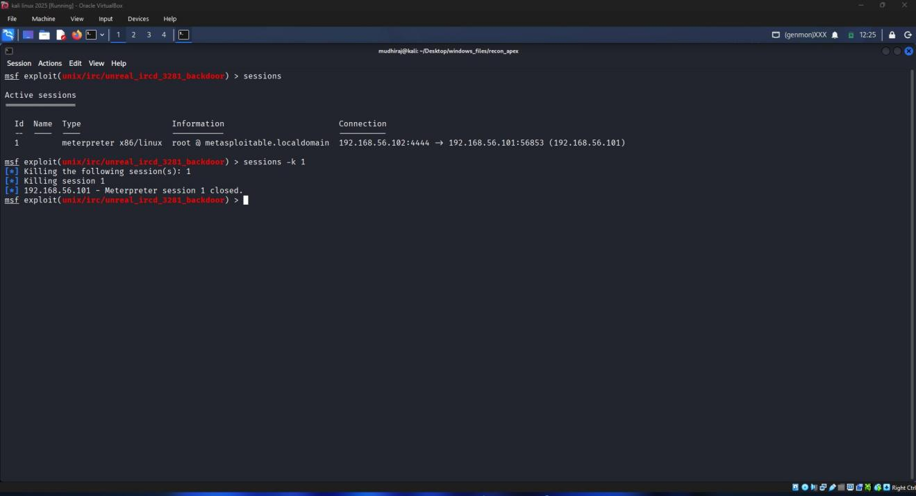
Figure 18. Active Session Identification
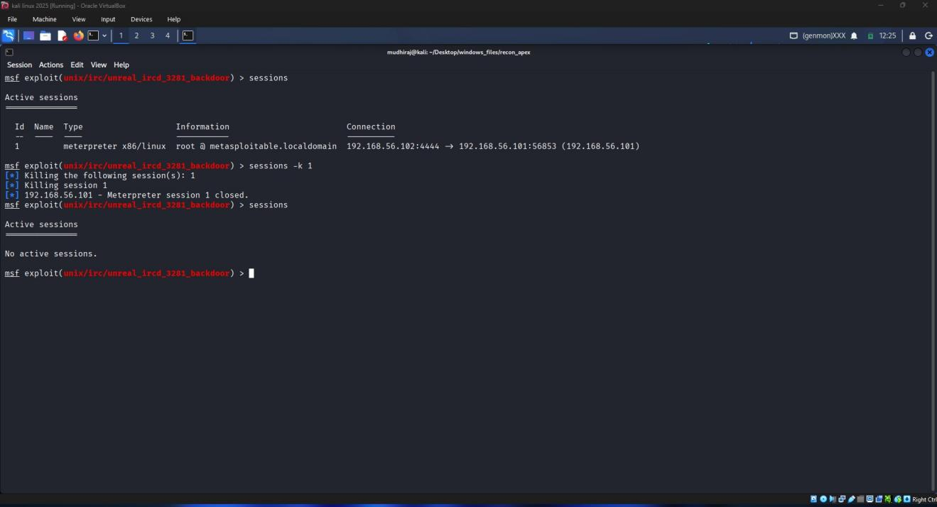
Figure 19. Session Termination

12. Log Analysis
Log analysis was performed on the Metasploitable 2 target. The available log inventory included authentication, system, Apache, Samba, PostgreSQL, FTP and other service logs. The reviewed authentication log showed scheduled CRON root sessions, while the messages and Apache error logs contained normal system or service activity. No direct UnrealIRCd exploit entry was observed in the reviewed logs.
Because the UnrealIRCd backdoor does not use the normal authentication process, the absence of a corresponding authentication entry was documented rather than treated as proof that no compromise occurred. The active Meterpreter session was therefore used as the primary indicator of compromise, followed by session termination and verification.

13. Findings and Risk Assessment
Finding | Evidence | Risk | Status
Large exposed attack surface | 23 open TCP ports identified by Nmap | High | Confirmed
Outdated vulnerable services | Multiple legacy service versions identified | High | Confirmed
Critical OpenVAS findings | 14 Critical results reported | Critical | Confirmed
UnrealIRCd backdoor | Controlled exploitation successful | Critical | Validated
Root-level access | Meterpreter post-exploitation verification | Critical | Confirmed
Unauthorized session detected | Active Meterpreter session identified | High | Contained

14. Mitigation Strategies
- Upgrade or remove vulnerable UnrealIRCd and other unsupported services.
- Apply vendor security patches and upgrade legacy operating systems and applications.
- Disable unnecessary network services and close unused ports.
- Restrict access to administrative and legacy services using firewall rules and network segmentation.
- Replace insecure legacy protocols with secure alternatives where applicable.
- Use strong authentication and remove default or unnecessary credentials.
- Perform periodic vulnerability assessments and verify remediation with follow-up scans.
- Monitor security-relevant logs and active network sessions for indicators of compromise.
- Maintain an incident response procedure covering detection, containment, eradication and recovery.
These recommendations are consistent with the mitigation guidance documented in the vulnerability assessment and controlled exploitation reports.

15. Lessons Learned
- Reconnaissance provides the baseline required to understand the target attack surface.
- Automated vulnerability scanning helps prioritize weaknesses for further investigation.
- Controlled exploitation can validate whether a critical finding has practical impact.
- Incident response should include evidence collection, containment and verification.
- Not every attack leaves a clear authentication entry in operating-system logs, so multiple indicators should be monitored.
- Keeping the test environment isolated is essential for safe cybersecurity experimentation.

16. Conclusion
The capstone successfully demonstrated a complete vulnerability assessment and controlled penetration-testing workflow against an intentionally vulnerable test network. The assessment progressed from laboratory setup and reconnaissance through OpenVAS vulnerability assessment, controlled UnrealIRCd exploitation, root-level access verification, incident response, and post-incident analysis.
The results demonstrate the security impact of outdated and vulnerable services and highlight the importance of patch management, service minimization, network restrictions, monitoring and incident response. All testing remained within the isolated VirtualBox laboratory.

17. Evidence and Deliverables
The detailed evidence supporting this final report is maintained in the project folders:
- 00_Lab_Setup – VirtualBox, Kali Linux, Metasploitable 2 and network configuration documentation.
- 01_Project_Planning – objectives, scope, tools and timeline.
- 02_Network_Diagram – laboratory network architecture.
- 03_Reconnaissance – Nmap outputs, scan files and reconnaissance report.
- 04_Vulnerability_Assessment – OpenVAS report and assessment evidence.
- 05_Controlled_Exploitation – Metasploit exploitation evidence and report.
- 06_Incident_Response – incident response reports, log analysis and session log.
The final project is intended to be accompanied by the screen-recorded project walkthrough stored in the 08_Video folder.

