STORED AND REFLECTED XSS ATTACKS IN DVWA

Objective:
To demonstrate Stored XSS and Reflected XSS vulnerabilities in DVWA and explain mitigation using Input Validation and Content Security Policy (CSP).
Introduction:
Cross-Site Scripting (XSS) is a web application vulnerability that allows attackers to inject malicious scripts into web pages viewed by other users. DVWA was used to demonstrate both Stored XSS and Reflected XSS in a controlled environment.
Stored XSS Attack:
A malicious JavaScript payload was entered into the Stored XSS module. The payload was saved in the application database and executed whenever the page was viewed.
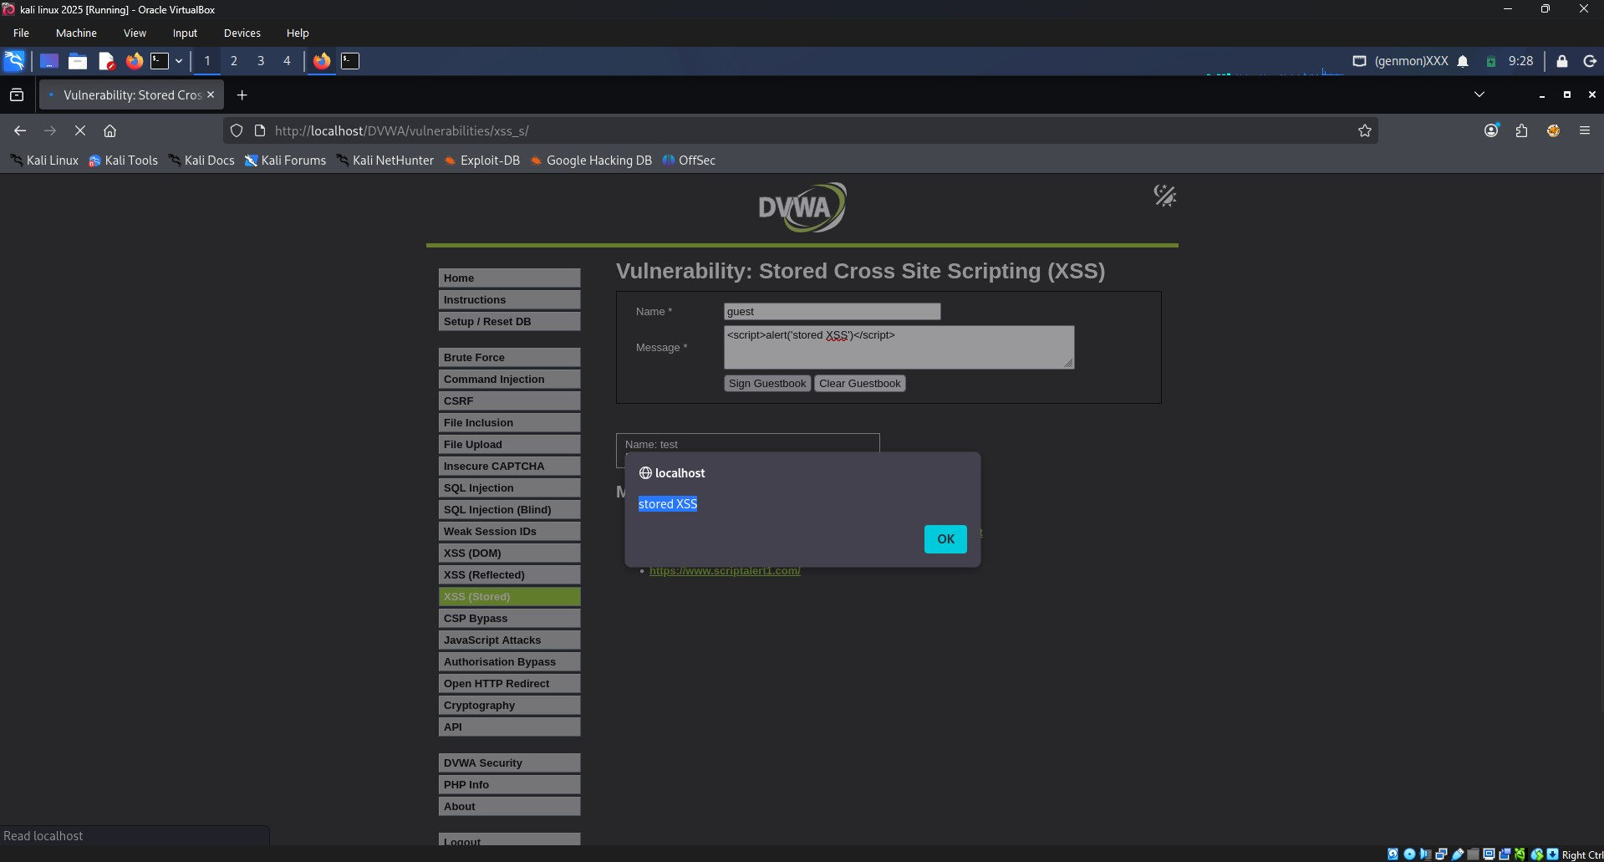
Figure 1: Stored XSS Payload Submitted in DVWA

Reflected XSS Using Query Parameters:
In the Reflected XSS module, user input was reflected back by the application without proper sanitization. A JavaScript payload was supplied through the input parameter and executed in the browser.
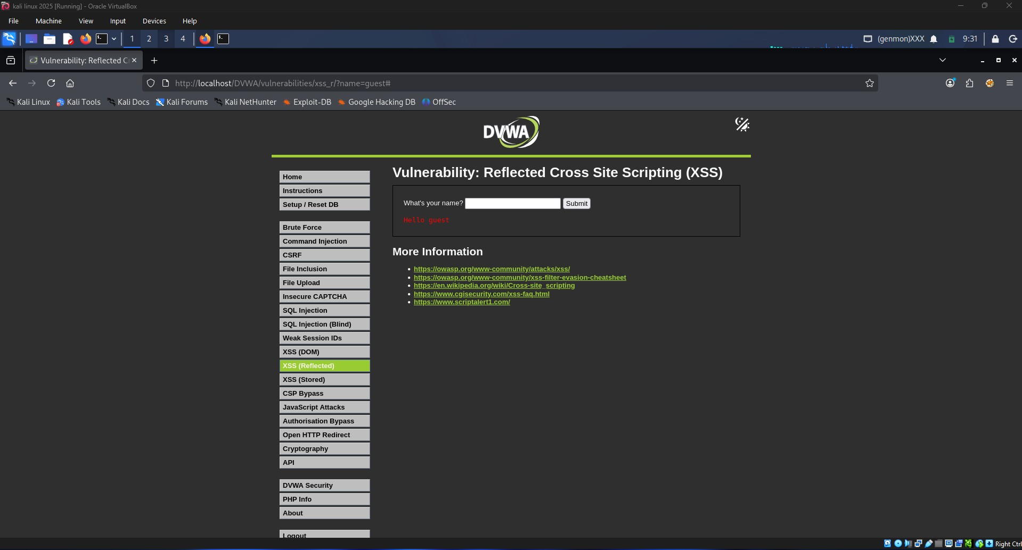
Figure 2: Reflected XSS Module - Normal Input
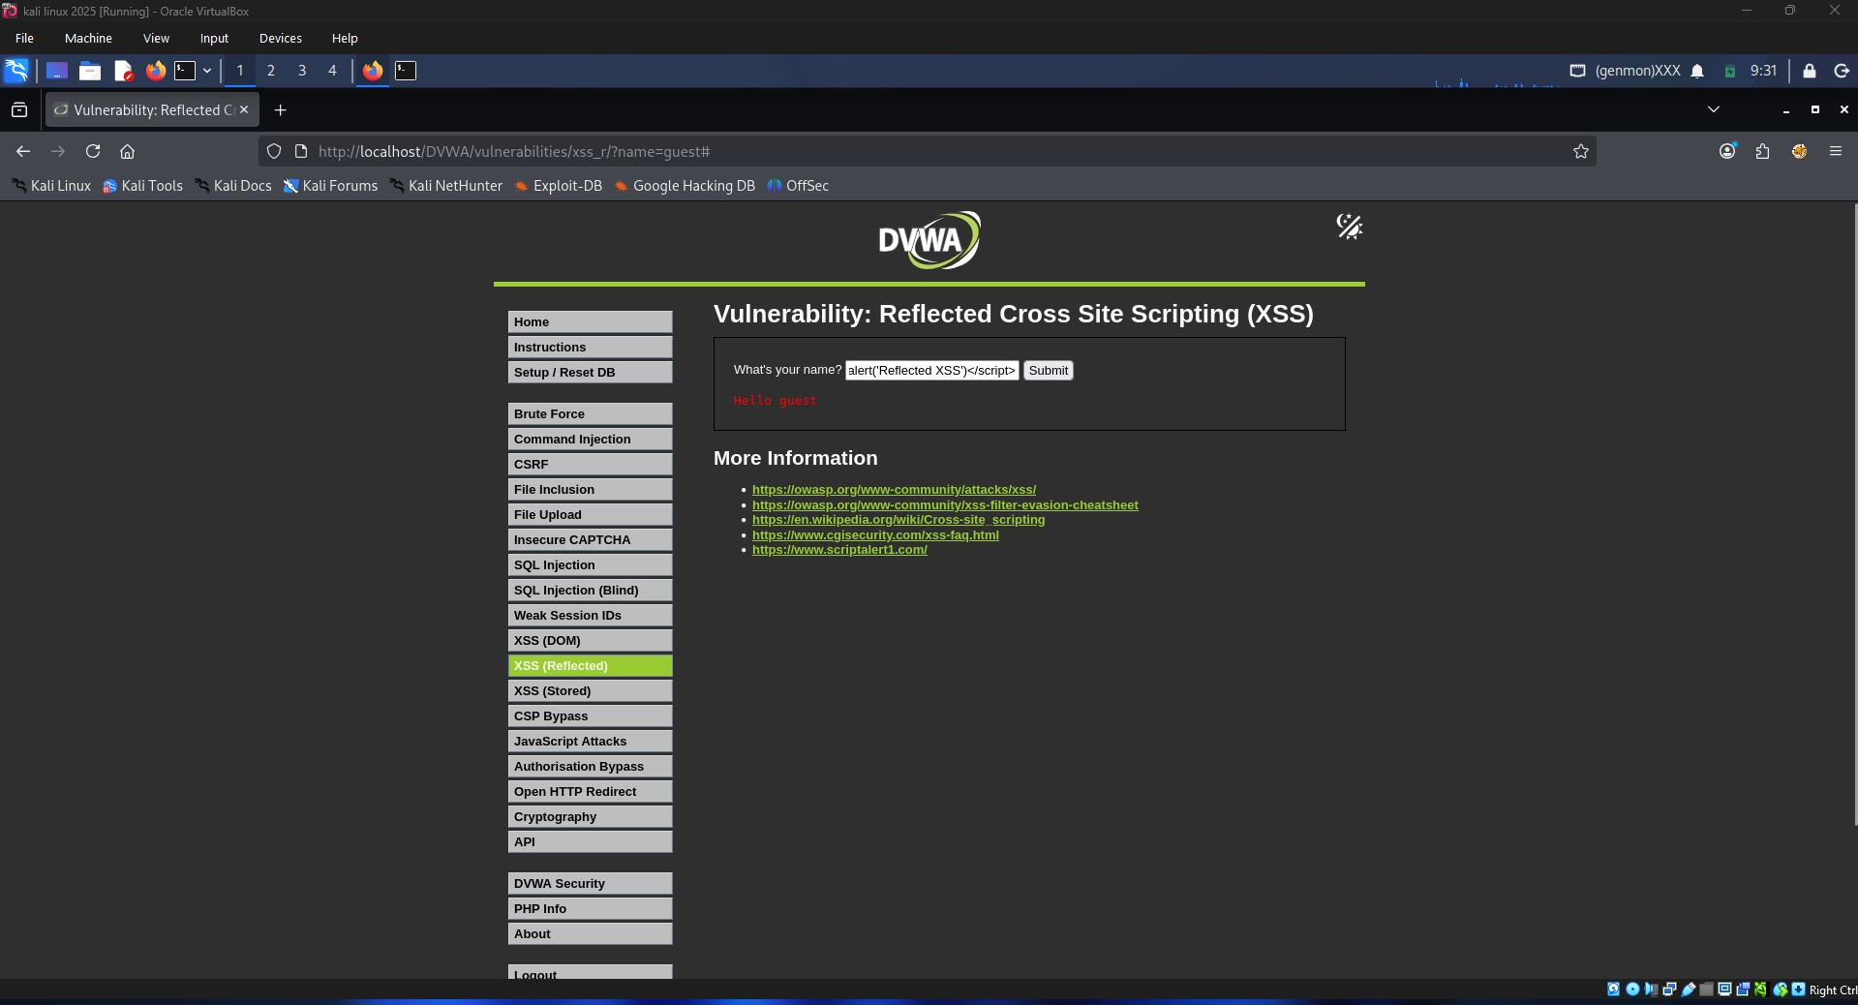
Figure 3: Reflected XSS Payload Entered
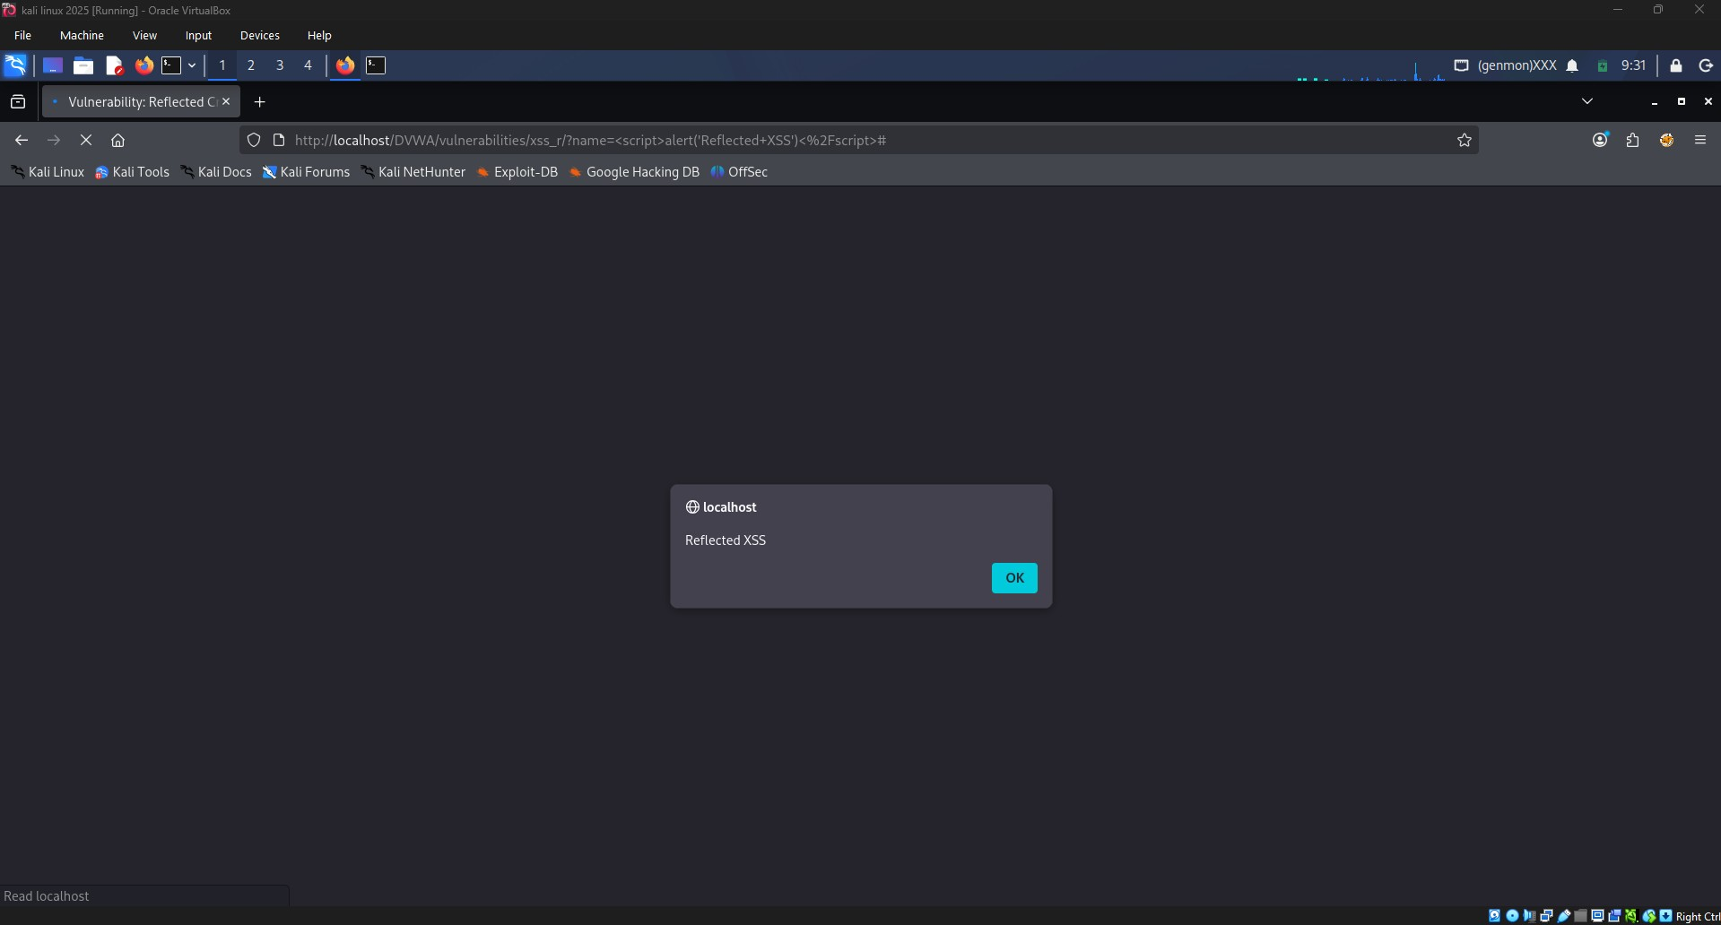
Figure 4: Reflected XSS Alert Popup Executed

Mitigation: Input Validation:
PHP Code:
$message = strip_tags($message);
This removes dangerous HTML tags such as <script> before storing or displaying user input. Input validation helps prevent malicious scripts from entering the application.

Mitigation: Output Encoding:
PHP Code:
echo htmlspecialchars($message, ENT_QUOTES, 'UTF-8');
This converts special characters into safe HTML entities.
For example:
<script>alert('XSS')</script>
becomes:
&lt;script&gt;alert('XSS')&lt;/script&gt;
The browser displays the text instead of executing it.

Mitigation: Content Security Policy (CSP):
Content-Security-Policy:
default-src 'self';
script-src 'self';
CSP restricts the execution of unauthorized scripts and reduces the impact of XSS attacks by allowing scripts only from trusted sources.
Conclusion:
Stored XSS and Reflected XSS vulnerabilities were successfully demonstrated in DVWA. The attacks showed how malicious scripts can execute in a user's browser. Proper input validation, output encoding, and Content Security Policy are effective controls for preventing XSS vulnerabilities.

