Incident Response Report

Capstone Project

Incident Response Simulation for Metasploitable 2

1. Introduction
Following the successful completion of the controlled exploitation phase, an incident response simulation was conducted to demonstrate the process of detecting, containing, eradicating, and verifying a simulated security incident. The activity was performed within an isolated Oracle VirtualBox laboratory using Kali Linux and the Metasploitable 2 virtual machine.
The objective was to identify an active Meterpreter session established during controlled exploitation, terminate the unauthorized session, and verify that the target system no longer contained any active remote sessions.

2. Objective
The objective of this incident response exercise was to:
- Detect an active compromise.
- Identify the active Meterpreter session.
- Contain the incident by terminating the session.
- Verify successful removal of unauthorized access.
- Document the incident response process.

3. Tools Used
Tool | Purpose
Kali Linux | Security Testing Platform
Metasploit Framework | Session Management
Meterpreter | Remote Access Session
Oracle VirtualBox | Virtual Laboratory

4. Incident Overview
Item | Value
Target Machine | Metasploitable 2
Target IP | 192.168.56.101
Attacker Machine | Kali Linux
Incident Type | Unauthorized Remote Session
Detection Method | Metasploit Session Monitoring

5. Incident Response Process

5.1 Attack Detection
After the exploitation phase, the Metasploit Framework remained active and was used to monitor active sessions established with the target system.
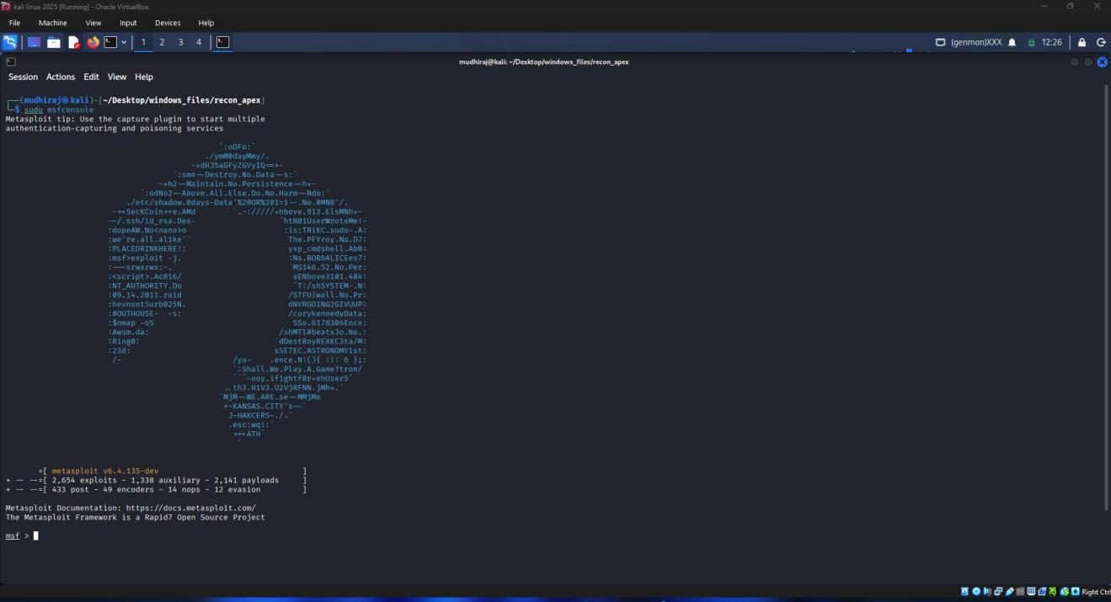
Figure IR-01. Metasploit Framework
Observation:
The exploitation framework remained active and was prepared for session monitoring and incident handling.

5.2 Session Identification
The active Meterpreter session was identified using the following command:
sessions
Observation:
The Metasploit Framework displayed one active Meterpreter session connected to the Metasploitable 2 target machine, confirming unauthorized remote access.
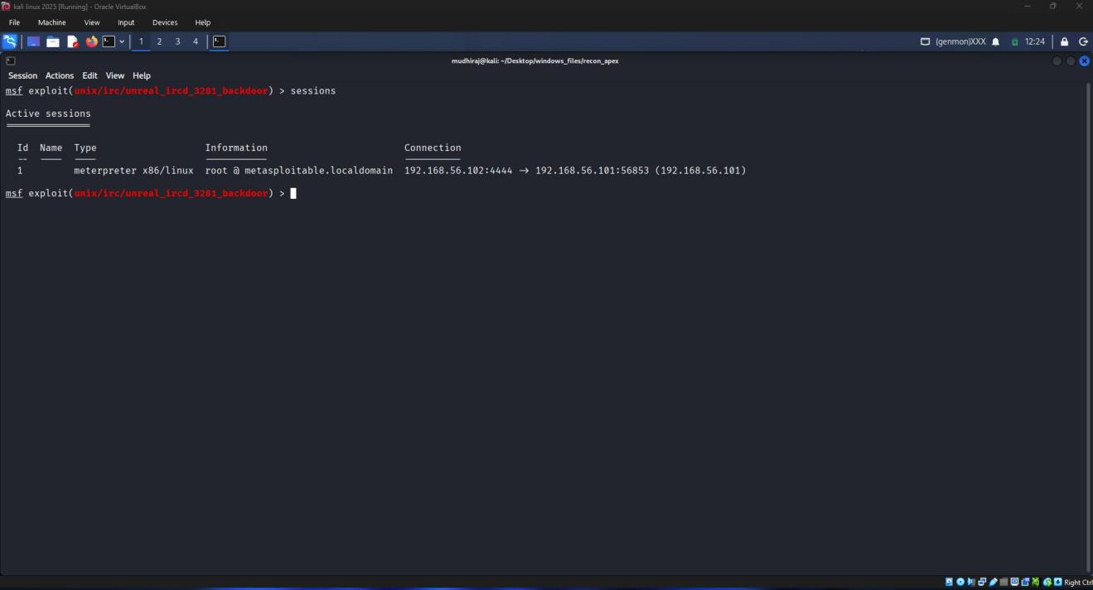
Figure IR-02. Active Session Detection

5.3 Containment
The unauthorized session was terminated using the following command:
sessions -k 1
Observation:
The active Meterpreter session was successfully terminated, preventing further interaction with the target system.
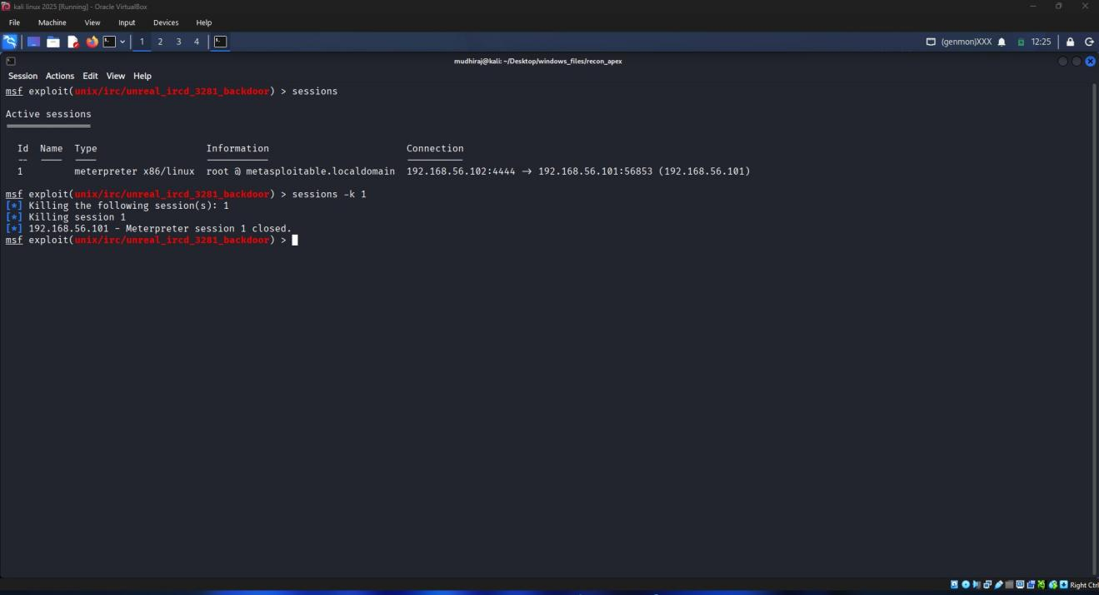
Figure IR-03. Session Termination

5.4 Verification
Following containment, the remaining sessions were verified using:
sessions
Observation:
The verification confirmed that no active Meterpreter sessions remained, indicating successful containment and eradication of the simulated incident.
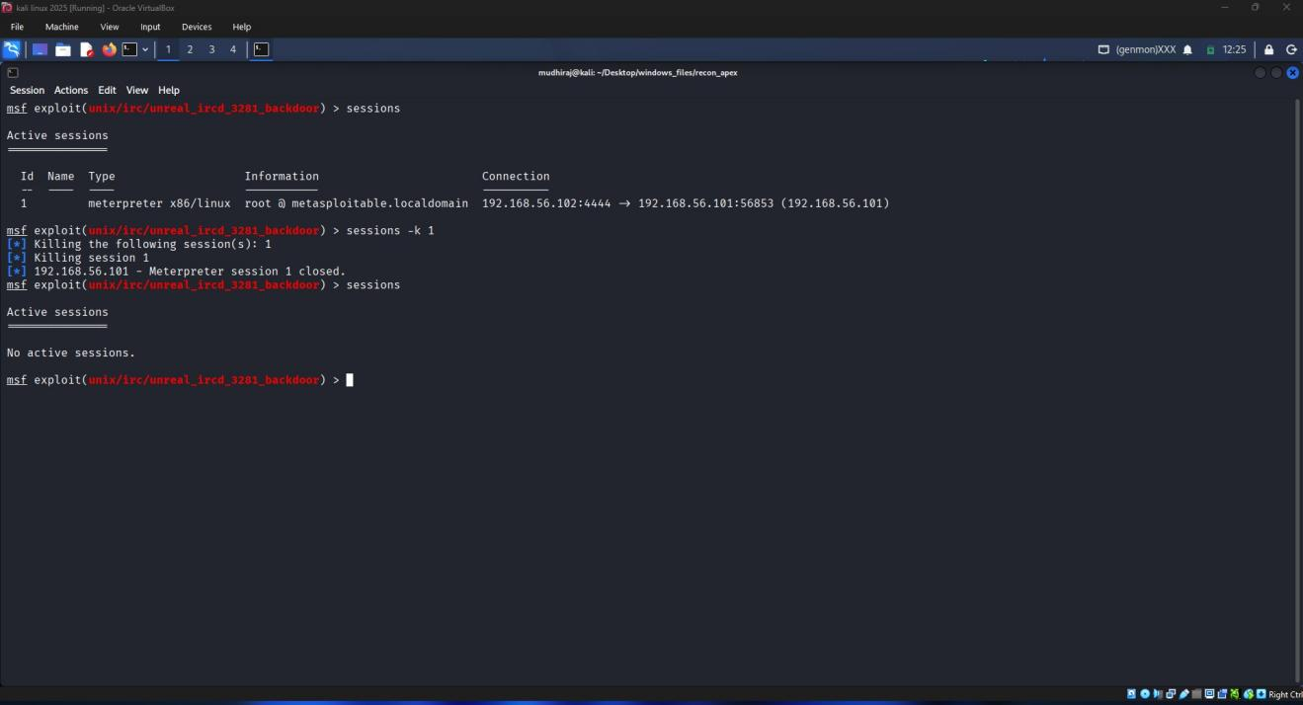
Figure IR-04. Verification of Incident Resolution

6. Incident Response Summary
Phase | Status
Detection | Completed
Identification | Completed
Containment | Completed
Eradication | Completed
Verification | Completed

7. Outcome
The simulated security incident was successfully detected and contained. The unauthorized Meterpreter session was identified, terminated, and verified as removed. This exercise demonstrated the fundamental incident response lifecycle within a controlled penetration testing environment.

8. Conclusion
The incident response simulation successfully demonstrated the detection and containment of an unauthorized remote session. Proper verification confirmed that the simulated threat had been removed. This exercise highlights the importance of continuous monitoring, timely response, and verification during cybersecurity incident handling.

