01. VirtualBox Configuration

Capstone Project

Vulnerability Assessment of Test Network

1. Introduction:
Oracle VirtualBox is an open-source virtualization platform that enables multiple operating systems to run simultaneously on a single physical computer. It provides an isolated environment for cybersecurity testing without affecting the host operating system.
For this project, VirtualBox was used to create a secure penetration testing laboratory consisting of two virtual machines:
- Kali Linux – Attacker Machine
- Metasploitable 2 – Vulnerable Target Machine
This isolated environment allows vulnerability assessment and controlled exploitation to be performed safely.

2. Objective:
The objective of configuring VirtualBox is to create a virtual penetration testing laboratory where security assessments can be performed without impacting real-world systems.

3. Software Information:
Component | Details
Virtualization Software | Oracle VM VirtualBox 7.2
Host Operating System | Windows 11
Guest Operating Systems | Kali Linux, Metasploitable 2

4. Virtual Machines Created:

4.1 Kali Linux:
Purpose:
- Security Testing
- Network Scanning
- Vulnerability Assessment
- Exploitation
- Password Auditing
Allocated Resources:
- RAM: 6 GB
- CPU Cores: 6
- Disk Size: 60 GB
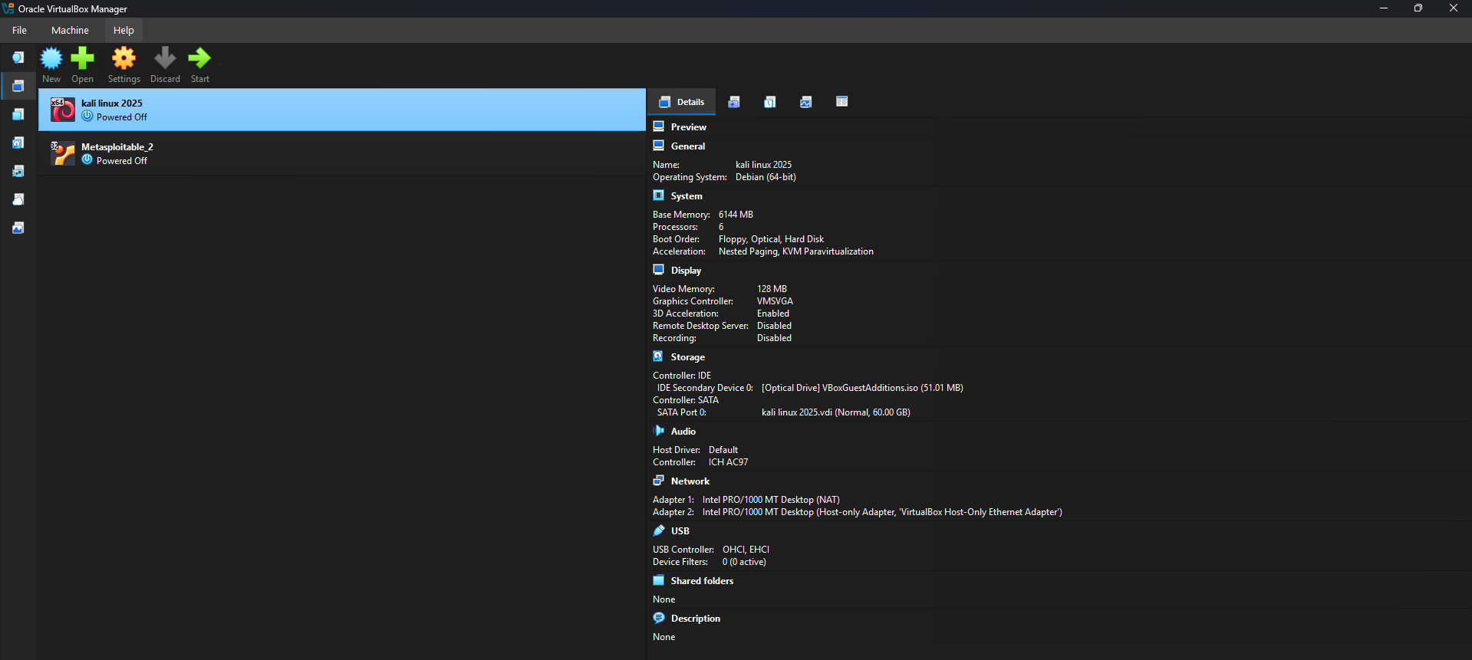
Figure 1. VirtualBox Manager showing Kali Linux Virtual Machine

Figure 1 shows the Kali Linux virtual machine configured in Oracle VirtualBox for security assessment activities.

4.2 Metasploitable 2:
Purpose:
Metasploitable 2 is an intentionally vulnerable Linux virtual machine used for penetration testing practice.
Allocated Resources:
- RAM: 512 MB
- CPU Cores: 1
- Disk Size: 8 GB
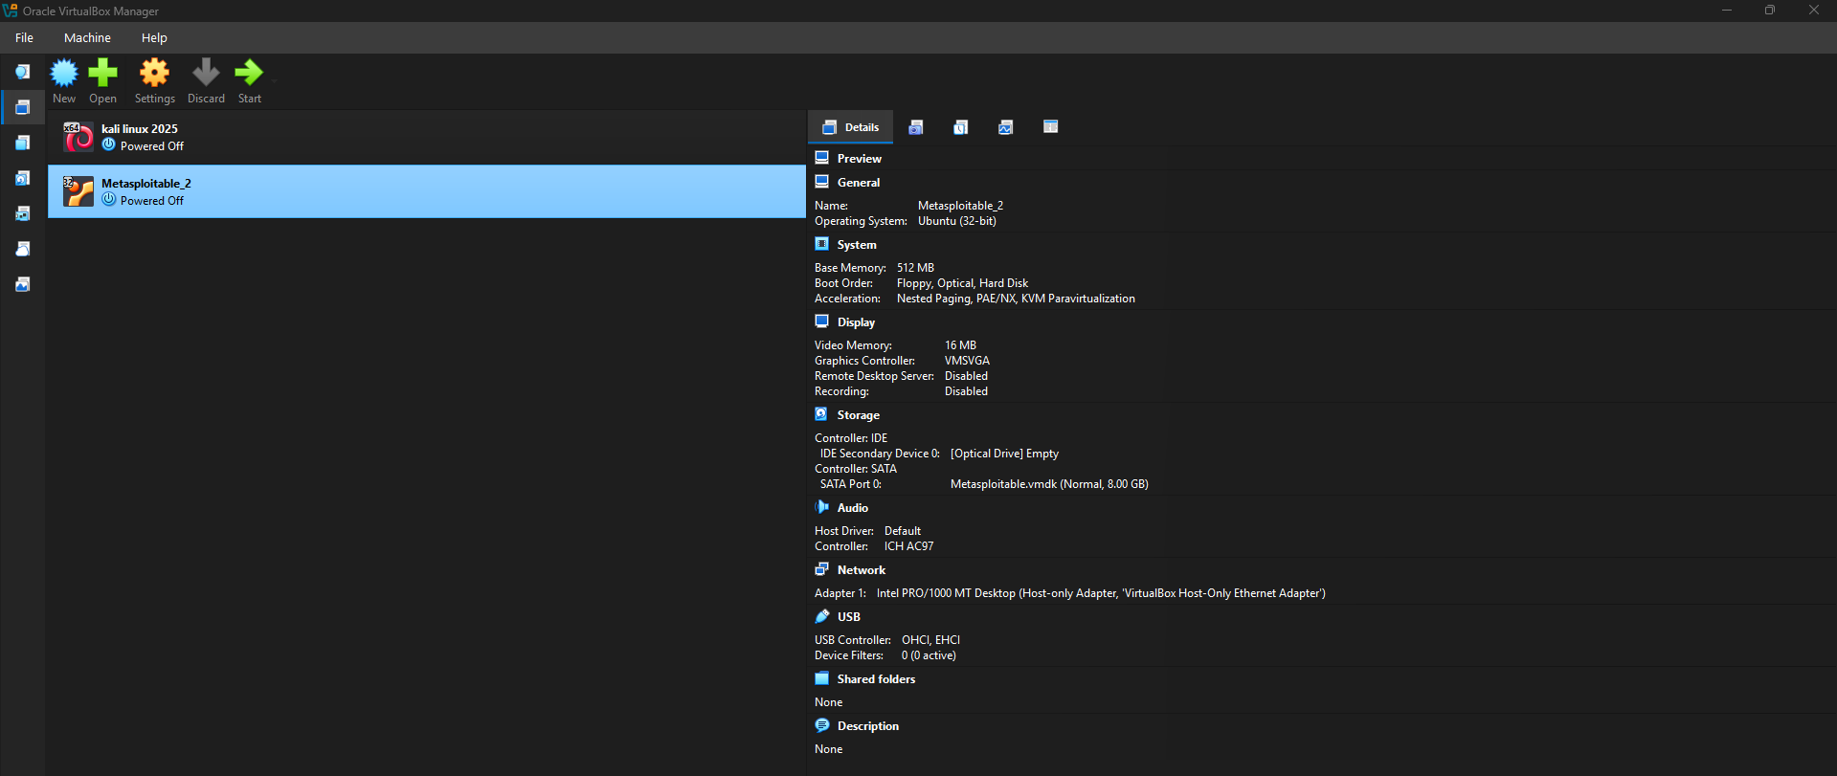Figure 2. VirtualBox Manager showing Metasploitable 2 Virtual Machine

Figure 2 shows the Metasploitable 2 virtual machine configured as the vulnerable target system used for vulnerability assessment and controlled exploitation.

5. VirtualBox Configuration:
The following configuration was verified before starting the project.

General:
- Name configured correctly
- Linux operating system selected
- Correct version selected
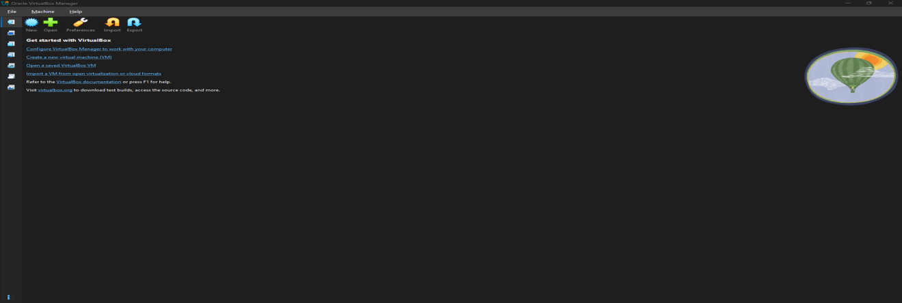

System:
- Base Memory allocated
- Processor cores configured
- Boot order verified

Display:
- Video Memory configured
- Graphics Controller verified

Storage:
- Virtual Hard Disk attached
- ISO (if required) attached

Network:
Network adapters were configured to allow communication between the attacker machine and the target machine.
Configuration:
- Adapter 1: Host-Only Adapter (vboxnet0)
- Adapter 2 (Kali only): NAT (Internet Access)

6. Verification:
Both virtual machines were successfully started.
The following checks were completed:
- Virtual machines boot successfully.
- No boot errors observed.
- Virtual hardware detected correctly.
- Virtual network adapter recognized.
- Both systems ready for penetration testing.

7. Outcome:
The VirtualBox environment was successfully configured for the cybersecurity laboratory.
Both virtual machines are isolated from external networks while maintaining communication with each other. This environment provides a safe platform for performing reconnaissance, vulnerability assessment, controlled exploitation, and incident response activities throughout the project.

The VirtualBox laboratory environment was validated before beginning reconnaissance and vulnerability assessment. All required virtual machines were operational, network communication was verified, and the environment was prepared for the subsequent phases of the penetration testing process.

8. Conclusion:
Oracle VirtualBox was successfully configured to host the cybersecurity testing environment. The platform provides a reliable and isolated infrastructure for ethical hacking activities, ensuring that all experiments are conducted safely without affecting production systems or external networks.

