02. Kali Linux Setup

Capstone Project

Vulnerability Assessment of Test Network

1. Introduction
Kali Linux is a Debian-based Linux distribution specifically designed for penetration testing, digital forensics, vulnerability assessment, and security auditing. It includes hundreds of pre-installed cybersecurity tools that assist security professionals in identifying and assessing system vulnerabilities.
For this project, Kali Linux was configured as the attacker machine used to perform reconnaissance, vulnerability scanning, controlled exploitation, and incident response activities within a secure virtual laboratory.

2. Objective
The objective of setting up Kali Linux is to prepare a secure and fully functional penetration testing environment equipped with the necessary cybersecurity tools required for vulnerability assessment and ethical hacking activities.

3. Kali Linux Installation and Boot
The Kali Linux virtual machine was created and started successfully using Oracle VM VirtualBox.
After booting the virtual machine, the login screen appeared, and the operating system loaded successfully into the desktop environment.
Figure 1. Kali Linux Boot Screen
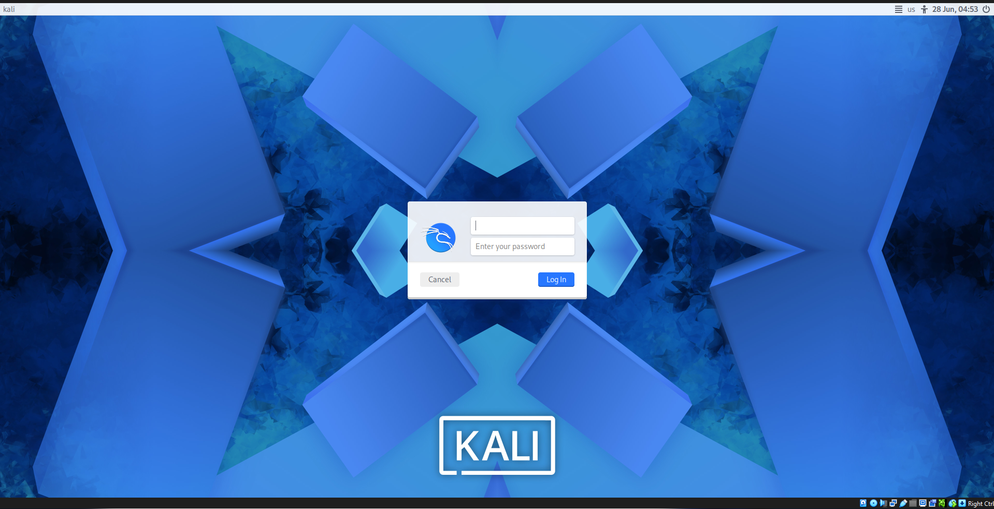
Figure 2. Kali Linux Desktop
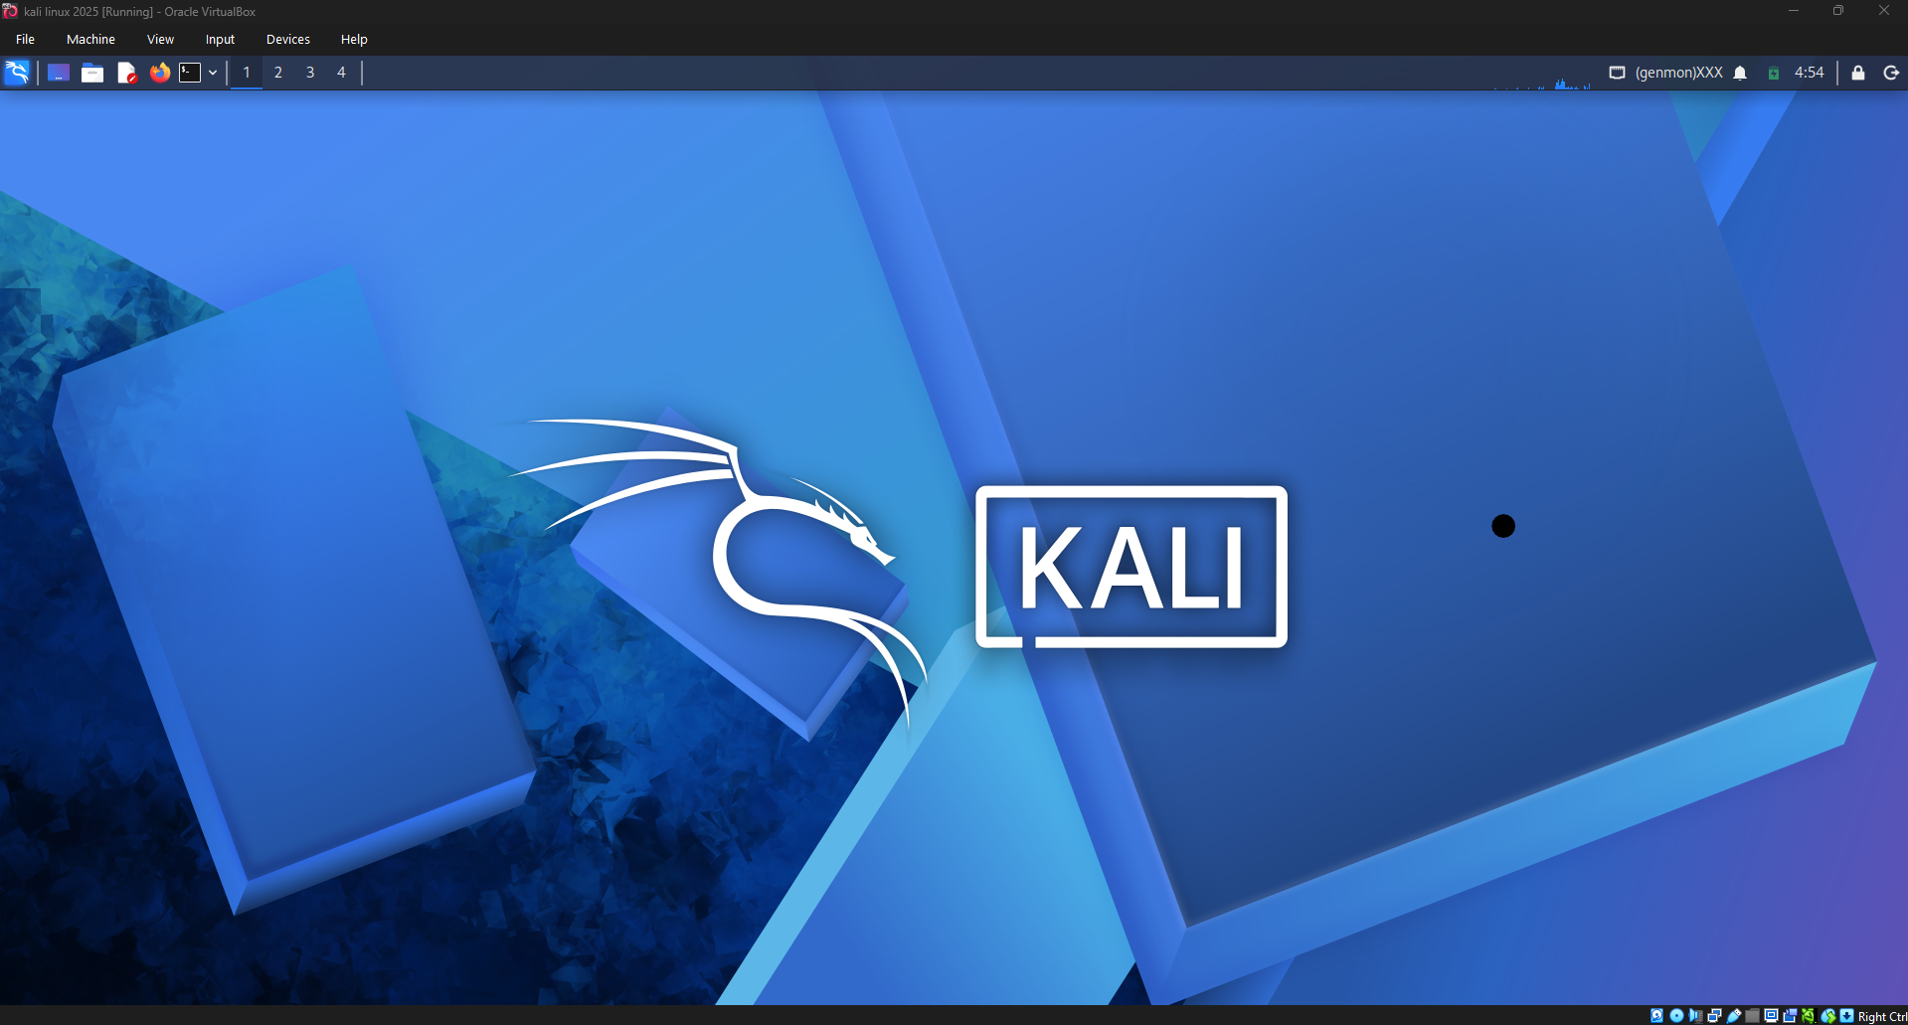

4. System Information
The following commands were executed to verify the operating system information.

Check Current User
whoami
Figure 3. Current User
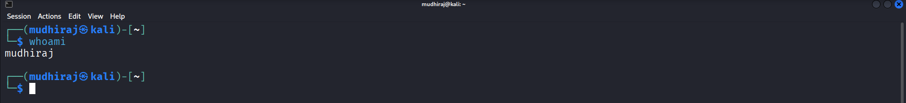

Check Hostname
hostnamectl
Figure 4. Hostname Information
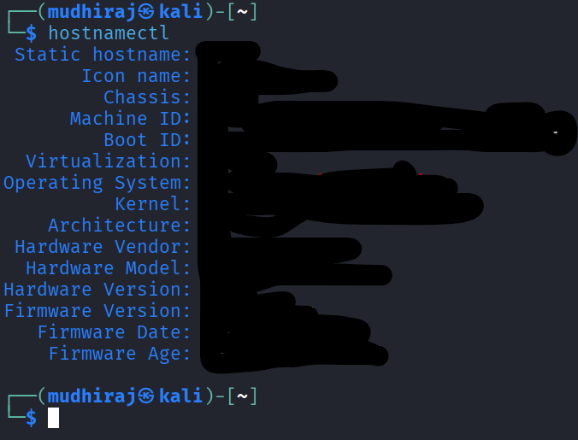

Check Kernel Version
uname -a
Figure 5. Linux Kernel Information

Check Operating System Version
cat /etc/os-release
Figure 6. Operating System Information
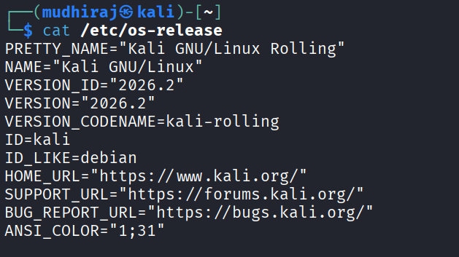

5. Updating the System
Before performing any security assessment, the package repository was updated to ensure the latest package information was available.
Command:
sudo apt update
The update completed successfully without critical errors.
Figure 7. Package Update
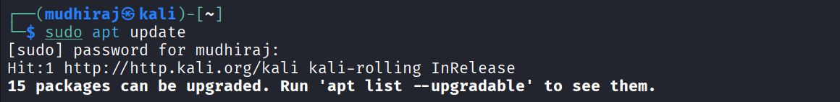

6. Verification of Security Tools
The availability of the required cybersecurity tools was verified.

Nmap
nmap --version
Figure 8. Nmap Version
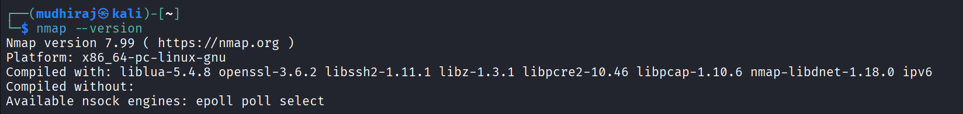

Metasploit Framework
msfconsole --version
Figure 9. Metasploit Framework Version
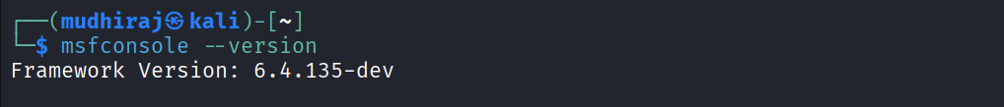

OpenVAS / Greenbone
gvm-check-setup
Figure 10. OpenVAS Verification
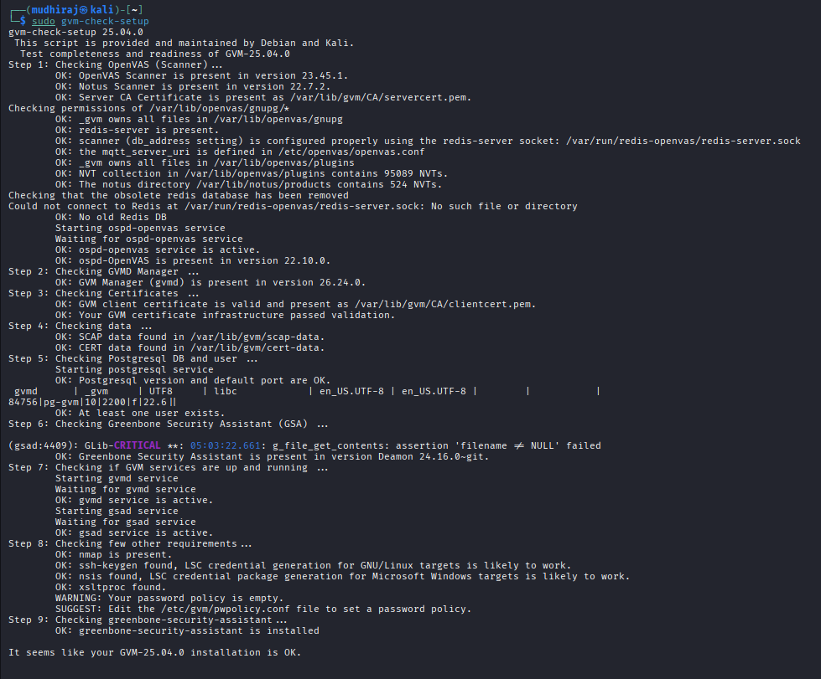

7. Outcome
The Kali Linux operating system was successfully configured and verified for penetration testing activities. All required tools were available, and the system was ready to perform reconnaissance, vulnerability assessment, controlled exploitation, and incident response within the isolated laboratory environment.

8. Conclusion
Kali Linux was successfully prepared as the primary attacker machine for this capstone project. The operating system, essential security tools, and system configuration were verified, providing a stable platform for conducting ethical hacking and vulnerability assessment activities throughout the project.

