03. Metasploitable_2 Setup

Capstone Project

Vulnerability Assessment of Test Network

1. Introduction
Metasploitable 2 is an intentionally vulnerable Linux virtual machine developed for learning penetration testing and vulnerability assessment. It contains multiple insecure services and known vulnerabilities that provide a safe environment for practicing ethical hacking techniques.
In this capstone project, Metasploitable 2 was configured as the target machine for reconnaissance, vulnerability scanning, controlled exploitation, and incident response activities.

2. Objective
The objective of setting up Metasploitable 2 is to create a vulnerable target system that can be safely used for cybersecurity testing within an isolated virtual laboratory.

3. Starting the Virtual Machine
The Metasploitable 2 virtual machine was successfully started using Oracle VM VirtualBox.
After booting, the Linux login prompt appeared, confirming that the operating system loaded correctly.
Figure 1. Metasploitable 2 Boot Screen
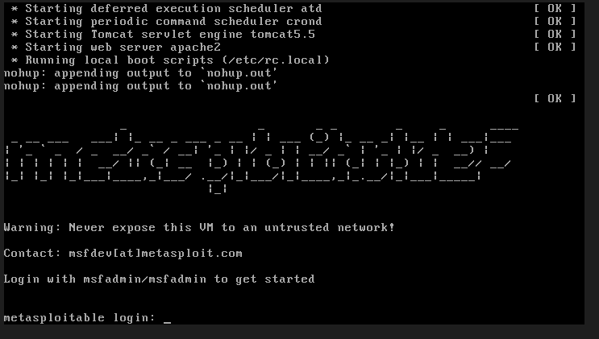

4. Login Verification
The default login credentials were used to access the system.
Username: msfadmin
Password: msfadmin
After successful authentication, the terminal became available for administrative tasks.
Figure 2. Metasploitable 2 Login
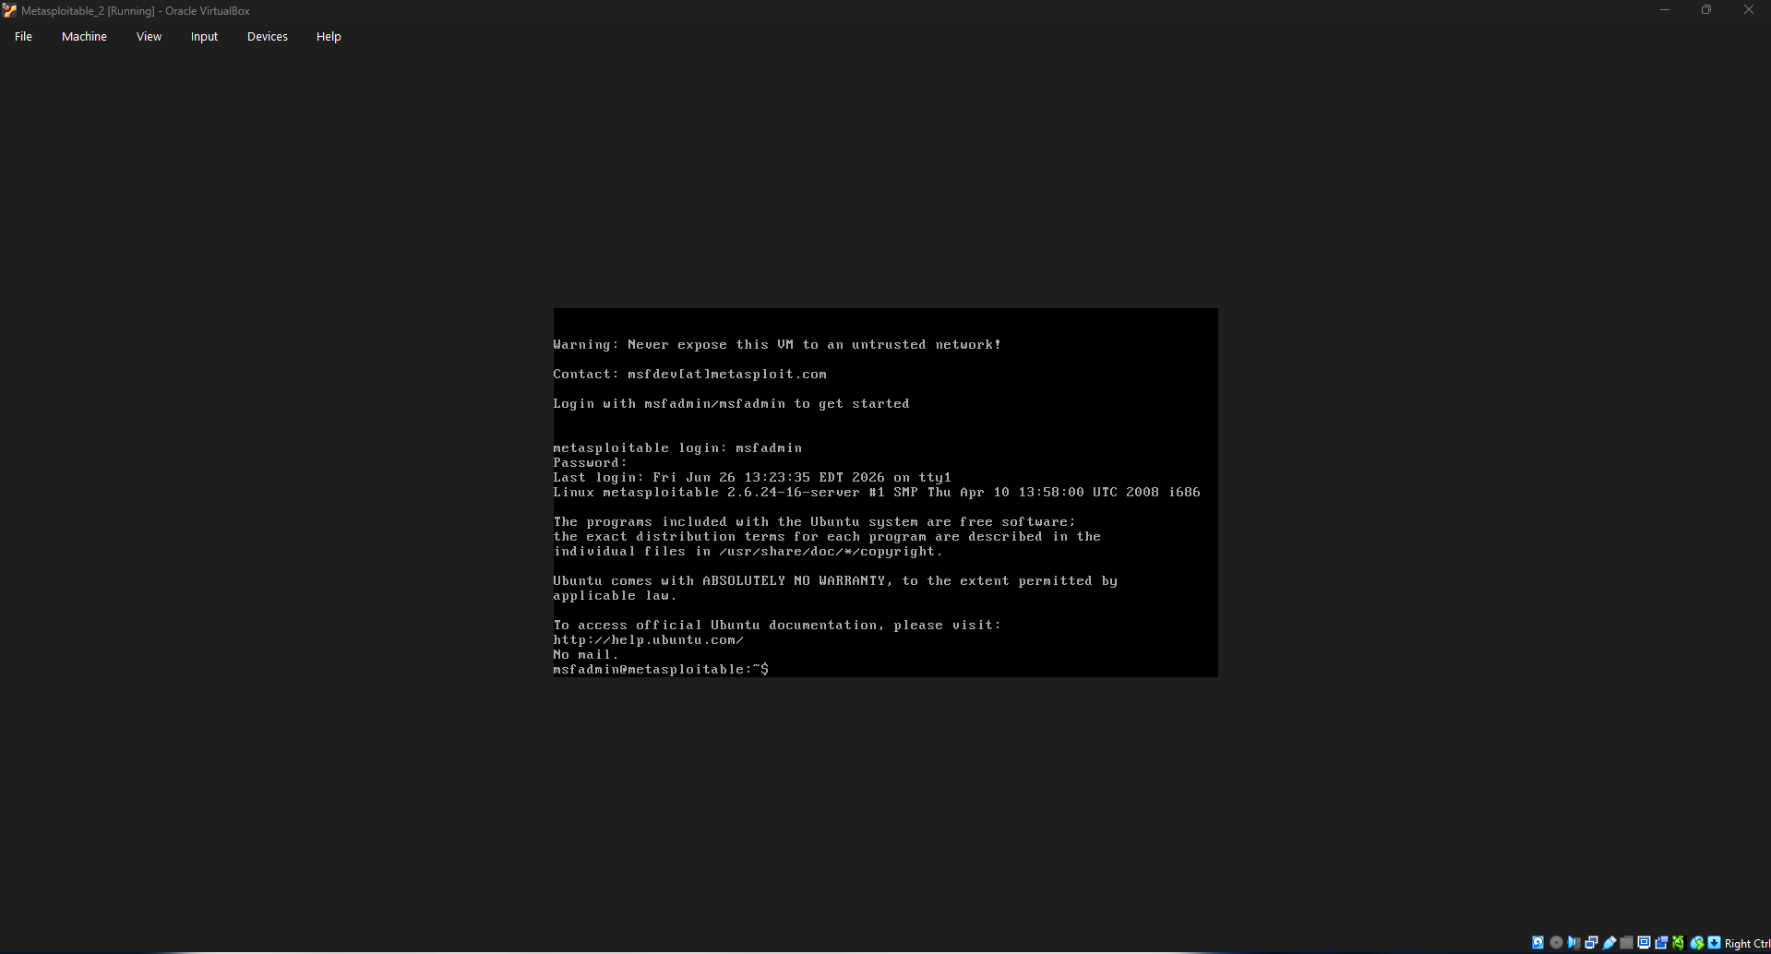

5. System Information
The following commands were executed to verify the operating system.

Check Hostname
hostname
Figure 3. Hostname


Check Linux Kernel
uname -a
Figure 4. Linux Kernel Information

Check IP Address
ifconfig
or
ip addr
Figure 5. Network Configuration
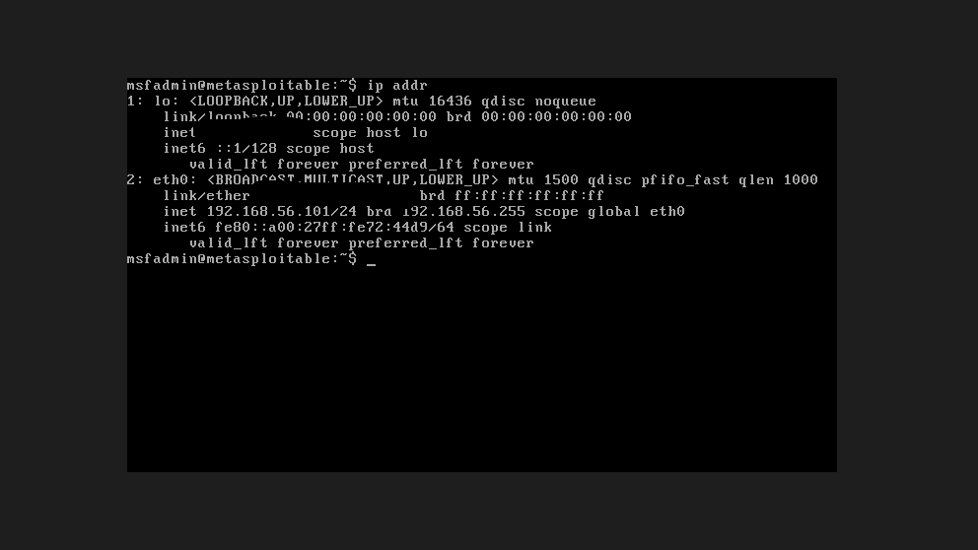

6. Verification of Running Services
To identify the network services available on the target machine, the following command was executed.
netstat -tuln
The output displayed several listening services that would later be analyzed during the vulnerability assessment phase.

Figure 6. Active Network Services
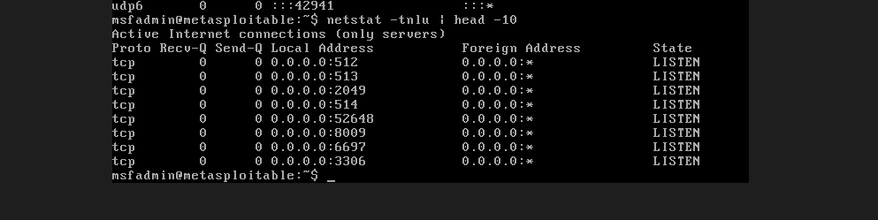

7. Outcome
The Metasploitable 2 virtual machine was successfully configured and verified as the vulnerable target system. The operating system booted correctly, the default credentials allowed successful login, network connectivity was confirmed, and the system was prepared for security assessment activities.

8. Conclusion
Metasploitable 2 was successfully deployed as the target machine for this capstone project. Its intentionally vulnerable configuration provides a controlled environment for practicing vulnerability assessment, penetration testing, and incident response techniques without affecting production systems.

