04. Network Configuration

Capstone Project

Vulnerability Assessment of Test Network

1. Introduction
A properly configured network is essential for communication between the attacker machine and the target machine during penetration testing. In this project, Oracle VM VirtualBox networking was configured to establish a secure and isolated laboratory environment where Kali Linux and Metasploitable 2 could communicate without exposing the vulnerable system to external networks.

2. Objective
The objective of the network configuration is to establish reliable communication between Kali Linux and Metasploitable 2 using a Host-Only Adapter while providing internet access to Kali Linux through a NAT Adapter for downloading updates and security tools.

3. Network Configuration
The network adapters of both virtual machines were configured using Oracle VM VirtualBox.

Kali Linux
- Adapter 1: Host-Only Adapter (vboxnet0)
- Adapter 2: NAT
The Host-Only Adapter enables communication with the target machine, while the NAT Adapter provides internet connectivity for updating tools and packages.

Figure 1. Kali Linux Network Adapter Configuration


Metasploitable 2
- Adapter 1: Host-Only Adapter (vboxnet0)
Only the Host-Only Adapter was enabled to ensure the vulnerable machine remained isolated from external networks.
Figure 2. Metasploitable 2 Network Adapter Configuration


4. IP Address Verification
The network configuration was verified by checking the IP addresses assigned to both virtual machines.

Kali Linux
Command:
ip a

Figure 3. Kali Linux IP Address
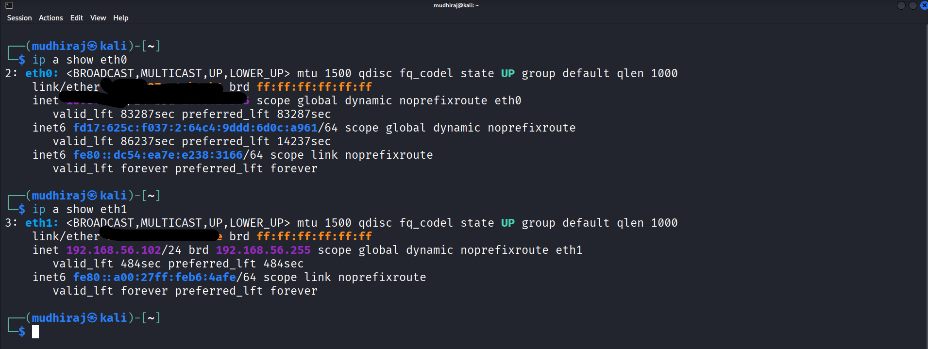

Metasploitable 2
Command:
ifconfig
Figure 4. Metasploitable 2 IP Address
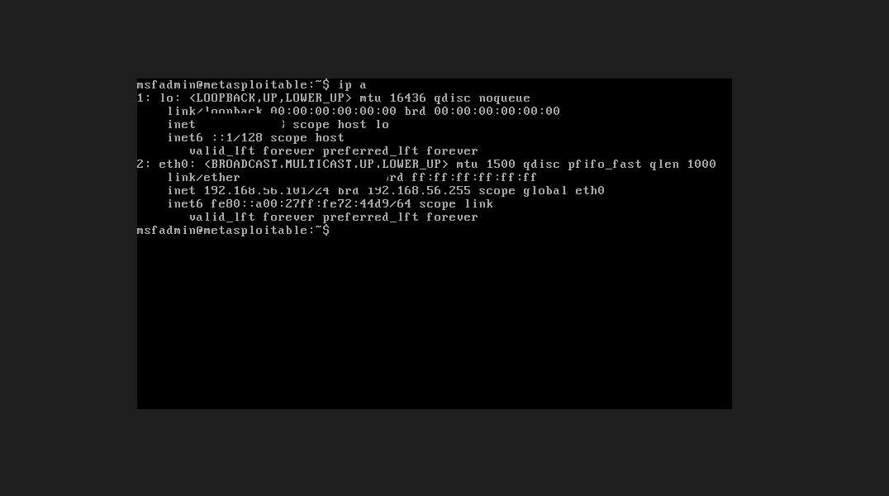

5. Network Connectivity Test
To verify communication between the two virtual machines, the ping command was executed from Kali Linux to the Metasploitable 2 IP address.

Command:
ping <Metasploitable_IP_Address>
Example:
ping 192.168.56.102
The target machine responded successfully, confirming proper network connectivity between the attacker and target systems.
Figure 5. Ping Test
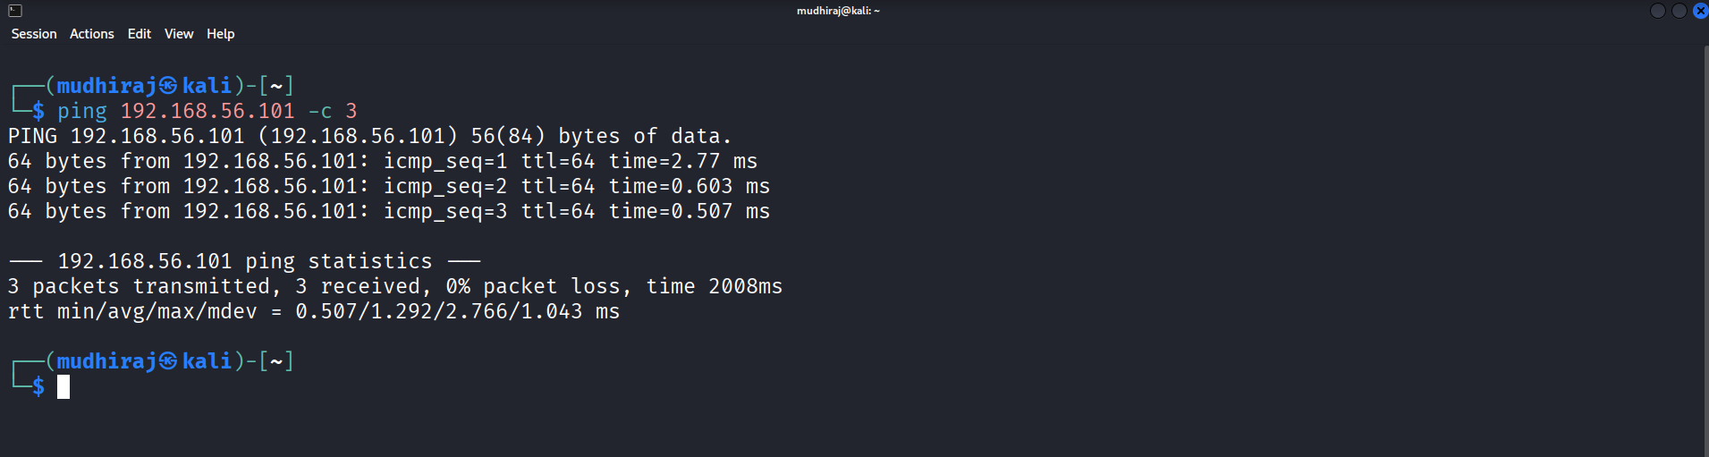

6. Network Verification
The following checks were completed successfully:
- Both virtual machines obtained valid IP addresses.
- Host-Only network communication was established.
- Kali Linux had internet access through the NAT Adapter.
- Metasploitable 2 remained isolated from the internet.
- Ping test completed successfully.

7. Outcome
The network configuration was successfully completed, allowing secure communication between Kali Linux and Metasploitable 2. The isolated laboratory environment was verified and prepared for reconnaissance, vulnerability assessment, controlled exploitation, and incident response activities.

8. Conclusion
The VirtualBox network was configured successfully using Host-Only and NAT adapters. Both virtual machines communicated reliably within the isolated laboratory environment while maintaining appropriate network security. This configuration provides a stable foundation for the subsequent penetration testing phases of the capstone project.

