Web Security Headers Configuration Report

1. SecurityHeaders Website Access:
The SecurityHeaders platform was accessed to evaluate the security posture of a web application. The tool provides an assessment of HTTP response headers and identifies missing security controls.
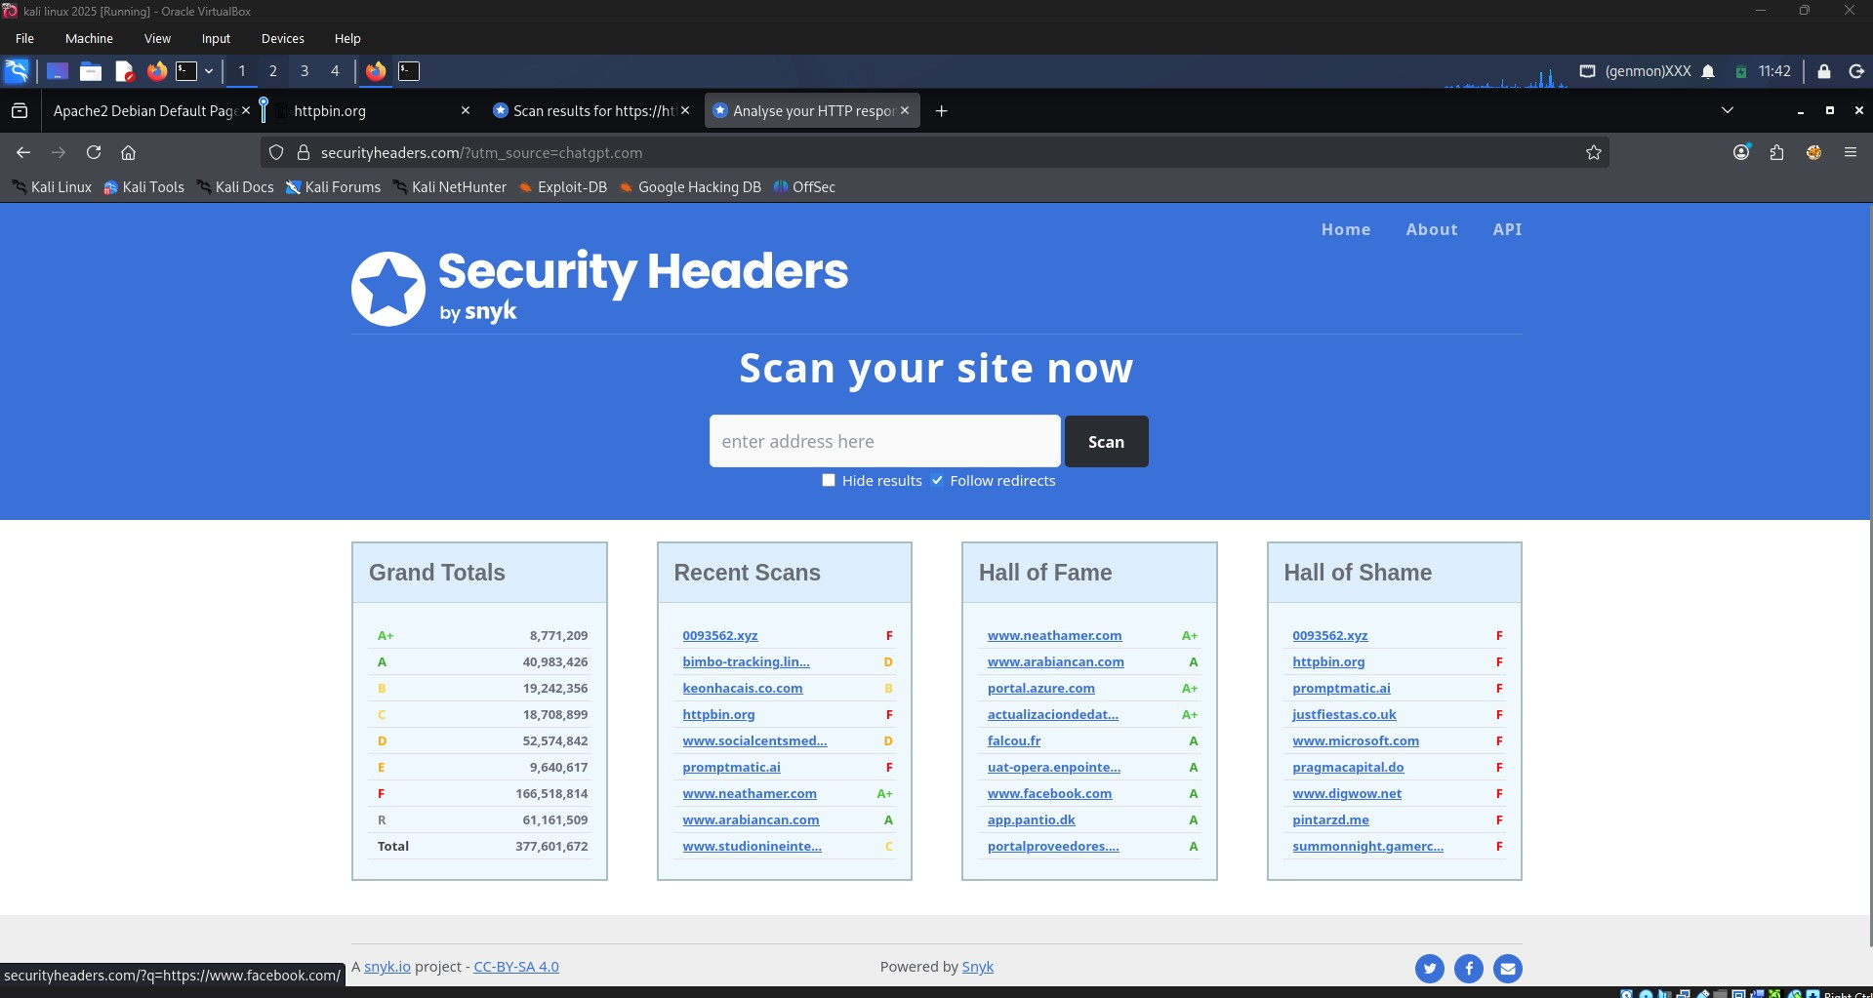

2. Security Headers Analysis Result:
A test website was analyzed using SecurityHeaders.com. The report highlighted missing security headers and demonstrated how inadequate header configurations can affect a website’s security rating.
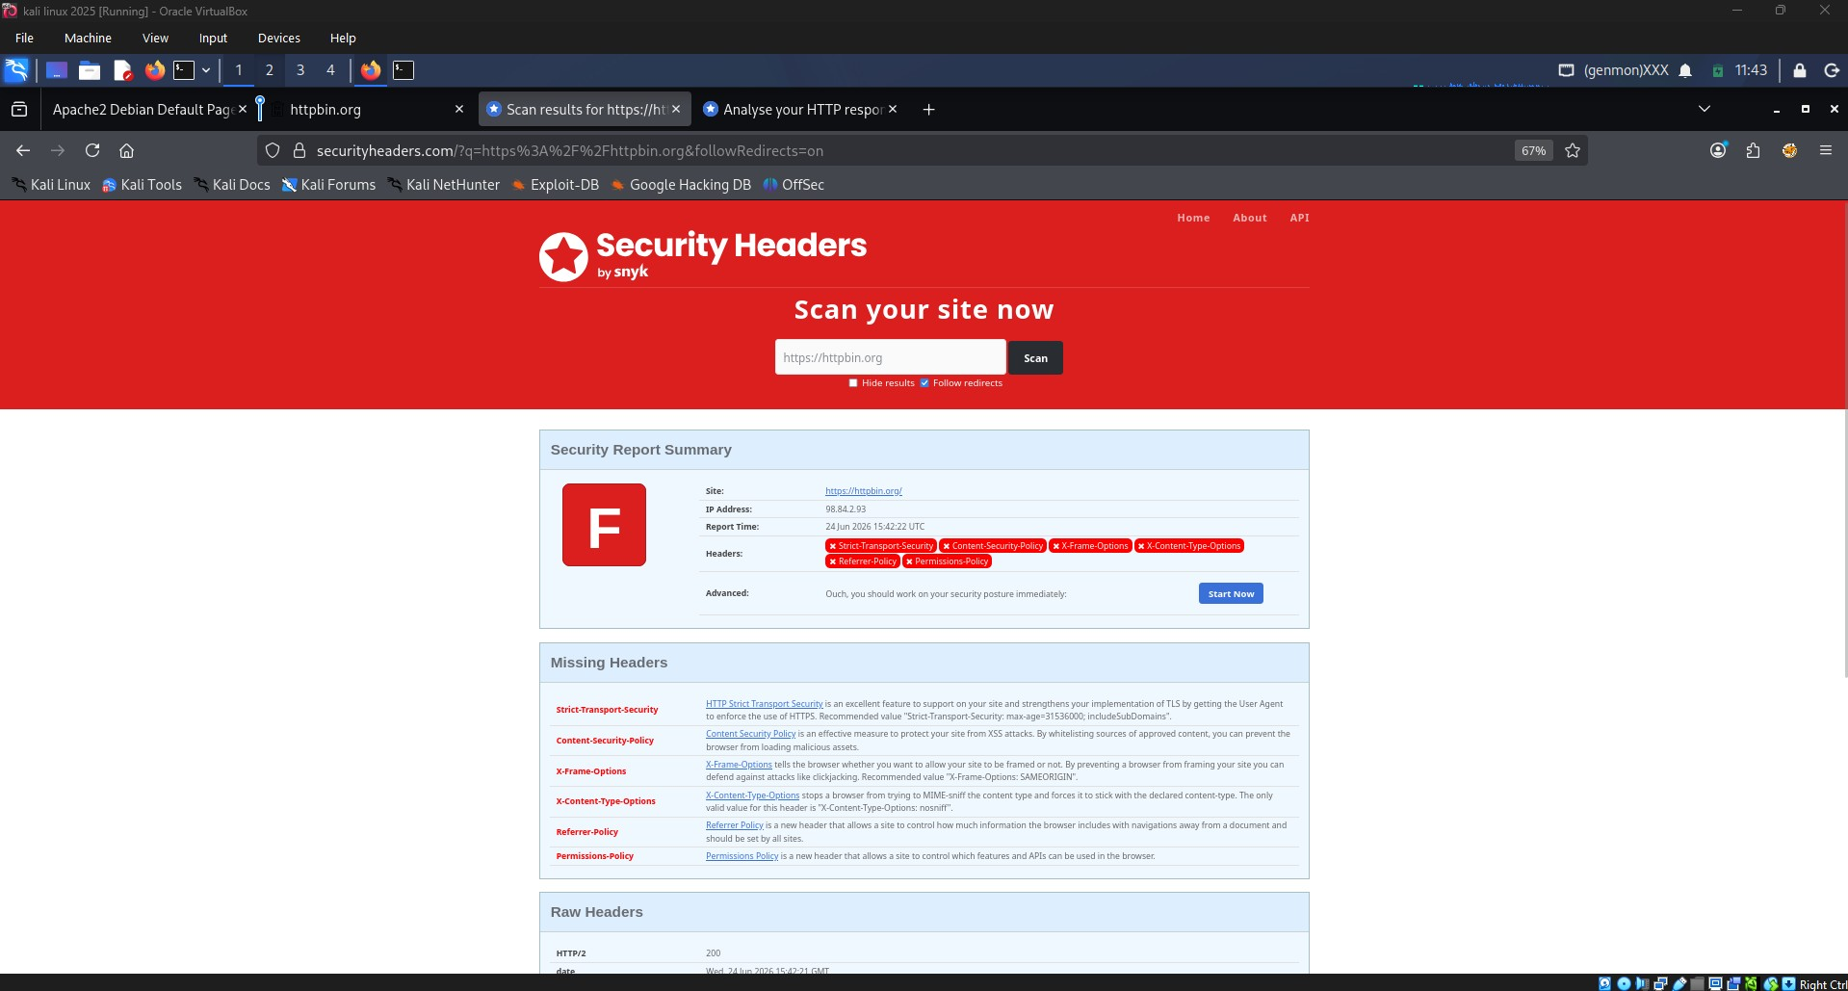

3. Apache Headers Module Enabled:
The Apache headers module was enabled to allow the web server to add custom security-related HTTP response headers.
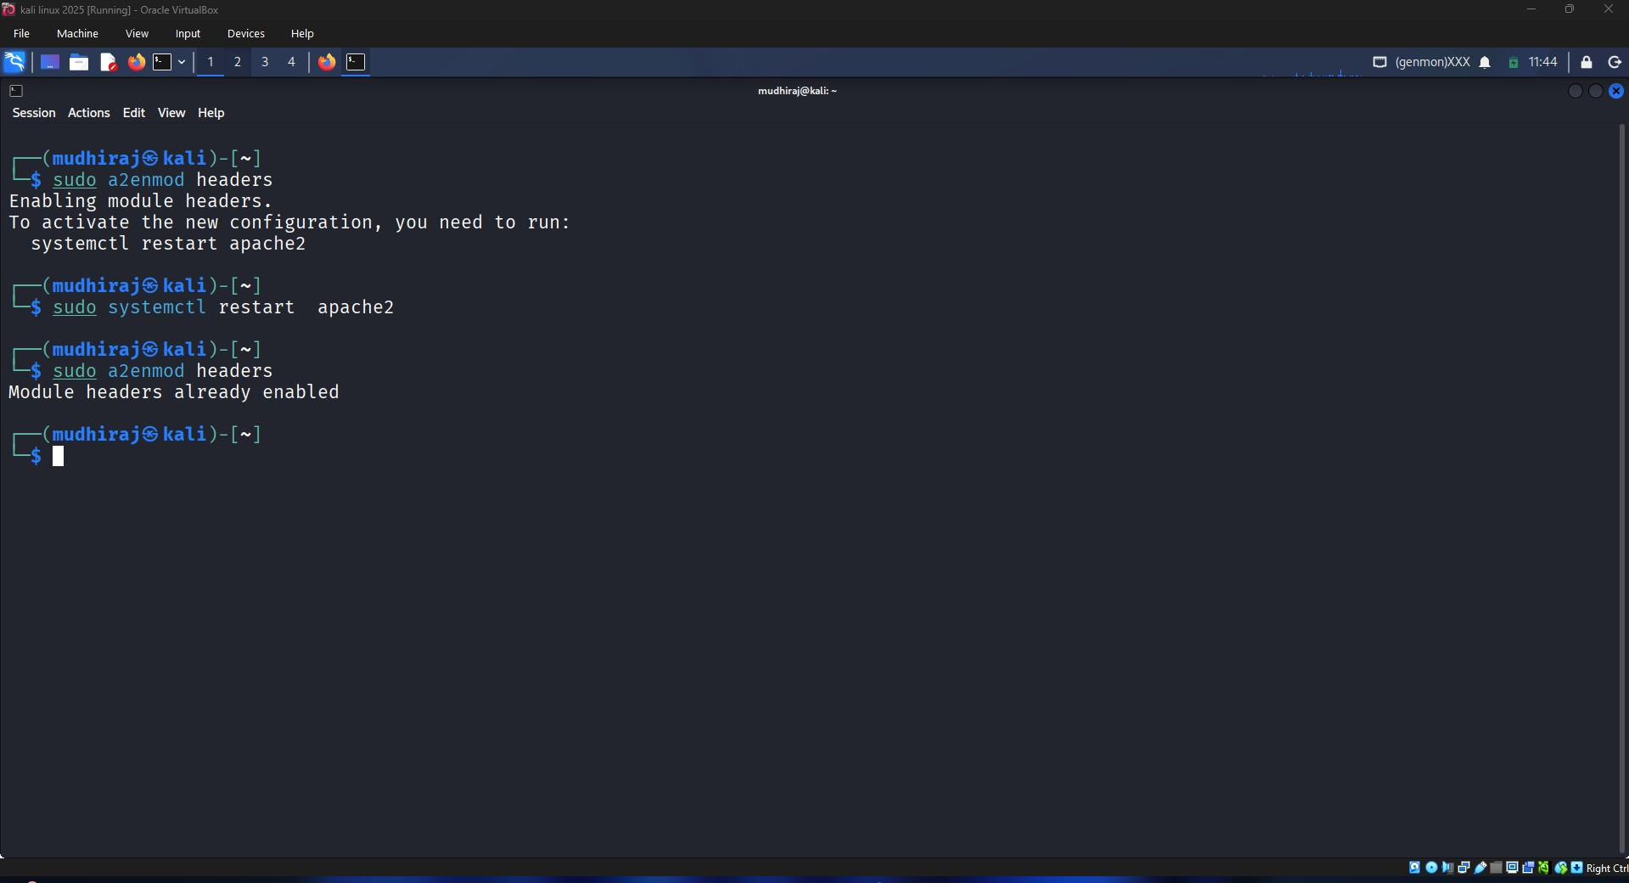

4. Apache Configuration Updated:
The Apache virtual host configuration file was modified to include security headers such as X-Frame-Options, X-Content-Type-Options, Referrer-Policy, and X-XSS-Protection.
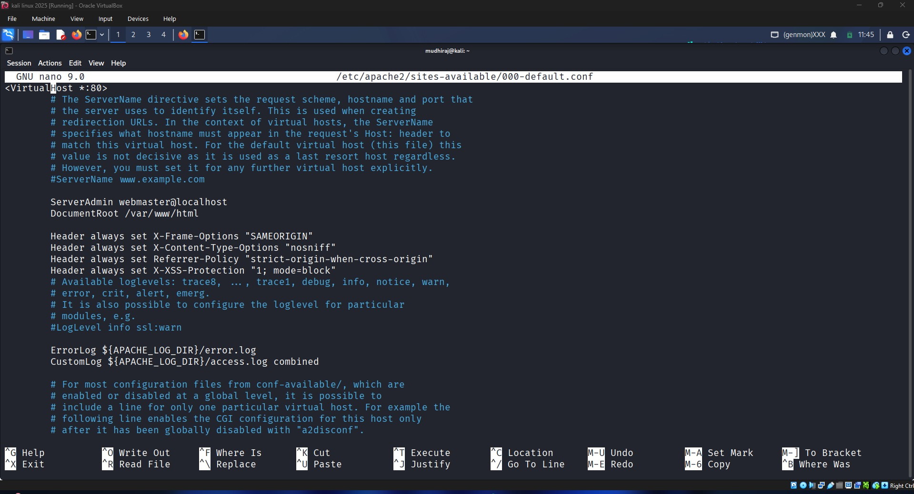

5. Apache Configuration Validation:
The updated configuration was validated using Apache configuration testing utilities. The successful validation confirmed that no syntax errors were present.
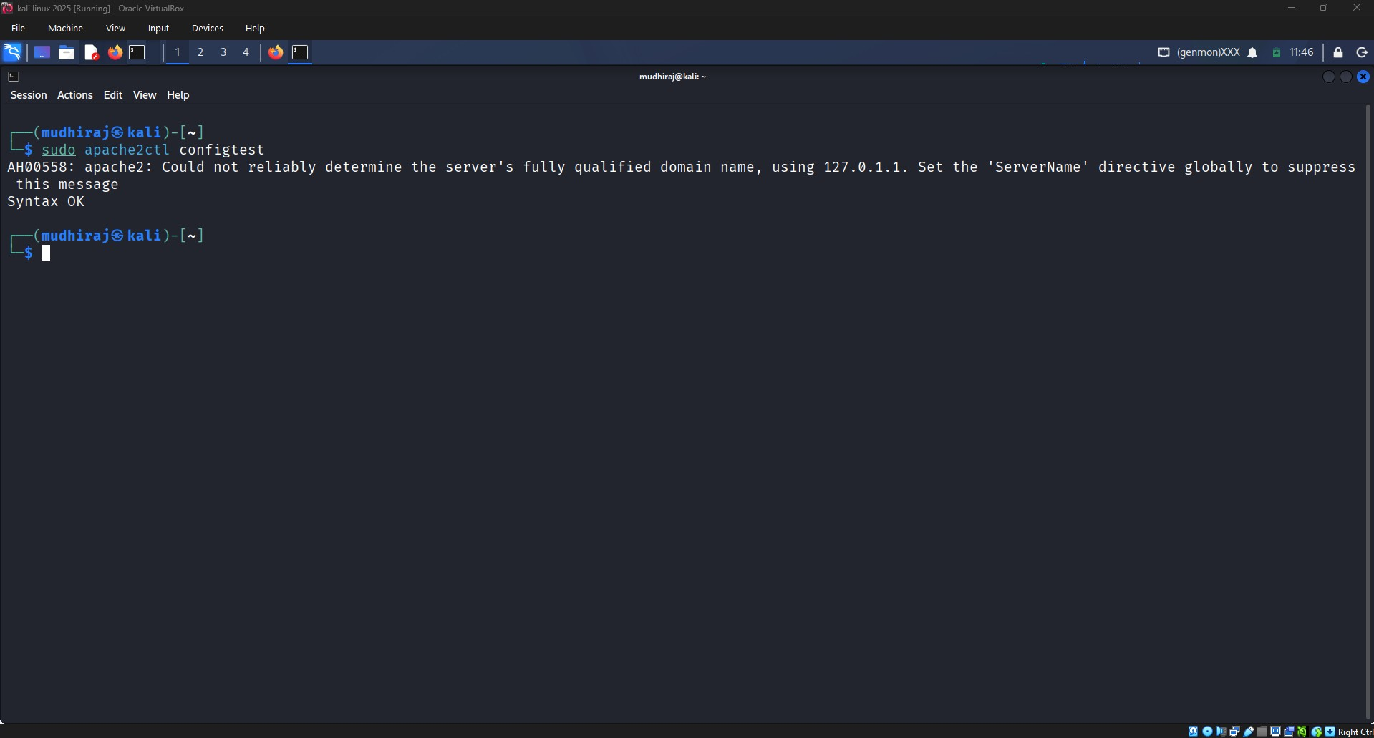

6. Security Headers Verification:
The Apache service was restarted and the configured headers were verified using HTTP response inspection. The results confirmed that the newly added security headers were successfully applied.
