Introduction:

- Internship: Cyber Security Internship at ApexPlanet
- Task: Foundation & Environment Setup
- Name: VANAM CHENCHU PUNEETH
- College: Siddharth Institute of Engineering & Technology
- Branch: Computer Science and Engineering

Objective:

The objective of this task is to build a basic cybersecurity laboratory environment using virtualization technologies. The lab consists of Kali Linux as the attacker machine and Metasploitable2 as the vulnerable target machine. The setup helps in understanding networking concepts, Linux fundamentals, cybersecurity basics, and security assessment tools such as Nmap and Wireshark.

Cybersecurity Basics:
- CIA Traid:
- Confidentiality : Ensures information is accessible only to authorizes users
- Integrity : Ensures information is not modify by unauthorized users
- Availability : Ensures the information and services are available whenever needed.

Threats :
- Phishing : A social engineering attack to trick user to get their credentials.
- Malware : Malicious software designed to gain unauthorized access to systems
- DDoS: Distributed Denial of Service to make a server can’t handle the traffic
- SQL Injection : Attack related database queries to get sensitive data from it
- Brute Force : Guessing password until one is right with software or programs
- Ransomware : Malware that encrypts files and demands payment for decryption.

- Lab Environment Setup :
- Software Used :
    - “Oracle VritualBox”
    - “Kali Linux 2025”
    - “Metasploitable”

They can be found on the screen shots below.

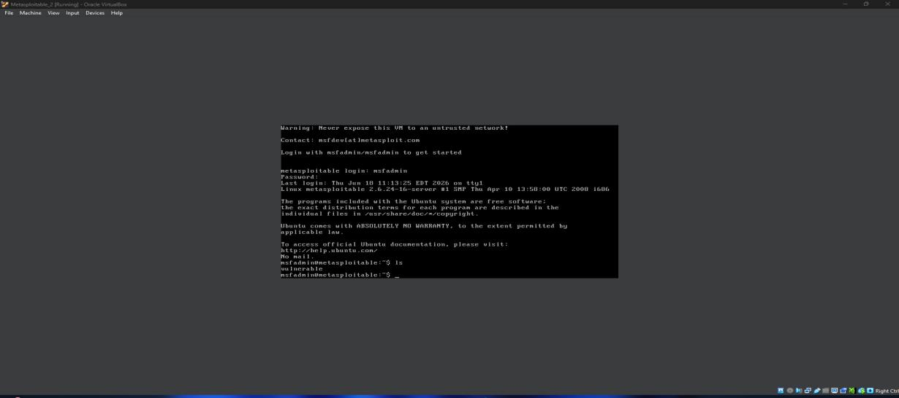

Below are the host only adapter setting in kali and metasploitable
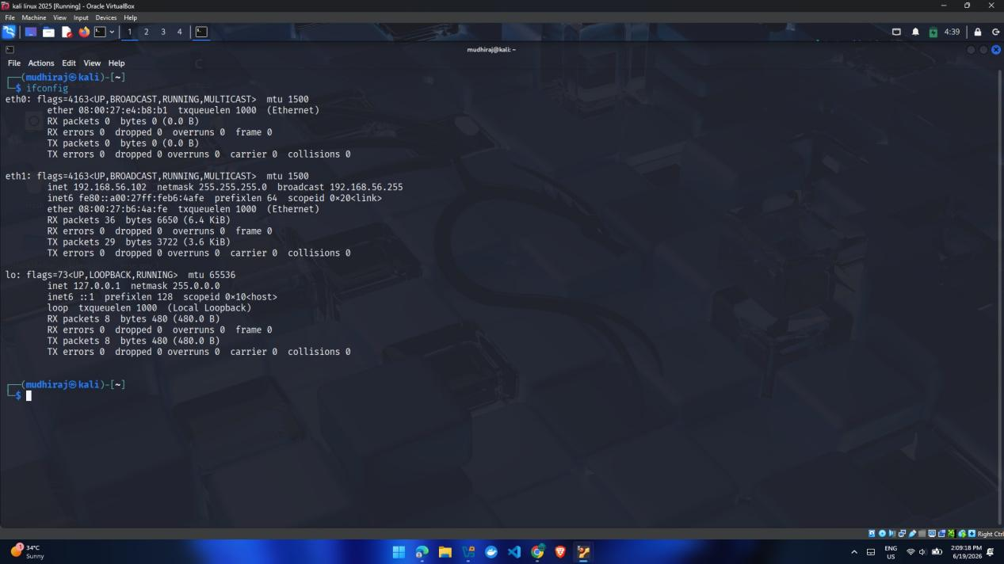
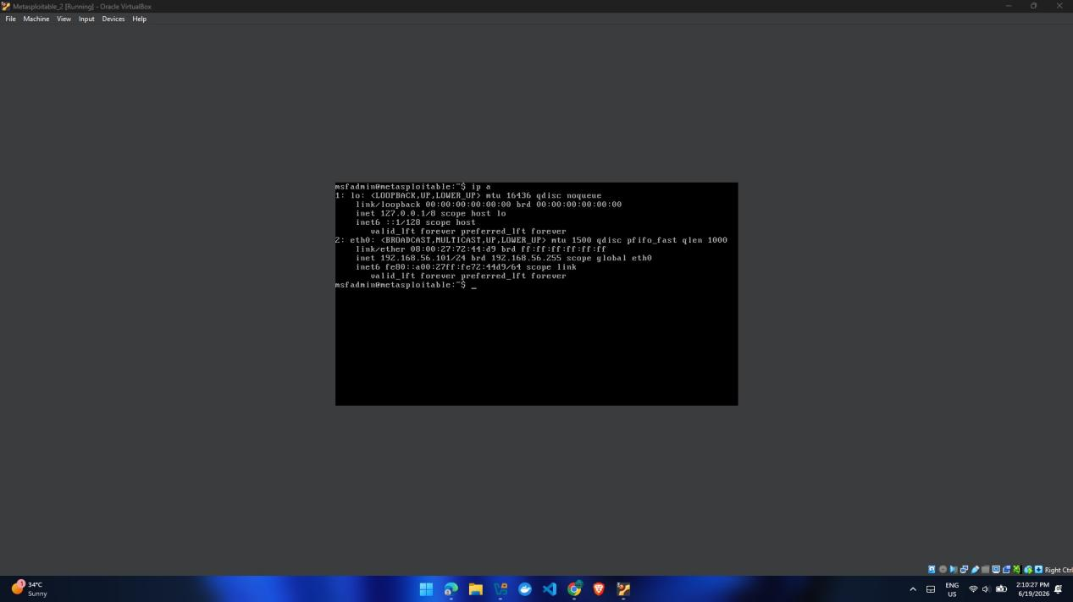

eth1 and eth0 in kali and metasplitable are in host only adapter they are in same network with VM DHCP sever.

Kali Linux had two adapter 1 and 2 with NAT and Host-Only one .
Metasploitable 2 has one adapter with Host-Only adapter only.

NAT Adapter : NAT (Network Address Translation) allows private IP addresses to access the internet using a public IP address.
Host-Only Adapter : Host-Only networking creates a private network between virtual machines.

- Networking Basics :
OSI LAYER
Layer | Functions | Examples
Application layer | UI/UX | chrome
Presentation Layer | Encryption/formatting/compression | SSL/TLS
Session layer | Maintains connecyion | Login session
Transport layer | Reliable delivery | TCP,UDP
Network Layer | Routing using ip addr | IP address
DataLink layer | MAC addr communication | Etherent
Physical Layer | Actual signals | Cable/Wifi

TCP/IP Protocol Suite
Same as OSI but has 4 layer with integrated into them

TCP/IP | Equals to OSI layer
Application layer | 7,6,5
Transport layer | 4
Internet layer | 3
Network layer | 2,1

DNS Deep Dive :
DNS converts domain names into IP addresses so computers can locate websites.

HTTP/HTTPS Deep Dive:
* Hyper Text Transfer Protocol is webpages transfer protocol used in web browers.
* In HTTPS it will transfer with encryption, so no middle man will see the text you sent over the network. Here ‘s’ indicates secure travel in internet.

IP Addressing :
* It is like a address to specifly indentifies a system in network, In real life it is home address.

Subnetting :
Subnetting is the process of dividing a large network into smaller logical networks for better management and communication.

NAT :
* Network Address Translation convert public IP to private IP for internet browsing.

My lab Example :
Kali Linux :
eth0 = NAT
Internet Access
eth1 = Host-Only
192.168.56.102
Metasploitable2 :
eth0 = Host-Only
192.168.56.101
Communication is happening in eth1 and eth0 of kali and Metasploitable 2.

4 .Cryptography Basics
Cryptography – Technique used to secure data from unauthorized access.
Symmetric Encryption – Uses the same key for encryption and decryption.
Asymmetric Encryption – Uses a public key for encryption and a private key for decryption.
AES – A popular symmetric encryption algorithm.
RSA – A popular asymmetric encryption algorithm.
Hashing – Converts data into a fixed-length value that cannot be reversed.
MD5 – A 128-bit hashing algorithm used for integrity checks.
SHA256 – A 256-bit secure hashing algorithm.
Digital Certificate – Electronic document used to verify the identity of a website or organization.
Certificate Authority (CA) – Trusted organization that issues digital certificates.
SSL – Older protocol used to secure network communication.
TLS – Modern protocol that secures data transmission over networks.
HTTPS – HTTP secured using SSL/TLS encryption.
OpenSSL – Open-source tool used for encryption, decryption, and certificate management.

Hands-on OpenSSL :
Encryption Command :
openssl enc -aes-256-cbc -in message.txt -out encrypted.enc
Encrypts a file using AES-256 encryption.
Decryption Command :
openssl enc -aes-256-cbc -d -in encrypted.enc -out decrypted.txt
Decrypts the encrypted file back to its original form.

Conclusion:
Successfully installed VirtualBox, Kali Linux, and Metasploitable2. Configured NAT and Host-Only networking, verified connectivity using ping, identified services using Nmap, and captured network packets using Wireshark. This lab environment will be used for future cybersecurity learning and penetration testing exercises.

