Firewall Configuration and Verification Report

1. Firewall Status Before Configuration:
The firewall configuration was checked using the command 'sudo iptables -L'. The output showed that all default policies were set to ACCEPT and no custom firewall rules were configured. This means all incoming and outgoing traffic was allowed.
2. Applying Firewall Rules:
Firewall rules were added to demonstrate traffic filtering. FTP (port 21) was allowed, SSH (port 22) was dropped, and Telnet (port 23) was rejected. After applying the rules, the firewall configuration was verified again using iptables.
3. Verifying Firewall Rules with Nmap:
An Nmap scan was performed against ports 21, 22, and 23. The results confirmed that FTP remained accessible while SSH and Telnet were filtered by the firewall rules. This verified that the configured rules were working as expected.
Conclusion
The firewall analysis demonstrated how iptables can be used to control network traffic. Initially, the system allowed all traffic. After applying custom rules, selected services were filtered, and the changes were successfully validated using Nmap scanning.
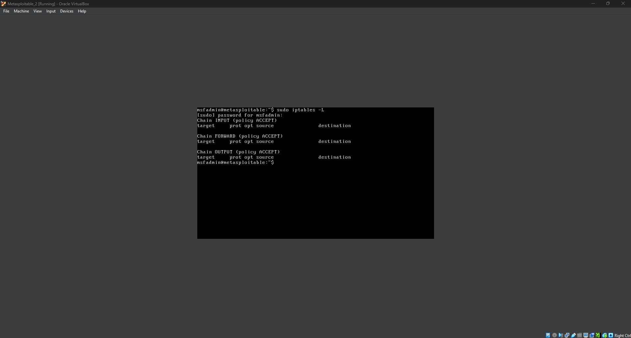
Figure 1: Firewall status before applying custom rules.
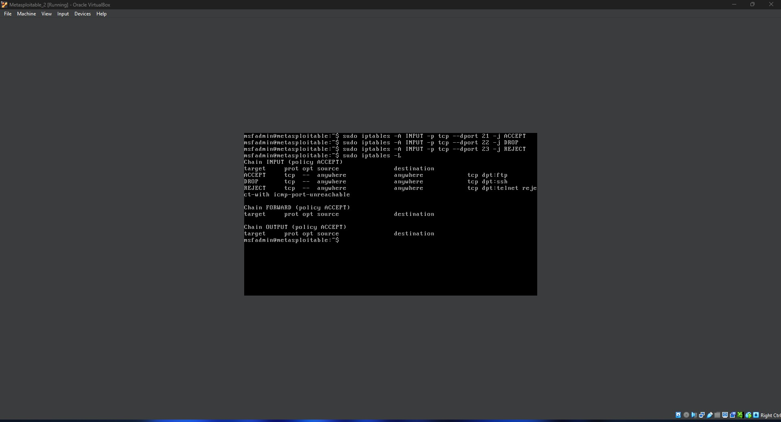
Figure 2: Firewall rules applied using iptables.
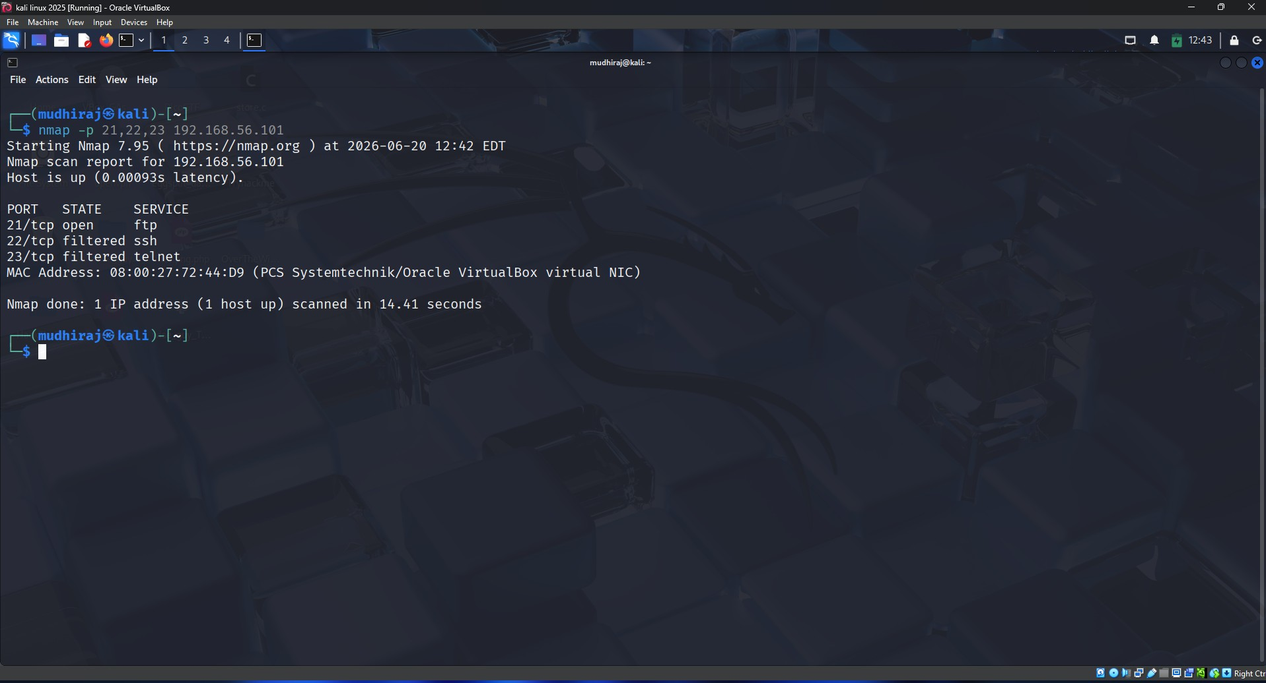
Figure 3: Nmap verification scan after firewall rules were applied.

