CSRF Attack and Token-Based Protection in DVWA
1. Objective
To demonstrate a Cross-Site Request Forgery (CSRF) attack in DVWA and understand how token-based protection mitigates the vulnerability.
2. Screenshot Details:
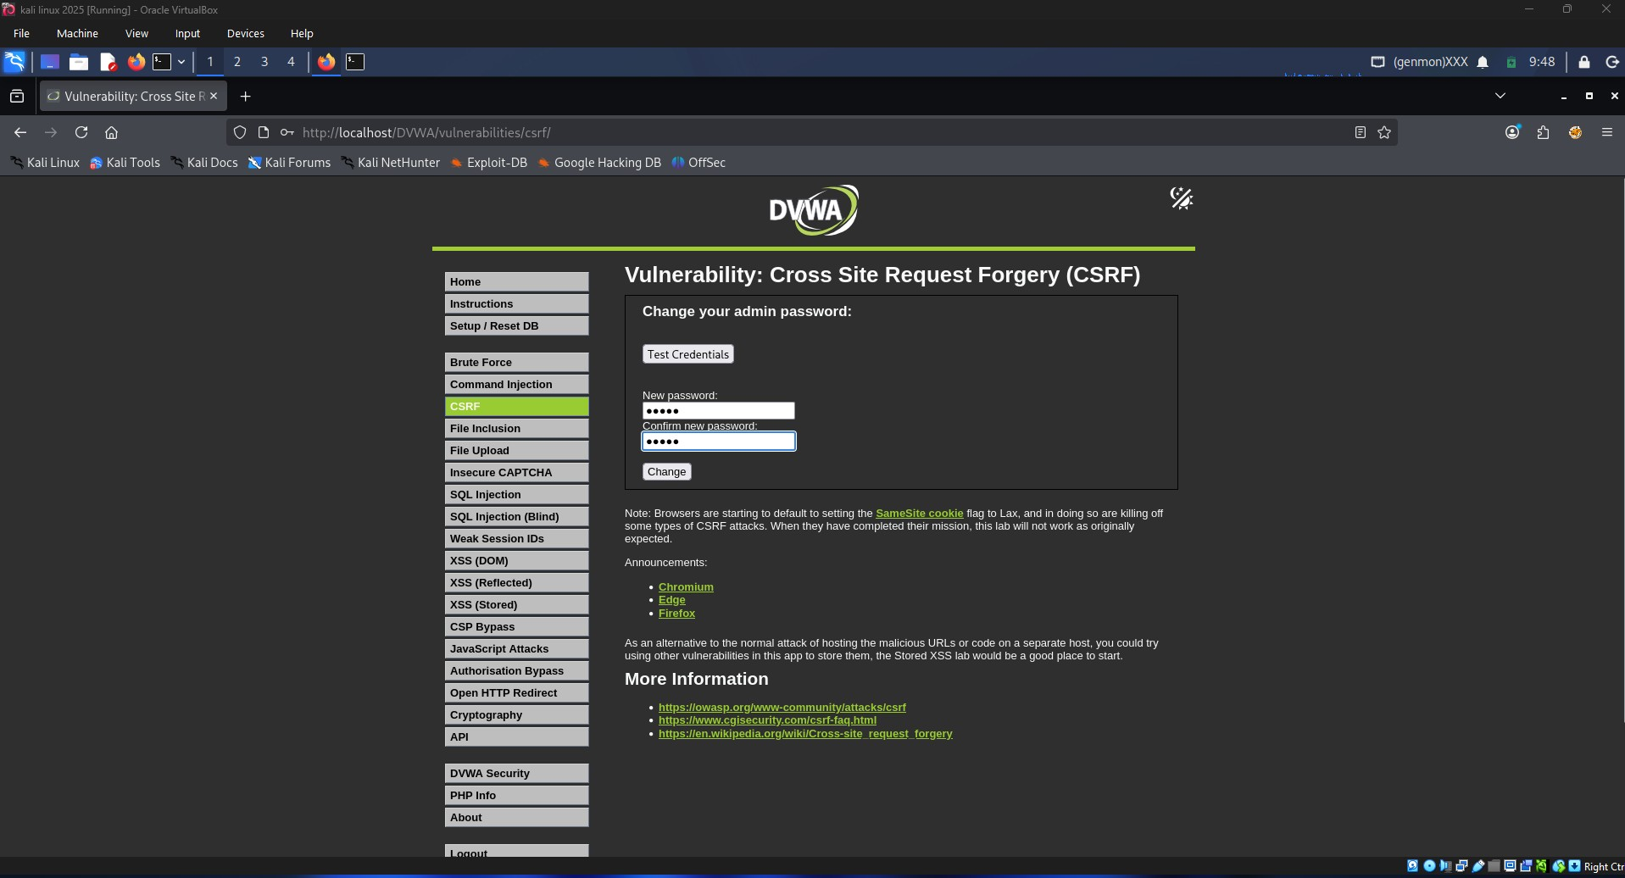
This screenshot shows the DVWA CSRF module where an authenticated user can change the administrator password.
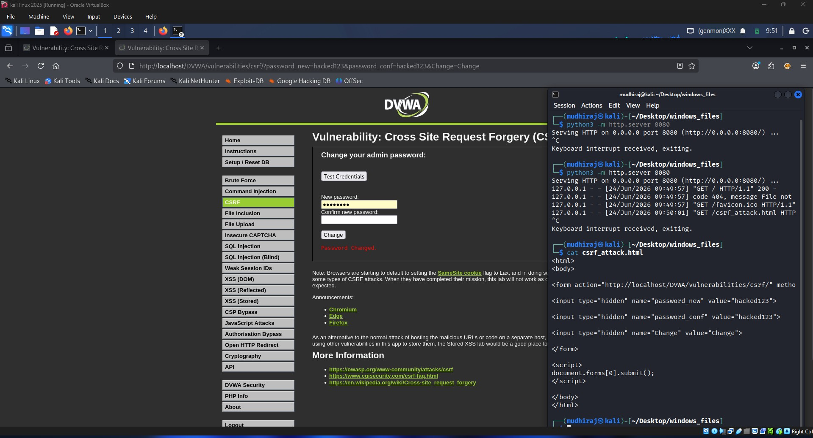
This screenshot demonstrates a successful CSRF attack using a malicious HTML page containing hidden form fields and automatic form submission.
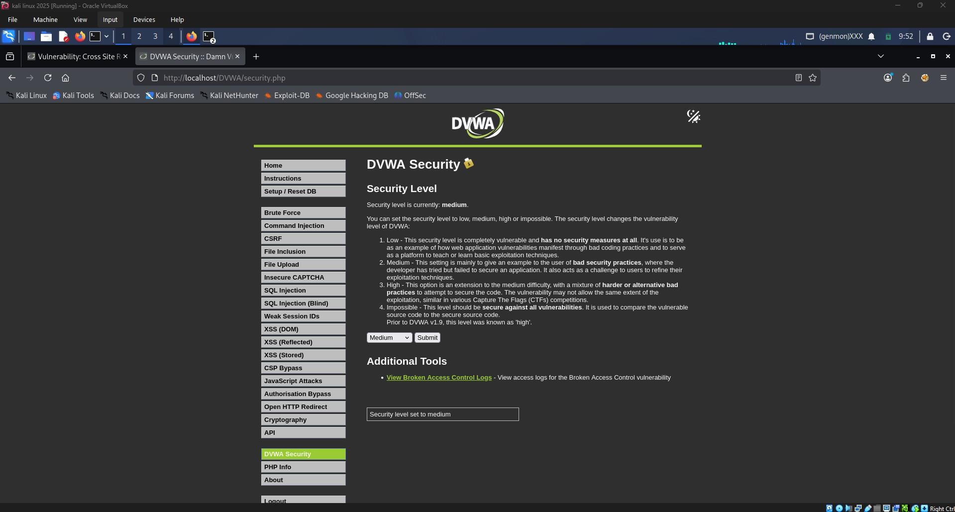
This screenshot shows DVWA security level changed to Medium, enabling additional protection mechanisms.
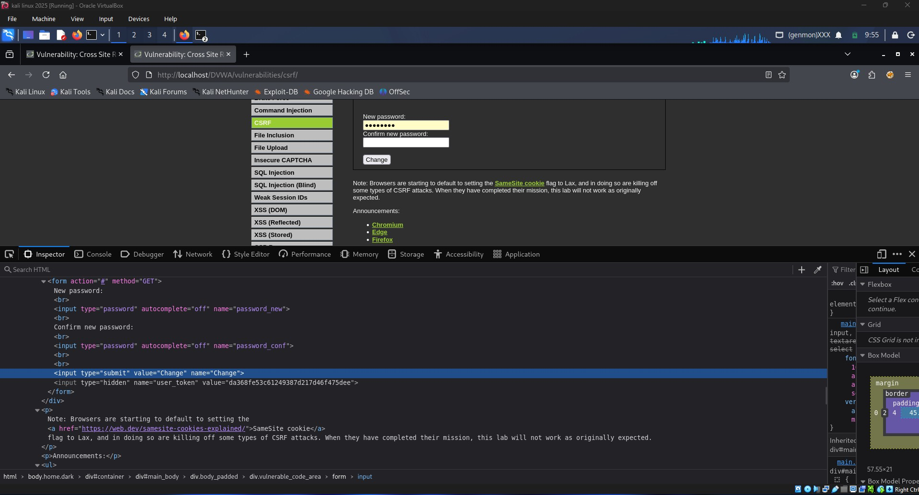This screenshot displays the hidden user_token field generated by DVWA for CSRF protection.

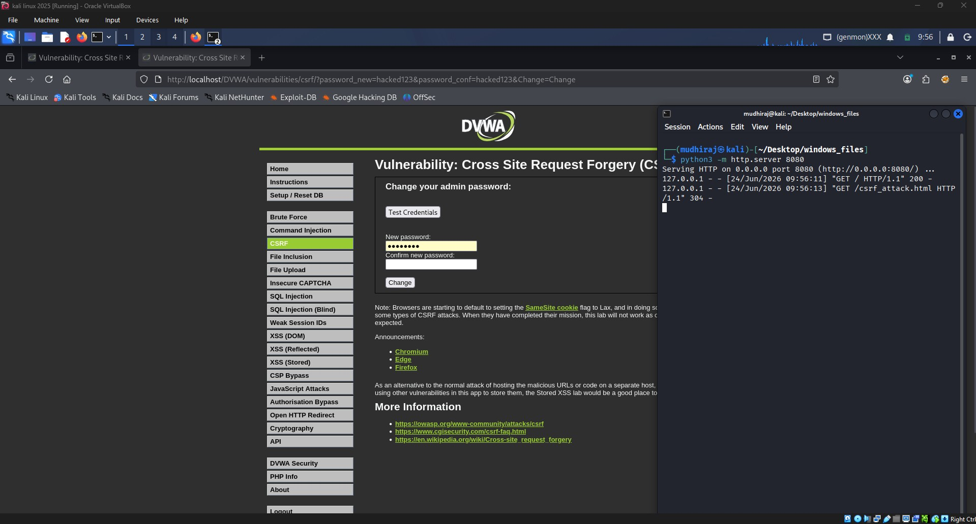
This screenshot demonstrates that the forged request is no longer valid when token-based protection is enabled.
3. CSRF Attack Explanation:
CSRF is a web attack that forces an authenticated user to perform unwanted actions. In DVWA Low Security, an attacker can create a malicious HTML page that automatically submits a password change request. Since the victim is already authenticated, the server accepts the request and changes the password.
4. Token-Based Protection:
DVWA Medium Security introduces a hidden user_token field. The server validates this token before processing sensitive requests. If the token is missing or invalid, the request is rejected, preventing CSRF attacks.
5. Result:
The CSRF attack was successfully demonstrated in Low Security mode. After enabling Medium Security and using CSRF tokens, the attack was mitigated because forged requests could not provide a valid token.

