Network Diagram

Capstone Project

Vulnerability Assessment of Test Network

1. Introduction
A network diagram provides a visual representation of the penetration testing laboratory used throughout this project. It illustrates the communication between the attacker machine and the vulnerable target machine within an isolated virtual environment. This setup ensures that all security testing activities are performed safely without affecting external systems.

2. Objective
The objective of the network diagram is to illustrate the architecture of the virtual laboratory, including the virtual machines, network adapters, and communication path used during the vulnerability assessment and controlled penetration testing process.

3. Network Architecture
The laboratory environment consists of the following components:
- Host Computer (Windows 11)
- Oracle VM VirtualBox
- Kali Linux Virtual Machine (Attacker)
- Metasploitable 2 Virtual Machine (Target)
- Host-Only Network (vboxnet0)
- NAT Network (Internet access for Kali Linux)
The Host-Only Adapter allows communication between Kali Linux and Metasploitable 2, while the NAT Adapter provides internet access to Kali Linux for downloading updates and security tools.

4. Network Diagram
Figure 1. Virtual Penetration Testing Laboratory
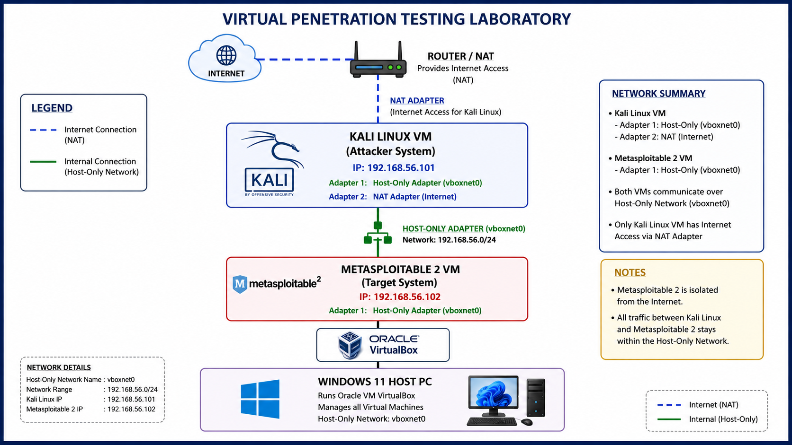

5. Network Communication
The communication flow is as follows:
- The Host Computer runs Oracle VM VirtualBox.
- Kali Linux acts as the attacker machine.
- Metasploitable 2 acts as the vulnerable target machine.
- Both virtual machines communicate through the Host-Only Adapter.
- Kali Linux additionally uses a NAT Adapter for internet connectivity.
- Metasploitable 2 remains isolated from the internet to maintain a secure testing environment.

6. Outcome
The network architecture was successfully configured to provide a secure and isolated penetration testing environment. Both virtual machines communicated successfully through the Host-Only Adapter, while Kali Linux maintained internet connectivity through the NAT Adapter.

7. Conclusion
The network diagram illustrates the overall structure of the virtual laboratory used in this project. The isolated environment ensures that vulnerability assessment, exploitation, and incident response activities can be performed safely without impacting external systems.

