Reconnaissance Report
Capstone Project
Vulnerability Assessment of Test Network

1. Introduction
This report documents the reconnaissance phase performed against the Metasploitable 2 virtual machine using Kali Linux. The objective was to identify active hosts, open ports, running services and operating system information before proceeding to vulnerability assessment.

2. Objective
To collect information about the target machine using Nmap and identify its exposed attack surface.

3. Tools Used
• Kali Linux
• Nmap 7.99
• Oracle VirtualBox
• Ping

4. Target Information
Target: Metasploitable 2
IP Address: 192.168.56.101
Network: Host-Only
Attacker: Kali Linux

5.1 TCP SYN Port Scan
Command: sudo nmap -sS 192.168.56.101
Observation: The scan discovered 23 open TCP ports including FTP, SSH, HTTP, MySQL, PostgreSQL, Samba, VNC, IRC and Apache Tomcat, indicating a large attack surface.
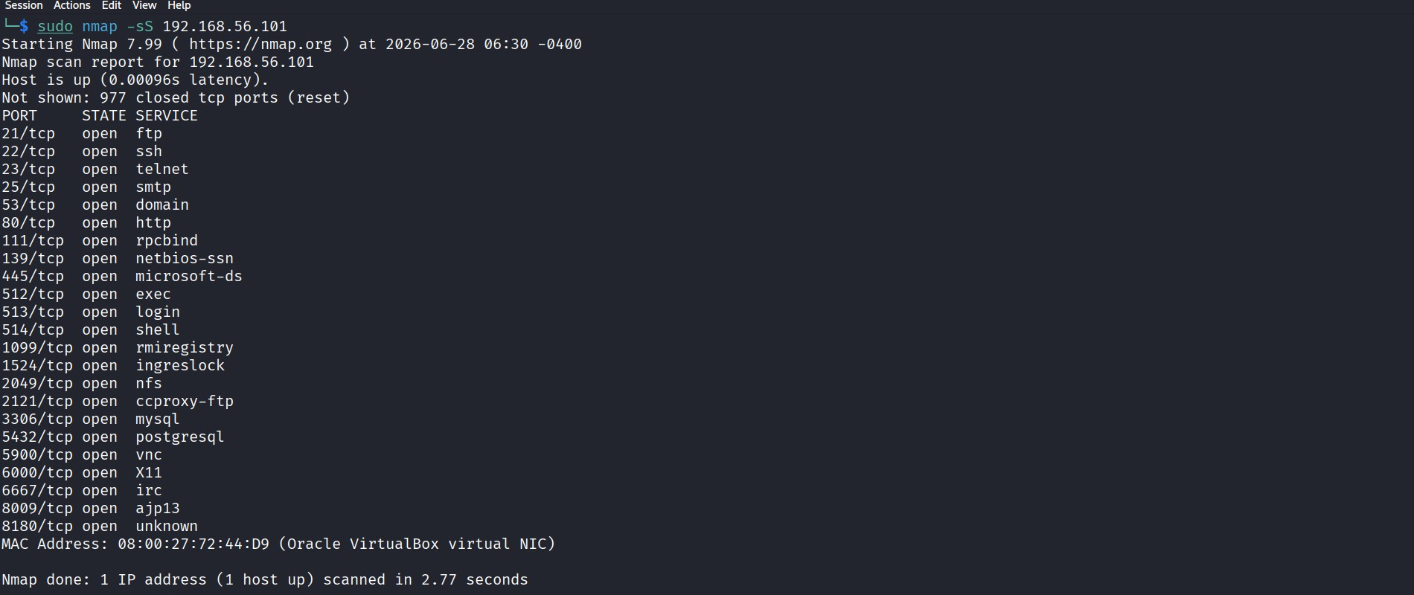
Figure RC-01. TCP SYN Port Scan
5.2 Service Enumeration
Command: sudo nmap -sV 192.168.56.101
Observation: Service detection identified versions such as vsFTPd 2.3.4, OpenSSH 4.7p1, Apache HTTP Server 2.2.8, Samba 3.x, MySQL 5.0.51a, PostgreSQL 8.3 and UnrealIRCd.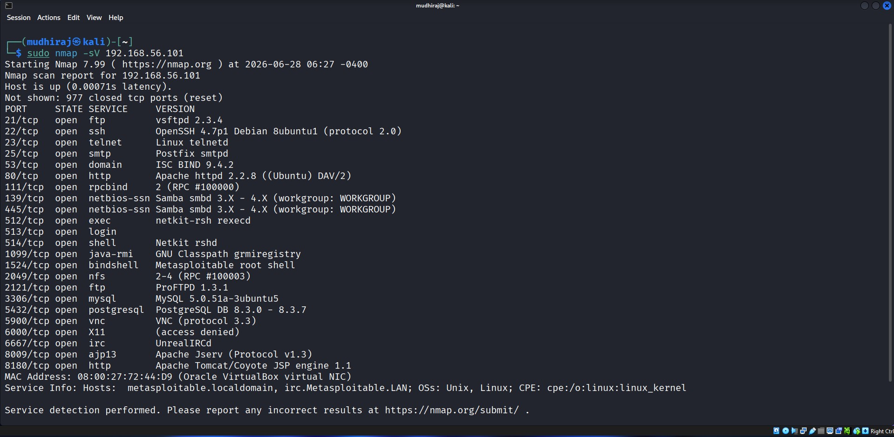
Figure RC-02. Service Enumeration
5.3 Operating System Detection
Command: sudo nmap -O 192.168.56.101
Observation: The target was identified as Linux kernel 2.6.x with an estimated network distance of one hop.
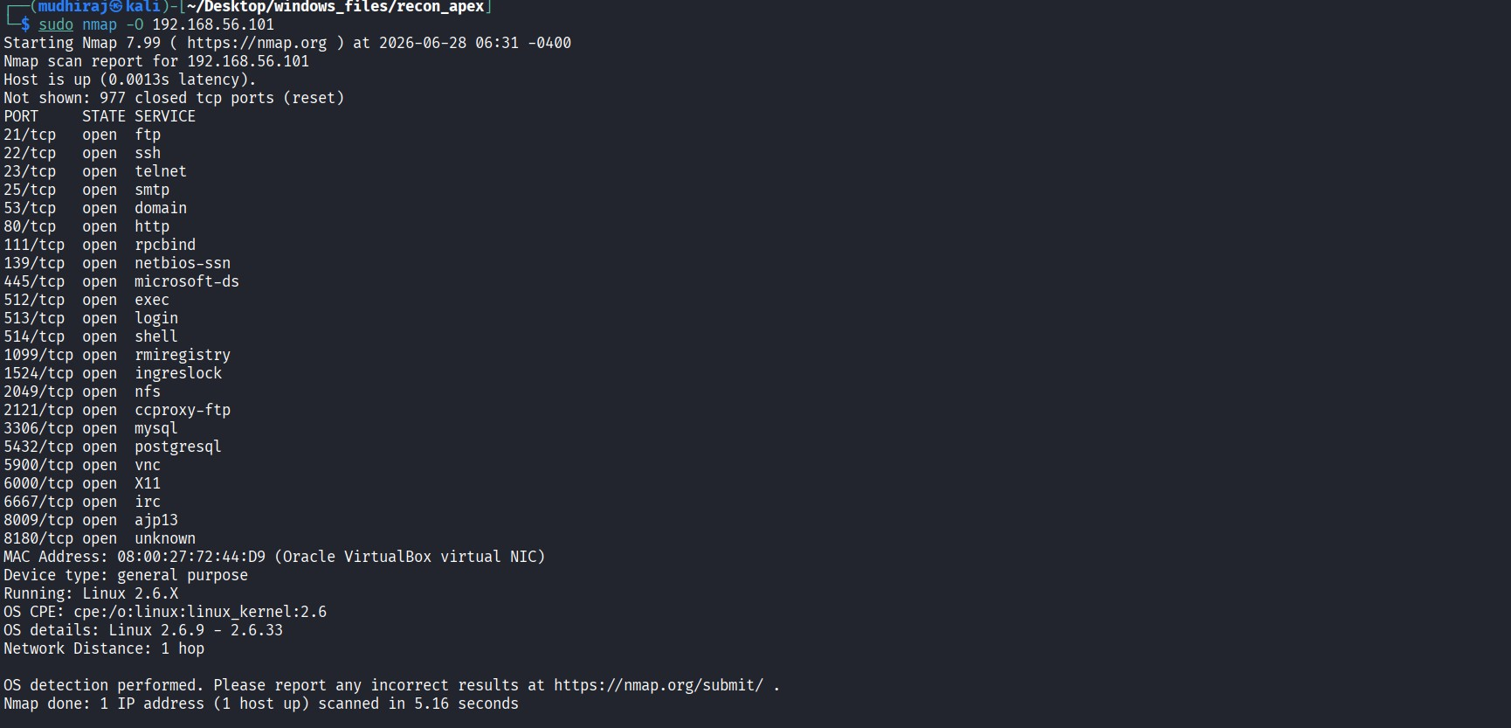
Figure RC-03. Operating System Detection
5.4 Aggressive Scan
Command: sudo nmap -A 192.168.56.101
Observation: The aggressive scan combined OS detection, service enumeration, default NSE scripts and traceroute to provide comprehensive reconnaissance results.
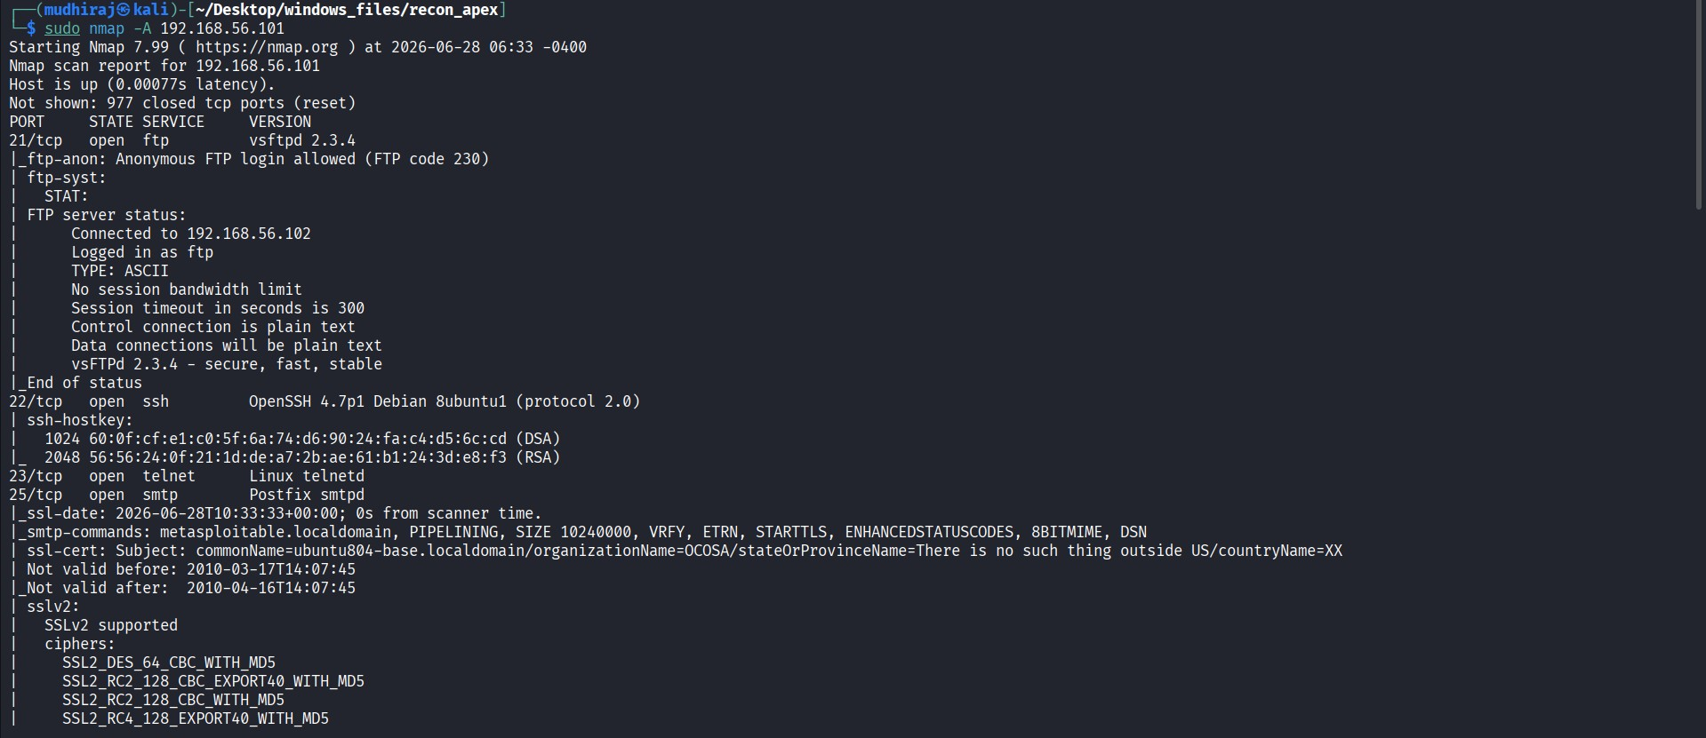
Figure RC-04. Aggressive Scan
6. Summary
Reconnaissance successfully identified the target host, open TCP ports, service versions and operating system details. These findings provide the baseline information required for the subsequent vulnerability assessment phase.
7. Conclusion
The reconnaissance phase was completed successfully in an isolated virtual laboratory using Kali Linux and Nmap. The collected information establishes the target's attack surface and supports the next phase of vulnerability assessment.

