Wireshark Traffic Analysis Report

1. HTTP Traffic Capture
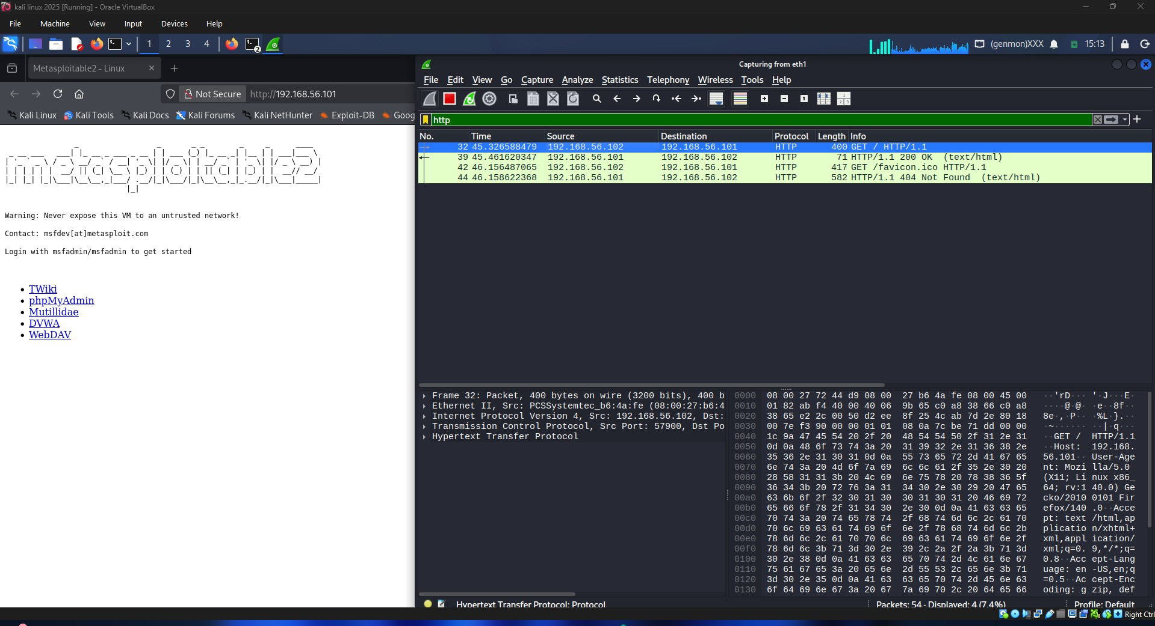
HTTP traffic was captured while accessing the Metasploitable web server. Wireshark displayed HTTP GET requests and responses exchanged between the client and server. This demonstrates how web traffic can be monitored and analyzed at the packet level.

2. FTP Traffic Capture
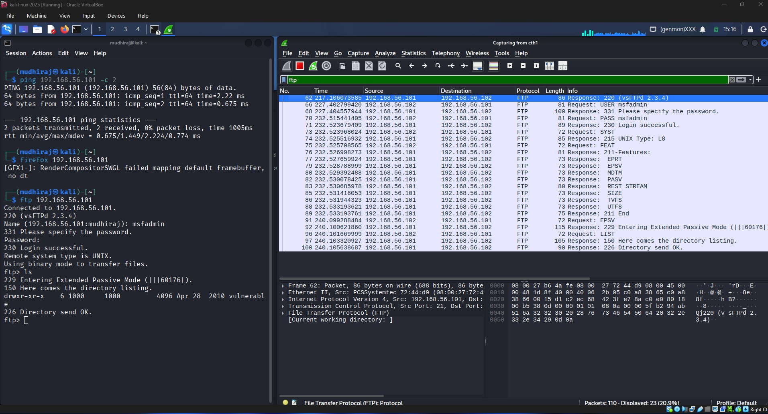
FTP traffic was captured while connecting from Kali Linux to the Metasploitable FTP service. The packets show the FTP login process and directory listing operations.

3. FTP Credential Analysis
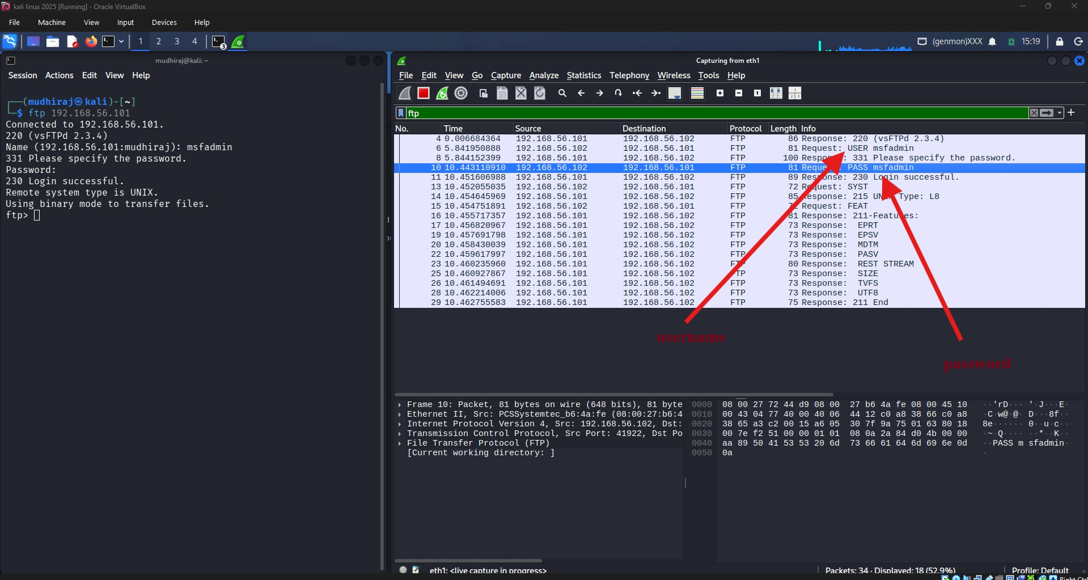
The capture reveals that FTP credentials are transmitted in plaintext. The username and password can be observed directly in network traffic, demonstrating why FTP is considered insecure.
4. DNS Traffic Capture
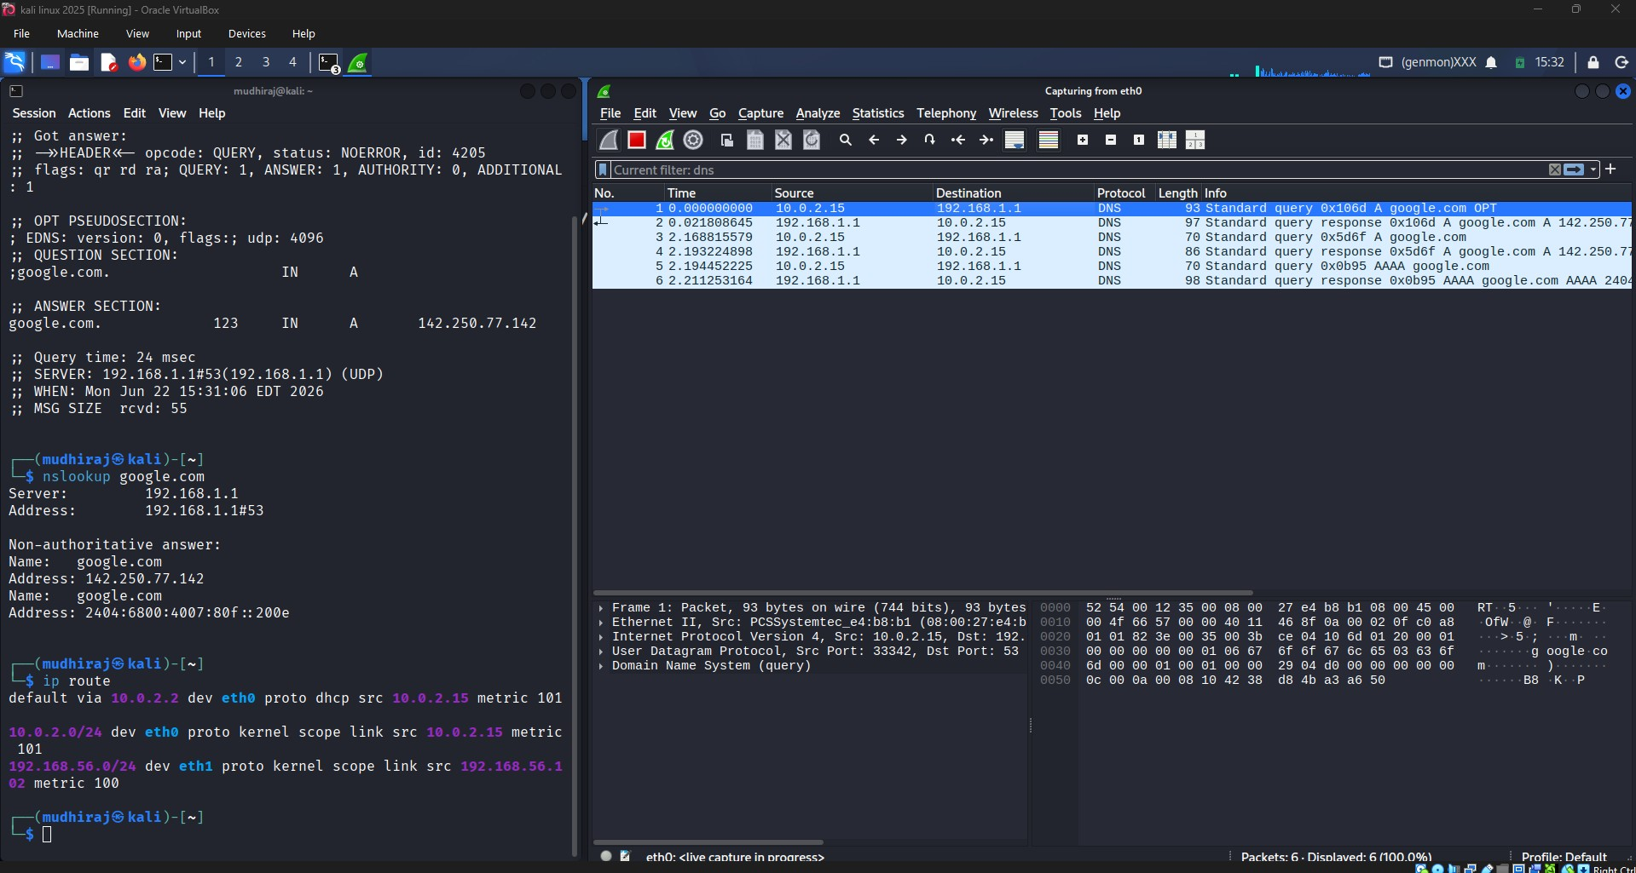
DNS traffic was captured while resolving google.com. The capture shows DNS queries and responses that translate domain names into IPv4 and IPv6 addresses.
5. SYN Flood Attack Simulation
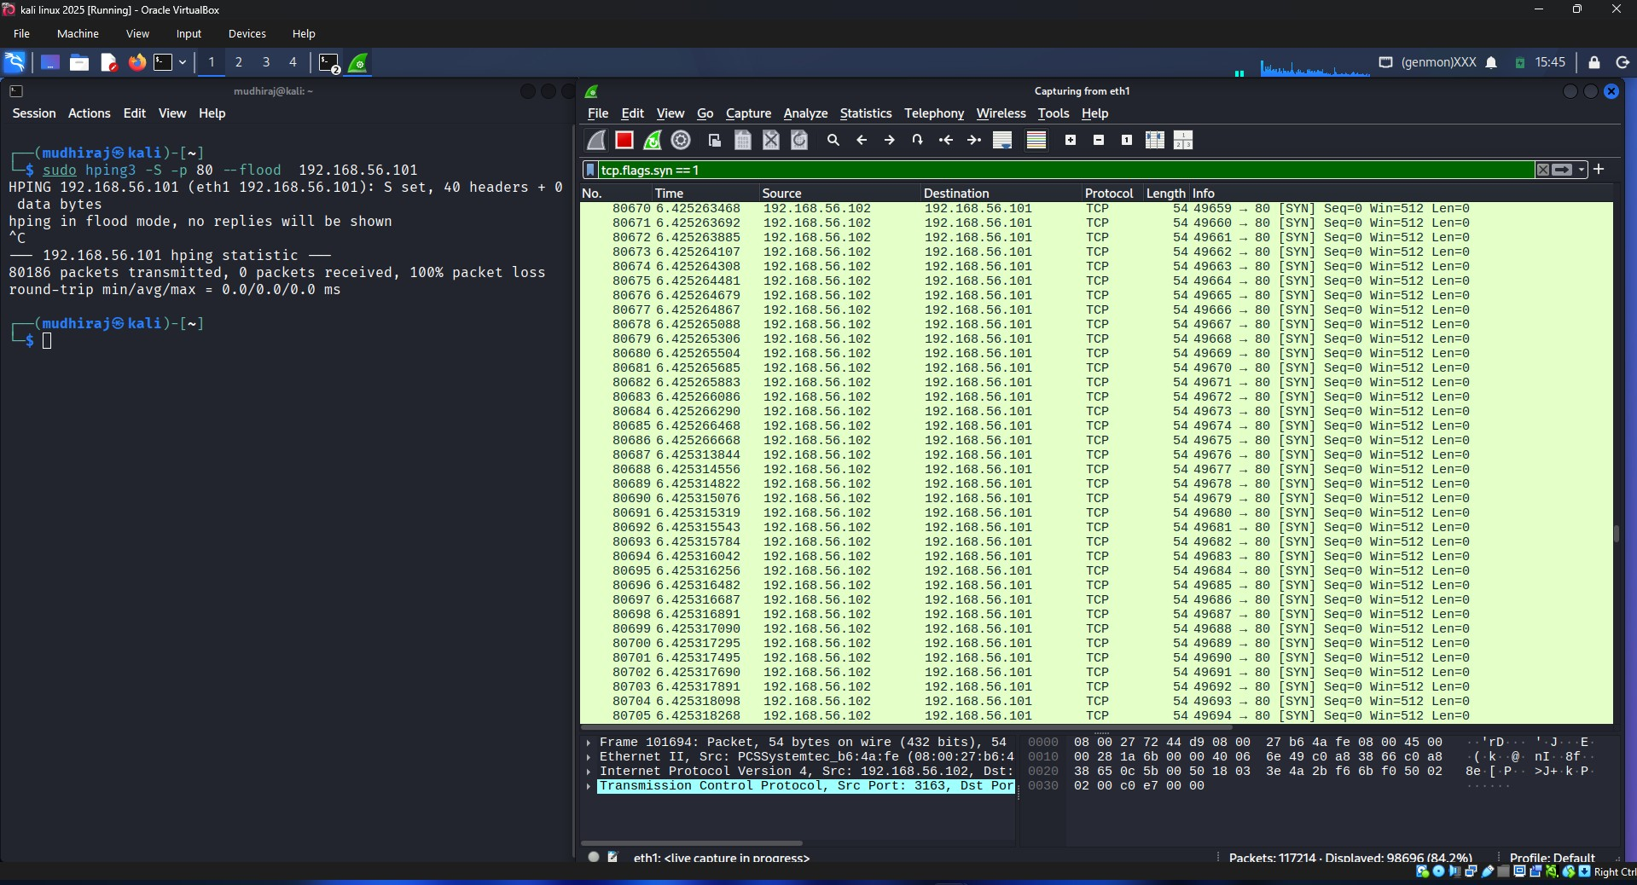
A SYN flood attack was simulated using hping3. Thousands of SYN packets were transmitted to the target system, and Wireshark successfully captured the traffic. This demonstrates how a denial-of-service attack can overwhelm a server with connection requests.

